If Possible the program will return the result in first 150 samples , else it will go for reproduction



[2, 5, 3, 0, 7, 4, 6, 1]

|  |  |  |  |  |  |  |  |  |
| --- | --- | --- | --- | --- | --- | --- | --- | --- |
|  | 0 | 1 | 2 | 3 | 4 | 5 | 6 | 7 |
| 0 |  |  |  | Q |  |  |  |  |
| 1 |  |  |  |  |  |  |  | Q |
| 2 | Q |  |  |  |  |  |  |  |
| 3 |  |  | Q |  |  |  |  |  |
| 4 |  |  |  |  |  | Q |  |  |
| 5 |  | Q |  |  |  |  |  |  |
| 6 |  |  |  |  |  |  | Q |  |
| 7 |  |  |  |  | Q |  |  |  |

The below output generated as program didn’t find the solution in first 150 samples

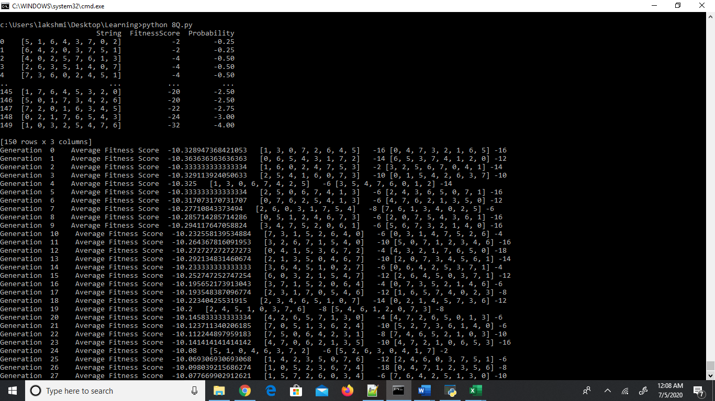

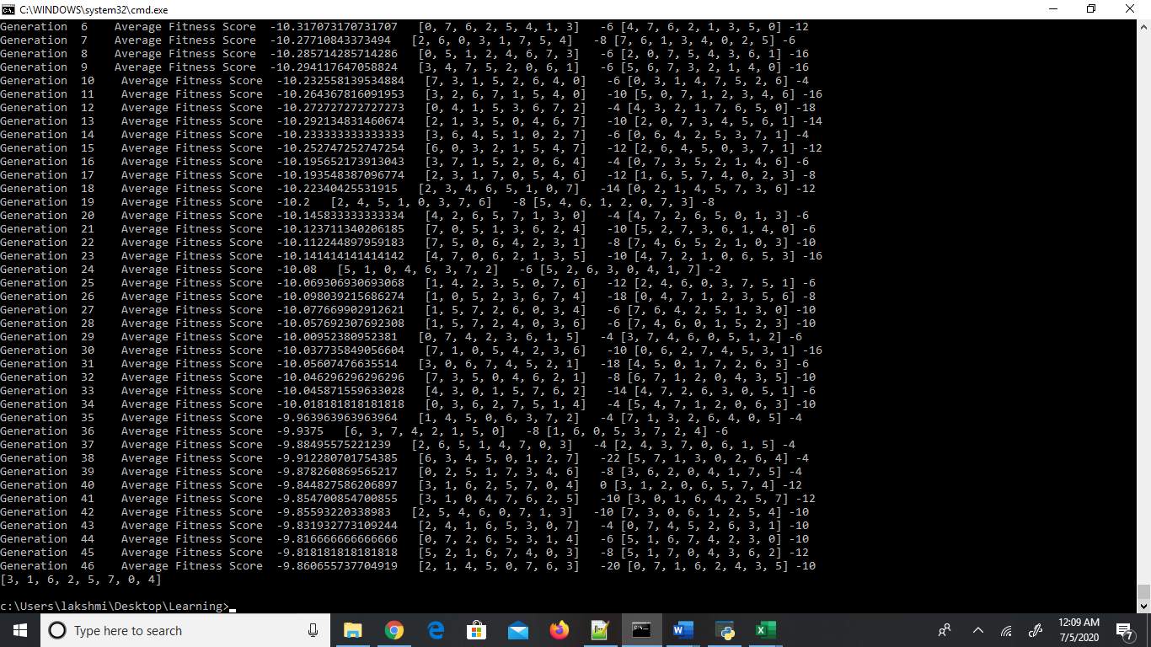

[3, 1, 6, 2, 5, 7, 0, 4]

|  |  |  |  |  |  |  |  |  |
| --- | --- | --- | --- | --- | --- | --- | --- | --- |
|  | 0 | 1 | 2 | 3 | 4 | 5 | 6 | 7 |
| 0 |  |  | Q |  |  |  |  |  |
| 1 |  |  |  |  |  | Q |  |  |
| 2 |  |  |  | Q |  |  |  |  |
| 3 | Q |  |  |  |  |  |  |  |
| 4 |  |  |  |  |  |  |  | Q |
| 5 |  |  |  |  | Q |  |  |  |
| 6 |  |  |  |  |  |  | Q |  |
| 7 |  | Q |  |  |  |  |  |  |