

Data Structures and Algorithms -23CSE203
Lab Manual

Submitted By

Submitted to

NAME | K. Naveen
ROLL NO | AV.SC.U4CSE25122
YEAR/SEM/SECTION | 2ST YEAR/ SEM-3/CSE-B
CREDITS | 05

NAME | DR. RAJ KUMAR BATCHU
DESIGNATION | ASST.PROFFESSOR (Sl. Grade)
DEPARTMENT | SCHOOL OF COMPUTING

Index
week |  | Page-numbers
1 | - A rocket launch system displays a count down before launch. Instead of using a loop, implement the count down using recursion. Write a recursive python program to display countdown from n to 1 followed by launch.  - Banks calculate the growth of investment using compound interest. The formula requires calculating powers, which can be implemented recursively. Write a recursive program to calculate P^n where P = Principal growth factor, n = number of years  - A HR department stores employee details in a list. Develop a recursive program to search for a given employee ID. Write a recursive function to search for an employee ID in a list.  - In a logistic department, the no of possible ways to arrange n diff parcels are calculated using the factorial formula(n!). Write a recursive formula to find the factorial of a given number  - Print first n terms in a fibanocci number series
2 | - Write the implementation for the linear search algorithm  - Write the implementation for the binary search algorithm  - Write the implementation for the binary search algorithm along with the sorting the input elements if they are not sorted.
3 | - Write a python program to implement bubble sort where the input elements are taken from the user.  - Write a python program to implement insertion sort where the input elements are taken from the user.  - Write a python program to implement selection sort where the input elements are taken from the user.
4 | - Write a python program to implement merge sort where the input elements are taken from the user  - Write a python program to implement quick sort where the input elements are taken from the user
5 | a) Write a Python program to implement a Singly Linked List (SLL) with the following operations:  1. Create LL  2. Insert at Beginning  3. Insert at End  4. Insert at Index  5. Delete by Value  6. Delete Prior Node  7. Delete Last Node  8. Count Number of Nodes  9. Display/Traverse  10. Exit  b) Write a Python program to implement a Double Linked List (DLL) with the following operations:  1. Create LL  2. Insert at Beginning  3. Insert at End  4. Insert at Index  5. Delete by Value  6. Delete Prior Node  7. Delete Last Node  8. Count Number of Nodes  9. Display/Traverse  10. Exit  c) Write a Python program to implement a Circular Linked List (CLL) with the following operations:  1. Create LL  2. Insert at Beginning  3. Insert at End  4. Insert at Index  5. Delete by Value  6. Delete Prior Node  7. Delete Last Node  8. Count Number of Nodes  9. Display/Traverse  10. Exit
6 | a) Write a python program to implement the stack operations such as push, pop, peek, display using array, linked list  b) Write a Python program to implement stack operations such as Push, Pop, Peek, and Display using an Linked List
7 | - Write a python program to implement Queue and its operations such as enqueue ,dequeue, peek, display with a menu driven approach. Implement using array .  - Write a python program to implement Queue and its operations such as enqueue ,dequeue, peek, display with a menu driven approach. Implement using linked list data structures  c) Write a python program to implement circular Queue and its operations such as enqueue ,dequeue, peek, display with a menu driven approach. Implement using array data structures  d) Write a python program to implement circular Queue and its operations such as enqueue ,dequeue, peek, display with a menu driven approach. Implement using linked list data structures

Lab-1
1a)
Aim:
A rocket launch system displays a count down before launch. Instead of using a loop, implement the countdown using recursion. Write a recursive python program to display count down from n to 1 followed by launch.
Program:
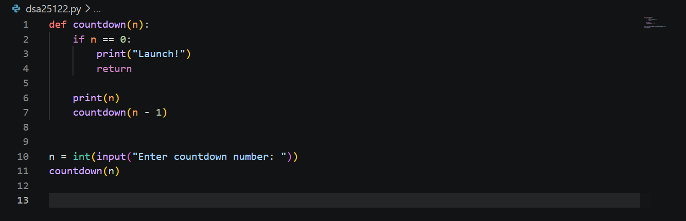
Output:
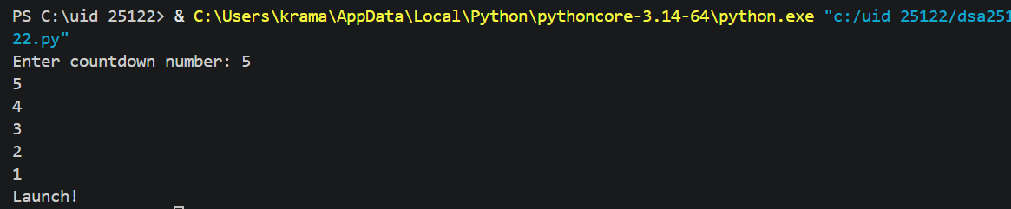
Error Table:
Error | Rectification

Description:
This program uses recursion to display a countdown from n to 1. The function calls itself with n - 1 until n becomes 0, then it displays "Launch".
1b)
Aim:
Banks Calculate the growth of investment using compound interest. The formula requires calculating powers, which can be implemented recursively. Write a recursive program to calculate P^n where
P = Principal growth amount, n = no of years
Program:
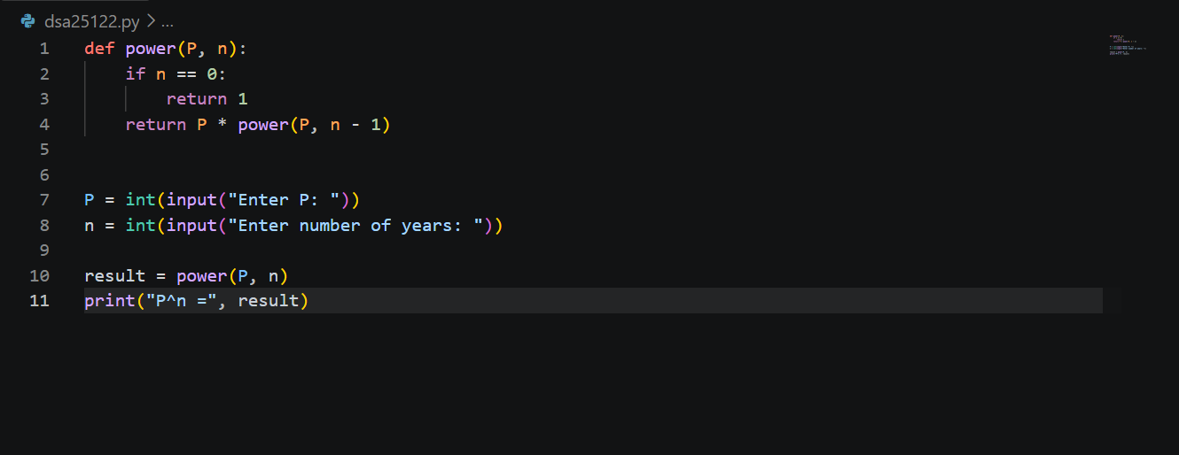
Output:
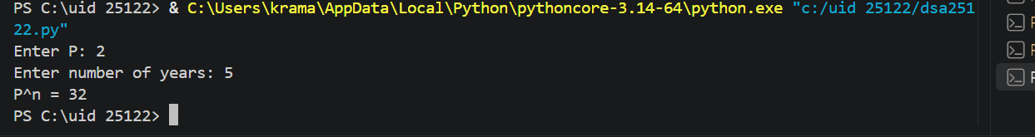
Error Table:
Error | Rectification
Negative values of n were not handled | Added n < 0 condition to handle negative number of years

Description:
The program recursively calculates P^n by multiplying P with the result of power(P, n-1). The recursion stops when n becomes 0.
1c)
Aim:
A HR department stores employee details in a list. Develop a recursive program to search for a given employee ID. Write a recursive function to search for an employee ID in a list.
Program: 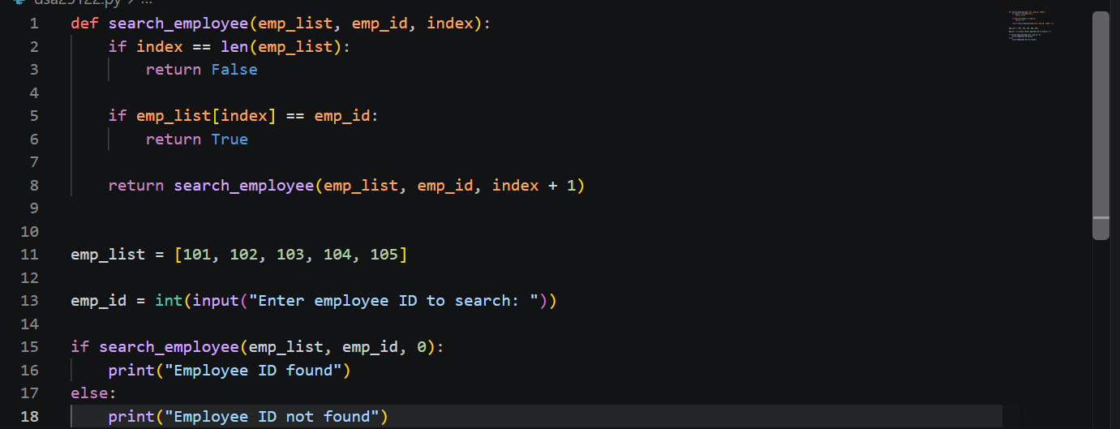
Output:
Error Table:
Error | Rectification
 | Added a condition to return "Employee ID not found"
  Employee ID not found in the list

Description:
The program recursively searches for a given employee ID in a list. It compares the employee ID with each element and continues searching until the ID is found or the end of the list is reached.
1d)
Aim:
In a logistic department, the no of possible ways to arrange n diff parcels are calculated using the factorial formula(n!). Write a recursive formula to find the factorial of a given number
Program:
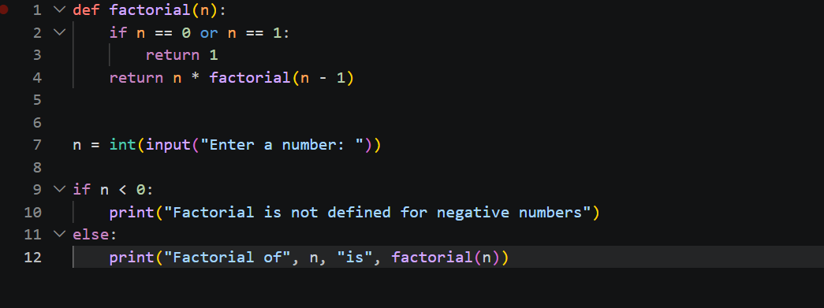

Output:
Error Table:
Error | Rectification
 | Added if n < 0 condition
  Negative values were not handled
Description:
The program uses recursion to calculate the factorial of a given number. The function repeatedly multiplies n by the factorial of n-1 until it reaches the base case 0 or 1.
1e)
Aim:
Print first n terms in a fibanocci number.
Program:
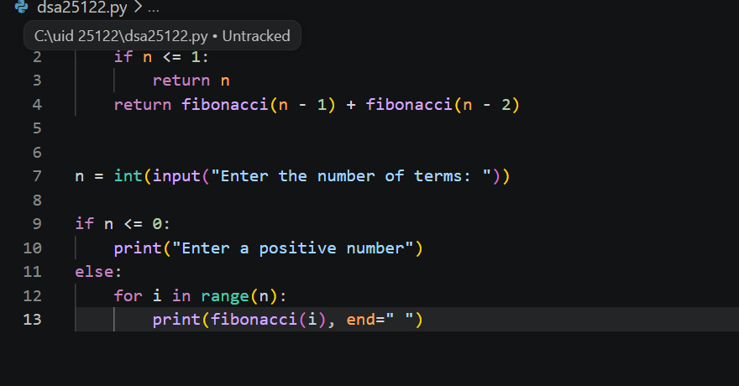
Output:
Error Table:
Error | Rectification
 | Added if n <= 0 condition
  Zero or negative number of terms was not handled

Description:
The program uses recursion to generate the Fibonacci series. Each term is calculated by adding the previous two terms, starting with 0 and 1.

Lab – 2
2a)
Aim:
Write a program for the linear search algorithm
Program:
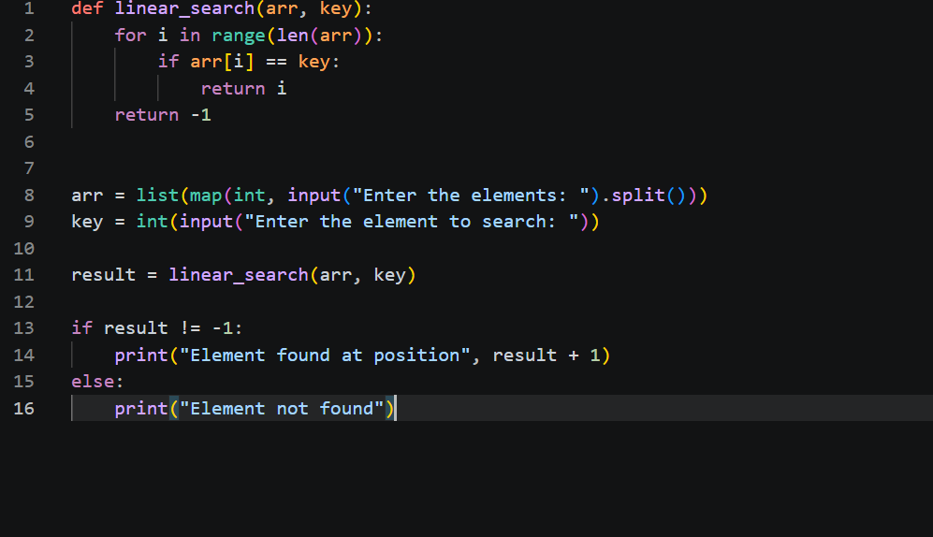
Output:
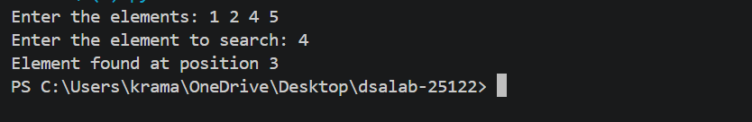
Error Table:
Error | Rectification
  Element not found was not handled
  Added return -1
Description:
The program searches for an element by checking each element of the list sequentially until the element is found or the end of the list is reached.

2b)
Aim:
Write a program for binary search algorithm considering the elements to be sorted
Program:
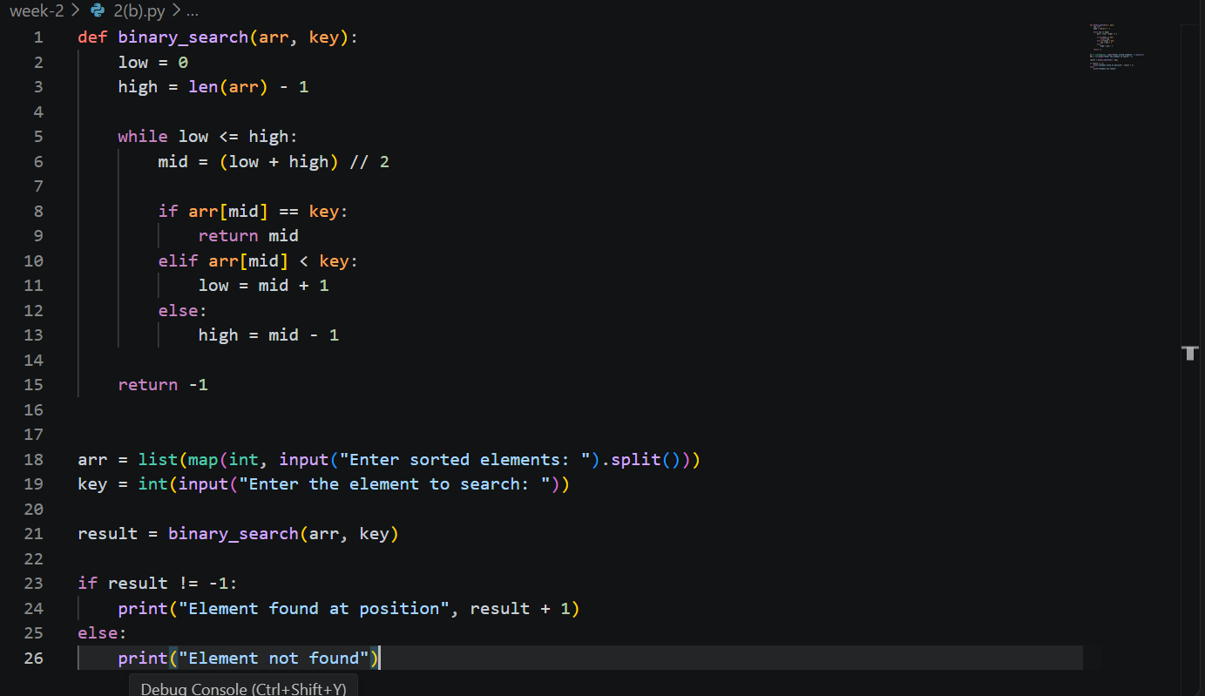

Output:
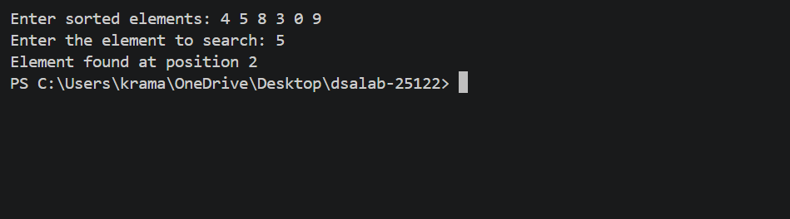
Error Table:
Error | Rectification
Wrote the mid formula outside the while loop which gave the infinite loop error | Added the mid formula inside the while loop
Description:
The program implements Binary Search by repeatedly dividing a sorted list into two halves and searching only the half that may contain the required element.

2c)
Aim:
Write a program for implementation of binary search along with the sorting the elements
Program:
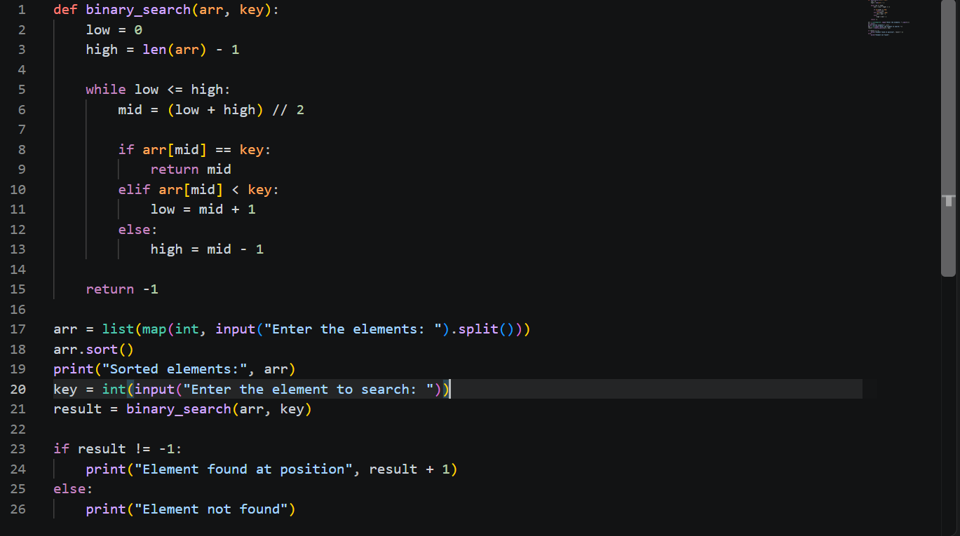

Output:
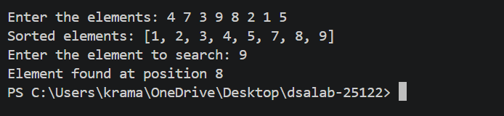
Error Table:
Error | Rectification
Used sorted method instead of which need to be referred to another variable as it returns a sorted array | Used the arr.sort() method which directly sorts the arr without using another variable
Description:
The program first sorts the input elements using arr.sort(). Then, it uses the Binary Search algorithm to find the required element by repeatedly dividing the sorted list into two halves.

Lab – 3
3a)
Aim:
Write a python program to implement bubble sort where the input elements are taken from the user.
Program:
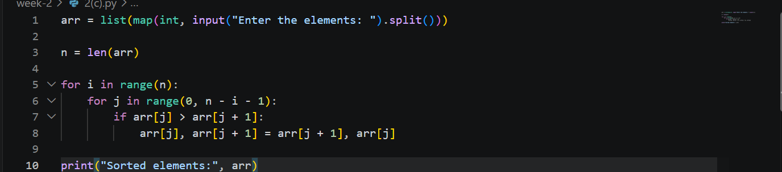

Output:
Error Table:
Error | Rectification
Gave the numbers in descending order | Changed the sign symbol while comparing the adjacent elements.
Description:
The program implements Bubble Sort by comparing adjacent elements and swapping them when they are in the wrong order. This process is repeated until all elements are arranged in ascending order.

3b)
Aim:
Write a python program to implement insertion sort where the input elements are taken from the user.
Program:
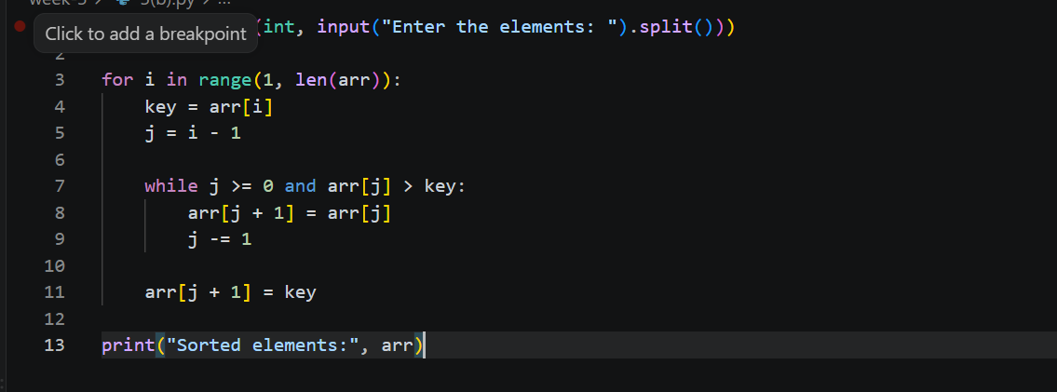

Output:
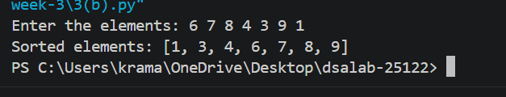
Error Table:
Error | Rectification
Description:
The program implements Insertion Sort by taking one element at a time and inserting it into its correct position among the already sorted elements.

3c)
Aim:
Write a python program to implement selection sort where the input elements are taken from the user.
Program:
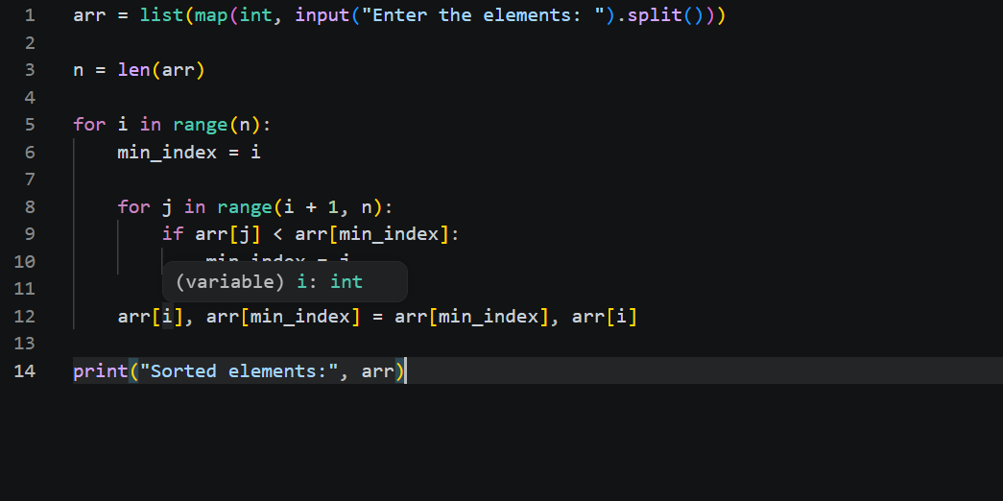

Output:
Error Table:
Error | Rectification
Description:
The program implements Selection Sort by finding the smallest element from the unsorted part of the list and swapping it with the first element of that part. This process continues until all elements are sorted in ascending order.

Lab-4

4a)
Aim:
Write a python program to implement merge sort where the input elements are taken from the user
Program:
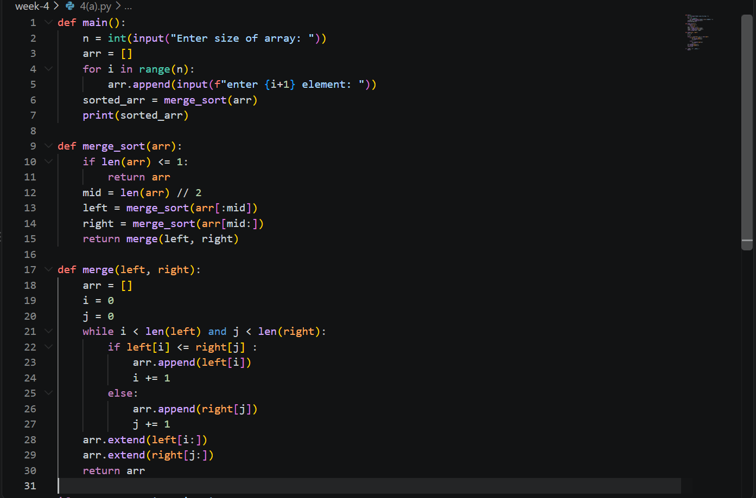
Output:
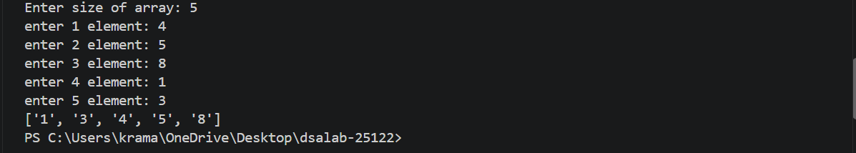
Error Table:
Error | Rectification
RecursionError: maximum recursion depth exceeded | base case in merge_sort() len(arr) <1 to len(arr) <= 1
PS C:\Users\Lab\Documents\cse25142\dsa-lab\week-4> python merge_sort.py  [2, 3, 7, 7, 8, 3, 7, 7, 8, 7, 7, 8] | kept the extend in the while loop instead of out of while loop

Description:
This Python program implements the Merge Sort algorithm to sort the elements of an array in ascending order. The program first takes the size and elements of the array from the user through the main() function. The merge_sort() function recursively divides the array into two halves until each sub-array contains one or zero elements. The merge() function then compares the elements of the two sorted halves and combines them into a single sorted array. The append() function adds elements to the result array, while the extend() function adds any remaining elements. Finally, the sorted array is displayed to the user. Merge Sort follows the divide-and-conquer approach and has a time complexity of O(n log n).
4b)
Aim:
Write a python program to implement quick sort where the input elements are taken from the user.
Program:
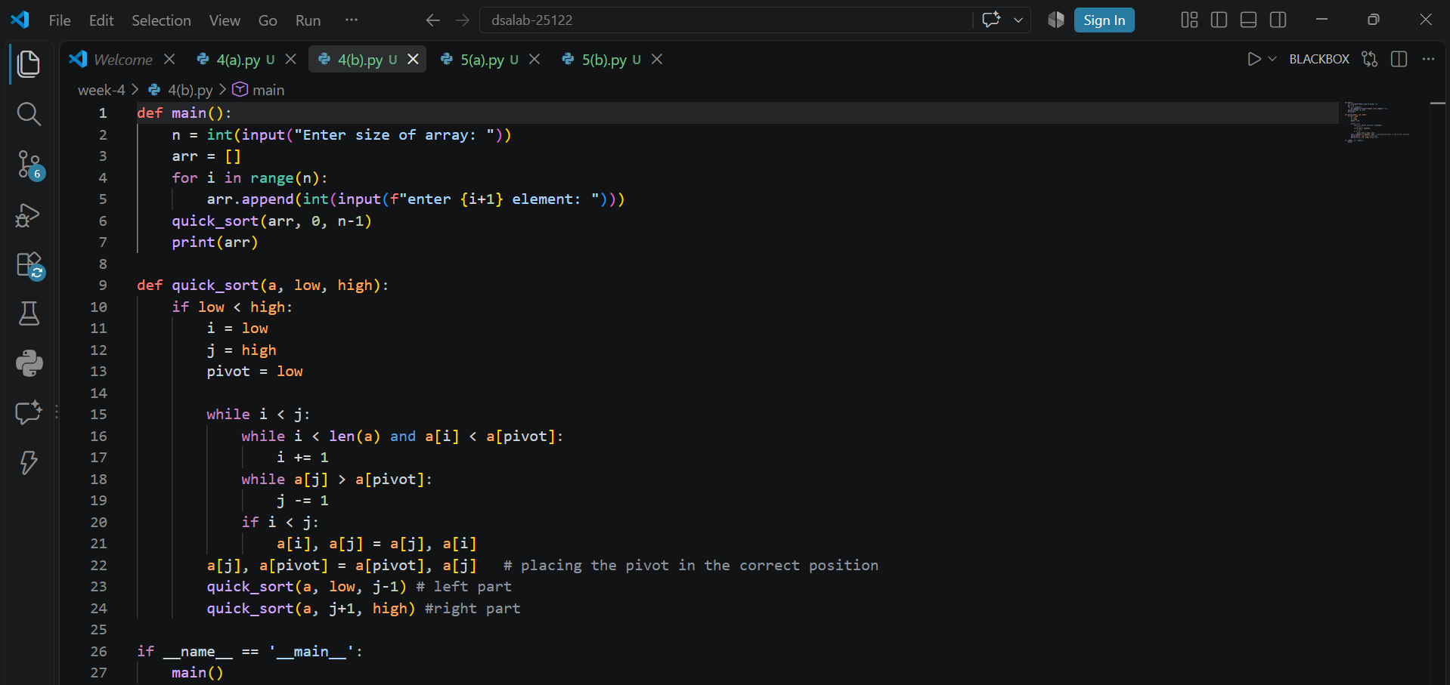
Output:
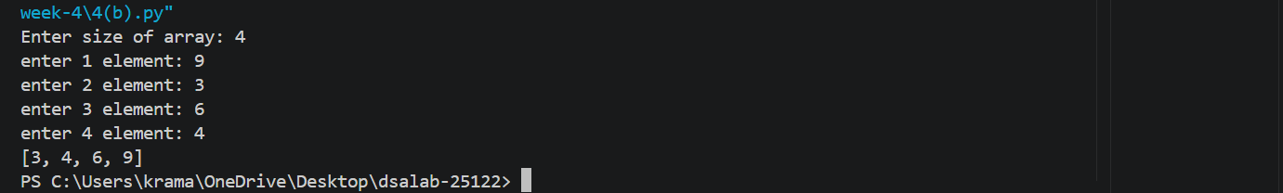
Error Table:
PS C:\Users\Lab\Documents\cse25122\dsa-lab-25122\week-4> python quick_sort.py  Enter size of array: 7  enter 1 element: 2  enter 2 element: 3  enter 3 element: 56  enter 4 element: 9  enter 5 element: -`  enter 6 element:  enter 7 element: 2 | Instead of inputting the integers, inputted the string added int before the input  arr.append(int(input(f”enter {i+1} element”)
PS C:\Users\Lab\Documents\cse25122\dsa-lab-25122\week-4> python quick_sort.py  Traceback (most recent call last):  File "C:\Users\Lab\Documents\cse25122\dsa-lab\week-4\quick_sort.py", line 24, in <module>  main()  File "C:\Users\Lab\Documents\2 \dsa-lab25122\week-4\quick_sort.py", line 5, in main  quick_sort(arr)  TypeError: quick_sort() missing 2 required positional arguments: 'low' and 'high'  PS C:\Users\Lab\Documents\cse25142\dsa-lab\week-4> | added the two parameters to the function
Traceback (most recent call last):  File "C:\Users\Lab\Documents\cse25122\dsa-lab-25122\week-4\quick_sort.py", line 29, in <module>  main()  File "C:\Users\Lab\Documents\cse25142\dsa-lab\week-4\quick_sort.py", line 9, in main  print(quick_sort(arr, 0, n-1))  ^^^^^^^^^^^^^^^^^^^^^^^  File "C:\Users\Lab\Documents\cse25122\dsa-lab25122\week-4\quick_sort.py", line 26, in quick_sort  quick_sort(a, j+1, high) #right part  ^^^^^^^^^^^^^^^^^^^^^^^^  File "C:\Users\Lab\Documents\cse25122\dsa-lab-25122\week-4\quick_sort.py", line 24, in quick_sort  a[j], a[pivot] = a[pivot] = a[j] # placing the pivot in the correct position  ^^^^^^^^^^^^^^  ValueError: too many values to unpack (expected 2) | Placed a comma

Description:
This Python program implements the Quick Sort algorithm to sort the elements of an array in ascending order. The program first takes the size and elements of the array from the user. The quick_sort() function selects the first element as the pivot and uses two pointers, i and j, to compare and rearrange the elements around the pivot. Elements smaller than the pivot are moved to the left, while elements greater than the pivot are moved to the right. After placing the pivot in its correct position, the function is recursively called for the left and right portions of the array. Finally, the sorted array is displayed. Quick Sort follows the divide-and-conquer approach and has an average time complexity of O(n log n).
Week-5
5(a)Aim:
Write a Python program to implement a Singly Linked List (SLL) with the following operations:
1. Create LL
2. Insert at Beginning
3. Insert at End
4. Insert at Index
5. Delete by Value
6. Delete Prior Node
7. Delete Last Node
8. Count Number of Nodes
9. Display/Traverse
10. Exit
Program:
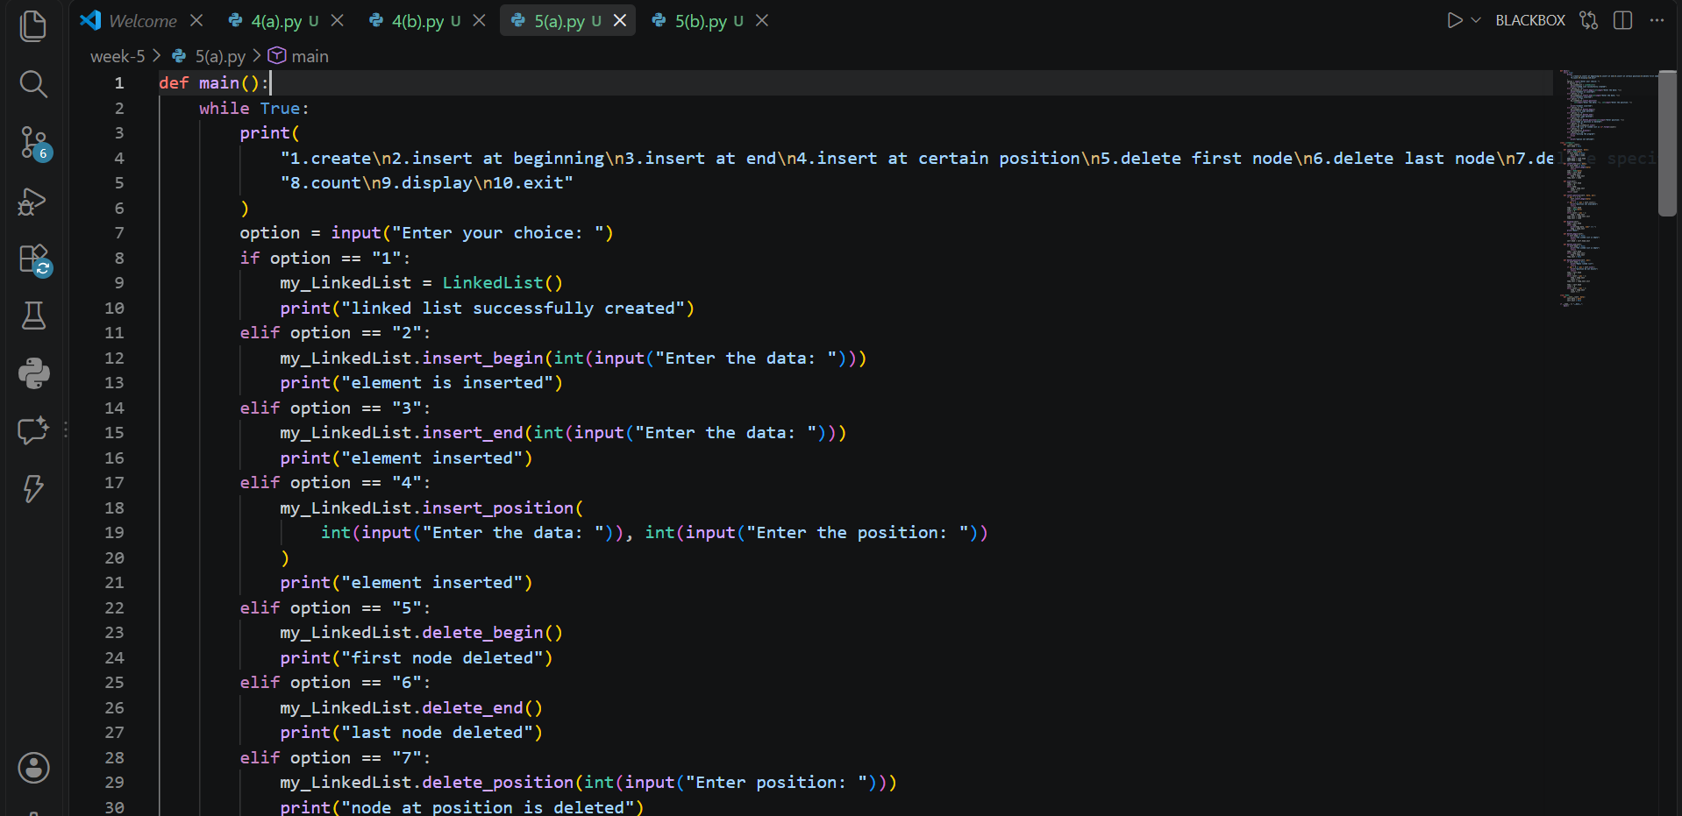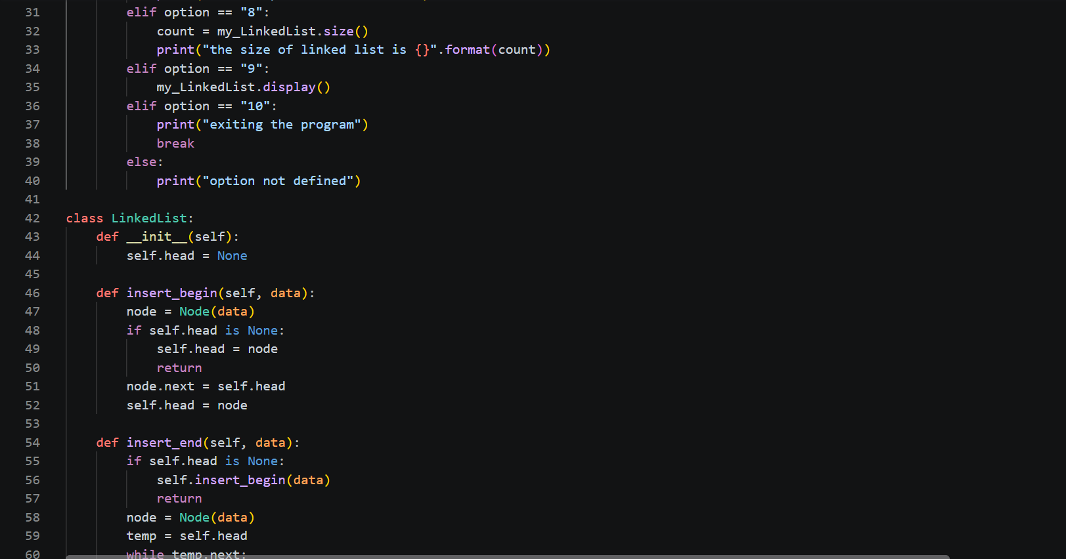
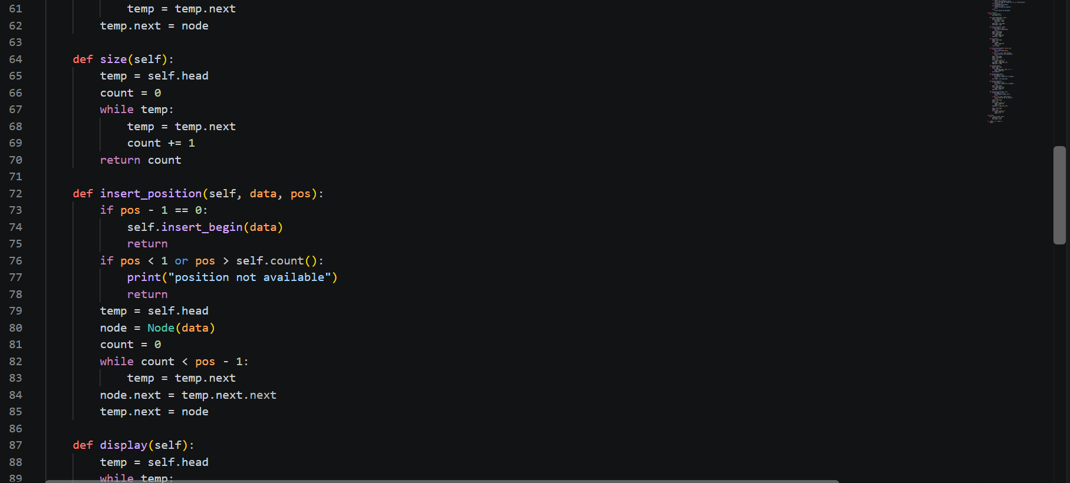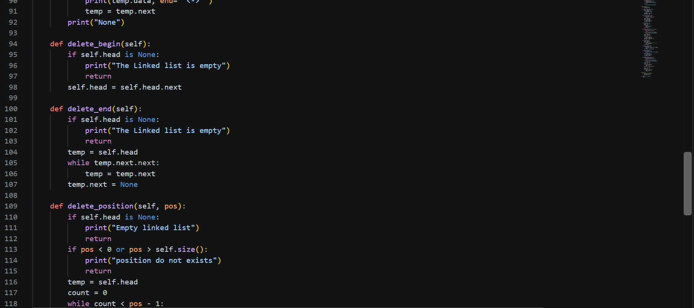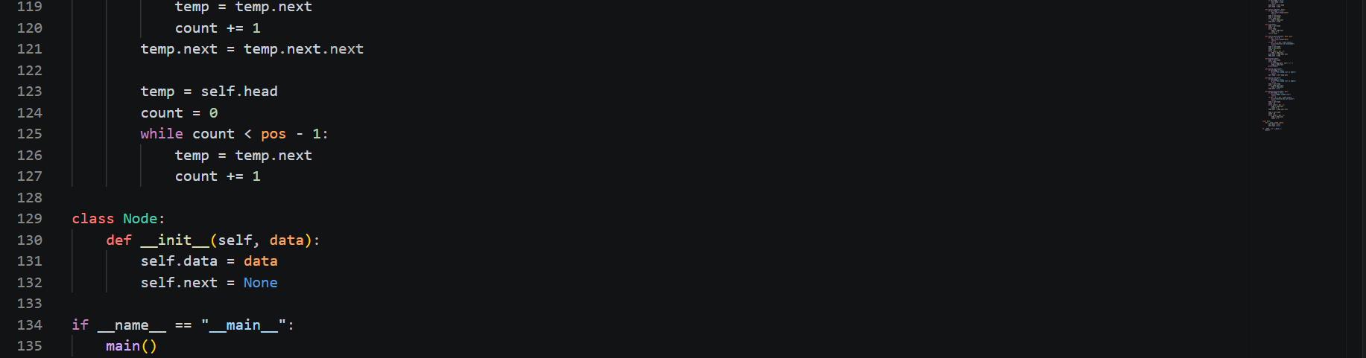
Output:
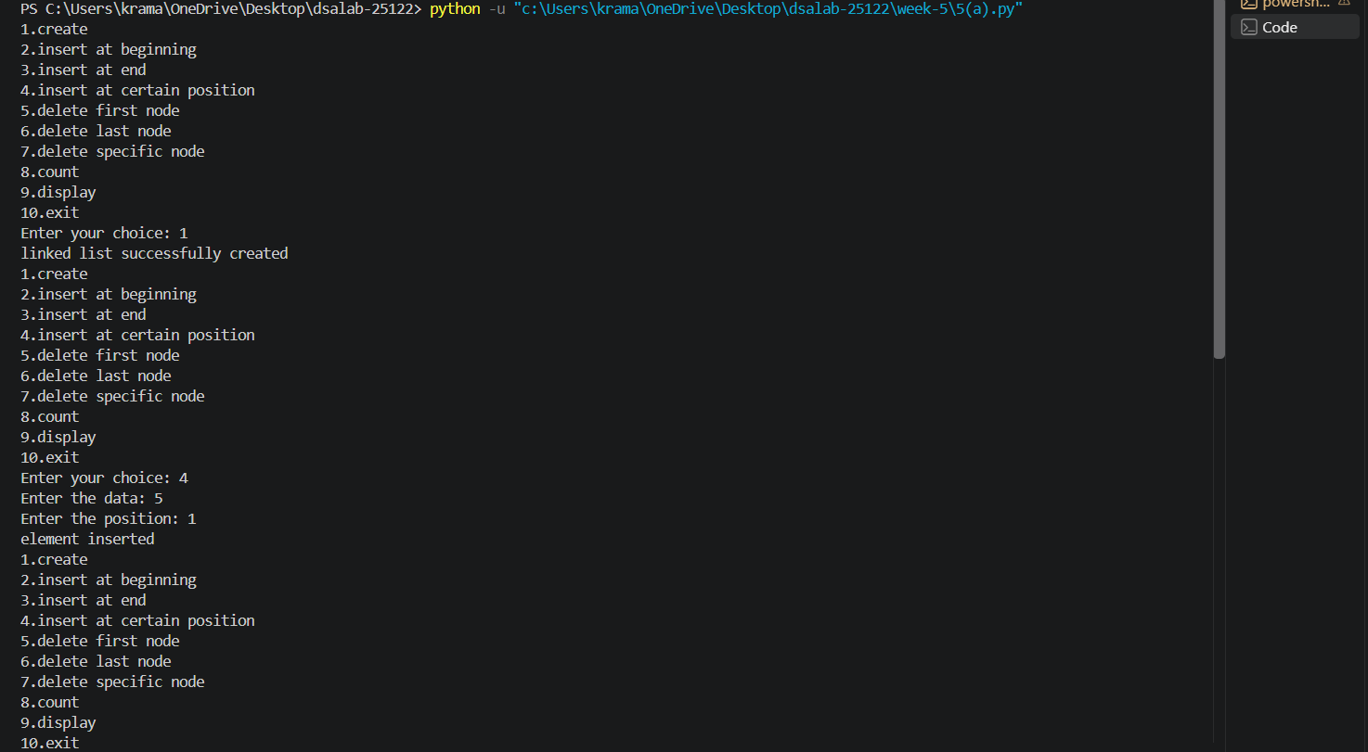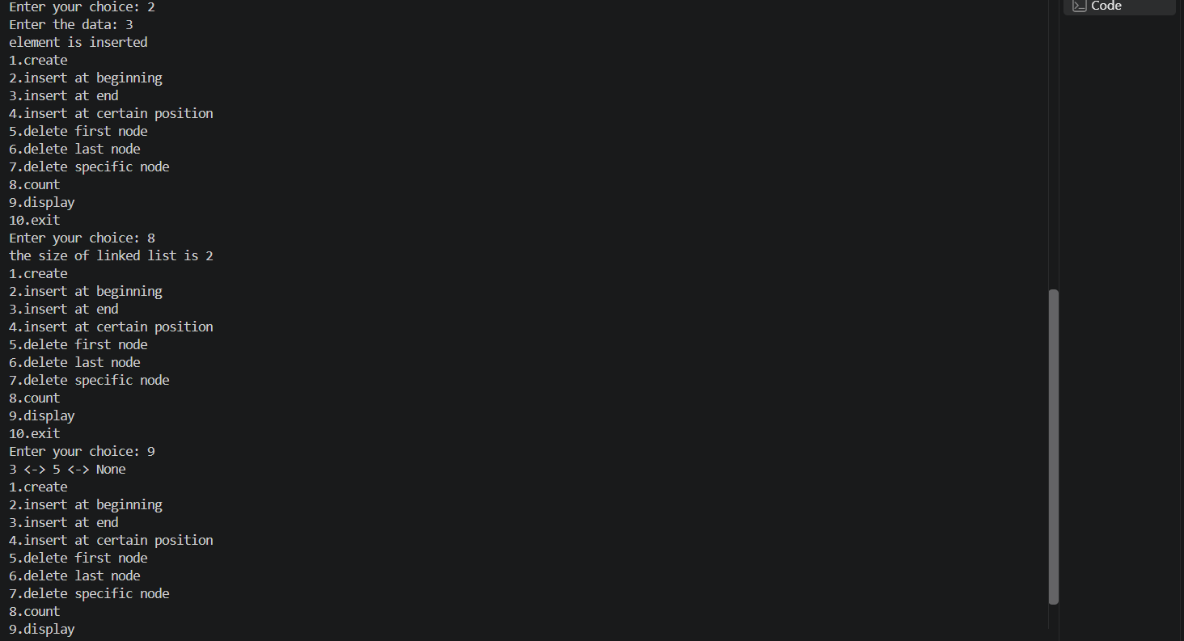
Error Table:
Error | Rectification
The program may display an incorrect message for insertion at a specific index even when the index is invalid | Check whether the index is valid before displaying the successful insertion message.
Description:
This Python program implements a Singly Linked List (SLL) using classes and provides a menu-driven interface to perform various operations. The program allows the user to create a linked list, insert nodes at the beginning, end, or a specified position, and delete nodes from the beginning, end, or a particular position. It also provides operations to count the total number of nodes and display all the elements in the linked list. The Node class is used to store data and maintain a reference to the next node, while the LinkedList class contains methods to perform the different operations. The main() function displays a menu and accepts the user's choice to execute the corresponding operation. The program continues running until the user selects the exit option.

5(b)Aim:
Write a Python program to implement a Double Linked List (DLL) with the following operations:
1. Create LL
2. Insert at Beginning
3. Insert at End
4. Insert at Index
5. Delete by Value
6. Delete Prior Node
7. Delete Last Node
8. Count Number of Nodes
9. Display/Traverse
10. Exit

Program:
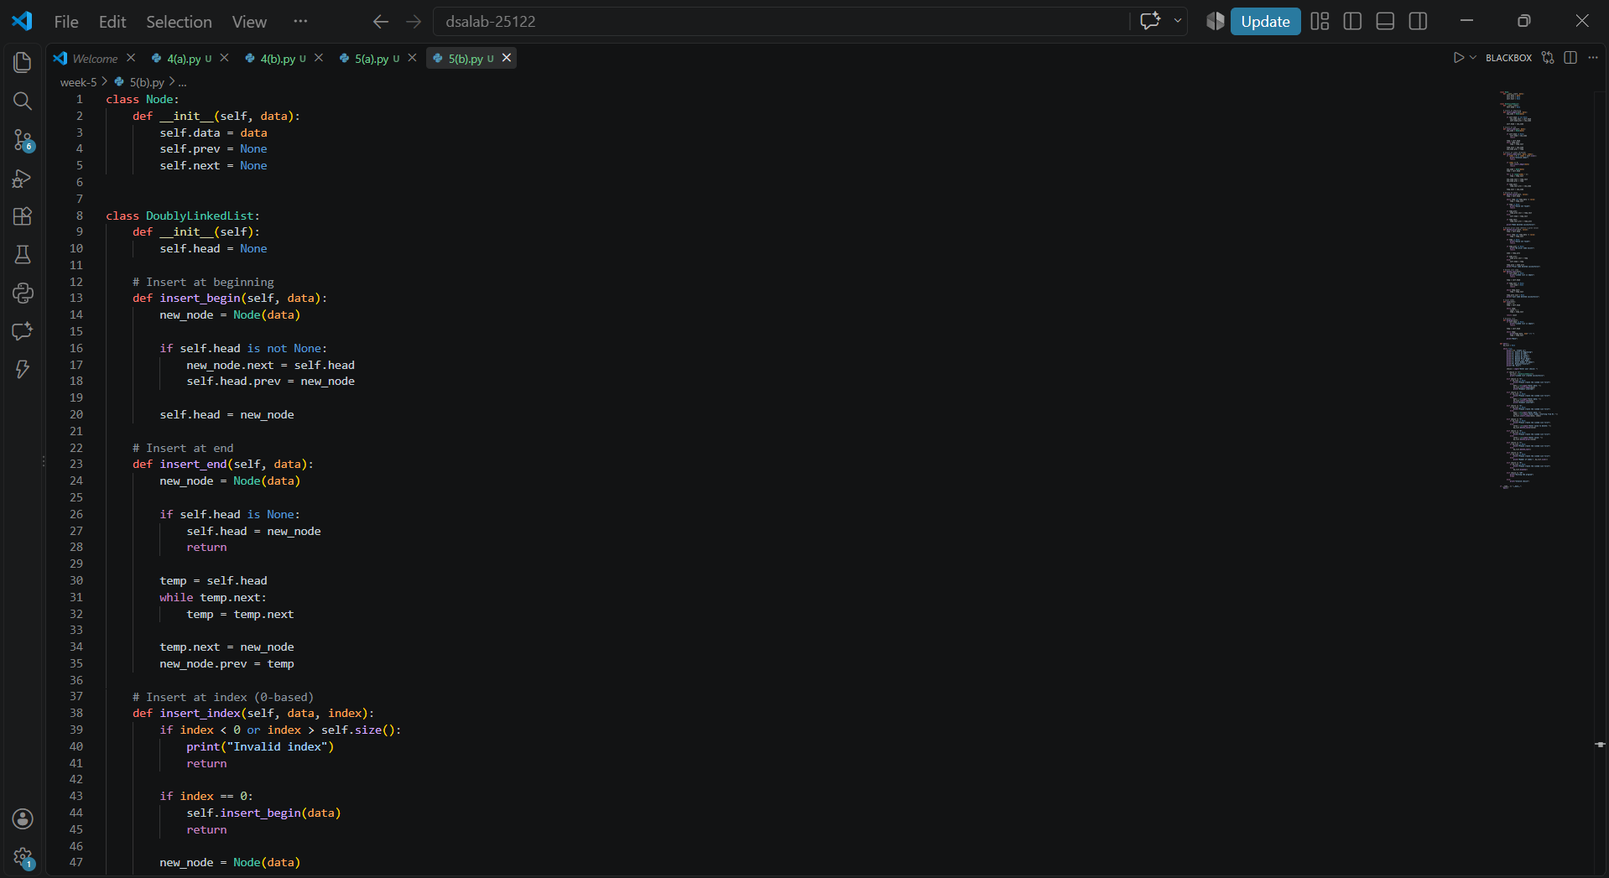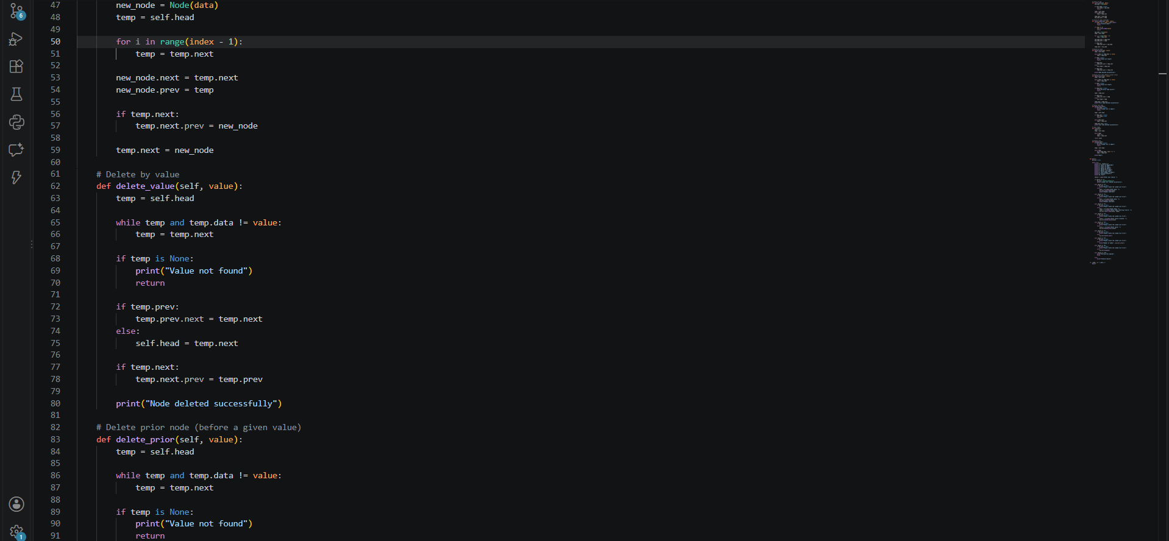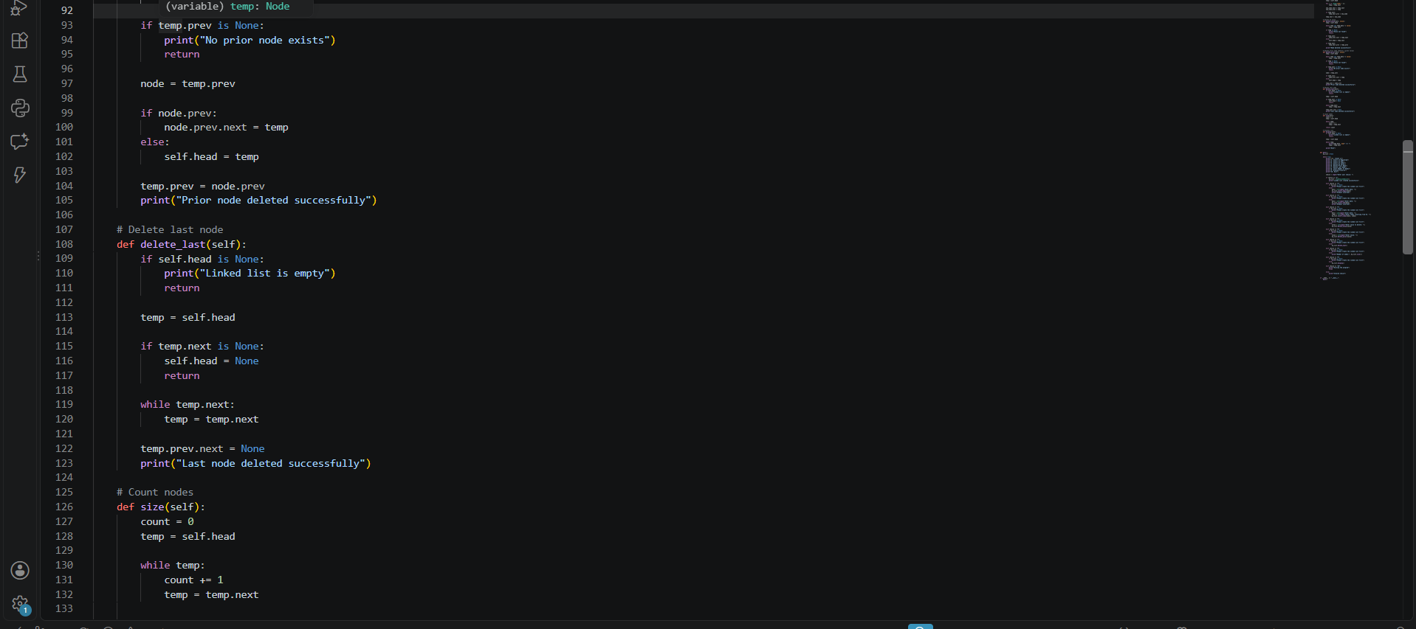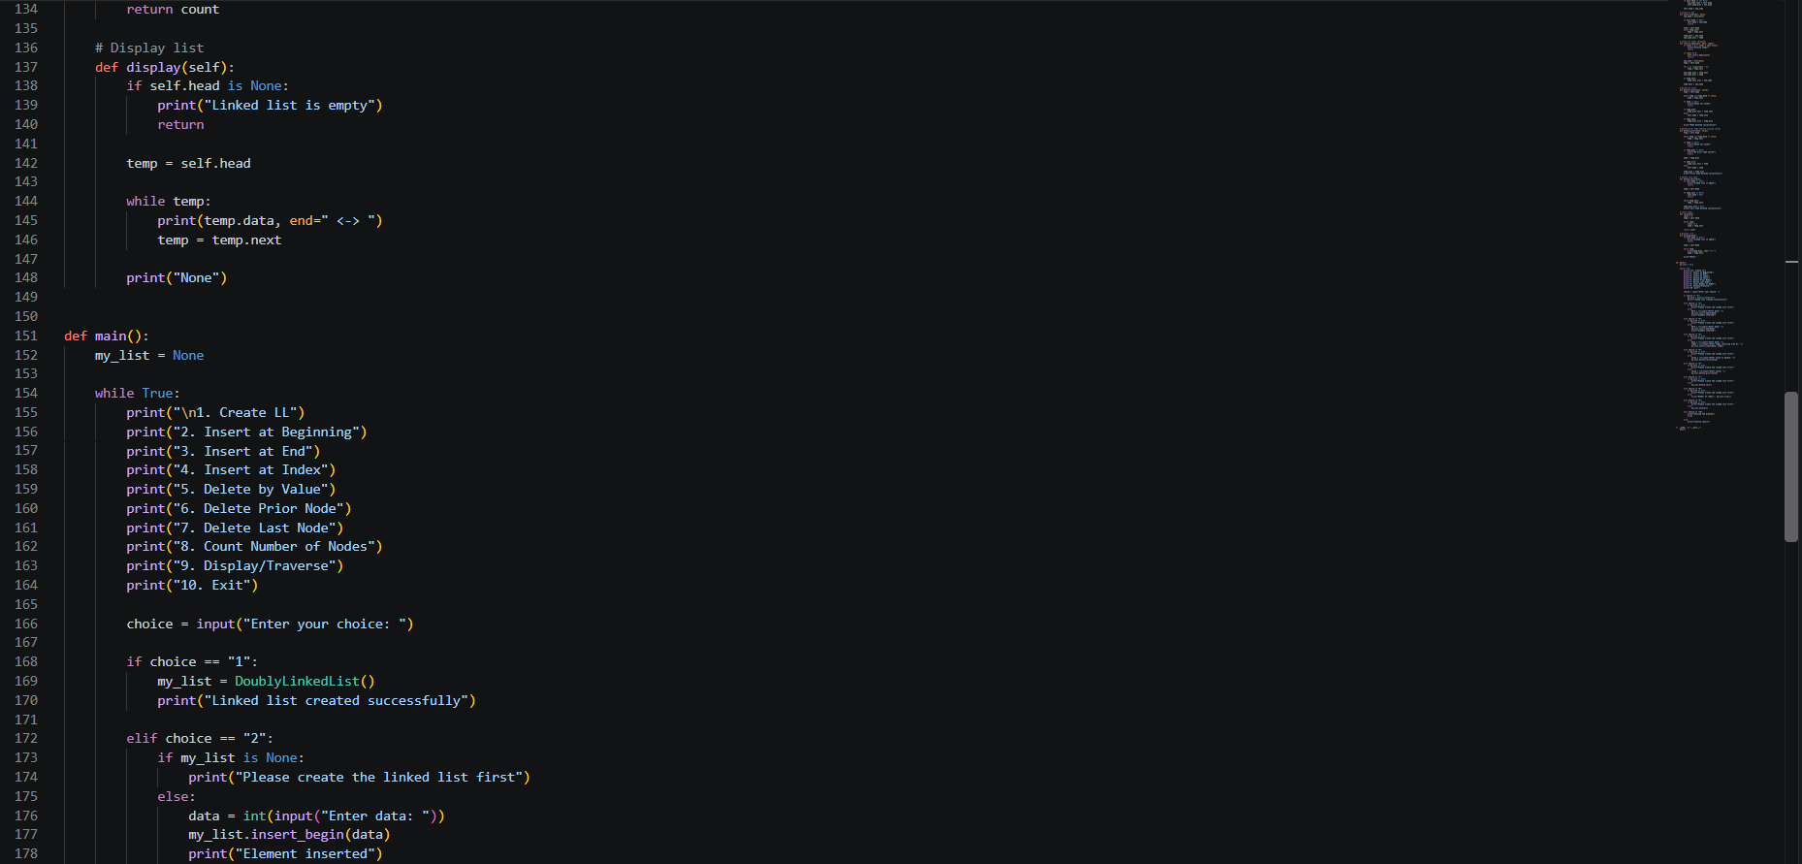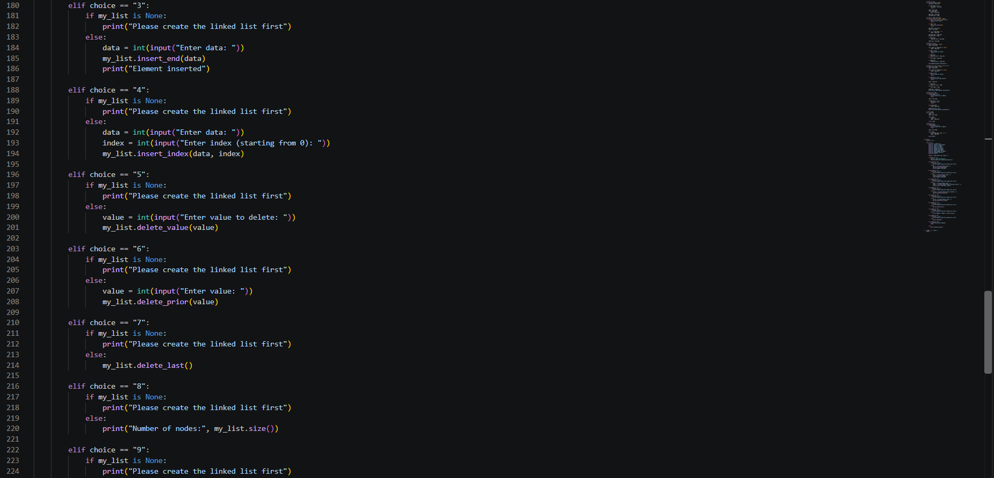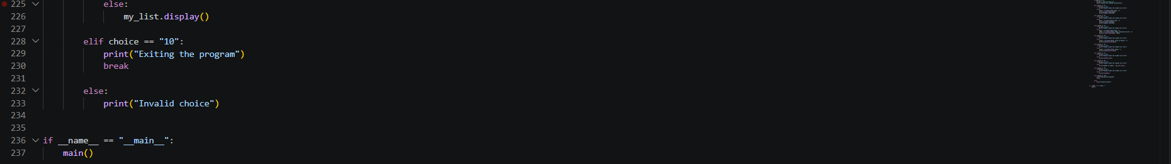
Output:
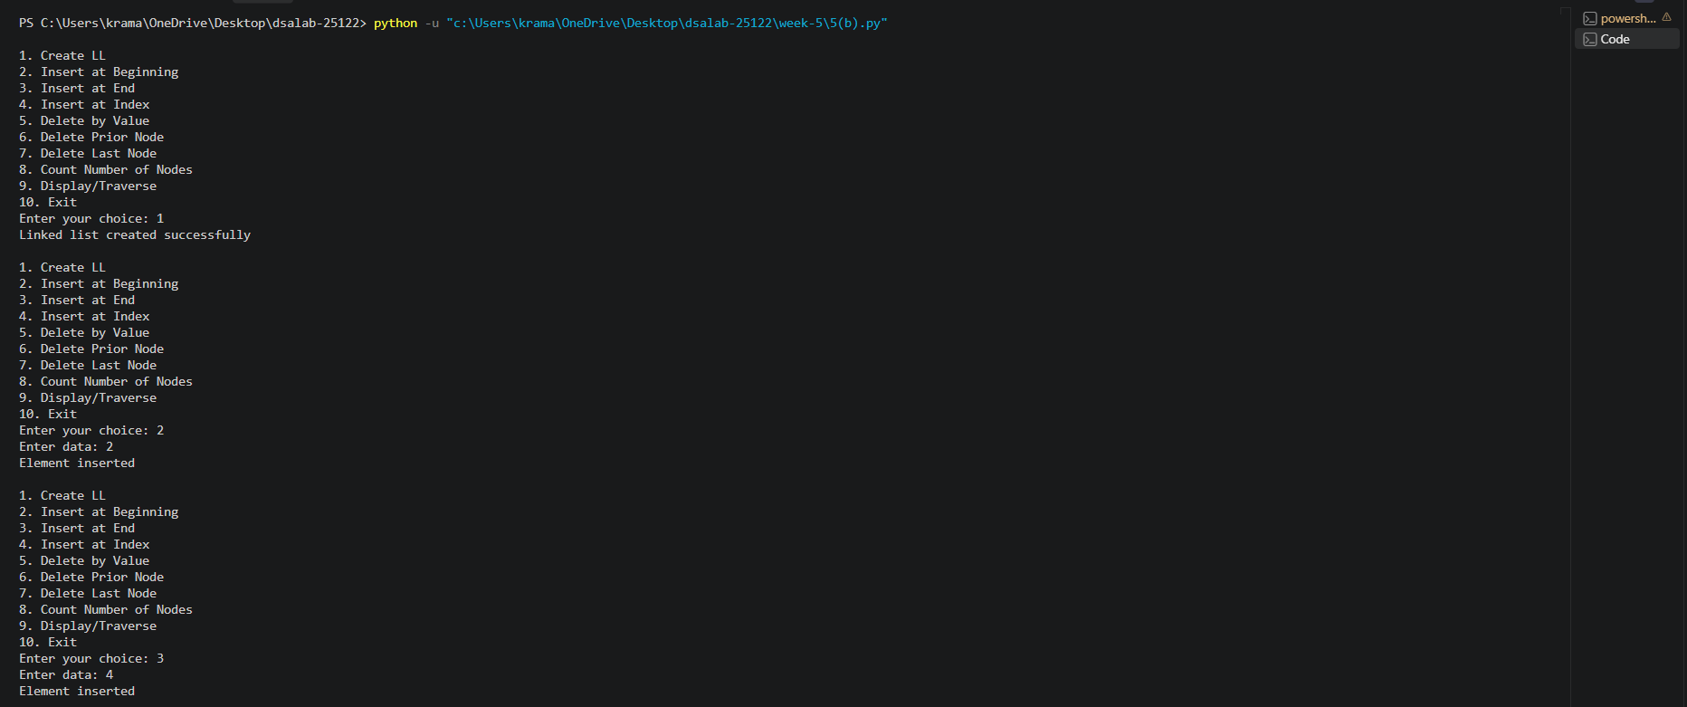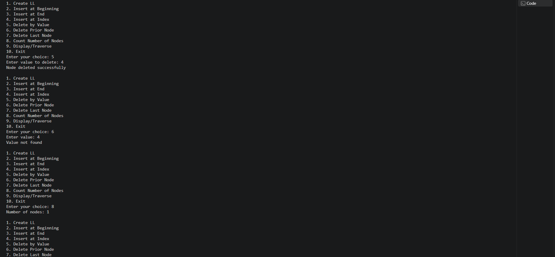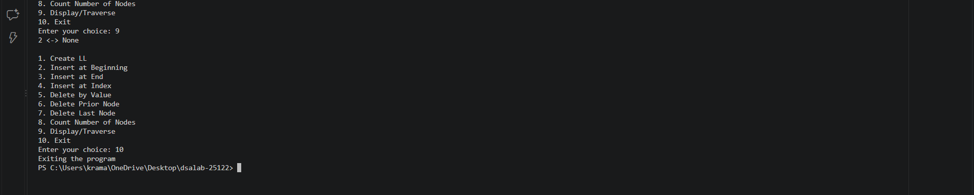
Error Table:
Error | Rectification
The prev and next links may not be updated correctly during insertion or deletion. | Update both links whenever a node is inserted or deleted.

Description:
This Python program implements a Doubly Linked List (DLL) using classes and provides a menu-driven interface to perform various operations. The program allows the user to create a doubly linked list, insert nodes at the beginning, end, or a specified index, delete a node by value, delete the node prior to a specified value, and delete the last node. It also provides operations to count the total number of nodes and display all the elements in the linked list. The Node class stores data and two pointers, prev and next, which point to the previous and next nodes, respectively. The DoublyLinkedList class contains methods to perform all the operations. The main() function displays a menu and accepts the user's choice to execute the corresponding operation. The program continues running until the user selects the exit option.
5(c)Aim:
Write a Python program to implement a Circular Linked List (CLL) with the following operations:
1. Create LL
2. Insert at Beginning
3. Insert at End
4. Insert at Index
5. Delete by Value
6. Delete Prior Node
7. Delete Last Node
8. Count Number of Nodes
9. Display/Traverse
10. Exit
Program:
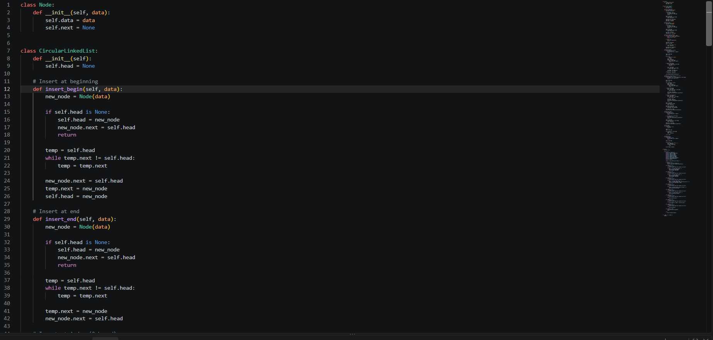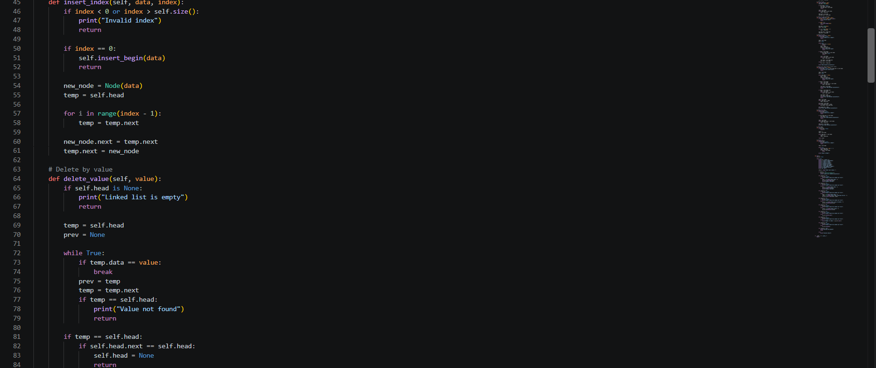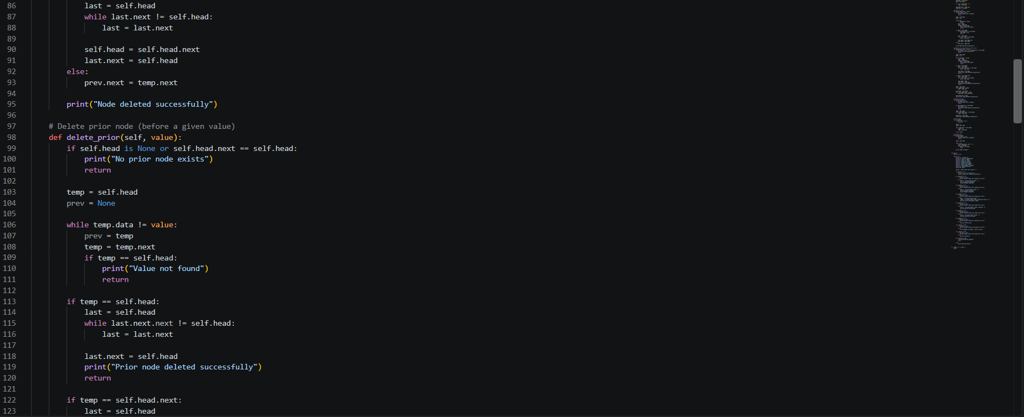
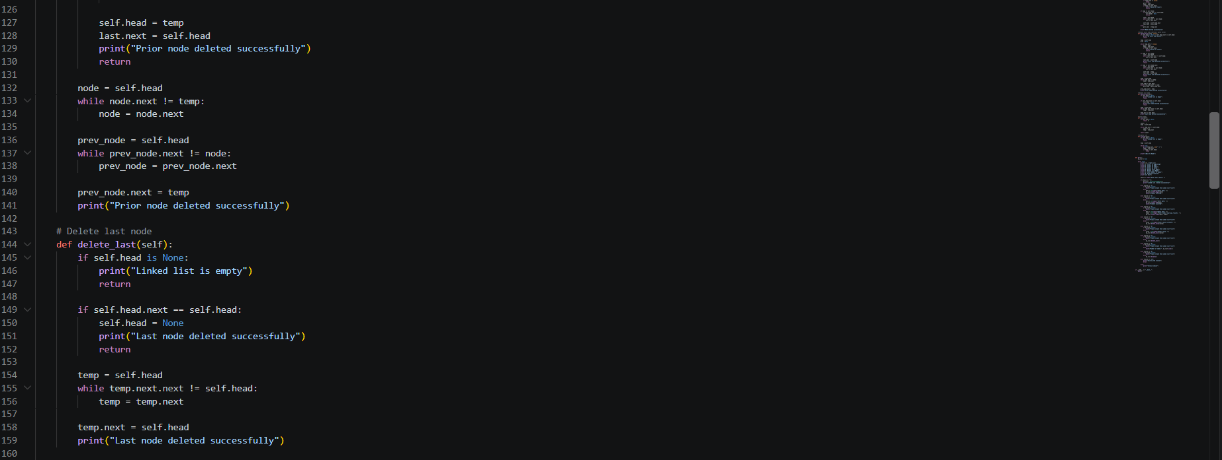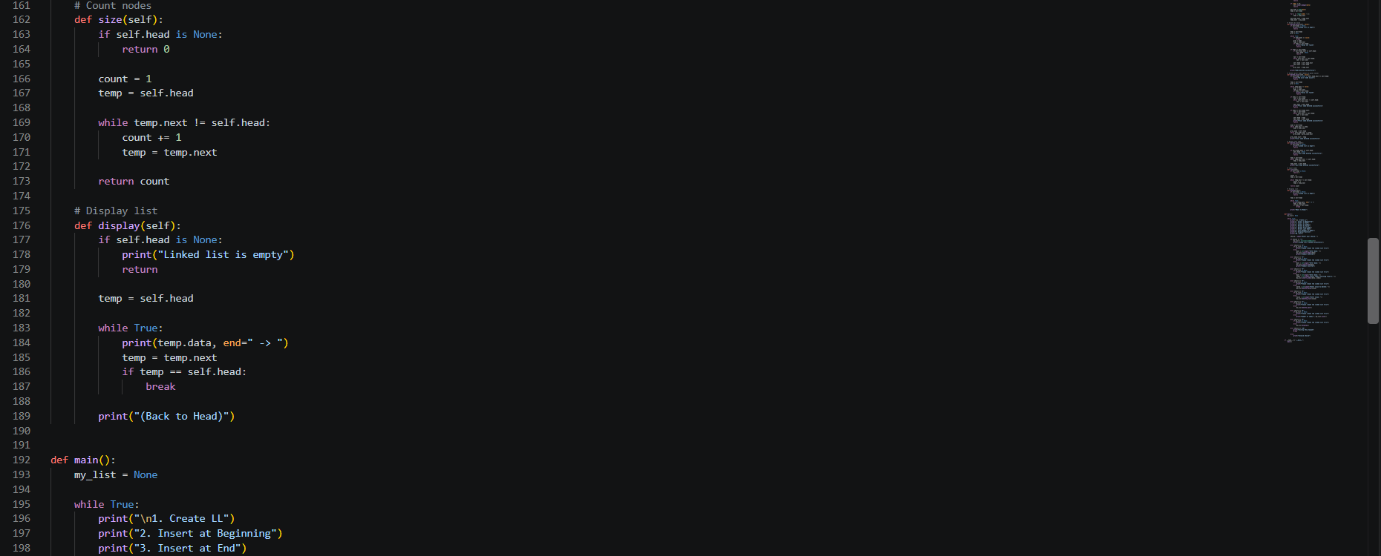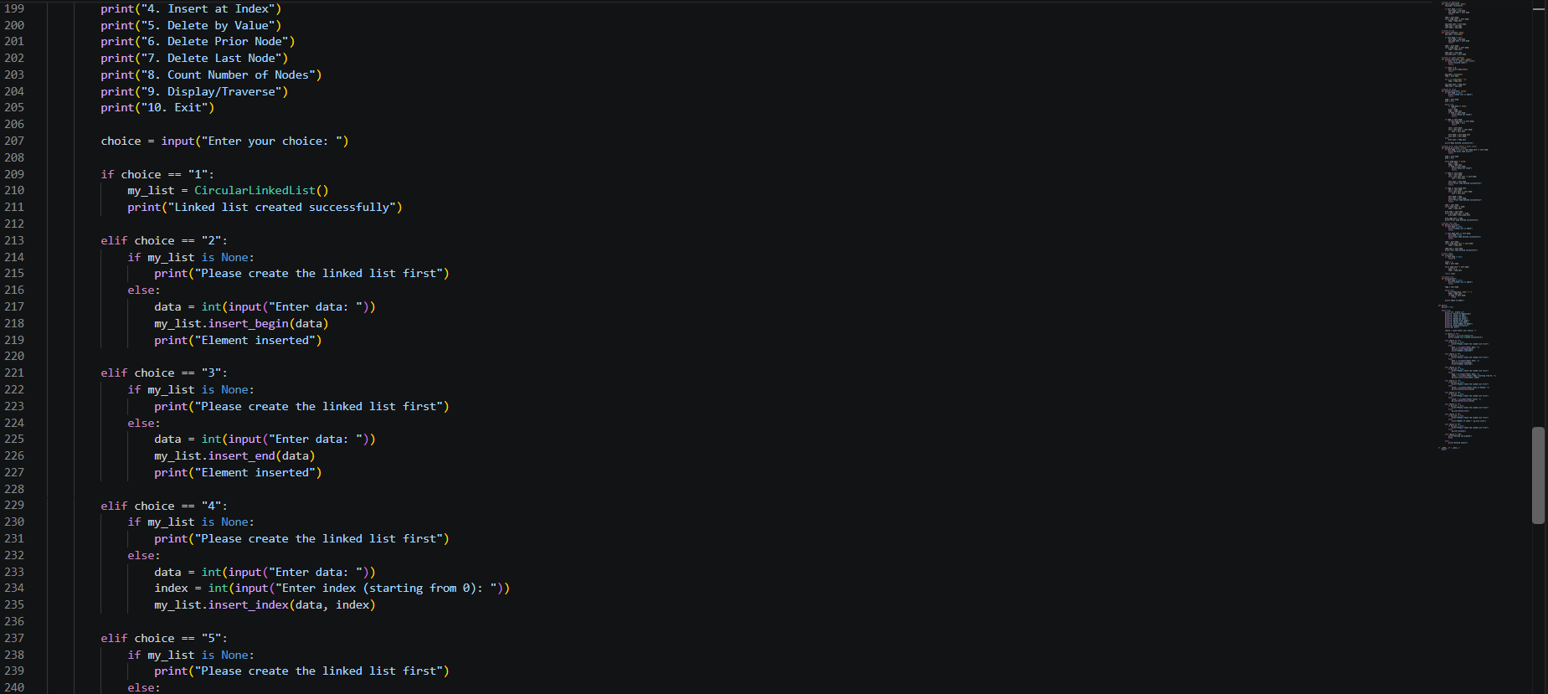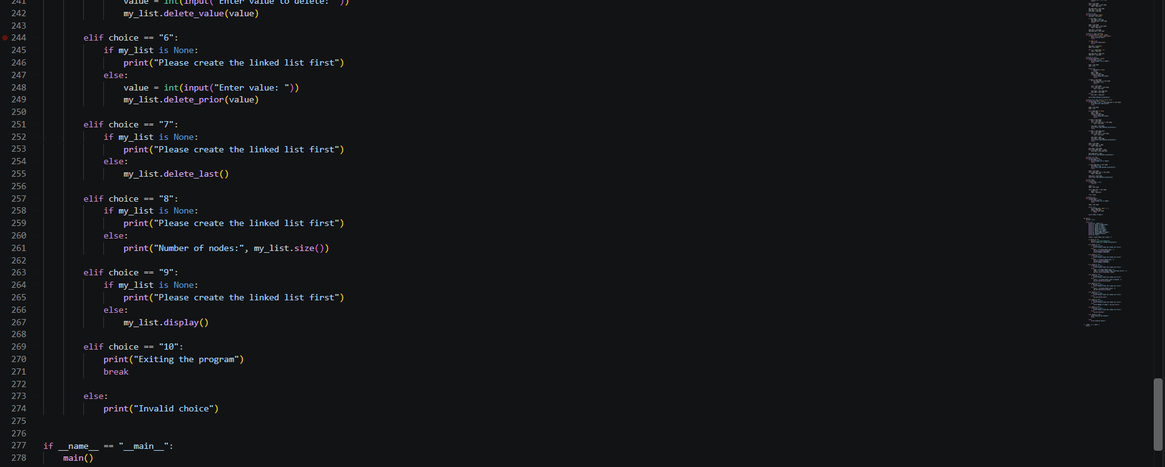
Output:
Error Table:
Error | Rectification
No errors

Description:
This Python program implements a Circular Linked List (CLL) using classes and provides a menu-driven interface to perform various operations. The program allows the user to create a circular linked list, insert nodes at the beginning, end, or a specified index, delete a node by value, delete the node prior to a specified value, and delete the last node. It also provides operations to count the total number of nodes and display all the elements in the linked list. The Node class is used to store data and maintain a reference to the next node, while the CircularLinkedList class contains methods to perform all the operations. In a circular linked list, the last node points back to the head instead of pointing to None. The main() function displays a menu and accepts the user's choice to execute the corresponding operation. The program continues running until the user selects the exit option.
Week-6
6(a)Aim:
Program:
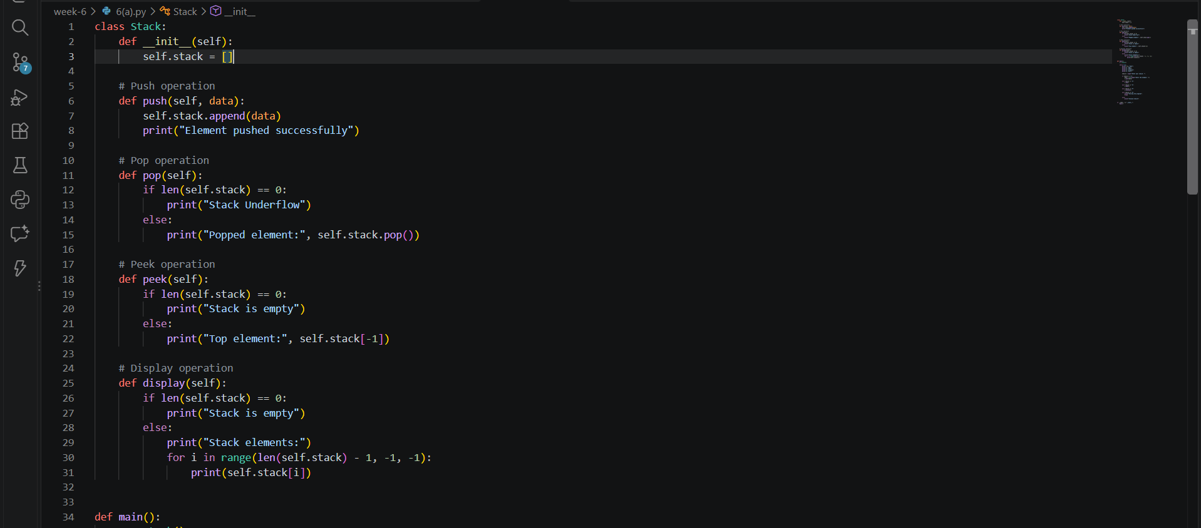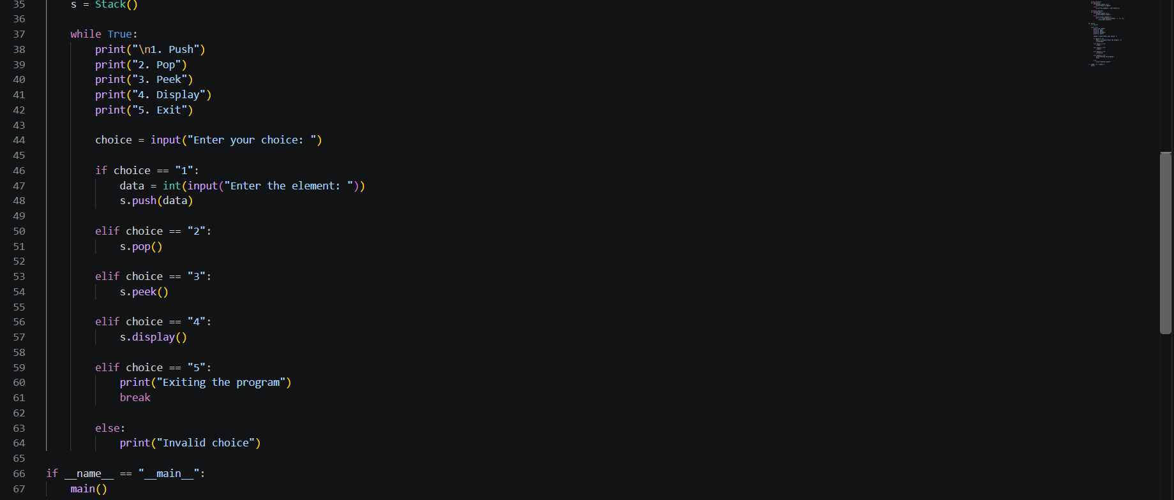
Output:
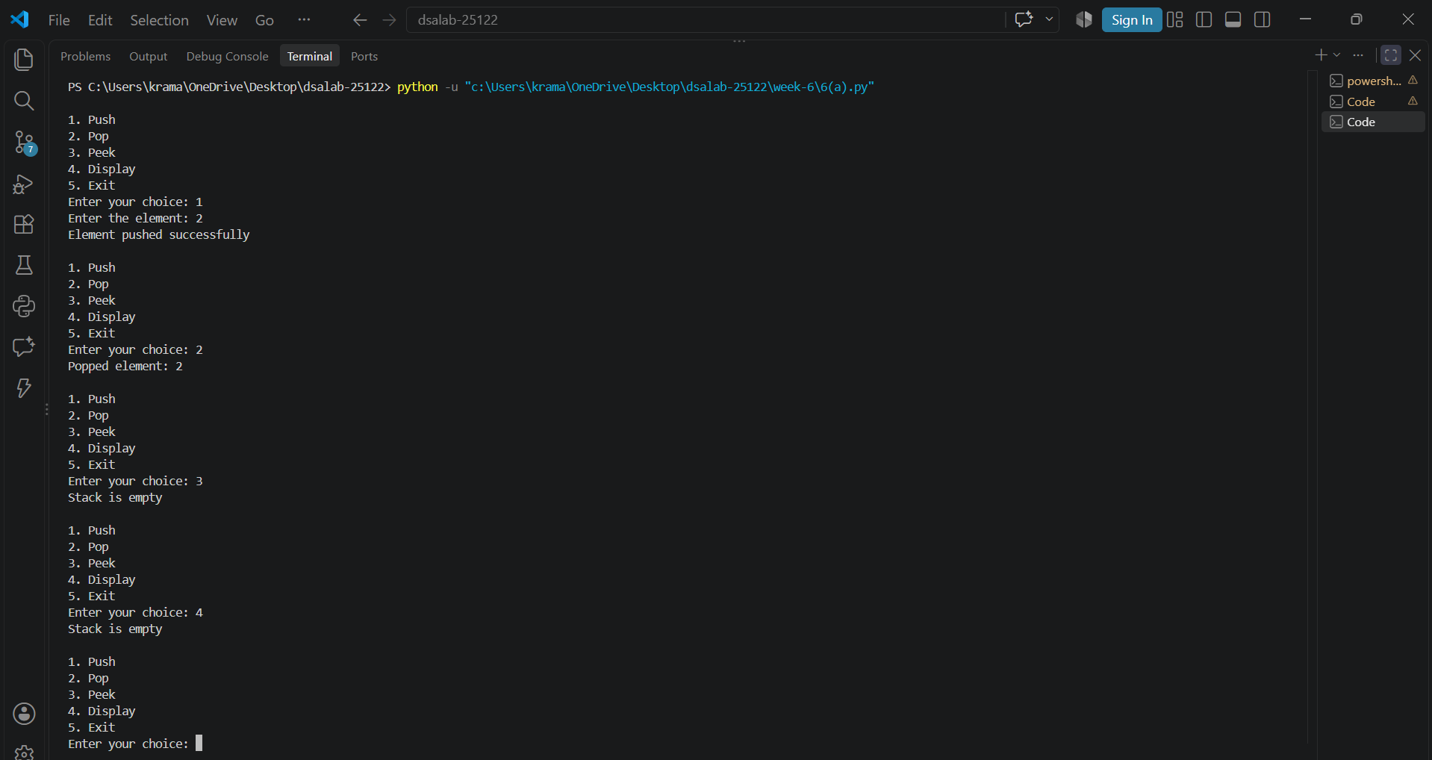
Error Table:
Error | Rectification
In peek, self.peek is taken in ‘if’ does not give correct answer for stack underflow. | Self.top is taken in ‘if’ to give correct output.

Description:
This Python program implements a stack using an array (Python list) and provides a menu-driven interface to perform various operations. The program supports four main operations: Push, Pop, Peek, and Display. The Push operation inserts an element at the top of the stack, while the Pop operation removes the top element from the stack. The Peek operation displays the top element without removing it, and the Display operation shows all the elements in the stack from top to bottom. The Stack class contains methods to perform these operations, while the main() function displays a menu and accepts the user's choice to execute the corresponding operation. The program follows the LIFO (Last In, First Out) principle, where the last element inserted is the first one to be removed. It also handles stack underflow when a Pop operation is performed on an empty stack. The program continues running until the user selects the Exit option.

6(b)Aim:
Write a Python program to implement stack operations such as Push, Pop, Peek, and Display using an Linked List
Program:
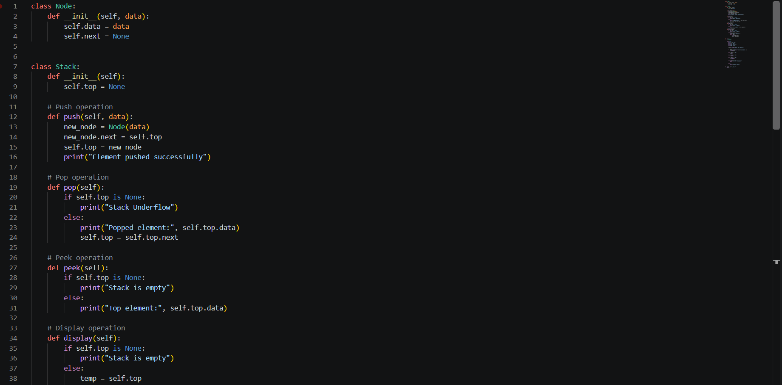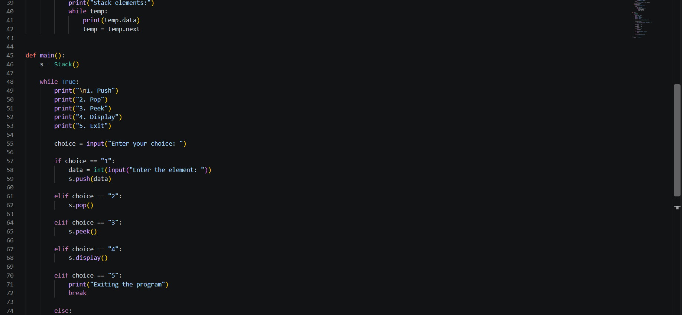
Output:
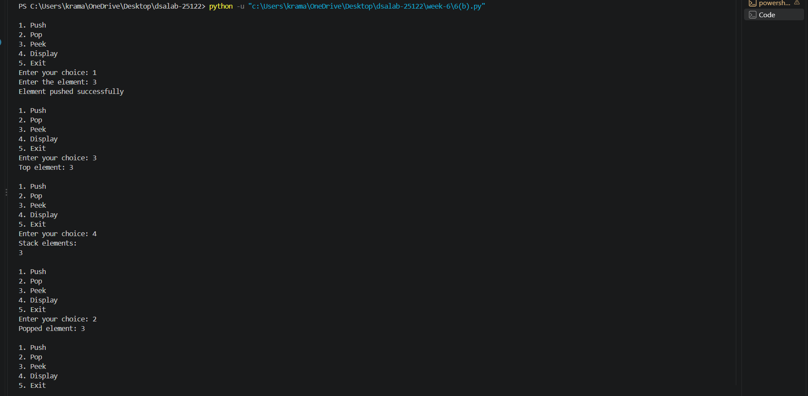
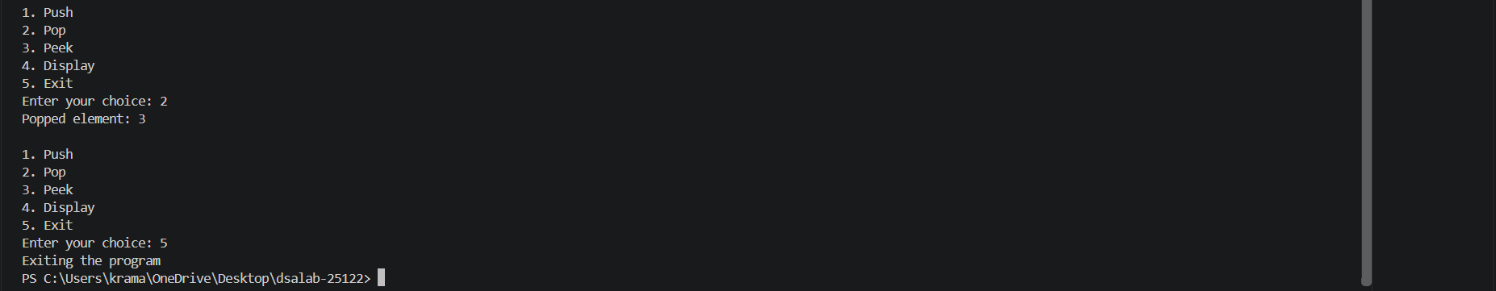
Error Table:
Error | Rectification
No errors

Description:
This Python program implements a stack using a Singly Linked List and provides a menu-driven interface to perform various operations. The program supports four main operations: Push, Pop, Peek, and Display. The Push operation inserts a new node at the top of the stack, while the Pop operation removes the top node. The Peek operation displays the top element without removing it, and the Display operation shows all the elements in the stack from top to bottom. The Node class is used to store data and a reference to the next node, while the Stack class contains methods to perform these operations. The program follows the LIFO (Last In, First Out) principle, where the last element inserted is the first one to be removed. It also handles stack underflow when a Pop operation is performed on an empty stack. The program continues running until the user selects the Exit option.

Week-7
7(a)Aim:
Write a python program to implement Queue and its operations such as enqueue ,dequeue, peek, display with a menu driven approach. Implement using array and linked list data structures
Program: 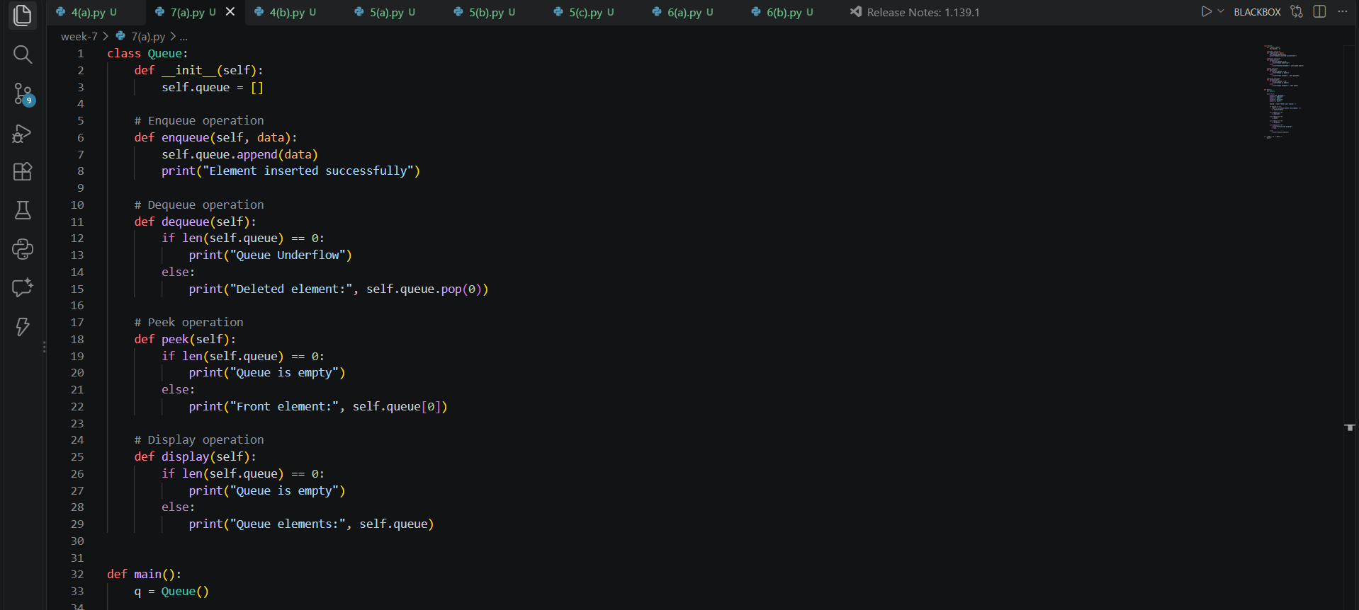 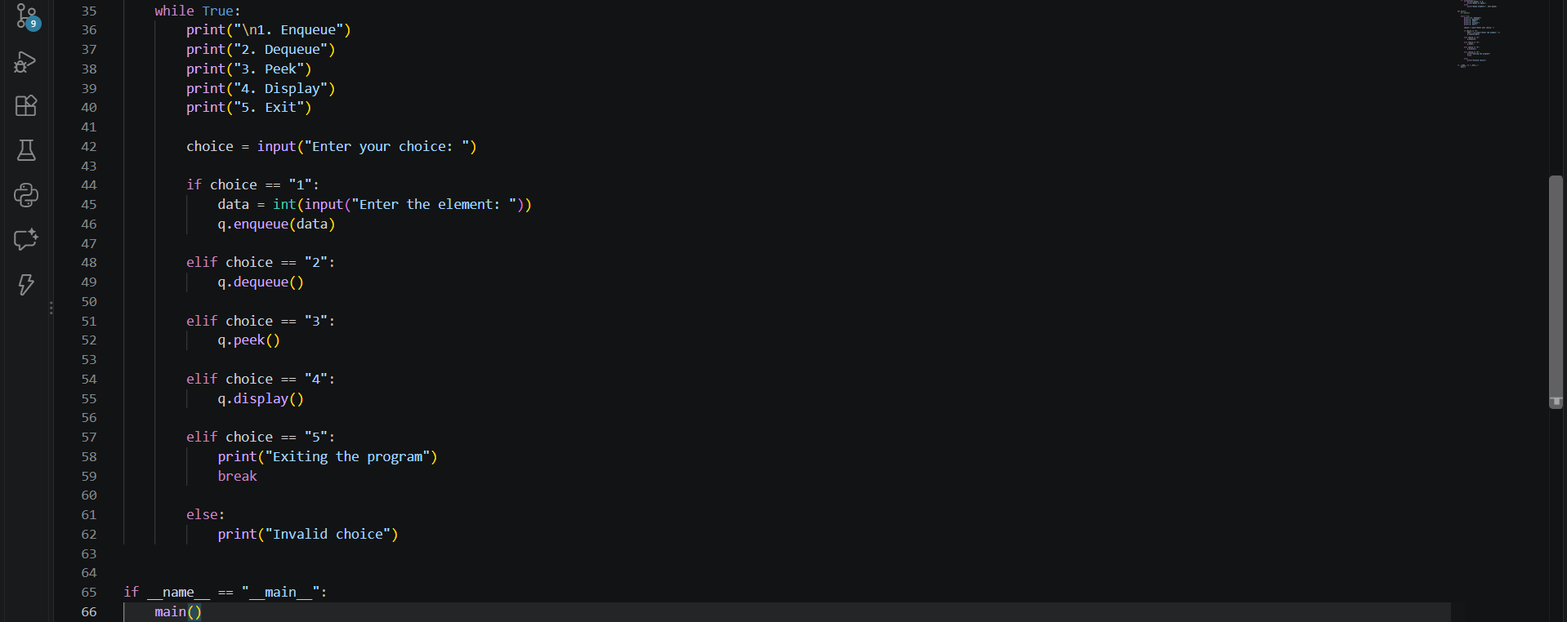

Output:
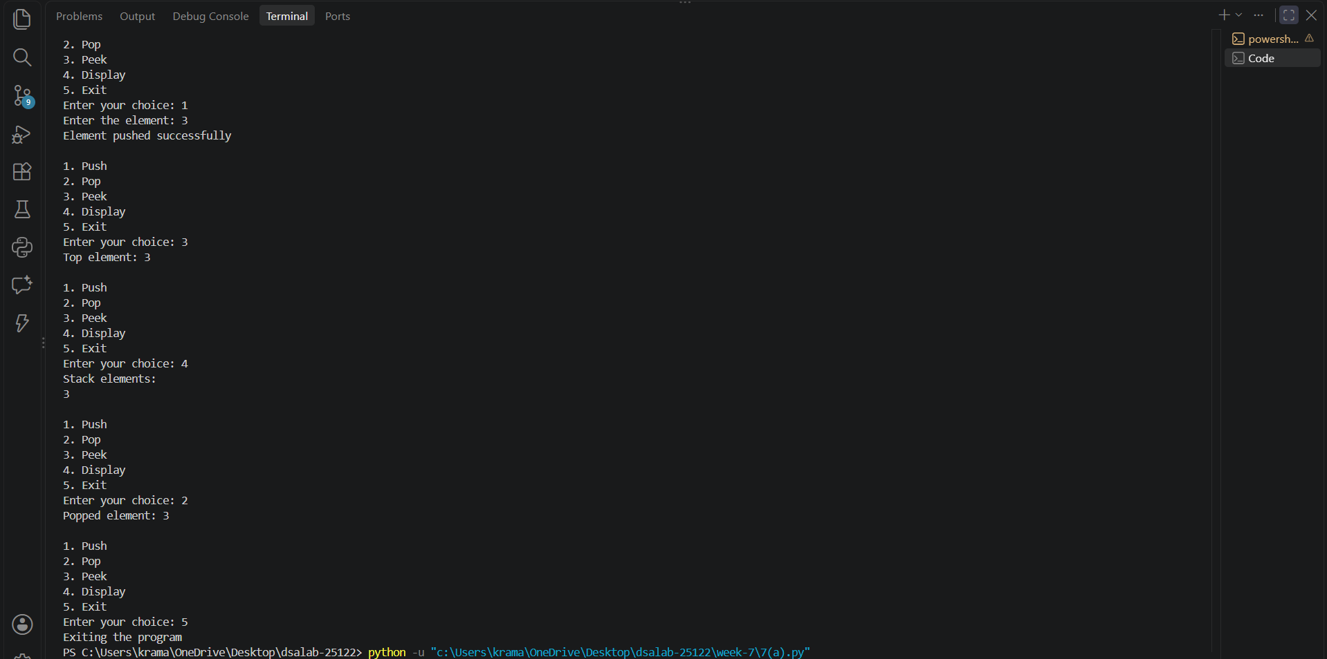
Error Table:
Error | Rectification
Queue Underflow | Check whether the queue is empty before performing the Dequeue operation.
Empty Queue | Check whether the queue contains elements before performing Peek or Display.

Description:
This Python program implements a Queue using both an Array and a Linked List with a menu-driven approach. It supports four main operations: Enqueue, Dequeue, Peek, and Display. The Enqueue operation inserts an element at the rear of the queue, while the Dequeue operation removes an element from the front. The Peek operation displays the front element without removing it, and the Display operation shows all the elements in the queue. The array implementation uses a Python list, while the linked list implementation uses nodes with pointers to connect elements. The program follows the FIFO (First In, First Out) principle, in which the first element inserted is the first one to be removed. It also handles queue underflow when a Dequeue operation is performed on an empty queue and displays an error message for invalid menu choices. The program continues executing until the user selects the Exit option.

7(b)Aim:
Write a python program to implement circular Queue and its operations such as enqueue ,dequeue, peek, display with a menu driven approach. Implement using array and linked list data structures
Program:
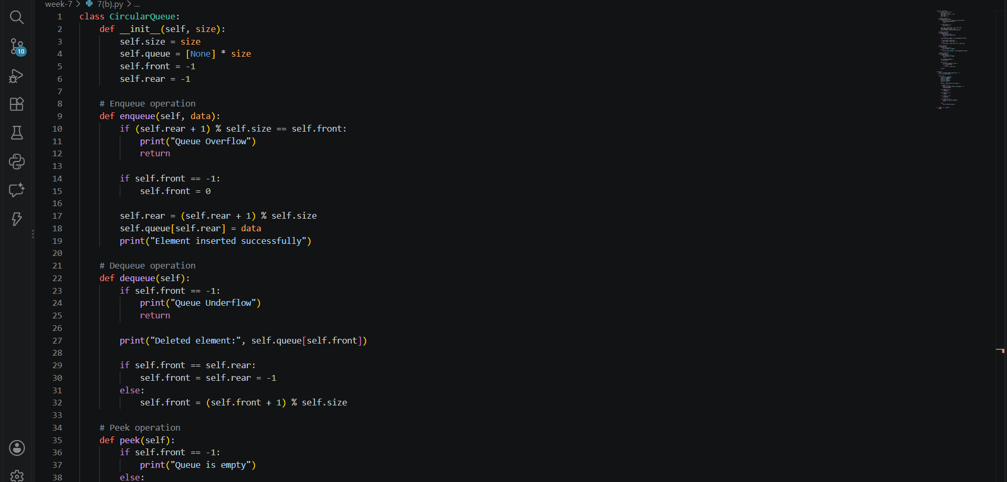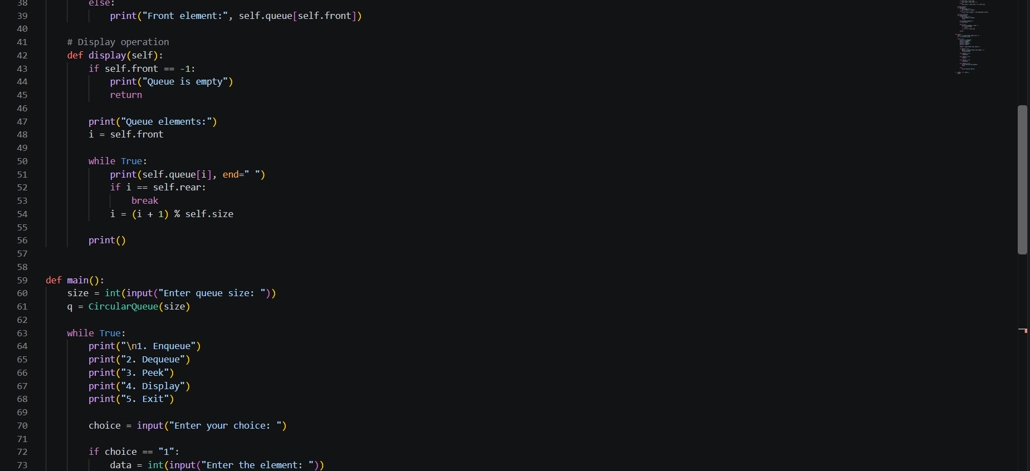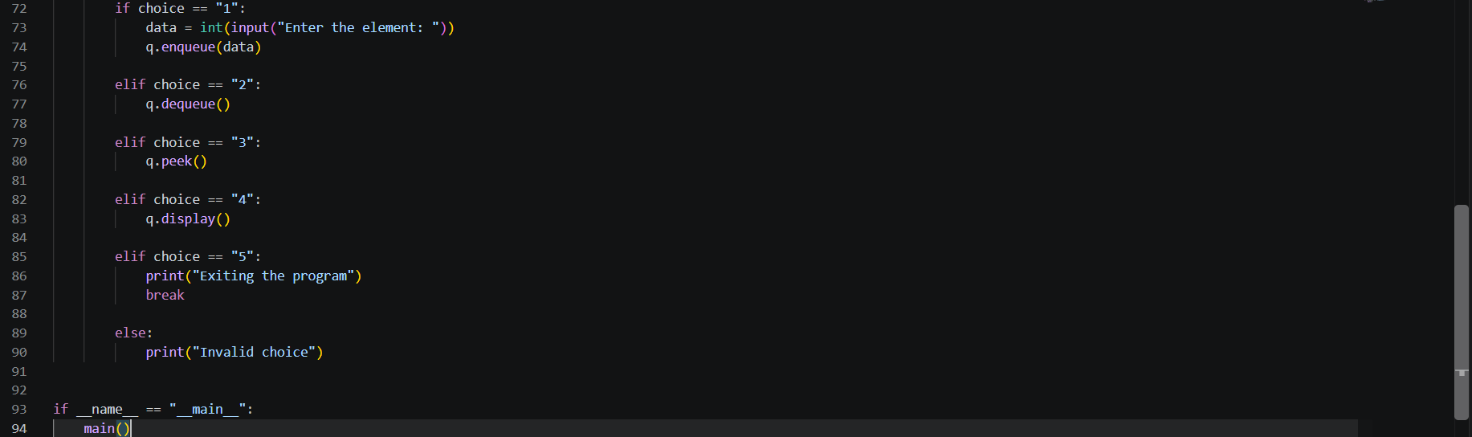
Output:
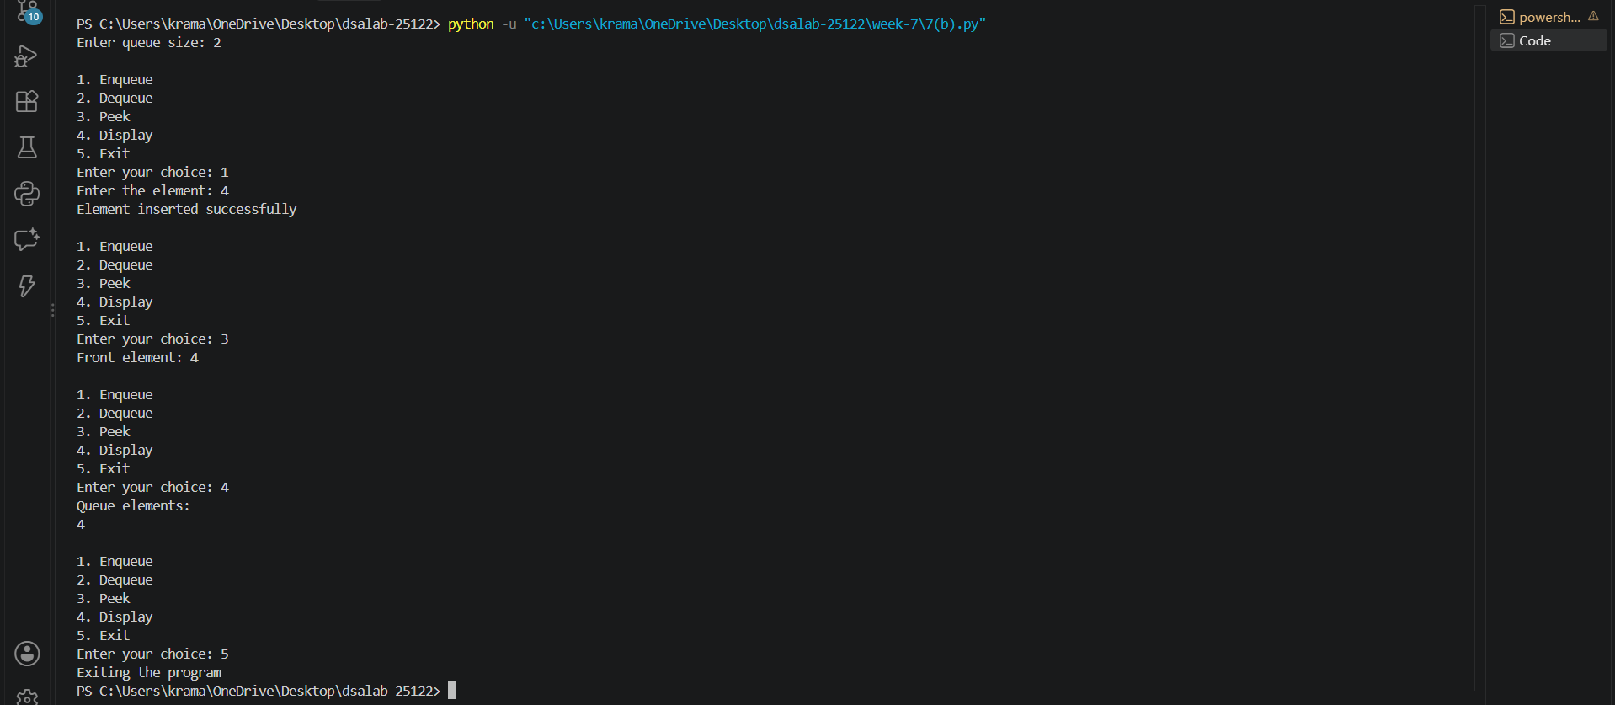

Error Table:
Error | Rectification
Queue Underflow | Check whether the queue is empty before performing the Dequeue operation.
Empty Queue | Check whether the queue contains elements before performing Peek or Display.

Description:
This Python program implements a Circular Queue using both an Array and a Linked List with a menu-driven approach. It supports four main operations: Enqueue, Dequeue, Peek, and Display. The Enqueue operation inserts an element at the rear of the queue, while the Dequeue operation removes an element from the front. The Peek operation displays the front element without removing it, and the Display operation shows all the elements in the queue. In the array implementation, the circular queue uses the modulo operator to reuse empty spaces, while the linked list implementation connects the last node back to the first node. Both implementations follow the FIFO (First In, First Out) principle. The program also handles queue overflow in the array implementation and queue underflow when a Dequeue operation is performed on an empty queue. The menu continues to appear until the user selects the Exit option.

7(c):
Aim: Write a python program to implement circular Queue and its operations such as enqueue ,dequeue, peek, display with a menu driven approach. Implement using array data structures
Program:
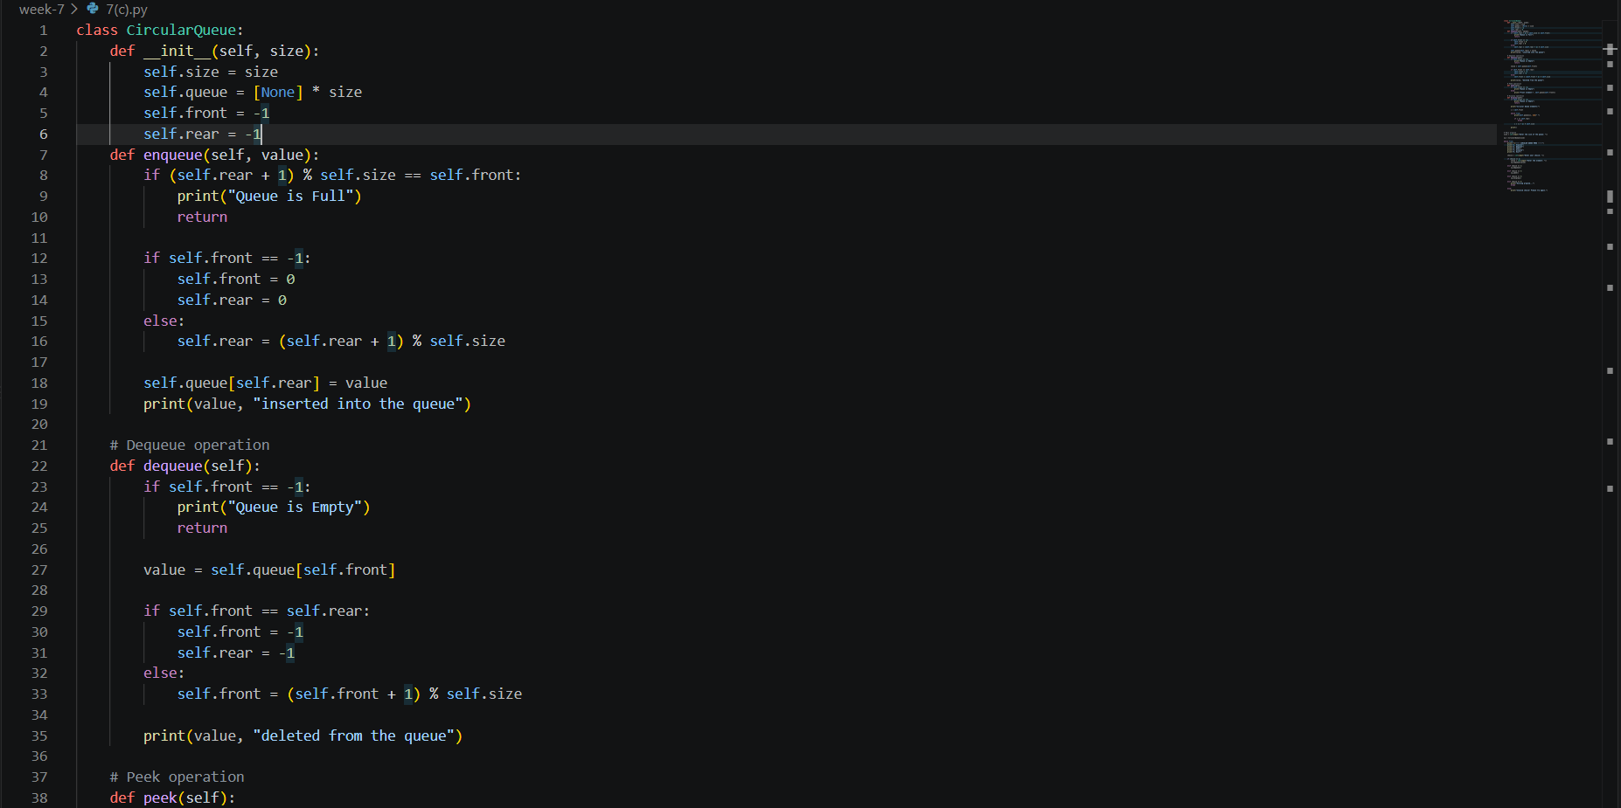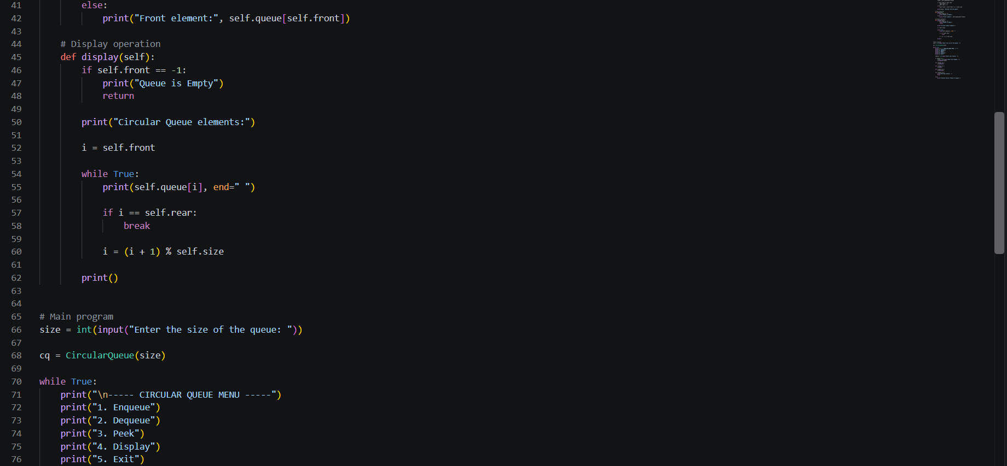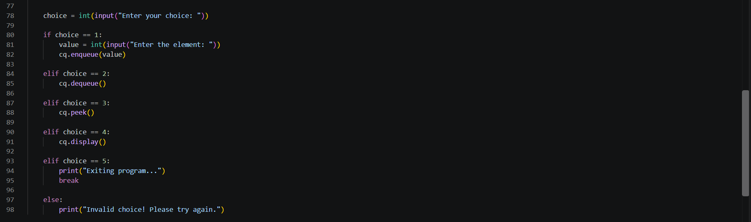
Output:
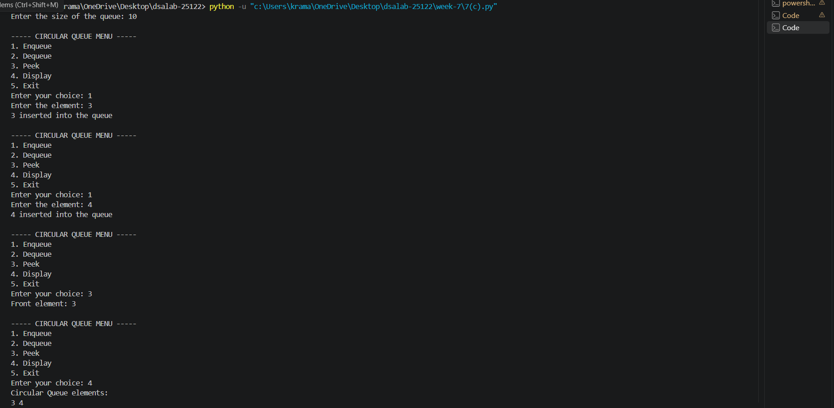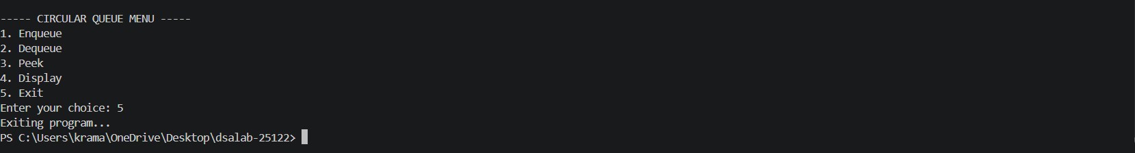
Error Table:
Error | Rectification
Queue Underflow | Check whether the queue is empty before performing the Dequeue operation.
Empty Queue | Check whether the queue contains elements before performing Peek or Display.
Description:
The program implements a Circular Queue using an array data structure in Python. A circular queue follows the FIFO (First In, First Out) principle, where the element inserted first is removed first. The program uses two pointers, front and rear, to keep track of the first and last elements of the queue. The enqueue operation inserts an element at the rear, while the dequeue operation removes an element from the front. The peek operation displays the front element without removing it, and the display operation shows all the elements currently present in the queue. The circular nature of the queue is achieved using the modulo (%) operator, which allows the rear and front positions to wrap around to the beginning of the array when they reach the last position. The program also checks for queue overflow when the queue is full and queue underflow when the queue is empty. A menu-driven approach is used so that the user can select the required queue operation repeatedly until choosing the exit option.

7(d):
Aim: Write a python program to implement circular Queue and its operations such as enqueue ,dequeue, peek, display with a menu driven approach. Implement using linked list data structures
Program: 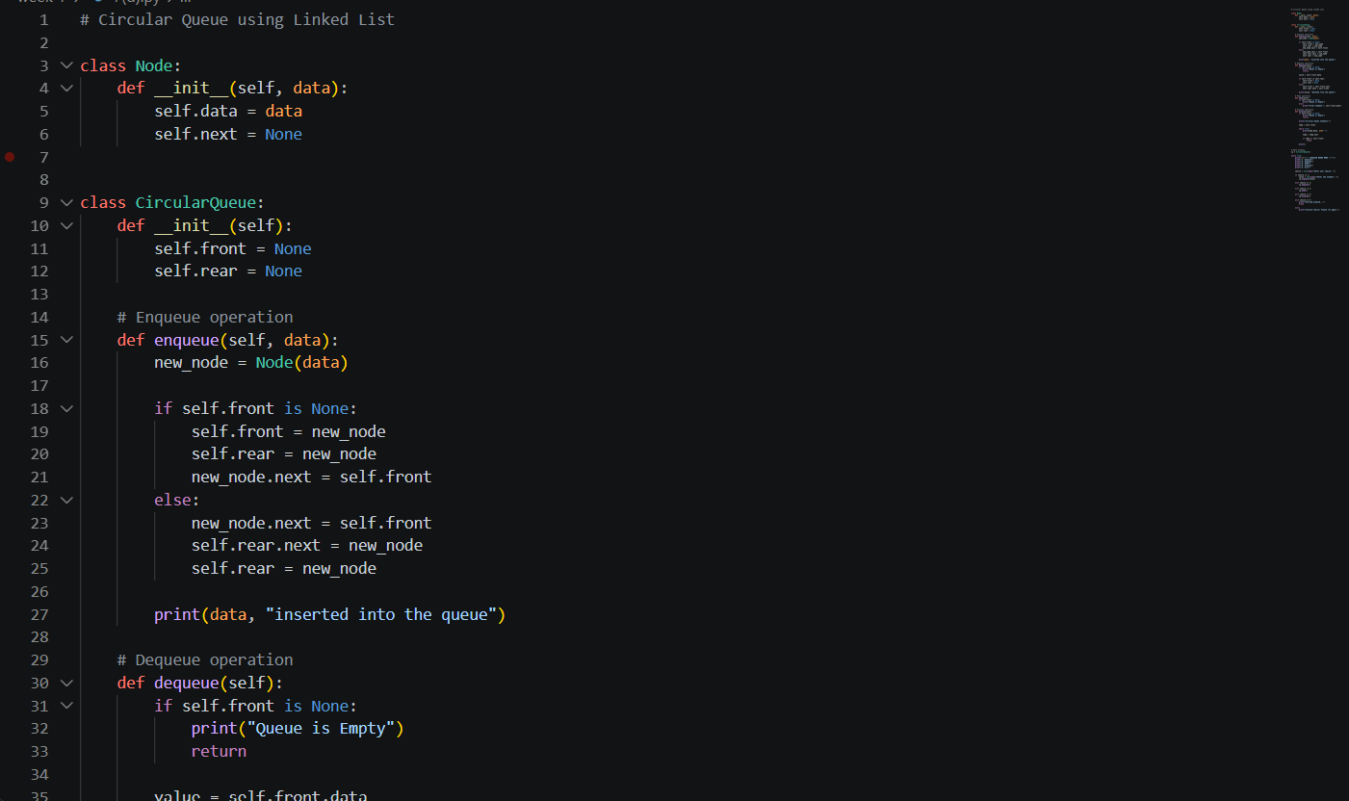 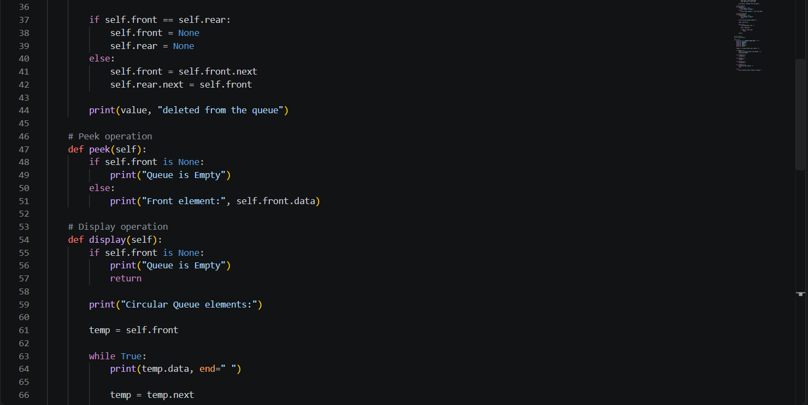 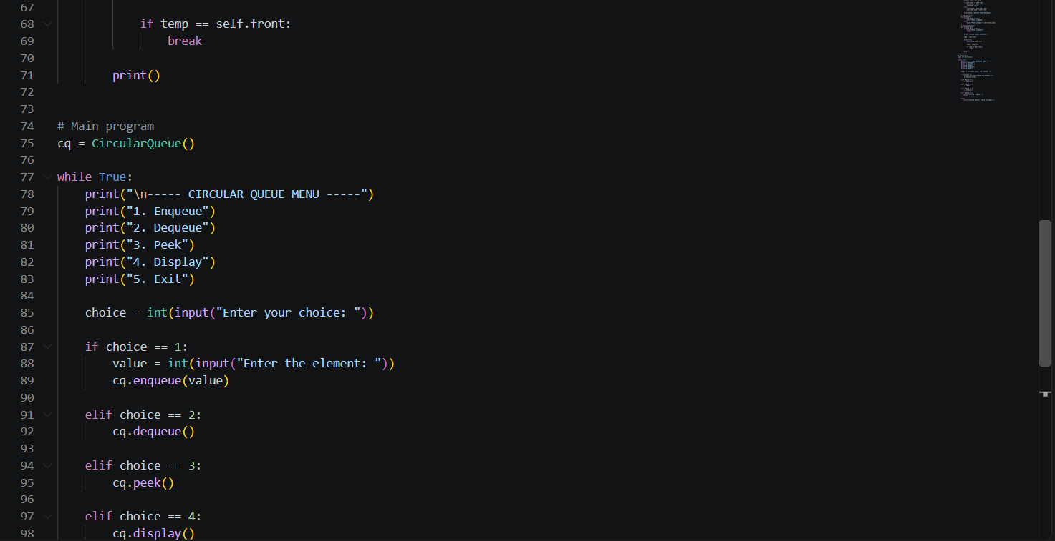 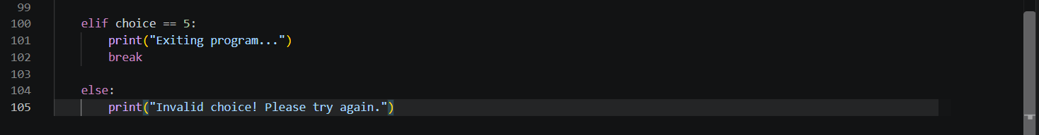
Output:
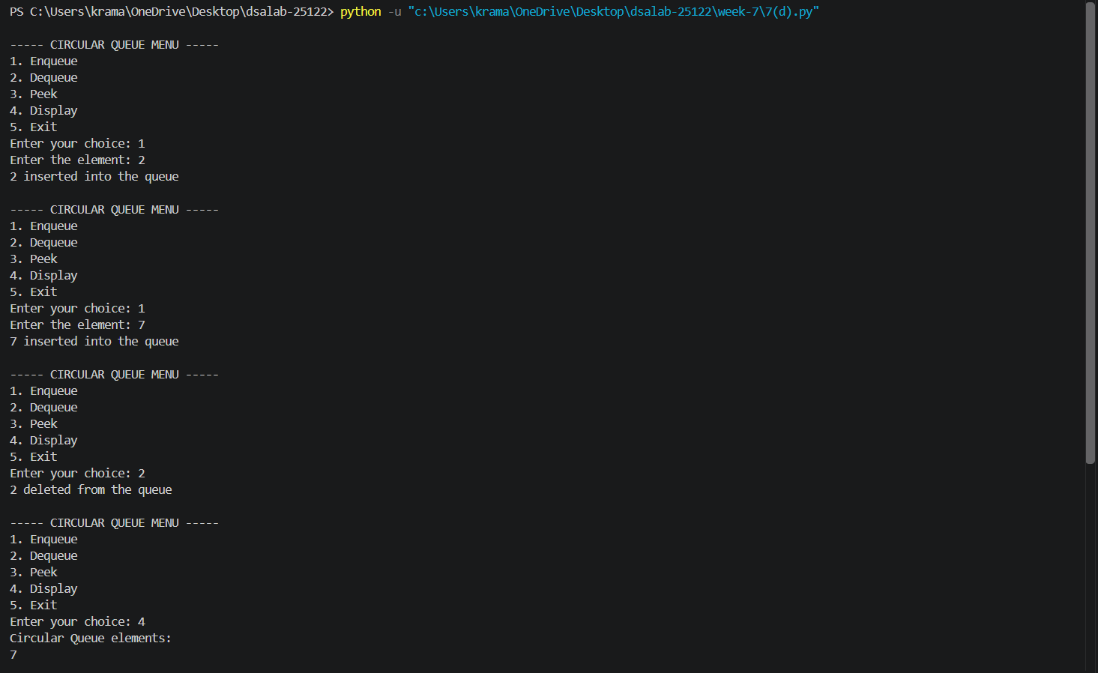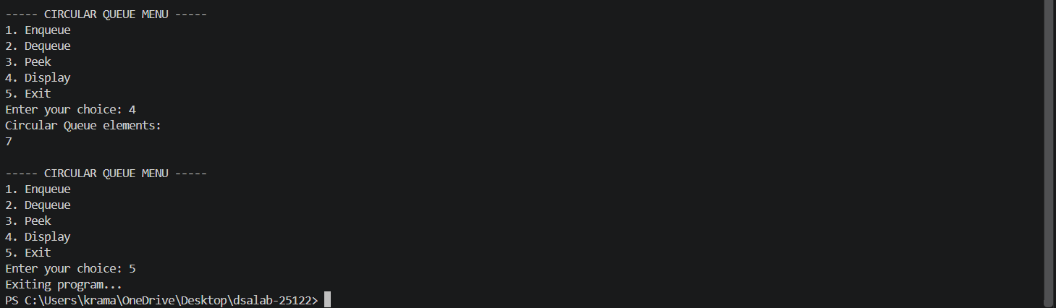
Error Table:
Error | Rectification
Queue Underflow | Check whether the queue is empty before performing the Dequeue operation.
Empty Queue | Check whether the queue contains elements before performing Peek or Display.

Description:
The program implements a Circular Queue using a Linked List in Python. A circular queue follows the FIFO (First In, First Out) principle, where the element inserted first is removed first. The program uses nodes to store the queue elements, with each node containing data and a next pointer. Two pointers, front and rear, are used to keep track of the first and last nodes. In the enqueue operation, a new node is inserted at the rear, while in the dequeue operation, the node at the front is removed. The peek operation displays the front element without removing it, and the display operation traverses the queue and displays all its elements. The circular nature is maintained by making the next pointer of the rear node point back to the front node. The program uses a menu-driven approach that allows the user to repeatedly perform different queue operations until selecting the exit option.

