CHAPTER 1

SYNOPSIS
This project entitled REPORT GENERATION FOR STUDENT PLACEMENT MANAGEMENT explains about the pool campus student management and Report Generation using Crystal report tool. This project mainly explains the various actions related to other student details, other college Detail, and Crystal Report Generation. This project shows some ease in adding, editing and deleting, searching the Records. It also provides a less time consuming process for viewing, adding, editing and deleting and Retrieving Records.

This project includes
Pool Campus Student Management System
For Admin:
- Manage Other College’s Details.
- Manage Students’ Details of other colleges.
- Upload other College/ Student details
For Placement Officer:
- Schedule Written Test Round.
- Enter Written Test Result.
- Next round Intimation (Technical).
- Schedule GD Round.
- Enter GD Round Results.
- Schedule Final HR Round(s).
- Enter Final Selected Students.
Report Generation Using Crystal Report tool
- Generating Reports using Different Search Criteria.
This module is developed on ASP.NET platform and is implemented using C#.
This application is first being developed statically later deployed dynamically with the necessary links available for the Placement Management.
This software is being developed in ASP.NET using c# which provides high security. The database used is MSsql Server (Management Studio) 2008 R2.

CHAPTER 2
PREAMBLE

2.1 GENERAL INTRODUCTION
The SPMS is aimed at developing an online application for Placement Department of the college. The system is an online application that can be accessed throughout the organization and outside as well with proper login provided. This application used for the Placement Department of the college to manage the student information with regards to placement. The SPMS application mainly allows the students to enter their personal information like student full name, E-mail, contact information etc. and academic information of previous education and current course details. Students logging should be able to upload their information in the form personal details and academic details. Company representatives logging in may also access/search any information put up by students.

Other College Placement Management and Report Generation is one of the modules in Student Placement Management System. Other College Placement Management is used for performing Manage Other College’s Details, Manage Students’ Details of other colleges, etc. over the Internet through a secure website. This can be very useful, especially for Students to Register, view Details from anywhere where internet access is available. In most cases a web browser such as Internet Explorer or Mozilla Firefox is utilized and any normal Internet connection is suitable. No special software or hardware is usually needed. At present, computers and their applications significantly affect almost every aspect of this project. The dynamic technology with efficient and secure methods of Placement Management makes easy for the students and faculties.

The objectives of Other College Placement Management and Report Generation include the following:
- Register other college Student Details through online
- Students can view the previous year question papers
- Students can be aware of the upcoming drives.
- Students can check their eligibility for the companies.
- Easy understanding for the end users.

2.2 STATEMENT OF THE PROBLEM
Due to maintenance of huge data manually will result in data loss hence maintaining computerized data will prevent loss of data.
Limitations were:
- Takes lot of time for the intimation for students for the upcoming companies; drive, etc.
- Manually Specific data can’t be retrieved.
- Other campus details can’t be stored manually as there would be time consuming.
- Can’t register the details of the other college students
- Time consuming.

2.3 OBJECTIVE OF THE STUDY
The objective of this project is to enhance the underlying technology. As mentioned in the synopsis the web page has to be rebuilt using ASP.NET technology without affecting the users. The users should not be interrupted in their task.

Following are the requirements:

- This has to take place without affecting the end users.
- The look and feel of the entire web page should be clear and comfortable to the end users.

2.4 SCOPE OF THE STUDY
The scope of this project is to replace the already existing web site of the placement management with the new changes as mentioned in the synopsis. The end user that is the student, admin can access the site for their Registering and viewing details.

2.5 METHODOLOGY
Placement Management was designed and developed based on the Waterfall Model. This model particularly expresses the interaction between subsequent phases.
In each phase of the software development process, we have to compare results obtained against that which is required. In all, quality has to be assessed and controlled.
Requirements Analysis

Verification and Validation
Design

Verification and Validation
Implementation

Verification and Validation
Testing

Verification and Validation
Maintenance

Verification and Validation

Fig 2.1 Waterfall model [5]

2.6 FEASIBILITY STUDY

The development of a computer-based system is more likely to be plagued by the scarcity of resourced bad difficulty delivery data. A feasibility study is not warranted system in which economic justification is obvious, technical risk, low, few legal problems are expected, and no reasonable alternative exits.
Three essential consideration are involved in the feasibility analysis
- Economic feasibility
- Technical feasibility
- Scheduled feasibility
- Time and Resource feasibility
- Functional or behavior feasibility

2.6.1 Economic Feasibility
This involves questions such as whether the firm can afford to build the system, whether its benefits should substantially exceed its cost, and whether the project has higher priority and profits than other projects that might use the same resources. This also includes whether the project is in the condition to fulfill all the eligibility criteria and the responsibility of both sides in case there are two parties involved in performing any project.

2.6.1.1 Cost Benefit Analysis

The proposed system cost analysis is as given below:
- Hardware Costs: Minimum hardware requirement is specified in 4.1. The hardware for this project is the personal system with good configuration. No extra hardware is needed.
- Cost of Development: Development cost and contingency reserves as determined necessary by the General Consultant. The cost of development include – training on technologies, man power and other resources.
- Engineering Costs: Plans, specifications, surveys, preliminary design and engineering and final design costs (provided by General Consultant) determine engineer cost estimate report costs.
- Financing Cost: Financing charges, fees, legal costs, credit facilities (insurance), reserves and other expenses related to financing.
- Administrative Expenses: Administrative costs are used in determining Operation and Maintenance Costs. Revenues for the purpose of determining economic feasibility are net of Operation and Maintenance Costs.

The benefits of this investment can be observed in many ways. The more obvious one is the tangible cost savings. But the intangible cost savings such as efficiency of the system, process time reduction, customer value, etc. are a lot more difficult to measure and allocate. However, the benefits far outweigh the costs.

2.6.2 Technical Feasibility

Technical feasibility centers on existing computer system and to what extent is supported the proposed. The assessment is based on an outline design of system requirements in terms of Input, Output, Fields, Programs and Procedures. This can be qualified in terms of volumes of data, trends, frequency of updating, etc. in order to give an introduction to the technical system.

The project development needed the man power with the following skills.
- Windows 7
- Knowledge of core ASP.NET
- Basic knowledge of Microsoft SQL Server 2008 R2

2.6.3 Scheduled Feasibility

System design provides the understandings and procedural details necessary for implementing the system recommended in the system study. Emphasis is on the translating the performance requirements into design specifications. The design phase is a transition from a user-oriented document (System proposal) to a document oriented to the programmers or database personnel.

2.6.3.1 Gantt Chart

Gantt Charts are useful tools for analyzing and planning complex projects. They:

- Give a basis for scheduling when these tasks will be carried out.
- Help you to plan out the tasks that need to be completed.
- Allow you to plan the allocation of resources needed to complete the project
- When a project is under way, Gantt Charts help you to monitor whether the project is on schedule. If it is not, it allows pinpointing the remedial action necessary to put it back on schedule.

S.No | Task | Possible start | Length | Type | Dependent on…
1 | High level analysis | 1 | 5 days | Sequential
2 | Selection of hardware platform | 1 | 1 day | Sequential | 1
3 | Installation and commissioning of hardware | 3 | 2 days | Parallel | 2
4 | Training on Technology | 3 | 3 days | Sequential | 2
5 | Core Module Analysis | 1 | 2 weeks | Sequential | 1
6 | Detailed analysis of supporting utilities | 1 | 2 weeks | Sequential | 4
7 | Programming of core modules | 4 | 3 weeks | Sequential | 4
8 | Programming of supporting modules | 4 | 3 weeks | Sequential | 5
9 | Review and analysis of designed modules | 5 | 1 week | Sequential | 6
10 | Review and analysis of supporting modules | 5 | 1 week | Sequential | 7
11 | Core module training | 7 | 1 day | Parallel | 6
12 | Development of unit testing | 6 | 1 week | parallel | 5
13 | Development of management analysis | 6 | 2 weeks | Sequential | 5
14 | Training | 7 | 1 week | Sequential | 1-13
15 | Documentation | 8 | 2 weeks | Sequential | 13
Table 2.1 Schedule List

2.6.4 Time and Resource Feasibility
This system helps the user to find in the best usage of resources keeping in track of all the transaction details and other necessary details related to bank over a period of time, thereby reducing the decision making process easier and worthwhile. It acts to be a solution provider in determining the best allocation of resources and finding out the way for time reduction.

2.6.5 Functional Feasibility
People are inherently resistant to change. Computers have been known to facility changes. An estimate should be made to know the reaction of the user is likely to have towards the new system.

Since this system is ready to use in the organization, this system is operationally feasible. As this system is technically, economically and functionally feasible the system is judged feasible. Viewing the collected information, recommendation, justification and conclusions are made on the developed system.

2.7 LIMITATIONS OF THE STUDY
As mentioned earlier, due to maintenance of huge data manually will result in data loss hence maintaining data would be complicated as well as retrieving information will be time consuming process.
CHAPTER 3

REVIEW OF LITERATURE

3.1 ARTICLES

Introduction

The management of placement and work-integrated learning has long been sup-ported by paper-based systems, databases, spreadsheets and E Mail communications. Unfortunately, in today’s fast-moving world most of these are inflexible to changes and cannot respond quickly enough, especially during out-of-term. They are also staff intensive. Many placement web sites convey information but lack the interactive features to allow action on the information provided.
Since 2002 engineering students at the University of Ulster have been using an interactive, web-based placement system to achieve and run their placement. This paper details the design features of this professionally-developed placement management system, known as PMS (Placement Management System), in relation to students, companies, academic staff and administrators. Operational experience over six years is related to the pedagogy of work-integrated learning and to evolving good practice. The ease and flexibility of use, especially for students, placement providers and administrators, will be demonstrated using the features of the system. The paper concludes with comments by users and an assessment of its impact on placements. The UK’s Association for Sandwich Education and Training (ASET) endorses PMS as achieving almost all of the requirements in its guide for online systems.
Abstract
The use of the Internet and the World Wide Web has revolutionized the provision of information and the facility for the user to take action on the information obtained. An early example of user enabling was the online shopping features within some web sites. These examples prompted us in the School of Engineering at the University of Ulster to explore the use of the Internet to enable students and companies to manage the placement process with the active involvement of the Industrial Placement Coordinator. This led to a unique web-based placement management system developed specifically by the placements practitioner and the software programmer to become PMS (Placement Management System) since autumn 2000. The basic system was able to manage the first cohort of engineering students into placement in 2002.
Since these early basics the programmer has been developed continuously as an open source product, now at version 4, and being implemented in several universities in the United Kingdom and under investigation by others worldwide.
PMS, like many other placement management web sites, provides information on placement providers and the placements they offer so that students may view and assess their opportunities. Indeed, all higher education institutions (HEIs) have well-developed web sites to inform their students of vacancies and how to prepare for their work-integrated learning experience. However, relatively few have developed the means to enable the student, the provider and the placements coordinator (with others) to take effective actions on the web as a follow-on from the information they have viewed. It is too often the case that information must be acted upon by wholly separate means away from the web. Changes and updates are laborious for staff and are at risk of being late. With PMS the user may control their information, the provider may promote their opportunities, and the student can take action to apply for any [2]
PMS IN ACTION
This section outlines of the nature of the provision within PMS for each of the main user types.

Students- Students need information and support in essentially three phases: pre-, in- and post-placement. In all circumstances each user must be listed as authorized to use PMS with a unique username and password (which can be refreshed easily). On every login they see the announcements page (which is editable by the placements coordinator) and changes in companies and vacancies since their last login. Any student may see only their own personal data and not that of any other person. PMS has a facility to deny any student the right to use the system if the placements coordinator wishes to apply this status. A targeted help list is provided for the student throughout their use of PMS as the system recognizes their login and selects the appropriate staff from the list of administrators.

Pre-placement- Features to enable search for: open or closed vacancies by generic type, approved placement providers, resources containing advice documents (and video or other configured MIME types) and personalized notes. Students are provided with the facility to create their CV using a variety of styles and continue to have ownership of their data through editing at any time (the data remains on the server and is presented as a ‘live’ pdf file to any authorized viewer).

The facilities listed so far are little more than the current provision in any good support web site. However, in PMS the student may take action to apply online for their choice of vacancy by ‘tagging’ their CV (with an optional electronic ‘covering letter’) to the vacancy of their choice or by other directed methods as specified by the placement provider. Further, they may see the list of their applications and view cryptic feedback on the status of each. Of course, having applied for a vacancy the student cannot unhappy, but the placements coordinator may do so if it is deemed appropriate.
The student may edit their own information but view only information owned by other users, especially placement providers and ‘the system’.

The student is asked to enter their in-placement contact details and the name and contact details of their work-based supervisor. On this action the latter will receive their welcome and credentials by E Mail to enable their use of PMS, particularly for online re-porting. In addition, the student is asked to complete online their Health and Safety re-port, thus indicating, for the record, key features of their induction.

Post-placement- Students returning to studies, usually final year, wish to complete their work and reports from placement expeditiously. PMS provides a full set of marks from assessments with feedback as soon as the online report is entered. The student continues to have access to their CV, which they may develop for use in seeking graduate employment. PMS maintains a record of the placement(s), assessments, notes and details entered by the student, academic tutor and work-based supervisor. As the same companies seek their graduate employees from the same cohort there is a growing use of PMS to promote graduate employment opportunities to students who continue to have access while at the HEI. Future developments will enhance this functionality to enable online applications in the style specified by the employer.

Placement Providers - It has been noticed that employers are becoming more pro-active in promoting their organization to the student body with a view to attracting the best into employment; this is especially obvious for engineering. Any recruitment can be a protracted and expensive exercise for the employer, but we believe that PMS ‘makes it easy to do business with us’. Several stages of activity may be identified as follows.
Company Presence. PMS is designed to list employers that are approved as placement providers. The requirement for ‘approval’ follows from the Code, Section 9, and Precept 3 and is fully elaborated by Laird and Turner in their paper (2007a). Consequently, a provider may be entered on PMS by the placements coordinator following off-line processes to establish that they can support the requirements for work-integrated learning. On this action, the contact person for the provider is sent their credentials by E Mail and may at any time thereafter edit their data, add specific documents (such as brochures, application forms, job descriptions and any configured MIME type attachments) and promote vacancies to the student users. These facilities are now used extensively by companies to edit their data at a time of their choosing. The company representatives (of-ten human resources personnel) have access to resource documents which are assigned for their information, e.g., terms and conditions of placement.

Vacancy Promotion. A provider (or the placements coordinator) may create a vacancy to state the details of the placement on offer (or clone an existing vacancy, if available). As this information will be available to all student users any concerns of discrimatory advertising are obviated. The advertised detail must include the closing date for the call for applications, location of the job and a description of the opportunity. The provider or placements coordinator may edit all of this information at any time.

iii. Applications. As the information is web-based, the provider may view the list of applicants and their current CV at any time. Specifically, at the expiry time for the call the named owner of the vacancy will receive an E Mail to advise that the vacancy has closed and to give the number of applicants. This feature allows the provider to promote a vacancy, forget about it (!), receive the reminder and then see all the applicants in one location without engaging any of his own resources. We consider these actions make it easy for the provider to do business with us!

Follow-up the decision to proceed to the next stage of selection for any student applicant rests with the employer. PMS presents them with the facility to E Mail the student to advise their options, such as call to interview or no further interest. Again, this makes work easy for the employer and provides a record on PMS which is viewable by the student and placements coordinator. As mentioned above, it is reserved to the placements coordinator to declare the student to be ‘placed’ in a vacancy within a company.

Academic Staff- Academic staff within a school/department or faculty frequently provides the academic component for work-integrated learning and its assessment; they act as the tutor for the student in placement. Once listed on PMS and issued with their credentials academic staff may edit their data, view designated resource documents (including their role guidance), view companies and vacancies and, most importantly, view the details of their assigned students together with the placement provider, contacts and work-based supervisor. Also, a route planning facility is included! Once the placements coordinator has set up the details for a given placement little further action is required as other stakeholders have access to the information they need.

The academic tutor will have specific activities as follows.

I. Site Visits. Within the specified dates the academic tutor may plan their visits using all the necessary information for their assigned students presented on PMS. Reports for all visits may be made online and amended within a 24-hour period before becoming ‘frozen’. This latter feature ensures data integrity for record and audit purposes. Students may view the content of reports and gain support from the feedback given. Of course, such reports should record what has been discussed on the visit already.

ii. Assessment. To qualify for a separate award or as part of their degree (or other) students have an assessment programmer. Academic tutors are able to view the assessment criteria, declare their allocation of marks and give extensive feedback comments to ad-vise the student. Again, after the 24-hour period the tutor may not change the data. It is possible for the placements coordinator to assign a different academic tutor for different reports, thus assuring objectivity and quality in the overall assessment programmer.

iii. Advice. When an item of advice needs to be recorded the academic tutor may make an entry in ‘notes’ to remind and ‘put it on the record’. Once entered, this note may not be edited at any time, thus preserving its integrity for audit purposes.

D. Work-based Supervisor. As described above, timely action by the student entering the details of this supervisor (appointed by the company) enables the latter to enter PMS where they may see designated documents (including their role guidance) and their report format. Towards the end of the placement a reminder facility will alert the supervisor that the report should be completed online. Following completion, the student may view the results, which, of course, should be known to him/her already from interview nearing the end of the placement. This feature of reporting online ensures that no paper needs circulation to achieve complete results for the student!

Placements Coordinator- The ability to intervene in almost all functions of PMS is allocated to the placements coordinator. However, in a complex arrangement involving several departments or faculties it has been found valuable to designate a senior coordinator with full con-figuration and editorial rights and other coordinators with rights commensurate with running their part of the work-integrated programmer. The definition of ‘rights’ derives from a feature of PMS named ‘policies’ in which the creating, editing and viewing powers of any type of user are defined by generic appointment types. When a new user is entered (always done by a coordinator) the appropriate policy is assigned. For example, a course director is allocated limited viewing rights so they may see the progress of their students and, thereby, maintain interest in placement activities.

By design, PMS has arranged for considerable configuration functions to be arranged by the senior coordinator (termed the ‘root user’). These actions include configuring the HEI organization, programmers of study, types of placements and vacancies, policies, administrators, assessment programmed, E Mail messages, announcements and help items. A significant feature for expandability is the concept of ‘channels’. This feature allows different student cohorts with different information needs and assessment regimes to be uniquely defined in configuration. For example, there will be a need for different announcements for students in business and engineering. By arranging separate channels for each type of student the appropriate information may be presented to the student at login, because PMS recognizes the type of student from their login credentials. Many of these settings require a once-off definition with minor adjustments thereafter, others may require changing weekly.
The most significant impact for the placements coordinator is the reduction in administration load, improved timeliness of information and ownership by the participating users giving con-trolled inter-visibility of information. In effect, the processes operate without paper, the system remains stable and time is reassigned to building relationships with placement providers, staff and students. [2]

Conclusion
The above articles are developed in Asp.net using C#, JavaScript, MSSql. As the project is content management which is related to viewing structure, the project being developed is in Asp.net using C#, JavaScript, MSSql which is effective in web design.
3.2 TECHNICAL REVIEW
ASP.NET

This proposed software is going to be developed using the latest technology from Microsoft called Microsoft. NET and it is the software that connects information, people, systems, and devices. It spans clients, servers, and developer tools, and consists of:
• The .NET Framework 1.1, used for building and running all kinds of software, including Web-based applications, smart client applications, and XML Web services.[3]
- Developer tools, such as Microsoft Visual Studio.NET 2003, which provides an integrated development environment (IDE) for maximizing developer productivity with the .NET Framework.[3]

A set of servers, including Microsoft Windows Server 2003, Microsoft SQL Server, and Microsoft BizTalk Server, that integrates, runs, operates, and manages Web services and Web-based applications.[3]
Client software, such as Windows XP, Windows CE, and Microsoft Office XP, that helps developers deliver a deep and compelling user experience across a family of devices and existing products. [3]

3.3.1 ADVANTAGES OF NET

The .NET Framework offers a number of advantages to developers. The following paragraphs describe them in detail.

3.3.1.1 Consistent programming model
Different programming languages have different approaches for doing a task. For example, accessing data with a VB 6.0 application and a VC++ application is totally different. When using different programming languages to do a task, a disparity exists among the approach developers use to perform the task. The difference in techniques comes from how different languages interact with the underlying system that applications rely on. [3]

With .NET, for example, accessing data with a VB .NET and a C# .NET looks very similar apart from slight syntactical differences. Both the programs need to import the System. Data namespace, both the programs establish a connection with the database and both the programs run a query and display the data on a data grid. The VB 6.0 and VC++ example mentioned in the first paragraph explains that there is more than one way to do a particular task within the same language. The .NET example explains that there's a unified means of accomplishing the same task by using the .NET Class Library, a key component of the .NET Framework. [3]

The functionality that the .NET Class Library provides is available to all .NET languages resulting in a consistent object model regardless of the programming language the developer uses. [3]

3.3.1.2 Direct support for security
Developing an application that resides on a local machine and uses local resources is easy. In this scenario, security isn't an issue as all the resources are available and accessed locally. Consider an application that accesses data on a remote machine or has to perform a privileged task on behalf of a no privileged user. In this scenario security is much more important as the application is accessing data from a remote machine. [3]

With .NET, the Framework enables the developer and the system administrator to specify method level security. It uses industry-standard protocols such as TCP/IP, XML, SOAP and HTTP to facilitate distributed application communications. This makes distributed computing more secure because .NET developers cooperate with network security devices instead of working around their security limitations.

3.3.1.3 Simplified development efforts
Let's take a look at this with Web applications. With classic ASP, when a developer needs to present data from a database in a Web page, he is required to write the application logic (code) and presentation logic (design) in the same file. He was required to mix the ASP code with the HTML code to get the desired result.

ASP.NET and the .NET Framework simplify development by separating the application logic and presentation logic making it easier to maintain the code. You write the design code (presentation logic) and the actual code (application logic) separately eliminating the need to mix HTML code with ASP code. ASP.NET can also handle the details of maintaining the state of the controls, such as contents in a textbox, between calls to the same ASP.NET page. [3]

Another advantage of creating applications is debugging. Visual Studio .NET and other third party providers provide several debugging tools that simplify application development. The .NET Framework simplifies debugging with support for Runtime diagnostics. Runtime diagnostics helps you to track down bugs and also helps you to determine how well an application performs. The .NET Framework provides three types of Runtime diagnostics: Event Logging, Performance Counters and tracing. [3]

3.3.1.4 Easy application deployment and maintenance

The .NET Framework makes it easy to deploy applications. In the most common form, to install an application, all you need to do is copy the application along with the components it requires into a directory on the target computer. The .NET Framework handles the details of locating and loading the components an application needs, even if several versions of the same application exist on the target computer. The .NET
Framework ensures that all the components the application depends on are available on the computer before the application begins to execute. [3]
3.3.2 NET FRAMEWORK
The Microsoft .NET Framework is a software component that can be added to or is included with the Microsoft Windows operating system. It provides a large body of pre-coded solutions to common program requirements, and manages the execution of programs written specifically for the framework. The .NET Framework is a key Microsoft offering, and is intended to be used by most new applications created for the Windows platform.[3]
The pre-coded solutions that form the framework's class library cover a large range of programming needs in areas including: user interface, data access, database connectivity, cryptography, web application development, numeric algorithms, and network communications. The functions of the class library are used by programmers who combine them with their own code to produce applications. [3]
Programs written for the .NET Framework execute in a software environment that manages the program's runtime requirements. This runtime environment, which is also a part of the .NET Framework, is known as the Common Language Runtime (CLR). The CLR provides the appearance of an application virtual machine, so that programmers need not consider the capabilities of the specific CPU that will execute the program. The CLR also provides other important services such as security mechanisms, memory management, and exception handling. The class library and the CLR together compose the .NET Framework. The framework is intended to make it easier to develop computer applications and to reduce the vulnerability of applications and computers to security threats. [3]
First released in 2002, it is included with Windows XP SP2, Windows Server 2003 and Windows Vista, and can be installed on older versions of Windows. [3]

Microsoft .NET Framework was designed with several intentions:
Interoperability - Because interaction between new and older applications is commonly required, the .NET Framework provides means to access functionality that is implemented in programs that execute outside the .NET environment. Access to COM components is provided in the System.Runtime.InteropServices and System.EnterpriseServices namespaces of the framework, and access to other functionality is provided using the P/Invoke feature.
Common Runtime Engine - Programming languages on the .NET Framework compile into an intermediate language known as the Common Intermediate Language, or CIL (formerly known as Microsoft Intermediate Language, or MSIL). In Microsoft's implementation, this intermediate language is not interpreted, but rather compiled in a manner known as just-in-time compilation (JIT) into native code. The combination of these concepts is called the Common Language Infrastructure (CLI), a specification; Microsoft's implementation of the CLI is known as the Common Language Runtime (CLR). [3]
Language Independence - The .NET Framework introduces a Common Type System, or CTS. The CTS specification defines all possible data types and programming constructs supported by the CLR and how they may or may not interact with each other. Because of this feature, the .NET Framework supports development in multiple programming languages. This is discussed in more detail in the .NET languages section below. [3]
Base Class Library - The Base Class Library (BCL), sometimes referred to as the Framework Class Library (FCL), is a library of types available to all languages using the .NET Framework. The BCL provides classes which encapsulate a number of common functions, including file reading and writing, graphic rendering, database interaction and XML document manipulation. [3]
Simplified Deployment - Installation of computer software must be carefully managed to ensure that it does not interfere with previously installed software, and that it conforms to increasingly stringent security requirements. The .NET framework includes design features and tools that help address these requirements. [3]
Security - .NET allows for code to be run with different trust levels without the use of a separate sandbox.
A design goal of the .NET Framework was to support platform independence [citation needed]. That is, a program written to use the framework should run without change on any type of computer for which the framework is implemented. However, Microsoft has only implemented the full .NET framework on the Windows operating system. Microsoft and others have implemented portions of the framework on non-Windows systems, but to date these implementations are neither complete nor widely used, so full cross-platform support has not been achieved.

JavaScript
JavaScript is the premier client-side scripting language used today on the web. It’s widely used in tasks ranging from the validation of form data to the creation of complex user interfaces. [4]
Some of the common uses of JavaScript include
- Form validation
- Page embellishments and special effects
- Navigation systems
- Basic mathematical calculations
- Dynamic document generation
- Manipulation of structured documents[4]
CSS
Cascading Style Sheets (CSS) is a style sheet language used for describing the presentation semantics (the look and formatting) of a document written in a markup language. Its most common application is to style web pages written in HTML and XHTML, but the language can also be applied to any kind of XML document, including plain XML, SVG and XUL.
CSS is designed primarily to enable the separation of document content (written in HTML or a similar markup language) from document presentation, including elements such as the layout, colors, and fonts. This separation can improve content accessibility, provide more flexibility and control in the specification of presentation characteristics, enable multiple pages to share formatting, and reduce complexity and repetition in the structural content (such as by allowing for table less web design). CSS can also allow the same markup page to be presented in different styles for different rendering methods, such as on-screen, in print, by voice (when read out by a speech-based browser or screen reader) and on Braille-based, tactile devices. It can also be used to allow the web page to display differently depending on the screen size or device on which it is being viewed. While the author of a document typically links that document to a CSS style sheet, readers can use a different style sheet, perhaps one on their own computer, to override the one the author has specified. [5]
CSS specifies a priority scheme to determine which style rules apply if more than one rule matches against a particular element. In this so-called cascade, priorities or weights are calculated and assigned to rules, so that the results are predictable.
The CSS specifications are maintained by the World Wide Web Consortium (W3C). Internet media type (MIME type) text/css is registered for use with CSS by RFC 2318 (March 1998). [5]
Advantages
- Separation of content from presentation
- Site-wide consistency
- Bandwidth
- Page reformatting
- Accessibility
Limitations
- Poor controls for flexible layouts
- Vertical control limitations
- Cannot explicitly declare new scope independently of position
- Absence of expressions

SQL SERVER 2008
Microsoft SQL Server 2008 is comprehensive, integrated data management and analysis software that enables organizations to reliably manage mission-critical information and confidently run today's increasingly complex business applications. SQL Server 2008 allows companies to gain greater insight from their business information and achieve faster results for a competitive advantage. SQL Server 2008 is the Data Platform leader:
- SQL Server is the fastest growing Database and Business Intelligence vendor.
- SQL Server ships more units than Oracle and IBM combined.[6]
- SQL Server is the #1 OLAP Servers on the market.
- SQL Server is more secure than Oracle. Since July 2008 more than 100 critical Oracle database security vulnerabilities have been identified, compared to ZERO for SQL Server for that period.[6]
- SQL Server is a benchmark leader, with the best price/performance for TPC-H 1TB & 3TB (non-clustered) as well as best performance for TPC-H 1TB.
- Gartner 2008 worldwide RDBMS market share reports highest growth rate in market share for Microsoft SQL Server. With 28% growth in market share, growth is almost twice the nearest competitor at 14.8% growth.
- SQL Server Manages the World's Largest Databases. [6]

CHAPTER 4

TECHNICAL DESCRIPTION

4.1 MINIMUM HARDWARE REQUIREMENTS
- Processor : Intel Pentium III and above
- Memory size : 128MB RAM and above
- Storage : 10GB Minimum
- Display : EGA/VGA Color Monitor
- Key Board : keyboard
- Mouse : Mouse

4.2 SOFTWARE REQUIREMENTS
- Technology : ASP.NET
- Database : Microsoft SQL Server 2008 R2
- Browser : Internet Explorer 6.0/Netscape Navigator
CHAPTER 5

SYSTEM DESIGN AND DEVELOPMENT

System design is a solution, how to approach to the creation of a new system. This important phase is composed of several steps. It provides the understanding and procedural details necessary for implementation of the system recommended in the feasibility study. Emphasis is on translating the performance requirements into design specification. Design goes through logical and physical stages of development. Logical design reviews the present physical system, prepares input and output specifications, makes edit, security and control specifications details, and the implementation plan prepares a logical design walk through.

The design phase is transition from user-oriented document to a document to the programmers or database personnel. For a candidate system, it describes the input, database and procedures all in a format compatible to user requirements. The logical design also specifies input, output, files and screen layouts. Physical design produce the working system by defining the design specification that tells the programmers exactly hat the candidate system should do in turn. [7]

5.1 ARCHITECTURAL DESIGN

Architectural design is concerned with refining the conceptual view of the system, identifying internal processing function, decomposing high level functions into sub functions, defining internal data streams and data stores and establishing relationships interconnections among functions, concentrate data structures and the packing scheme of the system.
SPMS application is implemented using ASP.NET architecture. an overview of the ASP.NET infrastructure and subsystem relationships, as they relate to the subject of security. The following illustration shows the relationships among the security systems in ASP.NET.

All Web clients communicate with ASP.NET applications through Microsoft Internet Information Services (IIS). IIS deciphers and optionally authenticates the request. If Allow Anonymous is set to true, no authentication occurs. IIS also finds the requested resource (such as an ASP.NET application), and, if the client is authorized, returns the appropriate resource. [7]

Web Clients
ASP.NET Applications
.NET Framework
Windows 2000, XP, 7 Operating System.
IIS

Fig 5.1 .Net Architecture

5.2 Dynamic modeling

Models are the things we build to help us understand things better. When dealing with concepts of reality we have as the only alternative those abstractions we develop as models, or in situations where it is simply to costly to build the real thing, we build models to help us understand. In short models are simplifications, or abstractions, of reality intended to promote understanding. Whether the models we create are good models or poor models depends on the extent to which they aid us in developing the understanding we seek. As to whether the model is correct or incorrect is probably which will only become evident in time.

The difficulty is, of most of the models we build is that they are static in nature. That is, they are models that represent a snapshot of something at a particular point in time. Yet, reality is not static. Reality is constantly changing through our interactions with it, and the interactions between all of its parts, reality is dynamic in its nature. The question arises as to how we can believe that it is possible to build static models of dynamic reality and except them to aid our understanding to anything more than a very limited extent. [6]

The answer to this question is provided by something call Dynamic Modeling, or as it was probably better known in prior incarnation, simulation. Reality operates “in” time, real time. Dynamic Modeling operates “on” time, serving to compress it in such a way that it provides us with a view of the evolution of our construction through time. [6]

The dynamic model of the system can be presented in the following forms:
- Use Case Diagram
- Sequence Diagram
- State Chart Diagram

5.2.1 Use Case Diagram:
Use Case Diagram are useful for presentations to management and/or project stakeholders, but for actual development you will find that use case provides significantly more value because they describe “the meet” of the actual requirements.
It consists of the following. [8]
- Actor:
An actor is a person, organization, or external system that plays a Role in one or more interactions with your system. Actors are drawn as stick figures.

- Use case:
A use case describes a sequence of actions that provide something of measurable value to an actor and is drawn as horizontal ellipse.

- Connector:
Connector simply connects the use case with the actor. Denoted by a line.

Use case for user operations

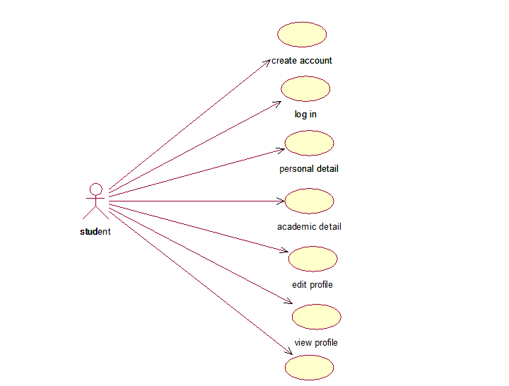
Fig 5.2 User operations – Use case Diagram of student

Actor name : students
Description : The students who logins for doing his operations.
Use case name : Login
Description : The students interacts with the placement management system by going through login after the login student can perform the required operations of the application he is allowed to perform.
Use case name : personal detail
Description : The student can add their personal detail of the academic for the placement.
Use case name : academin detail
Description: The student can add their academic detail for the placement.
Use case name: edit profile
Description: The student can edit for the required changes in his/her detail.
Use case name: view profile
Description: The students can view their profile as well as other details like test schedule, company information, selected students etc.
Use case name: logout
Description: The students return after completion.

Use case for Admin
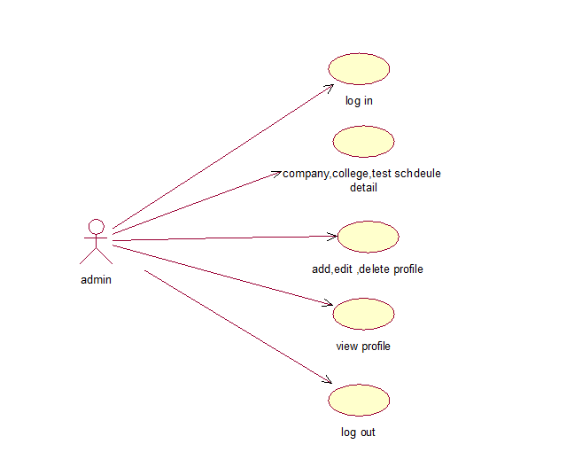
Fig 5.3 admin– Use caseDiagram

Actor name: admin
Description: The admin has all the privilege to access the profile or edit or delete.
Use case name: company, college, test schedule detail (all sub modules)
Description: admin can add the details of the company, student, test schedule etc, as well as he can edit and delete the profiles too.
Use case name: add, edit, delete, view profile
Description: admin can add, delete and view either details of student and company,
Use case name: logout
Description: The admin returns after completion.

5.2.2 Sequence Diagram

UML sequence diagrams model the flow of logic with in your system in a visual manner, enabling you both to document and validate your logic, and we are commonly used for both analysis and design purposes. Sequence or most popular UML artifact for dynamic modeling, which focus on identifying the behavior within your system. Other dynamic modeling techniques include Activity Diagrams, timing diagram and interaction viewing diagram. The sequence diagram, along with class diagram and physical data models are in my opinion the most important design- level model for the modern business application development.[6]

Object class 1
Object class 1
Object class 1

Fig 5.5 Sequence Diagram Representation

Sequence diagram for Pool Campus Management System

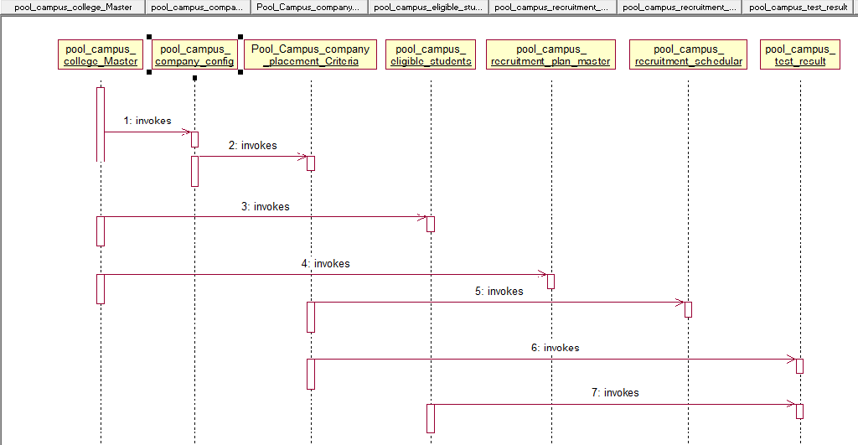

Fig 5.6 Pool Campus – sequence diagram

Sequence diagram for Report Generation

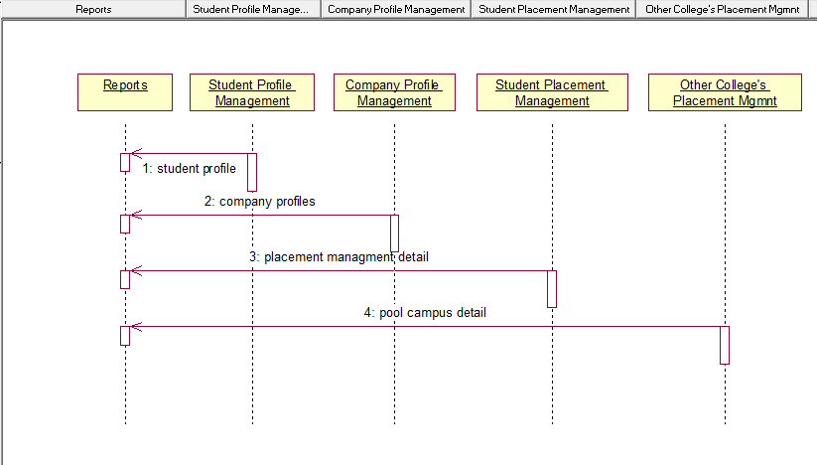
Fig 5.7 Report Generation – sequence diagram
The students and admin can generate the report using search criteria.
.
5.2.3 State chart Diagram
State chart diagram are used to describe the behavior of a system State chart diagram all of the possible state of an object as events occur. Each diagram usually represents objects of a single class and tracks the different state of its objects through the system.

State chart diagram are used to demonstrate the behavior of an object through many cases of the system. It is suggested to use the state chart diagrams for the classes where it necessary to understand the behavior of the object through the entire system. Not all the cases will require a state chart diagram and state chart diagram are not useful in describing the collaboration of all objects in a use case. State chart diagrams can be combined with other diagram like activity diagram and interaction diagram. [6]
State of the system
State of the system

Fig 5.11 State chart diagram representation

State chart diagram for login



Fig 5.12 Login – state chart diagram

If valid user then he can view the details.

State chart diagram for user operations

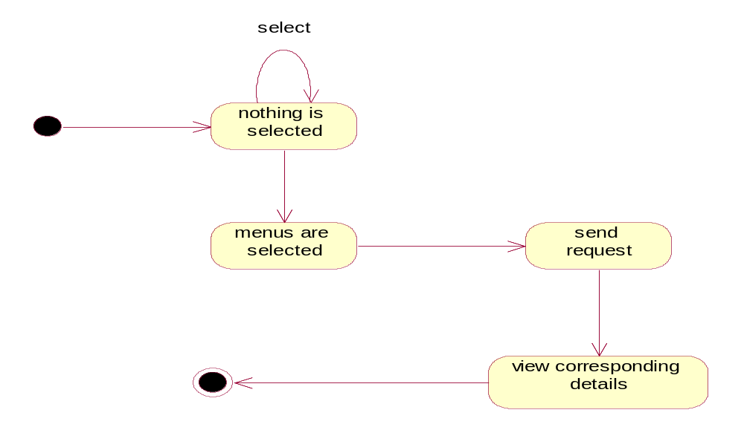
Fig 5.13 user operations – state chart diagram
5.3 MODULE DESIGN
The Student Placement Management System consists of different modules as shown below in the figure:

Module - Pool Campus Management
Manage Other College Detail
Enquiry
Main Menu
Student details of other college

Upload college/student details

Schedule written test round

Enter written test result

Next Round intimation

Schedule Gd round

Enter GD round Result

Schedule Final HR Round

Final Selected Student

Fig: 5.14 Pool Campus Student Detail

Other College Placement Management:
For Admin:
- Manage Other College’s Details: The Admin can add, edit and Delete other colleges’ details who are participating in the placement drive being conducted at the parent college
- Manage Students’ Details of other colleges: The Admin can add, edit and delete details of Students coming from other colleges to participate in the Placement Drive
- Upload other College/ Student details: The Admin can upload the details of other colleges and/or students of other colleges
For Placement Officer:
- Schedule Written Test Round: The Placement Officer should schedule the written test round for an already added company. Once the test is scheduled and finalized, an email will be generated and sent to other colleges’ placement office
- Enter Written Test Result: On finishing of any rounds of written Test, the Placement Officer will either upload an excel sheet containing the list of successful candidates or enter manually for each student of other colleges.
- Next round Intimation (Technical): On completion of written rounds, the Placement Officer should intimate other colleges with list of eligible students for the next round (if any), entering the test dates and other required details.
- Schedule GD Round: On completion of all the configured technical rounds for the company, the Placement Officer can schedule the GD round if it is configured and an intimation to other colleges with list of eligible candidates should be emailed
- Enter GD Round Results: On completion of GD round, the Placement Officer will enter the results by either uploading an excel sheet containing the list of successful candidates or by entering the details manually
- Schedule Final HR Round(s): On completion of all the configured tests for the company the Placement Officer will schedule the HR Round(s) for the eligible candidates. An email will be generated and sent to other colleges with the list of eligible candidates
- Enter Final Selected Students: On completion of all the rounds the Placement Officer will enter the list of all successful candidates. All the other colleges will be intimated with the list of successful candidates

Module – Report Generation

Main Menu
For Admin

For Placement Officer

For Teachers/HOD’s

For Students

Fig: 5.15 Report Generation

Reports Generation
For Admin:
- List of already added departments, courses and subjects with search criterion on Department, Course and Subjects
- List of students with search criterion on USN, Name, DOB, Department, Course
- List of Teachers/HODs with search criterion on Name, Department, Date Of Joining, Subject
- List of Companies with search criterion on Company Name, Department, Academic Year
- Placement Test Plan with search criterion on Company, Date, Department, Test Type (Written, Technical etc)
- List of Students eligible for placement drive with search criterion on USN, Name, Department, Status (Appeared, cleared, not appeared etc.)
- List of students selected with search criterion on Academic Year, Company, Department, Course etc.
- Attendance report of Students with search criterion on USN, Department, Course, Subject, Teacher
- List of Other colleges participated in the Placement Drive with search criterion on Date, Year, Company
- List of Successful students from Other Colleges participated in the Placement Drive with search criterion on College, Company, Year, Test Type ( Written, Interview etc.), Result( qualified, not qualified)
For Placement Officer:
- List of Companies with search criterion on Company Name, Department, Academic Year
- Placement Test Plan with search criterion on Company, Date, Department, Test Type (Written, Technical etc)
- List of Students eligible for placement drive with search criterion on USN, Name, Department, Status (Appeared, cleared, not appeared etc.)
- List of students selected with search criterion on Academic Year, Company, Department, Course etc.
- List of Other colleges participated in the Placement Drive with search criterion on Date, Year, Company
- List of Successful students from Other Colleges participated in the Placement Drive with search criterion on College, Company, Year, Test Type ( Written, Interview etc.), Result( qualified, not qualified)
For Teachers/HODs:
- List of students with search criterion on USN, Name, DOB, Department, Course
- List of Teachers/HODs of their respective department with search criterion on Name, Date Of Joining, Subject
- List of Companies associated with their respective departments with search criterion on Company Name, Academic Year
- Placement Test Plan for companies associated with their respective departments with search criterion on Company, Date, Test Type (Written, Technical etc)
- List of Students of their respective departments eligible for placement drive with search criterion on USN, Name, Status (Appeared, cleared, not Appeared etc.)
- Number of students of their department selected with search criterion on Academic Year, Company, Course etc. (Graph or Chart)
- Attendance report of Students of their respective departments with search criterion on USN, Course, Subject, Teacher
For Students:
- List of companies scheduled for Placement test for their department with search criterion on Name, Date
- List of companies, the student in eligible for
- Placement test plan for the companies, the student is eligible for, with search criterion on Company name, Date
- Attendance report for the student with search criterion on Subject

5.4 DATABASE DESIGN
The Project has been designed around these tables. The structure for all database tables has been given here. It contains relevant constraint.
Pool Campus Company Master

Field Name | Data Type | Size | Description | Modifiers
PoolCampusCompanyId | Int |  | System generated, primary key
CollegeName | Int |  | Foreign Key
CollegeAddress | Varchar | 50 | Foreign Key | Not null
ContatNumber | Float |  | Percentage of respective class or course | Not null
Is_Active | Int |  | Default value is one
Updated_Date | Datetime |  | Date of last time updated data
Updated_By | Varchar | 20 | Who has access
Fig: 5.15 Pool Campus Company Master

Pool Campus Placement criteria

Fig : 5.16 Pool Campus Placement Test Criteria

Field Name | Data Type | Size | Description | Modifiers
PoolCampusPlacemetnId | Int |  | System generated, primary key
PoolCampusCompanyId | Int |  | Foreign Key
CutOfType | Varchar | 50 | Foreign Key
CutOfTenth | Varchar | 50 | Percentage of respective class or course
CutOfTwelth | Varchar | 50
CutOfDegree | Varchar | 50
BackLogAllowed | Bit |  | Backlog Allowed True or False
GapInYearsAllowed | Bit |  | True or False
Updated_Date | Datetime |  | Date of last time updated data
Updated_By | Varchar | 20 | Who has access

Pool Campus Eligible Students

Field Name | Data type | Size | Description | Modifiers
USN | Varchar | 20 | Student university number, primary key
Password | Varchar | 50 | Giving password for student own account | Not null
First _Name | Varchar | 50 | Student first name
Middle_Name | Varchar | 50 | Student father name
Last_Name | Varchar | 50 | Student Surname
Gender | Varchar | 30 | Choose gender
Phone | Varchar | 20 | Student Contact number
Email | Varchar | 50 | Student Email Id | Not null
DepartmentId | Int |  | Super Admin generated department id, foreign key
CollegeId | Int |  | Super Admin generated college id, foreign key
CourseId | Int |  | Super Admin generated Course id, foreign key
Date_Of_Birth | Datetime |  | Birth date of student | Not null
Present_Address | Varchar | Max | Student detail present address
Permenant_Address | Varchar | Max | Student detail permanent address
Gap_In_Studies | Bit |  | To know whether gap in study or not | Not null
Gap_In_Study_Id | Int |  | Gap in study id | Not null
Is_Verified | Int |  | Default value is zero
Is_Active | Int |  | Default value is one it use for security.
Updated_Date | Datetime |  | Date of last time updated data
Updated_By | Varchar | 20 | Who has access
LoginType | Varchar | 20 | Select login type
Fig : 5.17 Pool Campus Eligible Students

Field Name | Data Type | Size | Description | Modifiers
PoolCampusRecruitmentResultId | Int |  | System generated, primary key
PoolCampusPlacementTestId | Int |  | Foreign Key
StudentId | Varchar | 50 | Foreign Key | Not null
Description | Float |  | Percentage of respective class or course | Not null
Is_Active | Int |  | Default value is one
Updated_Date | Datetime |  | Date of last time updated data
Updated_By | Varchar | 20 | Who has access
Pool Campus Placement Test Result

Fig :5.18 Pool Campus Placement Test Result

Pool campus company configuration

Fig :5.17 Pool campus company configuration
Field Name | Data Type | Size | Description | Modifiers
PoolCampusCompanyPlacementId | Int |  | System generated, primary key
PoolCampusCompanyCollegeId | Int |  | Foreign Key
CompanyId | Varchar | 50 | Foreign Key | Not null
DepartmentId | Float |  | Percentage of respective class or course | Not null
Is_Active | Int |  | Default value is one
Updated_Date | Datetime |  | Date of last time updated data
Updated_By | Varchar | 20 | Who has access
Pool Campus company master
Fig: 5.18 Pool Campus company Master

Field Name | Data Type | Size | Description | Modifiers
PoolCampusPlacemetnId | Int |  | System generated, primary key
PoolCampusCompanyId | Int |  | Foreign Key
TestDate | Varchar | 50 | Foreign Key | Not null
TestStatus | Float |  | Percentage of respective class or course | Not null
Is_Active | Int |  | Default value is one
Updated_Date | Datetime |  | Date of last time updated data
Updated_By | Varchar | 20 | Who has access
Pool Campus Test Schedule

Fig: 5.19 Pool campus Test schedule
Field Name | Data Type | Size | Description | Modifiers
PoolCampusPlacemetnId | Int |  | System generated, primary key
PoolCampusCompanyId | Int |  | Foreign Key
TestTypeId | Varchar | 50 | Foreign Key | Not null
Description | Float |  | Percentage of respective class or course | Not null
Is_Active | Int |  | Default value is one
Updated_Date | Datetime |  | Date of last time updated data
Updated_By | Varchar | 20 | Who has access

5.4.1 E-R Diagram

Entity Relationship Diagrams are a major data modeling tool and will help organize the data in the project into entities and define the relationships between the entities.

Entity: A data entity is anything real or abstract about which we want to store data.

Relationship: A data relationship is a natural association that exists between one or more entities. Cardinality defines the number of occurrences of one entity for a single occurrence of the related entity.

Attribute: A data attribute is a characteristic common to all or most instances of a particular entity. A attribute or combination of attributes that uniquely identifies one and only instance of an entity is called a primary key.

m
m
STUDENTS
issue
update
SERVER
ADMIN
have
REQUEST
OTHE COLLEGE DETAIL
SERVER
update
STATEMENTS
refer to
m
m
1
1
n
n
Fig 5.20 – ER Diagram

5.5 SCREEN SHOTS
Login Page
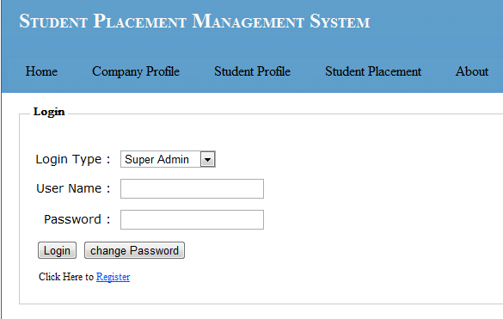
Fig: 5.21 Login page

Register Page For Login(New User)
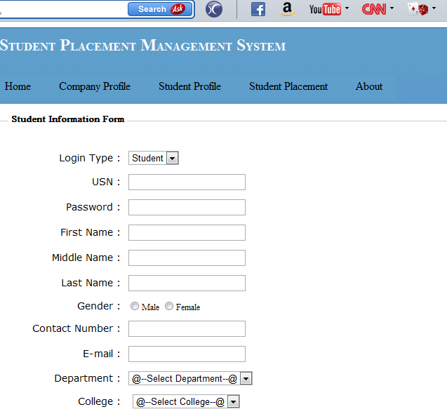

Fig: 5.22 Register page for login

Home Page
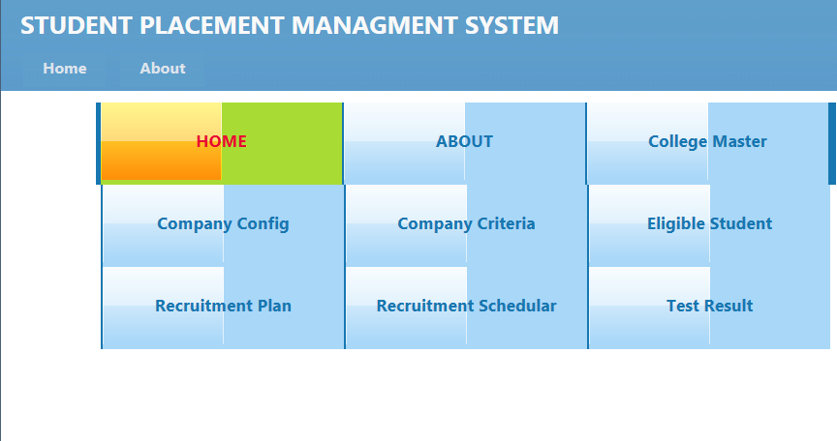
Fig: 5.23 Home Page
Pool Campus Company Master
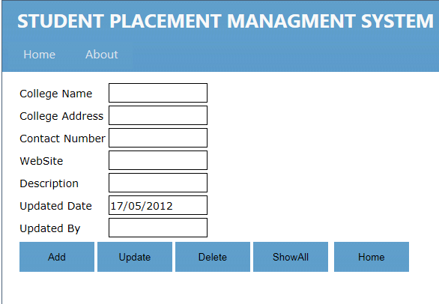

Fig: 5.24 pool campus company config
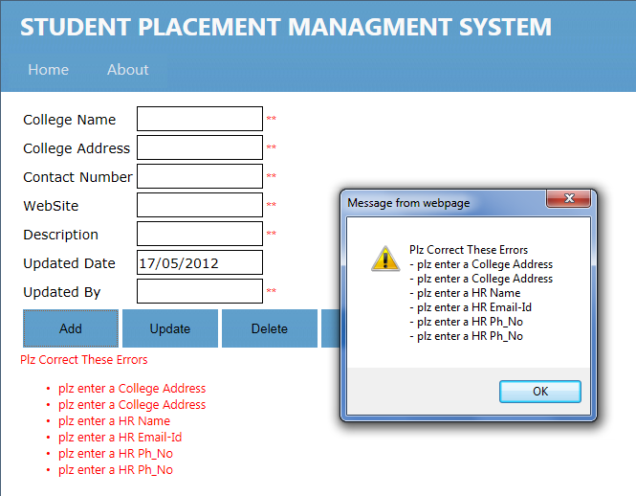

Fig: 5.25 pool campus company config validation
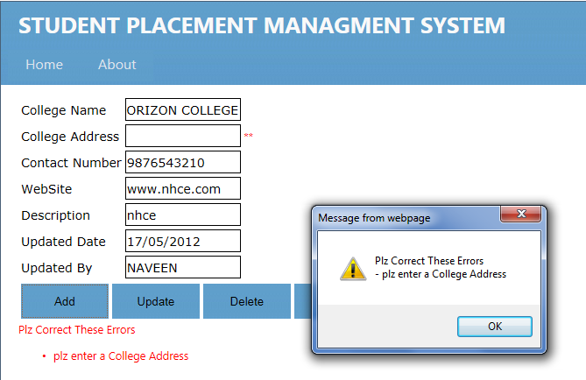
Fig: 5.26 Pool campus company config validations
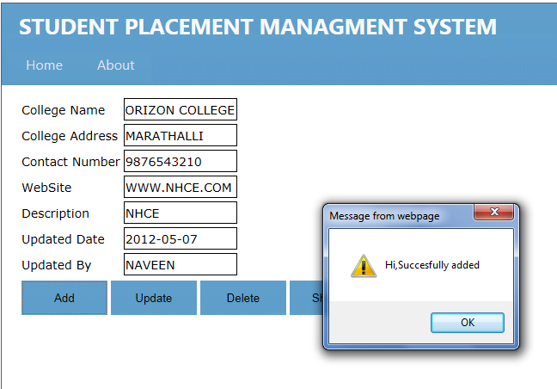
Fig: 5.27 PCCC Adding Data

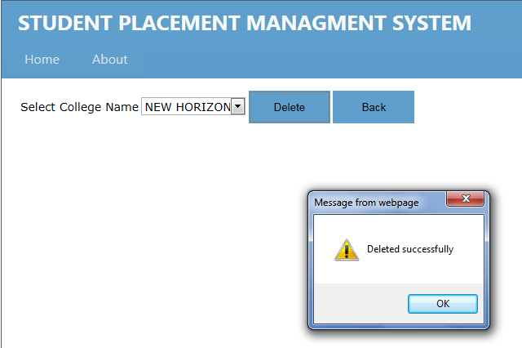
Fig: 5.28 pccm deleting data

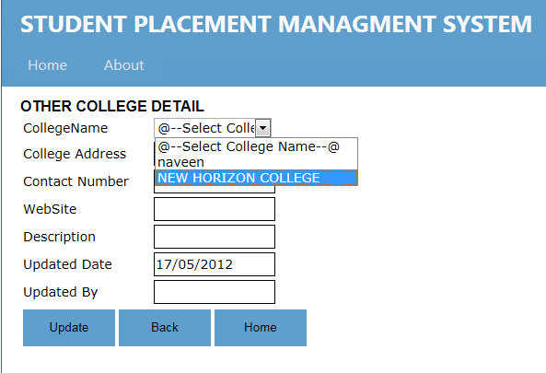
Fig: 5.29 updating PCCM
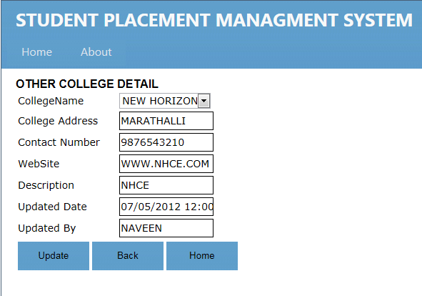
Fig: 5.31 Updated PCCM

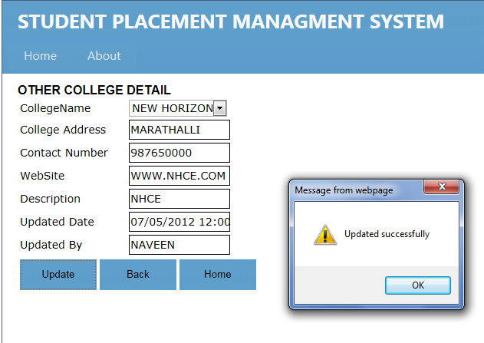
Fig: 5.30 PCCM Updated Successful
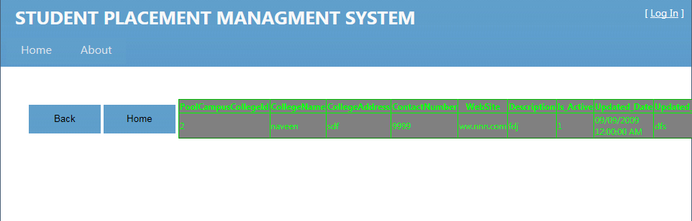
Fig: 5.32 Show Values of Added Data in PCCM

Pool Campus Company Configuration
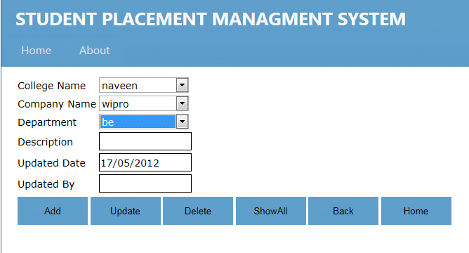

Fig: 5.33 pool campus company config

POOL CAMPUS ELIGIBLE STUDENTS
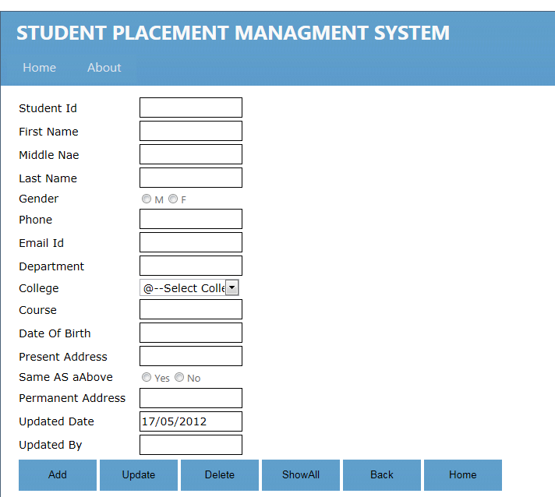
Fig: 5.34 Eligible students

POOL CAMPUS PLACEMENT CRITERIA

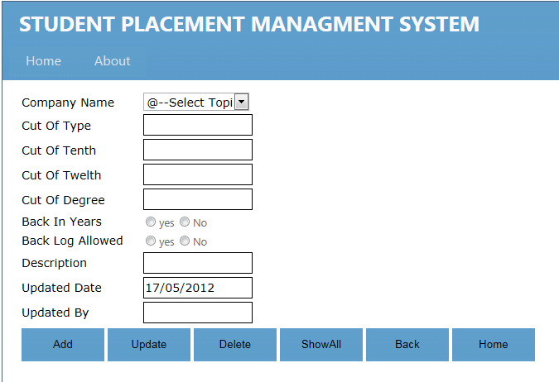
Fig: 5.35 pool campus placement criteria

POOL CAMPUS RECRUITMENT PLAN MASTER
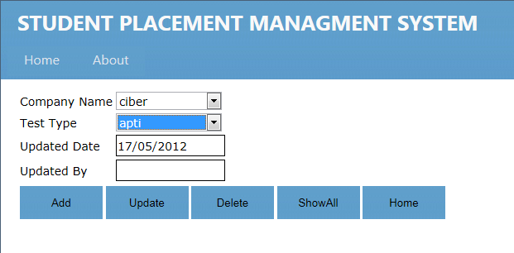
Fig: 5.36 pool campus recruitment plan master

POOL CAMPUS RECRUITMENT SCHEDULE
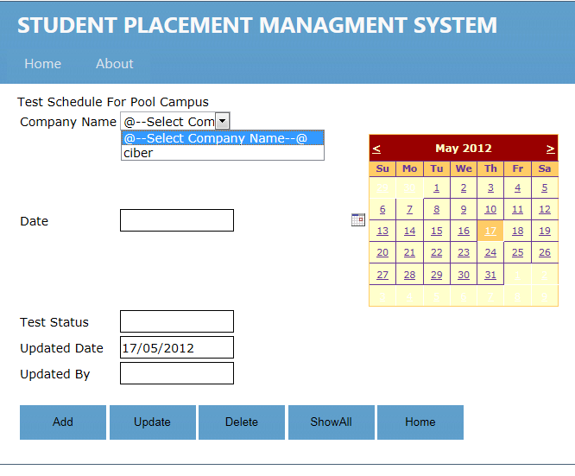 Fig: 5.37 schedule pool campus master

POOL CAMPUS RERUITMENT TEST RESULT
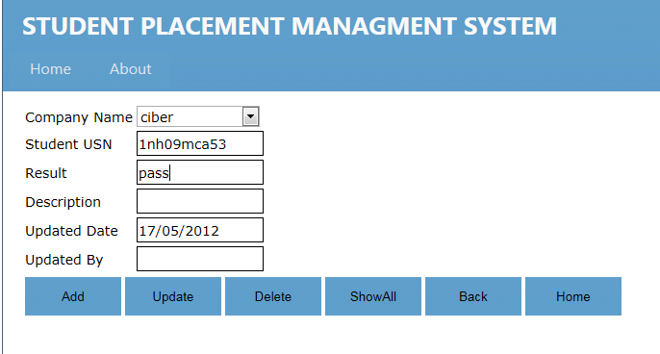
Fig: 5.38 Pool campus Recruitment test result

SCREEN SHOTS OF CRYSTAL REPORT GENERATION

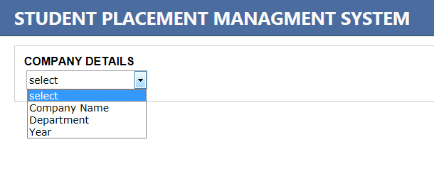
Fig: 5.39 crystal report search criteria

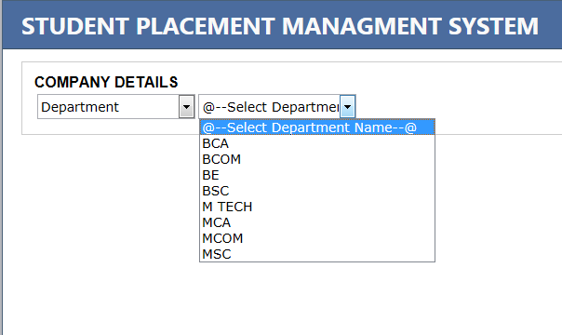
Fig: 5.40 showing search criteria
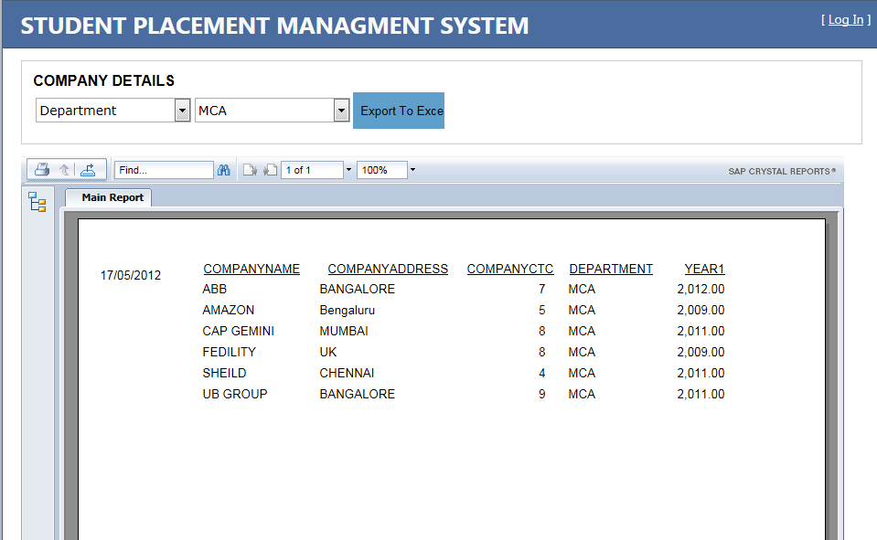
Fig: 5.41 report generation

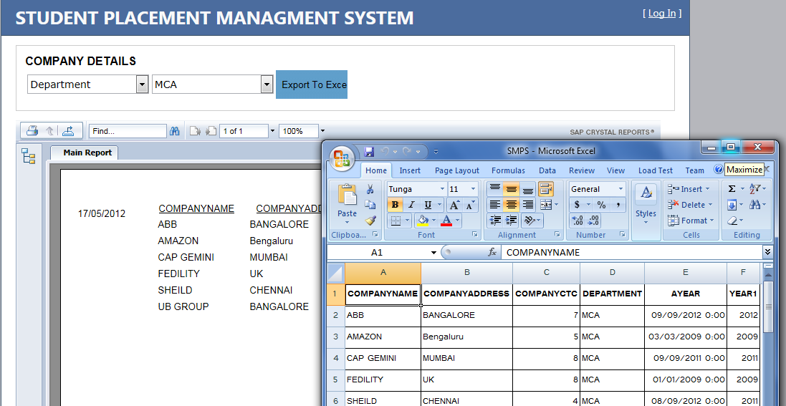

Fig: 5.42 Exporting To Excel
CHAPTER 6

SYSTEM TESTING

Testing is the process of exercising software to verify that it satisfies specified requirements and to detect faults by the measurement of software.

This system can be tested in different ways. Valid and invalid data should be created and the programs should be made to process the data to catch errors. In the system, testing can be performed for the validity of data or for the type of data or for the type of data. All conditions present in the program should be tested. Before proceeding one must sure that all the programs are working independently. [8]

6.1 Unit Testing
Testing of units may be carried out first by specification of units. Units may be user interfaces, inputs-outputs and program sources. After recognition of units, test cases are written so as to test each unit, for its correctness and accordance with specification. [8]

6.2 Integration Testing
As the components are constructed and tested they are then linked together to check if they work with each other. It is a fact that two components that have passed their entire test, when connected to each other produce one new component full of faults.

6.3 Validation Testing
In validation testing, the functionality of each of the software components needs to be tested, without knowing the inner details of implementation. All these things are clubbed in the single document and the different test cases are explained below: [8]

Test cases

S.No | Input | Expected Result | Passed/Failed | Actual result
1 | Enter wrong user name Or password in login page | Display invalid password Or user name | Passed | Same as expected result
2 | Without entering user name and password in login page | Display a warning instructing to enter user name and password | Passed | Same as expected result
3 | Entering correct password and user name | Open the home page | Passed | Same as expected result
4 | Choosing Tree view structure of Student Profile | Opens login page | Passed | Same as expected result
5 | Choosing Tree view structure opens after successful login | Opens the home page with menu items details in list format | Passed | Same as expected result
6 | Choosing Administrator from menu list | Opens the admin home page with tab menu format | Passed | Same as expected result
7 | Choosing Student from menu list | Opens the student home page with tab menu format | Passed | Same as expected result
8 | Choosing Teachers/HODs from menu list | Opens the teachers/HODs home page with tab menu format | Passed | Same as expected result
9 | If any field is empty while filling the information | Display message “please fill all the fields” | Passed | Same as expected result
10 | Choosing Super Admin from menu | Open Login form if login successful then super admin home page will open otherwise error message will display | Passed | Same as expected result

Table 6.1 Test Cases

CHAPTER 7

CONCLUSION

The fundamental goal of developing a system is the conformance to requirement specified. This goal is achieved after the implementation of the system. The system is efficient enough to carry out the task it was originally intended to do. The manpower requirement has been reduced and the tasks to be completed are just a few clicks away.

This system is designed with care to be high user oriented and thus the system was successfully developed and it satisfies the need of the user i.e. Customer. This system is highly flexible and can be used in organization with internet facility. This system is tested perfectly that it can work with the proper input. Error message will be displayed if any unrelated data is entered.

7.1 FUTURE ENHANCEMENTS

“Placement Management” system future enhancement will concentrate towards application integration with overall education software system. Further, menu structures such as Slide In menu, Windows XP menu style will be included to enhance the software usability.

7.2 MAINTENANCE
A system should be created whose design is comprehensive and farsighted enough to serve current and projected user for several years to come. Part of the analyst’s expertise should be in projecting what those needs might be in building flexibility and adaptability into the system. The better the system design, the easier it will be to maintain and the maintenance costs is a major concern, since software maintenance can prove to be very expensive.

It is important to detect software design errors early on as it is less costly than if errors remain unnoticed until maintenance is necessary. Maintenance is performed most often to improve the existing software rather than to respond to crisis or system failure. As user requirements change, software and documentation should be changed as part of the maintenance work. Maintenance is also done to update software in response to the change made in an organization. This work is not as substantial as enhancing the software, but it must be done. The system could fail if the system is not maintained properly.

Software maintenance is of course, far more than finding mistakes. We may define maintenance by describing by four activities that are undertaken after program is released for use.

The first maintenance activity occurs because it is unreasonable to assume that software testing will uncover all later errors in a software system. During the use of any large program, errors will occur and be reported to the developer. The process that includes the diagnosis and correction of one or more errors is called corrective maintenance.

The second activity that contributes to a definition of maintenance occurs because of the rapid change that is encountered in every aspect of the computing. Therefore adaptive maintenance- an activity that modifies software to properly interface with a changing environment is both necessary and commonplace.

The third activity that may be applied to definition of maintenance occurs when a software package is successful. As the software is used, recommendations for new capabilities, modifications to existing functions, and general enhancements are received from users. To satisfy requests in the category perfective maintenance is performed. This activity accounts for the majority of all effort expanded on software maintenance.

The fourth maintenance activity occurs when software is changed to improve future maintainability or reliability, or to provide a better basis for future and enhancements. Often called preventive maintenance, this activity is characterized by reverse engineering and re-engineering techniques.

CHAPTER 8

BIBILOGRAPHY
  - BOOKS

[1] Beginning ASP.NET 4: in C# by Imar Spaanjaars VB O’Reilly Publications
[2]Complete Reference: by heilbert schield
[3] Pro ASP.NET in C# by Matthew MacDonald, Adam Freeman 2010
[4] George Coach& Kevin Lonely, Oracle 9i the Complete Reference, Oracle Press Publication, 2001
[5] ASP.NET Unleashed by Stephen Walther, Kevin Hoffman, Nate Dudek.
[6] Asp.net Wikipedia article.
[7] PHP and MySQL for Dynamic Web Sites: Visual QuickPro Guide
[8]Automated software testing by Elfriede Dustin, Jeff Rashka, John Paul

8.2 WEBSITES

[1] www.asp.net/
[2] http://msdn.microsoft.com/en-us/library/dd566231.aspx
[3] http://en.wikipedia.org/wiki/JavaScript
[4] http://www.w3.org/Style/CSS/Overview.en.html
[5] http://developers.sun.com/scripting/javascript/
[6]http://wikipedia/article/asp/pcm/
[7] http://oracle/mssql/r2/
[8] http:// en.wikipedia.org/wiki/Software_testing/

