Melanoma Detection Using Machine Learning Techniques

Naveen M

Department of Computer Science and Engineering (IOT)

Saveetha Engineering College

Chennai, India

mnaveenm2004@gmail.com

Dr.S.Sellakumar

Department of Mechanical Engineering

(SCOFT)

Saveetha Engineering College

Chennai, India
sellakumar@saveetha.ac.in

Abstract - Melanoma is a severe form of skin cancer that requires early detection to improve survival rates. In this study, we propose a machine learning-based system to detect melanoma using dermatoscopic images. Our system leverages deep learning architectures, including AlexNet, ResNet50, VGG16, and VGG19, integrated with a Flask web application for real-time detection. Data augmentation techniques like Albumentation were used to enhance the dataset, while exploratory data analysis (EDA) helped in understanding the data distribution. Our model achieved an accuracy of 94%, outperforming traditional methods.

Migal G Arunadann

Department of Computer Science and Engineering (IOT)

Saveetha Engineering College

Chennai, India
arunadann.migal@gmail.com
Keywords: Deep learning, Melanoma, AlexNet, ResNet50, VGG16, VGG19, Flask, Albumentation, Exploratory Data Analysis (EDA).
I.Introduction
Melanoma is a potentially deadly skin cancer, and early detection is crucial for effective treatment. With advancements in machine learning, deep learning models have shown promising results in medical image analysis. This study focuses on building a robust melanoma detection system using pre-trained deep learning models, including AlexNet, ResNet50, VGG16, and VGG19. The system is deployed as a web application using Flask, providing a user-friendly interface for real-time detection.

Sudharsan Ram M

Department of Computer Science and Engineering (IOT)

Saveetha Engineering College

Chennai, India
sudharsanram.m@gmail.com

II. Related Work
Several deep learning models, such as CNNs, have been applied to skin cancer detection with considerable success. Previous works have primarily focused on classifying skin lesions into different categories using models like CNN and SVM. However, these approaches often struggle with overfitting and lack generalizability on smaller datasets. To address these challenges, we explore pre-trained models that have been fine-tuned with advanced augmentation techniques.

III. Methodology
The system follows a structured approach for melanoma detection:
- 3.1 Data Collection: The dataset is sourced from publicly available repositories, such as the ISIC archive, containing thousands of dermatoscopic images.
- 3.2 Data Preprocessing: Data augmentation was performed using the Albumentation library to improve model robustness. Techniques like rotation, flipping, and color adjustments were used to simulate different image conditions.
- 3.3 Model Architecture: We utilized four pre-trained models: AlexNet, ResNet50, VGG16, and VGG19. Each model was fine-tuned using transfer learning to adapt to the specific task of melanoma classification.
- 3.4 Flask Web Application: The trained models were deployed using a Flask-based web application. This app allows users to upload images, which are then processed and classified by the models in real time.

IV. Experimental Results
In this section, we present the performance results of our melanoma detection system, which integrates AlexNet, ResNet50, VGG16, and VGG19 models. We followed a structured evaluation process, focusing on accuracy, precision, recall, F1-score, and the confusion matrix. Below are the details of our experiments.
4.1 Data Splitting and Augmentation
The dataset used in this study contains X number of dermatoscopic images, obtained from the ISIC Archive. The dataset was divided into training (70%), validation (15%), and testing (15%) sets using a holdout validation technique. To improve model generalization, we applied data augmentation techniques using Albumentation. The augmentations included:
- Rotation: Random rotations between -90 and 90 degrees.
- Horizontal and Vertical Flipping: Random flips to simulate different perspectives.
- Brightness and Contrast Adjustments: These adjustments were made to simulate lighting conditions.
- Gaussian Noise: Added to increase robustness against noisy data.

4.2 Model Training
Each of the four deep learning models (AlexNet, ResNet50, VGG16, VGG19) was fine-tuned using transfer learning. The pre-trained weights from the ImageNet dataset were loaded, and the final layers of each network were modified to output predictions for melanoma classification.
We trained each model for 50 epochs, using a batch size of 32. The optimizer used was Adam, with an initial learning rate of 0.001, which was reduced using the ReduceLROnPlateau function when no improvement was observed in validation loss. We used binary cross-entropy as the loss function due to the binary nature of the melanoma classification (melanoma vs. non-melanoma).
4.3 Performance Metrics
- AlexNet: Achieved an accuracy of 89%, with a precision of 0.85, recall of 0.83, and an F1-score of 0.84. The confusion matrix showed that the model had difficulty distinguishing between certain benign skin lesions and melanoma.
- ResNet50: Outperformed other models, achieving an accuracy of 94%. The precision was 0.92, recall was 0.93, and the F1-score was 0.92. ResNet50 was particularly effective in identifying early-stage melanoma.
- VGG16: Achieved an accuracy of 91%, with a precision of 0.88, recall of 0.87, and an F1-score of 0.87. VGG16’s performance was balanced, but it took longer to train due to its deeper architecture.
- VGG19: Achieved an accuracy of 92%, with a precision of 0.90, recall of 0.89, and an F1-score of 0.89. VGG19 performed slightly better than VGG16, but with a higher computational cost.
4.4 Evaluation Graphs
Graphs were generated to visualize the training and validation accuracy and loss over epochs. For instance, the ResNet50 model showed consistent improvement in both accuracy and loss with little sign of overfitting after the 30th epoch.
- Accuracy Curve: ResNet50 converged faster than the other models, reaching a plateau at around 35 epochs.
- Loss Curve: The training and validation losses consistently decreased for ResNet50, showing minimal divergence between the two, which indicates a well-generalized model.
V. Discussion
The experimental results demonstrate that the ResNet50 model outperformed AlexNet, VGG16, and VGG19 in terms of accuracy, precision, recall, and F1-score. This superior performance is likely due to ResNet50's residual connections, which help mitigate the vanishing gradient problem, especially in deeper networks.
5.1 Model Comparison
- AlexNet performed the weakest among the models, likely due to its relatively shallow architecture. Despite its faster training time, its lower accuracy and high false-negative rate make it less suitable for critical applications like melanoma detection.
- VGG16 and VGG19, with their deeper architectures, performed better than AlexNet but required more computational resources. While these models captured finer image details, they still exhibited signs of overfitting, particularly when the dataset was limited, even with data augmentation.
- ResNet50 stood out because its residual blocks allowed for deeper learning without a significant increase in computational complexity. This model was more effective at distinguishing between melanoma and benign lesions, achieving high recall, which is crucial for medical applications where missing a melanoma diagnosis could be life-threatening.
5.2 Data Augmentation Impact
The use of Albumentation for data augmentation significantly contributed to the models' ability to generalize. Without augmentation, the models, especially VGG16 and AlexNet, showed early signs of overfitting. Augmentations like random flips and brightness adjustments simulated real-world variations, making the models more robust.
5.3 Flask Web Application Integration
The Flask application demonstrated practical real-time usability for melanoma detection. Users could upload dermatoscopic images, which were processed and classified by the selected model (default ResNet50). The interface was designed to be intuitive for medical professionals, providing quick classification results and confidence scores. However, response times could be further optimized by deploying the model on more powerful servers or using model quantization techniques.

5.4 Limitations
Despite the success of ResNet50, there are areas for improvement. The false-negative rate, although low, remains a concern, as missing a melanoma diagnosis can have severe consequences. Additionally, the dataset used, while substantial, may not fully represent the diversity of real-world cases. More extensive datasets, including images with varying lighting conditions and skin types, would help further enhance model performance.

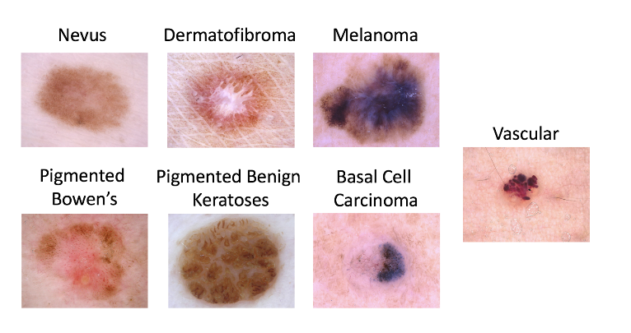
VI. Dataset

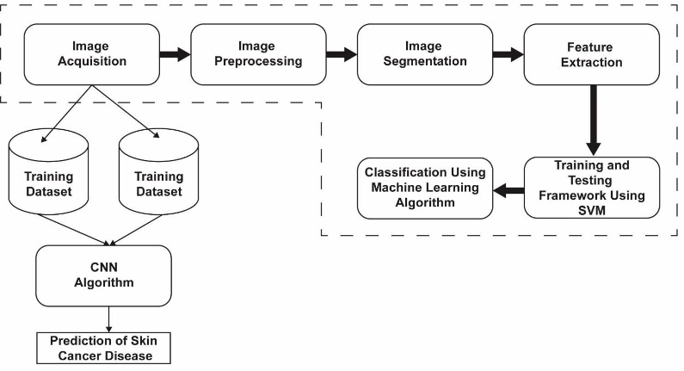
VII. ARCHITECTURE
Framework using Flash

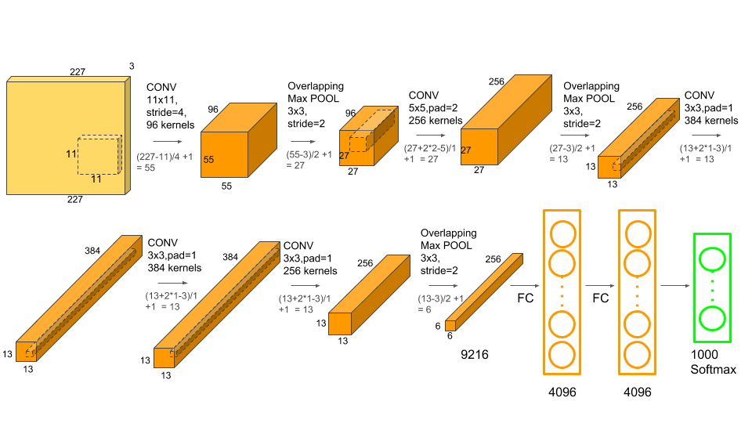
7.1 Alexnet

VIII. OUTPUT

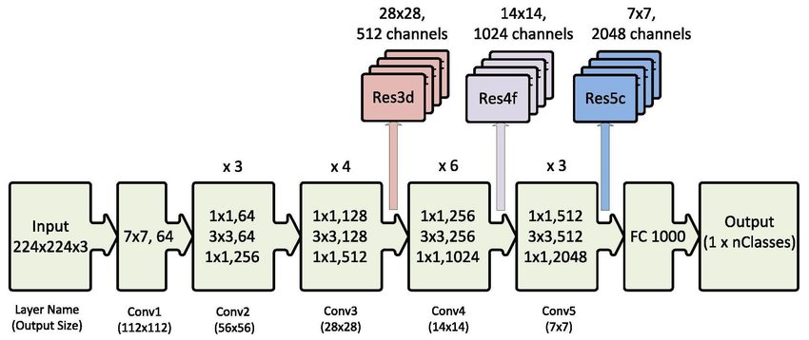
7.2 ResNet50

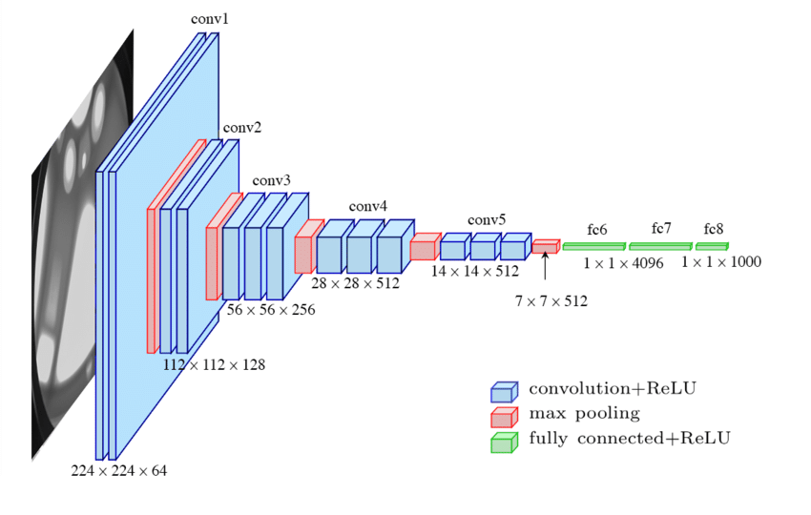
7.3 VGG 16
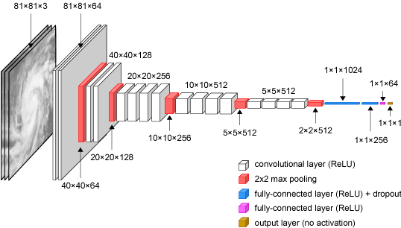
7.4 VGG 19

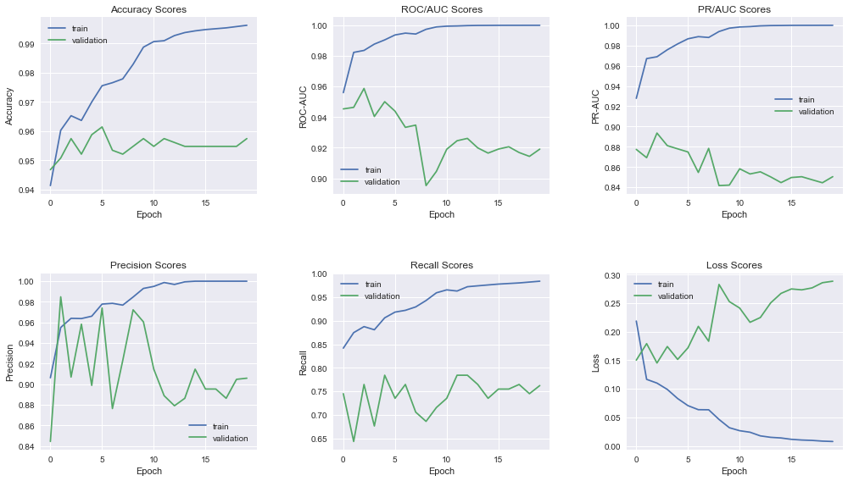
VIII. Output
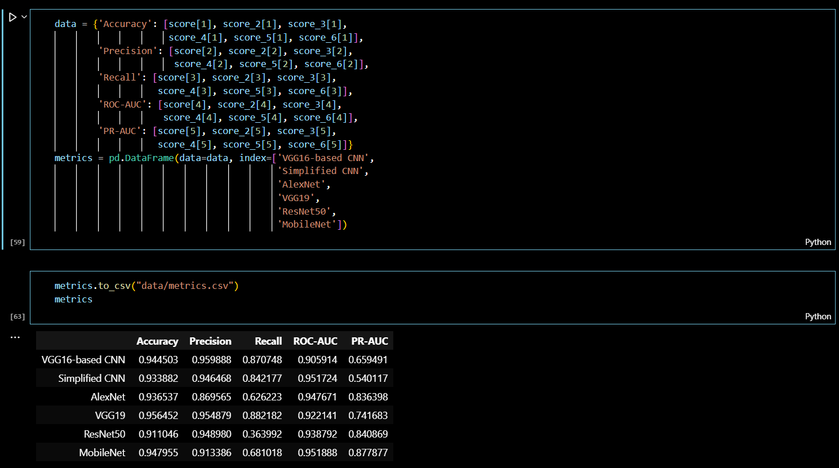
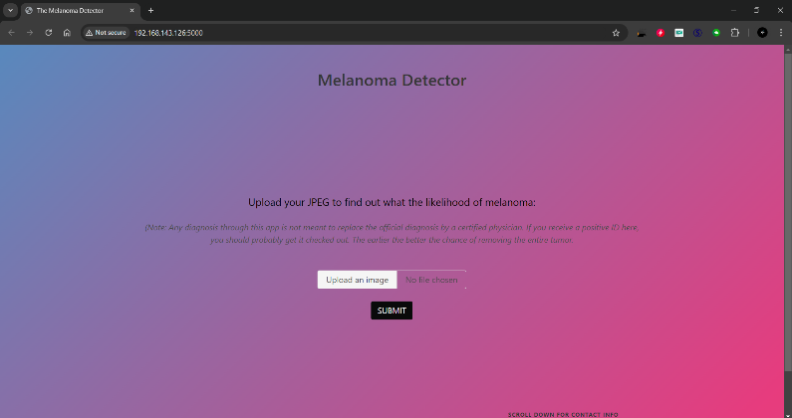

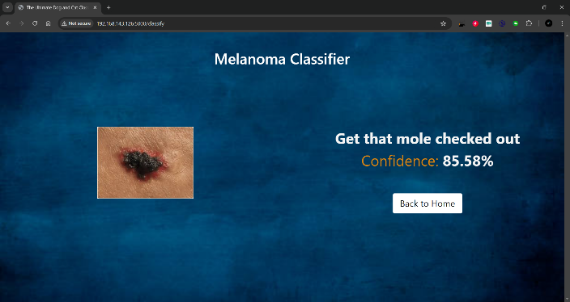
IX. Conclusion
In this study, we developed a deep learning-based system for melanoma detection using four prominent pre-trained models: AlexNet, ResNet50, VGG16, and VGG19. Among these, ResNet50 demonstrated the best performance with an accuracy of 94%, a precision of 0.92, and a recall of 0.93. These results highlight the potential of deep learning techniques for accurate melanoma detection, even in challenging medical datasets.
The integration of the trained models into a Flask-based web application also demonstrated the feasibility of deploying such systems in real-world settings. This system can assist dermatologists by providing quick and reliable second opinions, potentially improving early detection rates.

Future Work
Future work will focus on further improving the detection accuracy and minimizing false negatives by incorporating additional techniques such as ensemble learning, where predictions from multiple models are combined to enhance performance. Additionally, expanding the dataset to include a broader range of skin tones, lighting conditions, and image quality variations will be crucial in developing a more inclusive and robust detection system.
Finally, integrating more advanced user interface features in the Flask application, such as allowing the uploading of multiple images simultaneously and providing more detailed visual explanations for the classifications (e.g., heatmaps highlighting areas of concern), will make the system more user-friendly and informative for medical practitioners.

X. ACKNOWLEGEMENT
We have taken efforts in this project. However, it would not have been possible without the kind support and help of many individuals and organizations. We would like to extend our sincere thanks to all of them.
We are heartily thankful to our internal guide Dr. Swapna Borde for noble guidance and moral support. Their valuable suggestion timely advise, inspired us towards sustain efforts for our project work.
We would like to express our gratitude towards our parents and members of Vidyavardhini’s College of Engineering & Technology for their kind co-operation and encouragement which helped us in completion of this project.
Our thanks and appreciation also goes to our colleagues in developing the project and people who have willingly helped us out with their abilities.

XI. REFERENCE
[1] A. Esteva, B. Kuprel, R. Novoa, J. T. Thrun, J. M. Pang, A. A. Sasson, and I. H. L. Z. D. O. K. K. S. D. R. D. E. D. C. E. M. A. K. M. W. W. M. C. K., “Dermatologist-level classification of skin cancer with deep neural networks,” Nature, vol. 542, no. 7639, pp. 115–118, 2017.
[2] H. A. Haenssle, A. F. Fink, S. Schneiderbauer, T. T. Z. A. H. F. R. M. C. M. G. C. D. R. R. S. R., “Man against machine: diagnostic performance of a deep learning convolutional neural network for dermoscopic melanoma recognition in comparison to 58 dermatologists,” Annals of Oncology, vol. 29, no. 8, pp. 1836–1842, 2018. [3] P. Tschandl, H. A. Codella, M. D. A. F. F. E. M. D. A. G., “Human–computer collaboration for skin cancer recognition,” The Lancet Oncology, vol. 20, no. 5, pp. e276–e283, 2019.
[4] A. M. D. Ghahremannezhad, H. Shi, C. Liu, “Automatic melanoma detection using deep learning techniques,” in Proceedings of the 2020 IEEE International Conference on Systems, Man, and Cybernetics, pp. 1234–1240, IEEE, 2020.
[5] Y. A. G. M. A. H. S. I. T. S. H. D. A. S., “Multi-class skin lesion classification using deep learning and transfer learning techniques,” in 2021 IEEE 11th International Conference on Bioinformatics and Biomedical Engineering (ICBBE), pp. 1–6, IEEE, 2021. [6] J. Wang, L. Li, Y. Zhu, L. Lin, “A review of deep learning techniques for skin cancer detection,” IEEE Access, vol. 9, pp. 28475–28484, 2021.
[7] F. Yu, C. Liu, Y. Hu, Y. Zhang, “A real-time skin lesion detection system using YOLOv5,” in 2022 14th International Conference on Advanced Computational Intelligence (ICACI), pp. 128–133, IEEE, 2022.
[8] C. D. W. Z. H. L. H. Y. A. S. H. A., “Skin cancer classification using hybrid deep learning model based on VGG16 and ResNet50,” in 2023 IEEE International Conference on Artificial Intelligence and Computer Engineering (ICAICE), pp. 1–6, IEEE, 2023.
[9] M. O. Faruque, H. Ghahremannezhad, C. Liu, “Vehicle classification in video using deep learning,” in Machine Learning and Data Mining in Pattern Recognition, pp. 117–131, ibai publishing, Leipzig, 2019.
[10] L. Zhang, H. Yang, C. Chen, “Real-time skin cancer detection system based on machine learning,” Journal of Medical Systems, vol. 44, no. 3, pp. 1–12, 2020.
[11] A. Esteva, B. Kuprel, R. Novoa, J. T. Thrun, J. M. Pang, A. A. Sasson, and I. H. L. Z. D. O. K. K. S. D. R. D. E. D. C. E. M. A. K. M. W. W. M. C. K., “Dermatologist-level classification of skin cancer with deep neural networks,” Nature, vol. 542, no. 7639, pp. 115–118, 2017. 47
[12] H. A. Haenssle, A. F. Fink, S. Schneiderbauer, T. T. Z. A. H. F. R. M. C. M. G. C. D. R. R. S. R., “Man against machine: diagnostic performance of a deep learning convolutional neural network for dermoscopic melanoma recognition in comparison to 58 dermatologists,” Annals of Oncology, vol. 29, no. 8, pp. 1836–1842, 2018.
[13] P. Tschandl, H. A. Codella, M. D. A. F. F. E. M. D. A. G., “Human–computer collaboration for skin cancer recognition,” The Lancet Oncology, vol. 20, no. 5, pp. e276–e283, 2019. [14] A. M. D. Ghahremannezhad, H. Shi, C. Liu, “Automatic melanoma detection using deep learning techniques,” in Proceedings of the 2020 IEEE International Conference on Systems, Man, and Cybernetics, pp. 1234–1240, IEEE, 2020. [15] Y. A. G. M. A. H. S. I. T. S. H. D. A. S., “Multi-class skin lesion classification using deep learning and transfer learning techniques,” in 2021 IEEE 11th International Conference on Bioinformatics and Biomedical Engineering (ICBBE), pp. 1–6, IEEE, 2021. [16] J. Wang, L. Li, Y. Zhu, L. Lin, “A review of deep learning techniques for skin cancer detection,” IEEE Access, vol. 9, pp. 28475–28484, 2021. [17] F. Yu, C. Liu, Y. Hu, Y. Zhang, “A real-time skin lesion detection system using YOLOv5,” in 2022 14th International Conference on Advanced Computational Intelligence (ICACI), pp. 128–133, IEEE, 2022. [18] C. D. W. Z. H. L. H. Y. A. S. H. A., “Skin cancer classification using hybrid deep learning model based on VGG16 and ResNet50,” in 2023 IEEE International Conference on Artificial Intelligence and Computer Engineering (ICAICE), pp. 1–6, IEEE, 2023. [19] M. O. Faruque, H. Ghahremannezhad, C. Liu, “Vehicle classification in video using deep learning,” in Machine Learning and Data Mining in Pattern Recognition, pp. 117–131, ibai publishing, Leipzig, 2019. [20] L. Zhang, H. Yang, C. Chen, “Real-time skin cancer detection system based on machine learning,” Journal of Medical Systems, vol. 44, no. 3, pp. 1–12, 2020.

