FORM 2
THE PATENTS ACT, 1970
(39 of 1970)
&
The Patent Rules, 2003
COMPLETE SPECIFICATION
(See sections 10 & rule 13)
1. TITLE OF THE INVENTION

SMART DAM MONITORING SYSTEM USING IOT, MACHINE LEARNING, AND COMPUTER VISION
2. APPLICANTS (S)
Name | Nationality | Address
SAVEETHA ENGINEERING COLLEGE | Indian | Saveetha Nagar, Thandalam, Chennai, Tamilnadu, India, 602105
3. PREAMBLE TO THE DESCRIPTION
COMPLETE SPECIFICATION
The following specification particularly describes the invention and the manner in which it is to be performed.

SMART DAM MONITORING SYSTEM USING IOT, MACHINE LEARNING, AND COMPUTER VISION

TECHNICAL FIELD

The present invention relates to the field of intelligent infrastructure monitoring and management systems. More particularly, the invention pertains to a Smart Dam Monitoring System that integrates Internet of Things (IoT), Machine Learning (ML), and Computer Vision (CV) technologies to enable real-time monitoring, predictive analysis, and automated safety control of dam infrastructure.
The invention falls within the domains of IoT-based environmental sensing, structural health monitoring (SHM), machine learning–based rainfall prediction, and computer vision–based public safety systems. It specifically addresses the application of embedded systems using microcontrollers such as ESP32, cloud-based data management platforms, and AI-driven analytics for monitoring water levels, environmental conditions, structural vibrations, and downstream safety conditions.
The system further relates to autonomous decision-support systems for critical infrastructure, wherein real-time sensor data, predictive models, and visual intelligence are combined to support proactive dam operation, disaster mitigation, and public safety assurance.
.

BACKGROUND
Dams are critical infrastructure used for water storage, irrigation, flood control, and power generation. However, traditional dam monitoring systems rely largely on manual inspection and periodic measurements, resulting in delayed responses to sudden environmental or structural changes. This reactive approach increases the risk of flooding, structural damage, and loss of life.
Existing dam monitoring solutions are fragmented, focusing individually on parameters such as water level, weather data, or structural condition, without providing a unified operational view. In addition, reliance on general weather forecasts rather than local, real-time data limits accurate decision-making.
A major safety limitation of current systems is the lack of an automated mechanism to detect human or animal presence in downstream areas before water release, making operations prone to human error, especially during emergencies or low-visibility conditions.
Although recent advances in IoT, Machine Learning, and Computer Vision offer potential solutions, these technologies are rarely integrated into a single, low-cost system for dam management. Therefore, there is a need for an intelligent, integrated, and automated dam monitoring system that enables real-time monitoring, predictive analysis, and enhanced public safety.
OBJECTS OF THE INVENTION

The primary object of the present invention is to provide an intelligent and automated Smart Dam Monitoring System that enhances dam safety, operational efficiency, and disaster preparedness.
The further objects of the invention are:
- To enable real-time monitoring of dam parameters such as water level, temperature, humidity, and structural vibration using IoT sensors.
- To provide localized rainfall prediction using Machine Learning based on real-time environmental data.
- To ensure downstream public safety by automatically detecting the presence of humans or animals using Computer Vision techniques.
- To facilitate autonomous decision-making and gate control based on integrated sensor data, predictions, and safety verification.
- To reduce human dependency and response time during critical dam operations.
- To offer a low-cost, scalable, and cloud-based monitoring solution suitable for real-world dam infrastructure.
SUMMARY

The present invention provides a Smart Dam Monitoring System that integrates Internet of Things (IoT), Machine Learning, and Computer Vision technologies to enable real-time monitoring, predictive analysis, and automated safety control of dam operations. The system uses an ESP32 microcontroller interfaced with sensors to continuously monitor water level, environmental conditions, and structural vibrations.
Sensor data is transmitted to a cloud-based platform for analysis, where a Machine Learning model predicts rainfall using real-time temperature and humidity data. Simultaneously, a Computer Vision module monitors downstream areas to detect the presence of humans or animals, ensuring safety before water release.
Based on integrated sensor inputs, predictions, and safety verification, the system autonomously generates alerts and controls dam gate operations. The invention offers a low-cost, scalable, and intelligent solution that enhances dam safety, reduces human dependency, and improves disaster preparedness.

DESCRIPTION

The present invention relates to a Smart Dam Monitoring System that integrates IoT, Machine Learning, and Computer Vision for real-time monitoring and automated dam safety management. An ESP32 microcontroller serves as the central unit, interfaced with sensors to measure water level, temperature, humidity, and structural vibration.

Sensor data is transmitted to a cloud platform for analysis, where a Machine Learning model predicts rainfall using environmental data. Simultaneously, a Computer Vision module monitors downstream areas to detect human or animal presence and ensure safety before water release.

Based on sensor readings, predictions, and safety verification, the system generates alerts and autonomously controls dam gate operation. The invention provides a low-cost, scalable, and reliable solution for intelligent dam monitoring and disaster preparedness.

BRIEF DESCRIPTION OF THE DRAWINGS

FIG. 1: A schematic diagram illustrating the entity relationship and control architecture of the Smart Dam Monitoring System, showing the association between location-based sensors, data logging, alert generation, administrative control, automation rules, and gate controller operations.
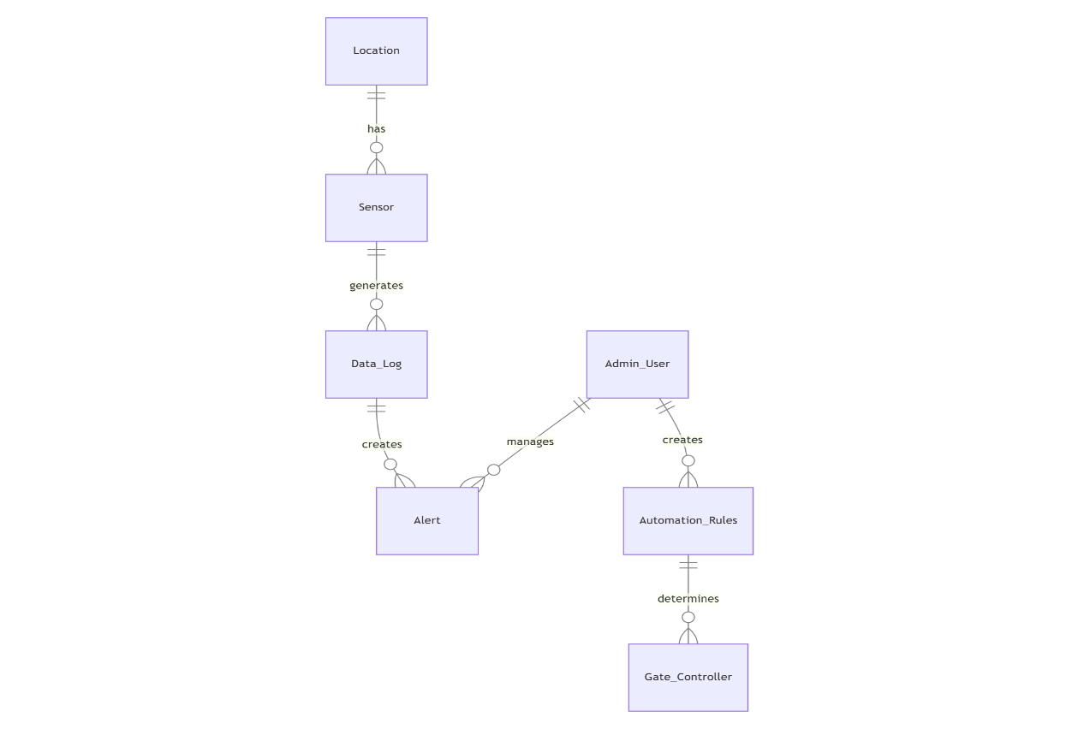
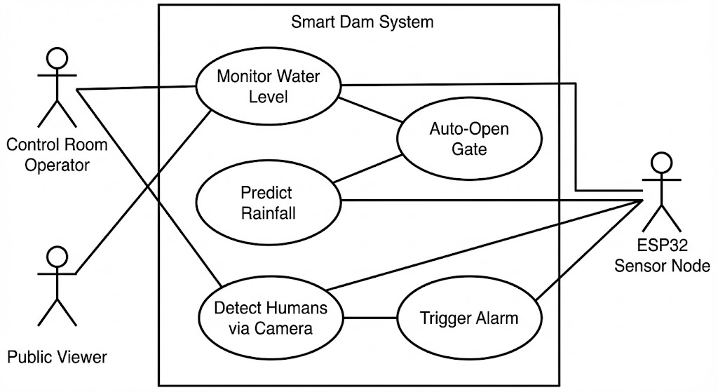
FIG. 2: A use case diagram of the Smart Dam Monitoring System, illustrating the interaction between system actors—including the control room operator, public viewer, and ESP32 sensor node—and the core system functions such as water level monitoring, rainfall prediction, automated gate operation, human detection via camera, and alarm triggering.

FIG. 3: A class diagram of the Smart Dam Monitoring System illustrating the interaction between the ESP32 sensor node, sensors, Machine Learning engine, Computer Vision module, cloud database, decision logic, and dashboard for real-time monitoring and automated control.

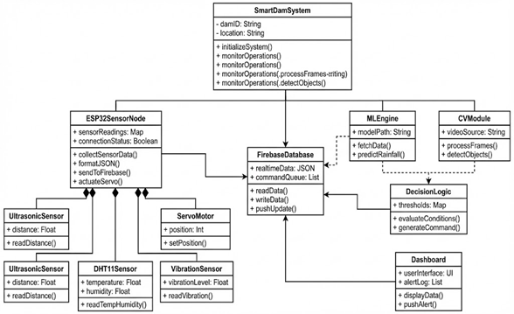

FIG. 4: A sequence diagram of the Smart Dam Monitoring System showing the continuous flow of sensor data, rainfall prediction, object detection, decision evaluation, automated gate control, and alert notification.

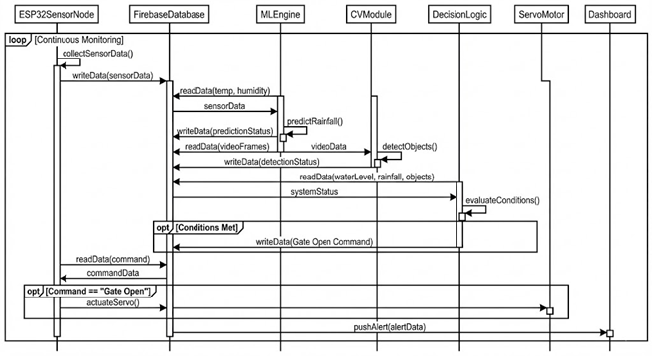

INNOVATIVE FEATURES

● Integrated Multi-Sensor Data Fusion
● Real-Time Rainfall Prediction using Machine Learning
● Automated Downstream Safety Detection using Computer Vision
● Adaptive Autonomous Gate Control and Alert Coordination
● Continuous Real-Time Monitoring and Decision Support

We claim,

• A Smart Dam Monitoring System, comprising an Internet of Things (IoT)–based sensor network, a cloud data platform, a Machine Learning engine, and a Computer Vision module, configured to monitor dam conditions in real time and perform automated safety control.
• The system as claimed in claim 1, wherein the IoT sensor network includes sensors for monitoring water level, temperature, humidity, and structural vibration using an ESP32-based sensor node.
• The system as claimed in claim 1, wherein the Machine Learning engine predicts rainfall likelihood using real-time environmental data to support proactive dam operation.
• The system as claimed in claim 1, wherein the Computer Vision module detects the presence of humans or animals in downstream areas prior to gate operation.
• The system as claimed in claim 1, wherein automated decision logic generates control commands to operate a dam gate actuator and trigger alerts based on integrated sensor data, predictions, and safety conditions.

ABSTRACT

SMART DAM MONITORING SYSTEM USING IOT, MACHINE LEARNING, AND COMPUTER VISION

The present invention relates to a Smart Dam Monitoring and Safety Management System configured for continuous, real-time supervision, predictive assessment, and autonomous operational control of dam infrastructure. The system comprises an Internet of Things (IoT)–enabled multi-sensor network operatively coupled to an embedded processing unit for acquiring real-time data corresponding to water level, environmental parameters, and structural vibration. The sensor network is communicatively connected to a cloud-based data management platform for secure data storage and synchronization.
A Machine Learning–based analytical module is operatively configured to process real-time environmental data and generate localized rainfall prediction outputs to support proactive water management decisions. In parallel, a Computer Vision–based safety verification module is configured to process visual data captured from downstream surveillance units to detect the presence of humans or animals within predefined hazardous zones. The system further includes an autonomous decision-making module configured to evaluate sensor data, predictive outputs, and safety status to generate control commands for dam gate actuation and alert mechanisms.
The invention enables automated gate control, real-time alert dissemination, and centralized visualization through a monitoring interface, thereby minimizing human dependency, reducing response latency, and enhancing operational safety. The disclosed system provides a scalable, cost-effective, and intelligent solution for dam monitoring, disaster risk mitigation, and critical infrastructure management.

