SCM · ERP | INDENTS MODULE
Indents Dashboard (Overview)
A simple, screenshot-led guide to every card, chart, filter and button on the page.

Item | Detail
Module | Indents
Screen name | Overview (Indents Dashboard)
Where to find it | Left menu → Indents → Overview tab
Page address | http://localhost:5173/indents/dashboard
Who it is for | Anyone who raises, approves, allocates or tracks indents
What you can do here | Read summary numbers and jump to the right list. Nothing is edited on this page.
Guide version | 1.0 · 31 August 2026

1. Indents Dashboard Overview
The Overview is the first screen of the Indents module. It is a live summary of every indent (material request) you are allowed to see — how many there are, what stage each one is at, and which ones need somebody to act.
The two questions this page answers
Question | Where the answer is
What needs my action right now? | The four work-queue tiles at the top of the page
How is the whole pipeline shaped? | The summary strip and the Status Breakdown donut chart

Three things to know before you start
- Numbers are buttons. Every number on this page is a shortcut. Click it and you land on the matching list.
- Read-only. You cannot create, edit, approve or delete an indent from this page. It only shows and links. (The one exception is the New indent button in the top-right corner.)
- Your view is your own. The page shows what your login is allowed to see. Two people can open the same screen and see different numbers — that is normal, not an error.
2. Page Screenshot
This is the complete page as it appears on a desktop screen.
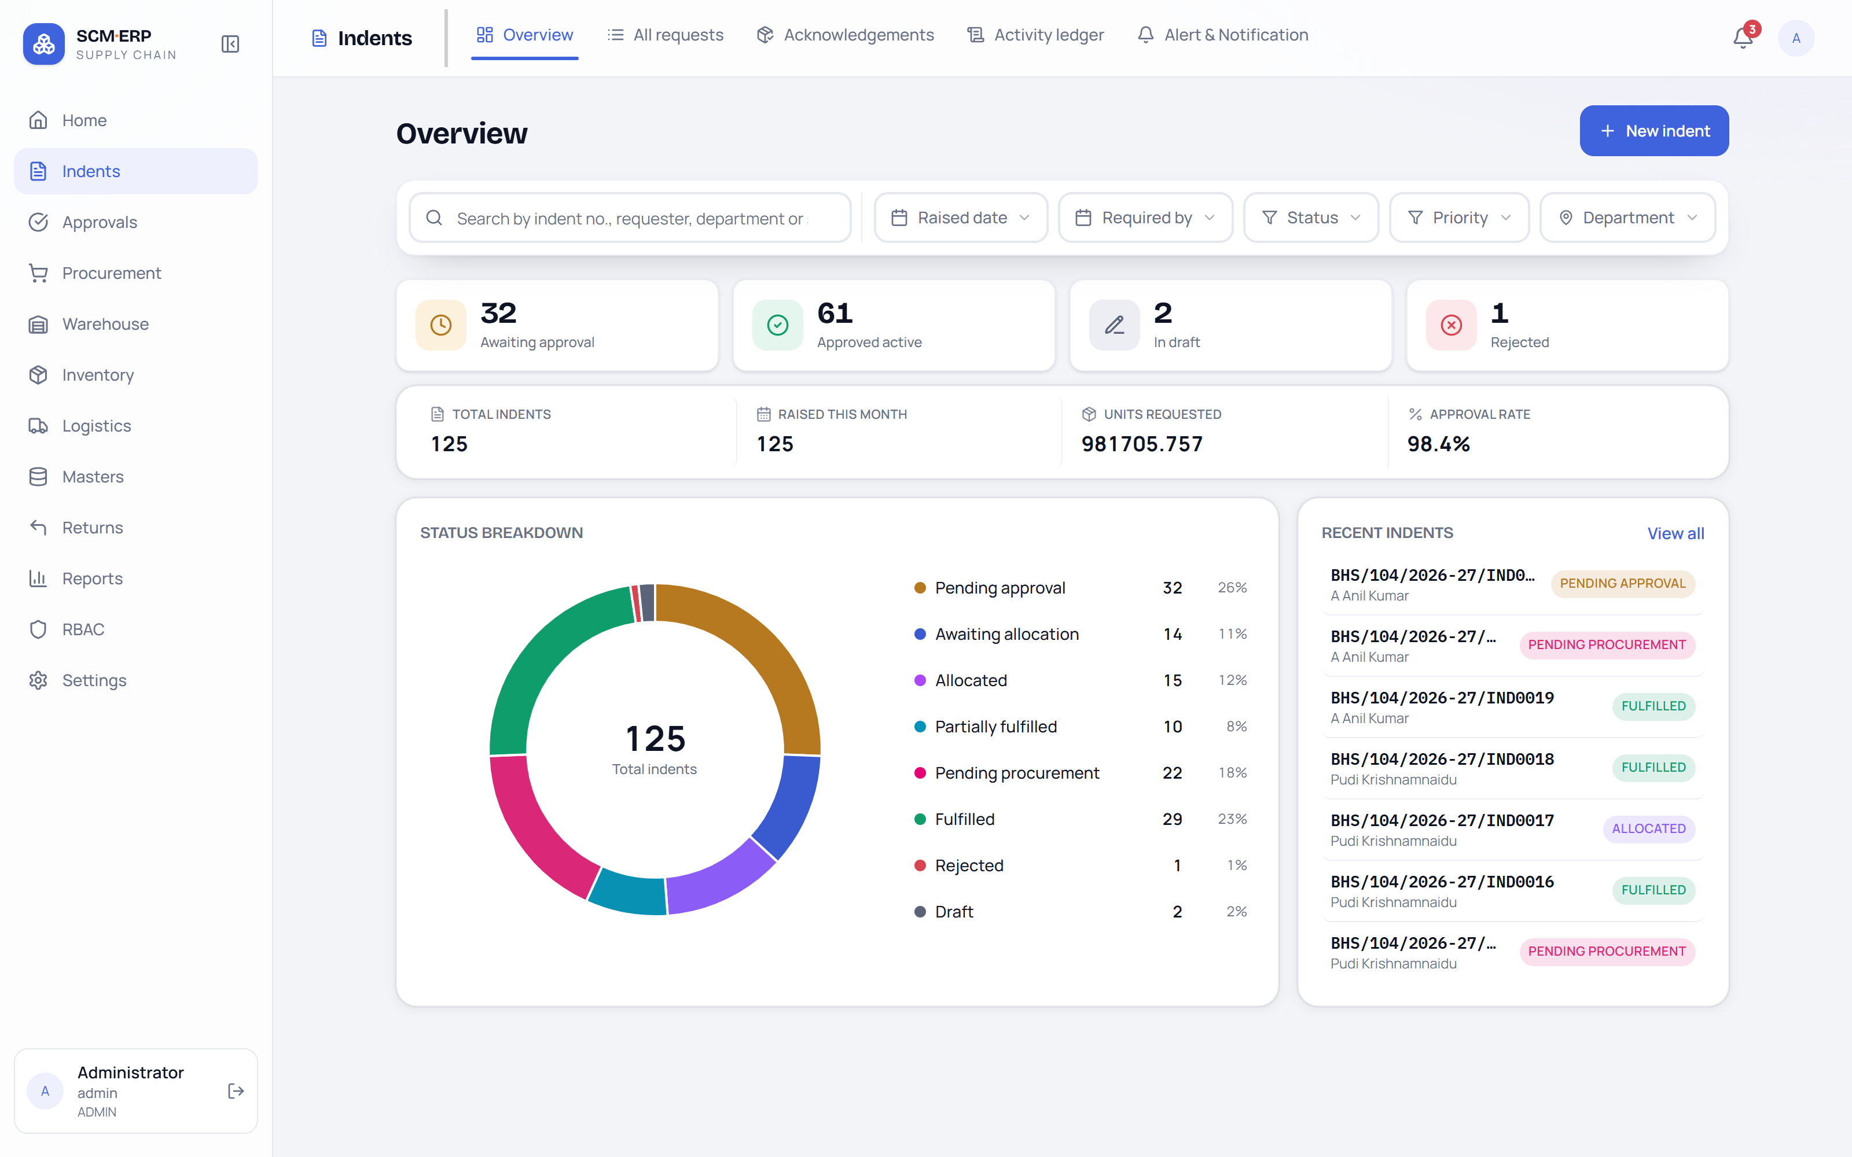
The Indents Overview page, full screen.
The same page with numbered callouts
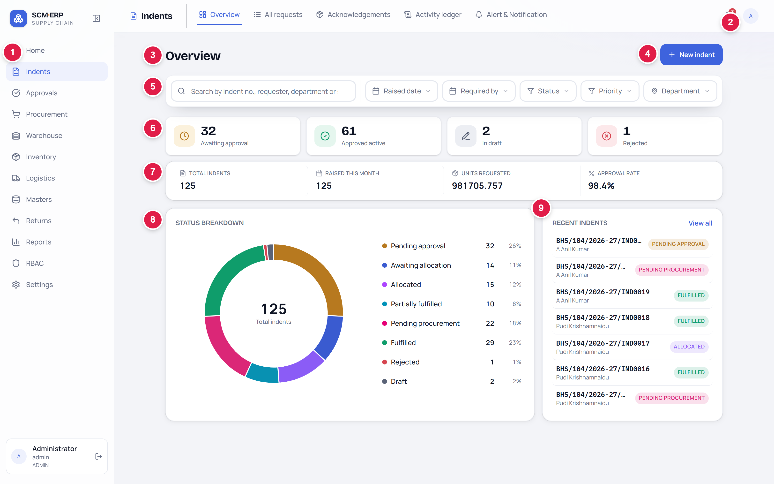
Numbers 1–9 are explained in the table below.
# | Area | What it is
1 | Left menu (module rail) | Moves you between modules — Home, Indents, Approvals, Procurement, Warehouse, Inventory, Logistics, Masters, Returns, Reports, RBAC, Settings.
2 | Indents tab strip | The screens inside the Indents module: Overview, All requests, Acknowledgements, Activity ledger, Alert & Notification. Overview is the current tab.
3 | Page title | Confirms which screen you are on — “Overview”.
4 | New indent button | Opens a blank indent form so you can raise a new request.
5 | Filter bar | Search box plus five filters. Everything below it obeys these filters.
6 | Work queue tiles | Four counts of indents that need attention. Each tile is clickable.
7 | Summary strip | Four quiet totals: Total indents, Raised this month, Units requested, Approval rate.
8 | Status Breakdown | Donut chart plus legend — how the indents split across their stages.
9 | Recent Indents | The latest indents, each with its current status. Click a row to open it.

3. Dashboard Summary / KPI Cards
3.1 Work queue tiles (the four big numbers)
These sit at the top because they are the reason most people open the page. Each tile shows a count, and clicking the tile opens the All requests list already filtered for you.
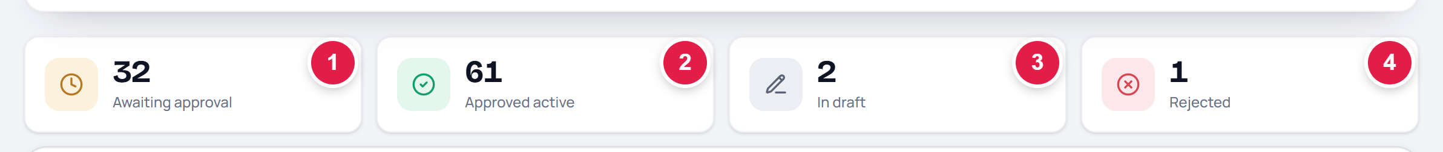
The four work-queue tiles, left to right.
# | Tile | What the number counts | What happens when you click it
1 | Awaiting approval | Indents sitting with an approver, waiting for a yes or no. | Opens the list filtered to Pending approvals + Returned for correction.
2 | Approved active | Indents that cleared approval and are still moving — waiting for stock, allocated, part-served, being purchased or on order. | Opens the list filtered to Awaiting allocation, Allocated and Partially fulfilled.
3 | In draft | Indents that were started but never submitted. Nobody can see or act on these except the person who created them. | Opens the list filtered to Draft.
4 | Rejected | Indents an approver declined. | Opens the list filtered to Rejected.

! Why a tile count and its list can differ
• Awaiting approval counts only indents pending approval, but the list it opens also adds Returned for correction — so the list can show a few more rows.
• Approved active counts every approved indent still in progress (including the ones now being purchased or already ordered), while the list it opens shows the allocation stages only — so the list can show fewer rows.
• Both are working as designed. Use the tile for the headline number and the donut chart for the exact per-stage split.

3.2 Summary strip (the four quiet totals)
Just under the tiles is a single strip of four totals. These give context — they tell you how big the picture is, not what to do next.
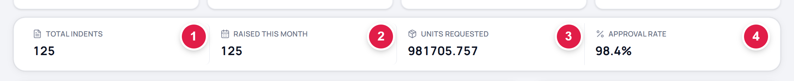
The summary strip, left to right.
# | Label | What it means | Clickable?
1 | Total indents | How many indents match your current filters. With no filters applied, this is every indent you can see. | Yes — opens the full All requests list.
2 | Raised this month | How many of those were created in the current calendar month. | Yes — opens the list for this month.
3 | Units requested | The total quantity asked for across all lines of all those indents. It is a quantity, not a money value. | No — display only.
4 | Approval rate | Of the indents that have actually been decided (approved or rejected), the share that were approved. Shown as a percentage. | No — display only.

i Reading the example above
• Total indents 125 and Raised this month 125 — every indent in the system was raised this month.
• Units requested 981705.757 — the sum of all requested quantities; decimals appear because some items are measured in fractional units.
• Approval rate 98.4% — out of 62 decided indents, 61 were approved and 1 was rejected.

4. Status Breakdown — Chart Explanation
The donut chart on the left half of the lower row shows how your indents are spread across their life stages. The legend beside it repeats the same information as text.
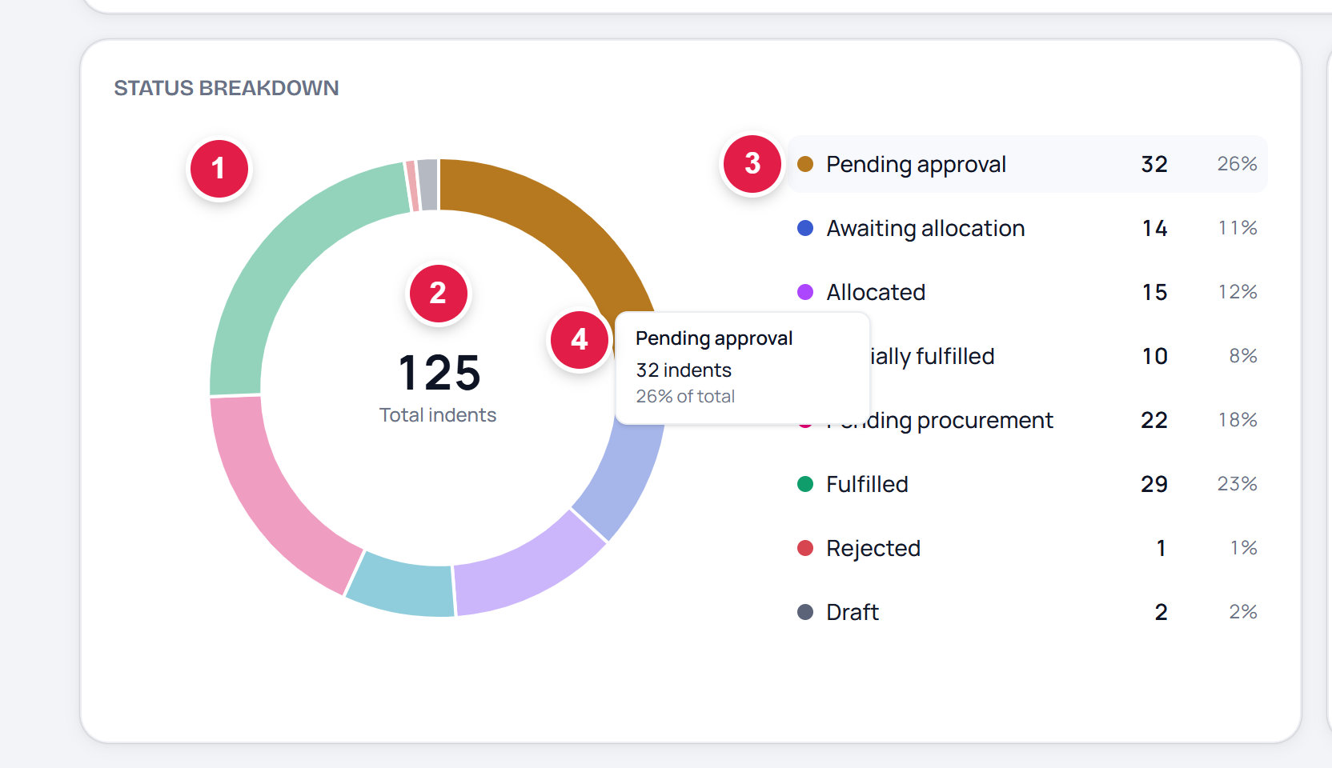
The Status Breakdown card, with a slice hovered.
# | Part | What it does
1 | Donut ring | One coloured arc per status. The bigger the arc, the more indents are sitting at that stage.
2 | Centre total | The total number of indents drawn in the chart. It always matches the Total indents figure in the summary strip.
3 | Legend | One row per status: colour dot, status name, count and share of the total. Rows read in lifecycle order, top to bottom.
4 | Hover tooltip | Point at a slice (or at a legend row) and a small box shows the status name, the exact count and the percentage. The matching legend row lights up at the same time.

What each status means
Status | Plain-English meaning
Draft | Started but not submitted yet. Only the creator sees it.
Submitted | Sent in, about to enter the approval chain.
Pending approval | Waiting with an approver right now.
Returned for correction | Sent back to the requester to fix something and resubmit.
Approved | Cleared the approval chain.
Awaiting allocation | Approved; the store has not set aside stock for it yet.
Allocated | Stock has been set aside for this indent.
Partially fulfilled | Part of the request has been served; the rest is still owed.
Pending procurement | Stock was not available, so the requirement is being purchased.
Partially ordered / Ordered | A purchase order has been raised for some or all of it.
Fulfilled | Complete and closed.
Rejected | An approver declined it.

i Reading the chart correctly
• Only statuses that actually have indents appear. A status with zero indents is left out rather than shown as an empty row — so your legend may be shorter or longer than a colleague's.
• The colours are fixed per status and are the same colours used on the status pills everywhere else in the module, so a colour always means the same thing.
• The centre number and the Total indents card will always agree. If you have filtered the page, both drop together.
• If there is nothing to show, the ring is drawn empty and the card reads “No status data available for the selected filters.”

5. Filters and Controls
The filter bar sits directly under the page title. It controls the ENTIRE page — the four tiles, the summary strip, the donut chart and the Recent Indents list all recalculate together whenever you change a filter.
The filter bar: one search box and five filters.
# | Control | What it does
1 | Search box | Type to narrow the page by indent number, requester, department or status. Results update as you type. An × appears inside the box to clear it.
2 | Raised date | Filters by when the indent was created.
3 | Required by | Filters by when the requester needs the items.
4 | Status | Filters by one or more indent stages.
5 | Priority | Filters by Normal or Urgent.
6 | Department | Filters by the department / location the indent belongs to.

5.1 Raised date
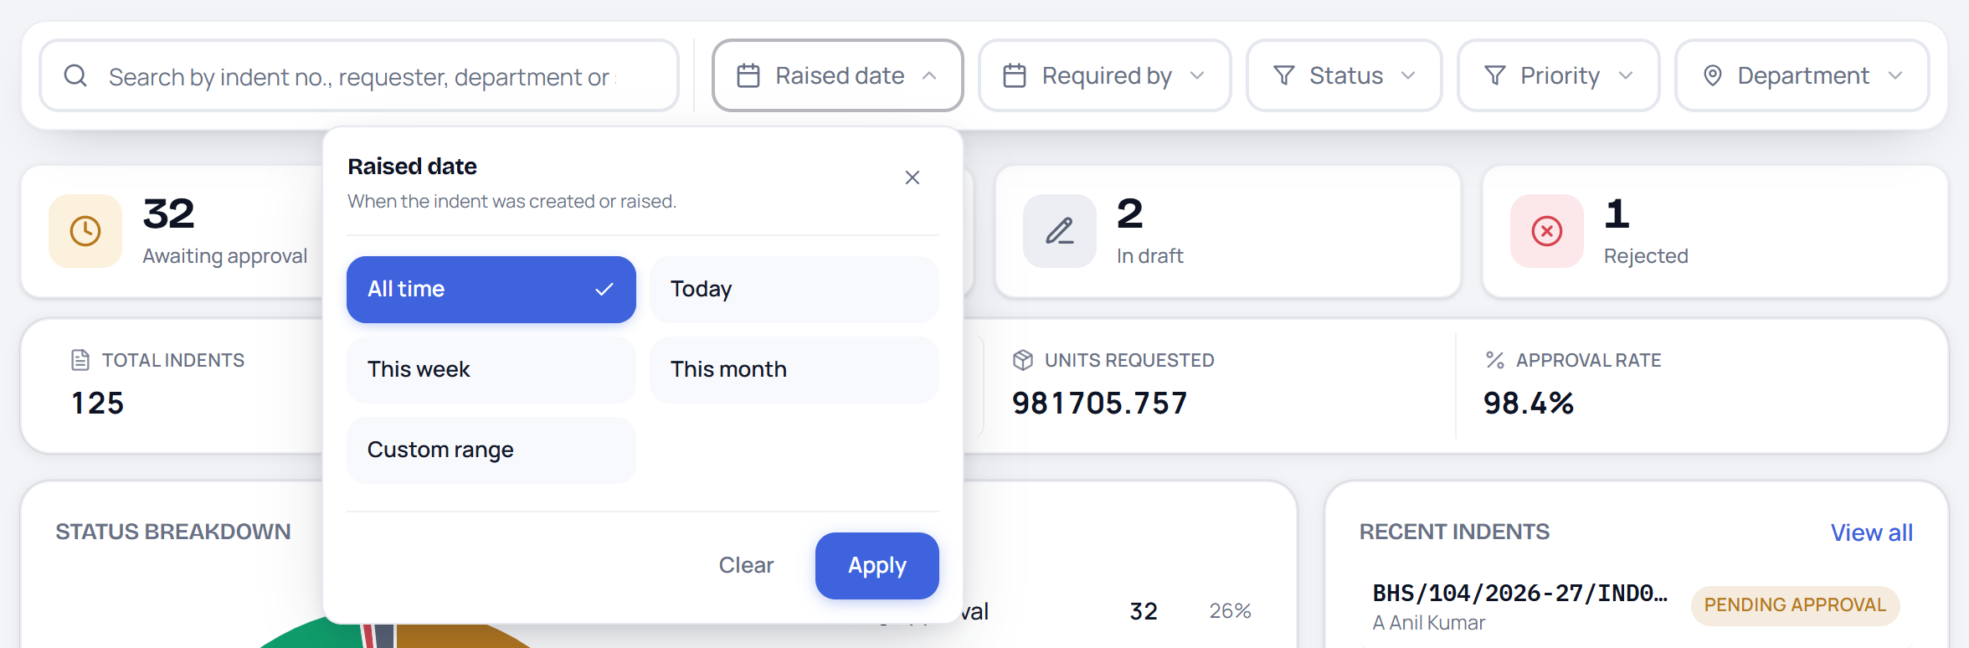
Raised date — “When the indent was created or raised.”
Choose All time, Today, This week, This month, or Custom range (which reveals a From and a To date box). Press Apply to use the choice, or Clear to remove it.
5.2 Required by
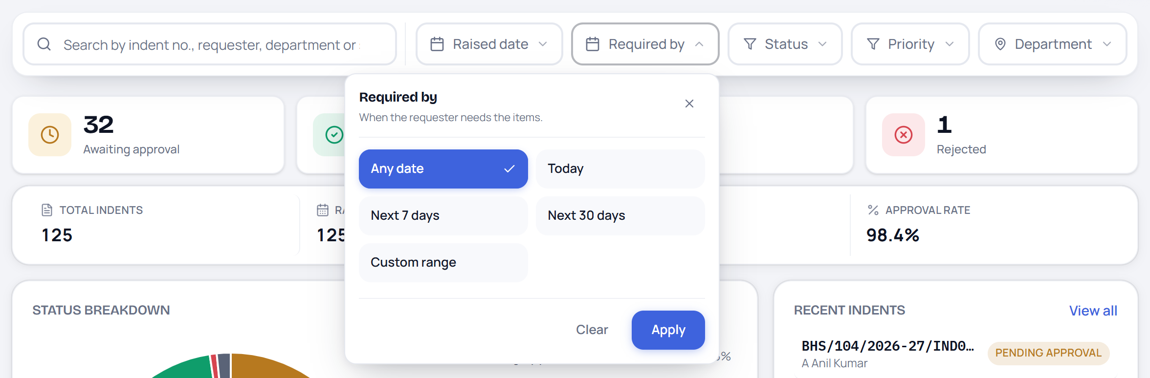
Required by — “When the requester needs the items.”
Choose Any date, Today, Next 7 days, Next 30 days, or Custom range. Use this to find requests that are due soon.
5.3 Status
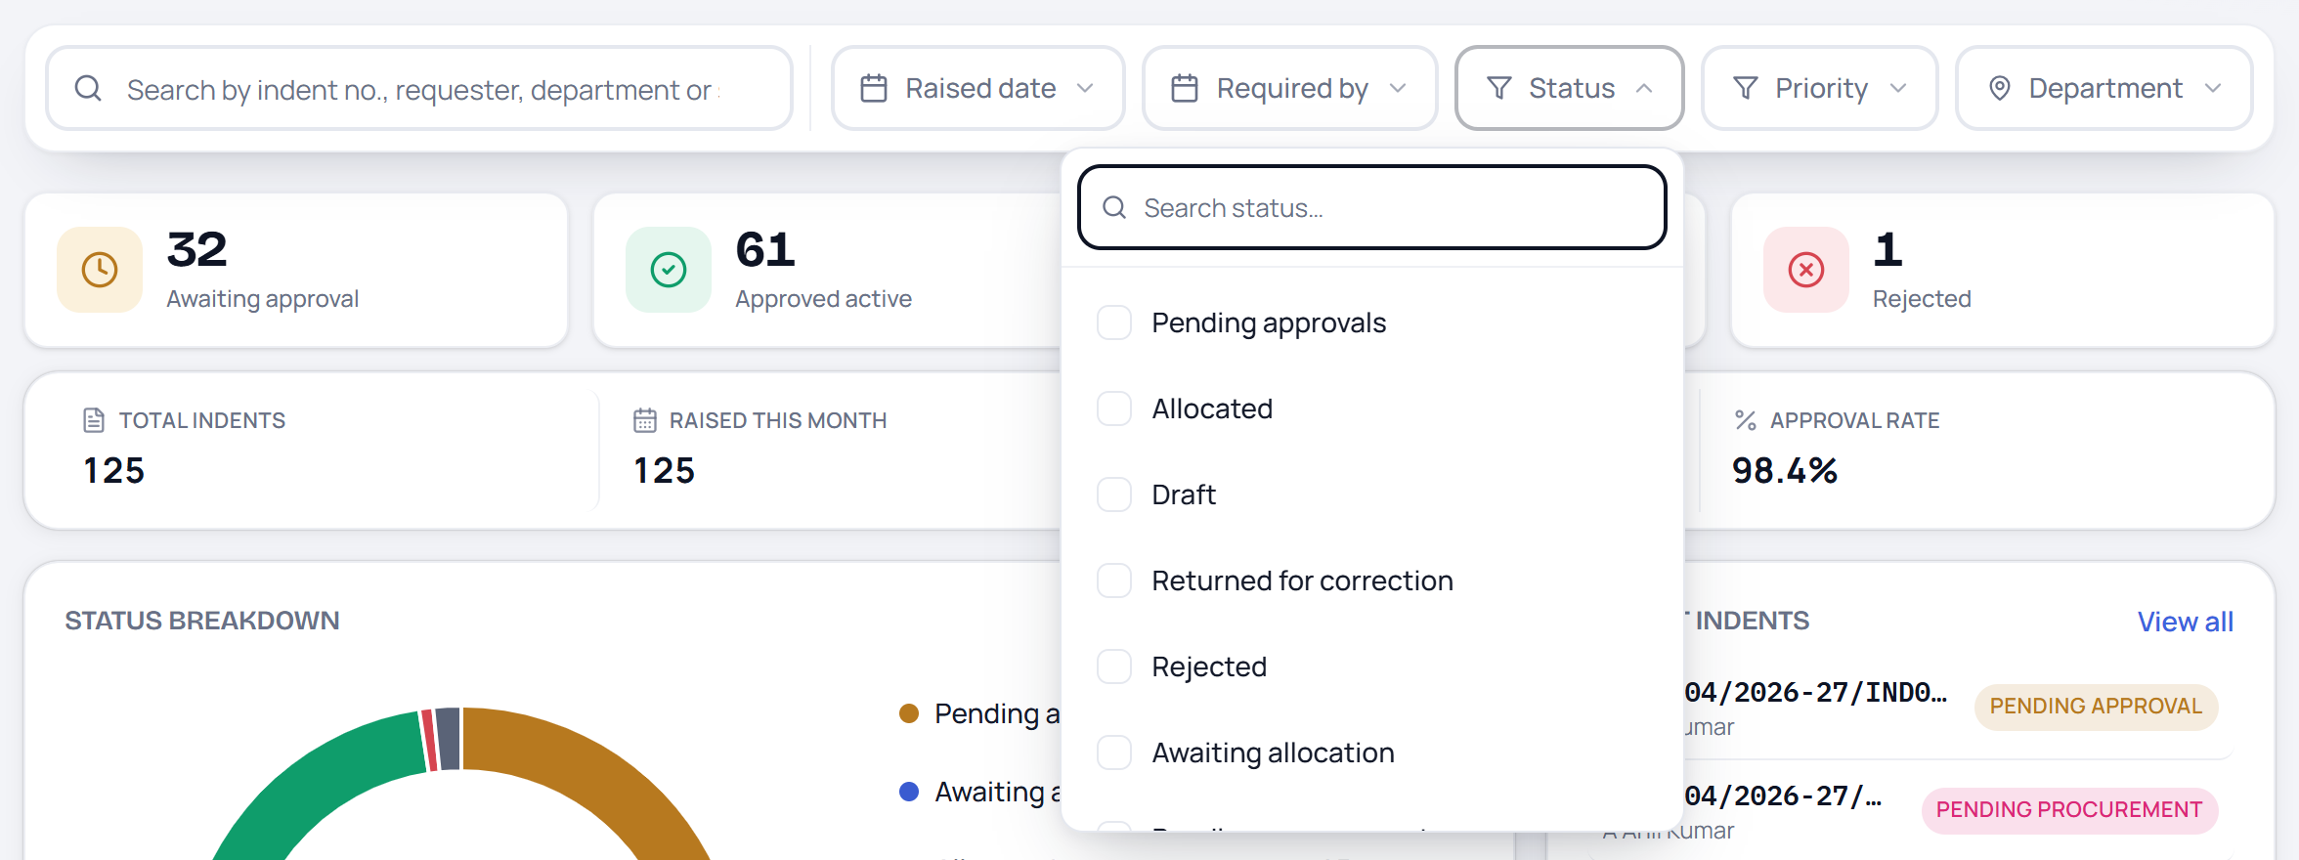
Status — tick as many stages as you need.
A search box at the top of the menu helps you find a status quickly. The available choices are: Pending approvals, Allocated, Draft, Returned for correction, Rejected, Awaiting allocation, Pending procurement, Partially fulfilled and Fulfilled. Ticking more than one shows all of them together.
5.4 Priority
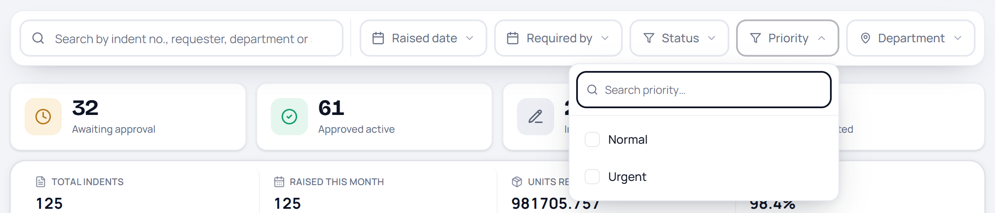
Priority — Normal or Urgent.
Tick Urgent on its own to see only the requests marked as urgent by the requester.
5.5 Department
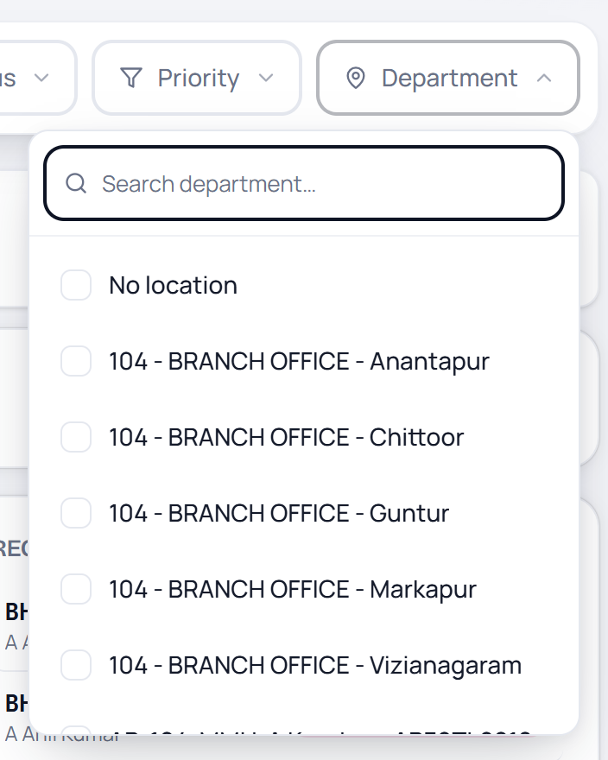
Department — the branch offices, mobile units and warehouses you can see.
A long, searchable list of departments and locations (branch offices, MMU vehicles, central warehouse, and a No location entry for indents with none). Tick one or several.
5.6 Active filters and clearing them
As soon as a filter is in use, two things appear:
- a grey chip under the bar naming the filter — for example “Search: IND0021” — with a small × to remove just that one;
- a Clear all link at the right-hand end of the bar, which removes every filter and returns the page to its full view.
The filter buttons themselves also change: an active one turns blue and shows a small count badge (for example, Status 2) with its own × to clear it.
! The single most important habit
• If a number looks wrong or a list looks empty, check the filter bar first. A filter left on from earlier is the most common reason the page “looks broken”.
• Clear all resets everything in one click.

6. Individual Dashboard Sections
6.1 Recent Indents
The card on the right of the lower row lists the most recent indents that match your filters — up to seven rows.
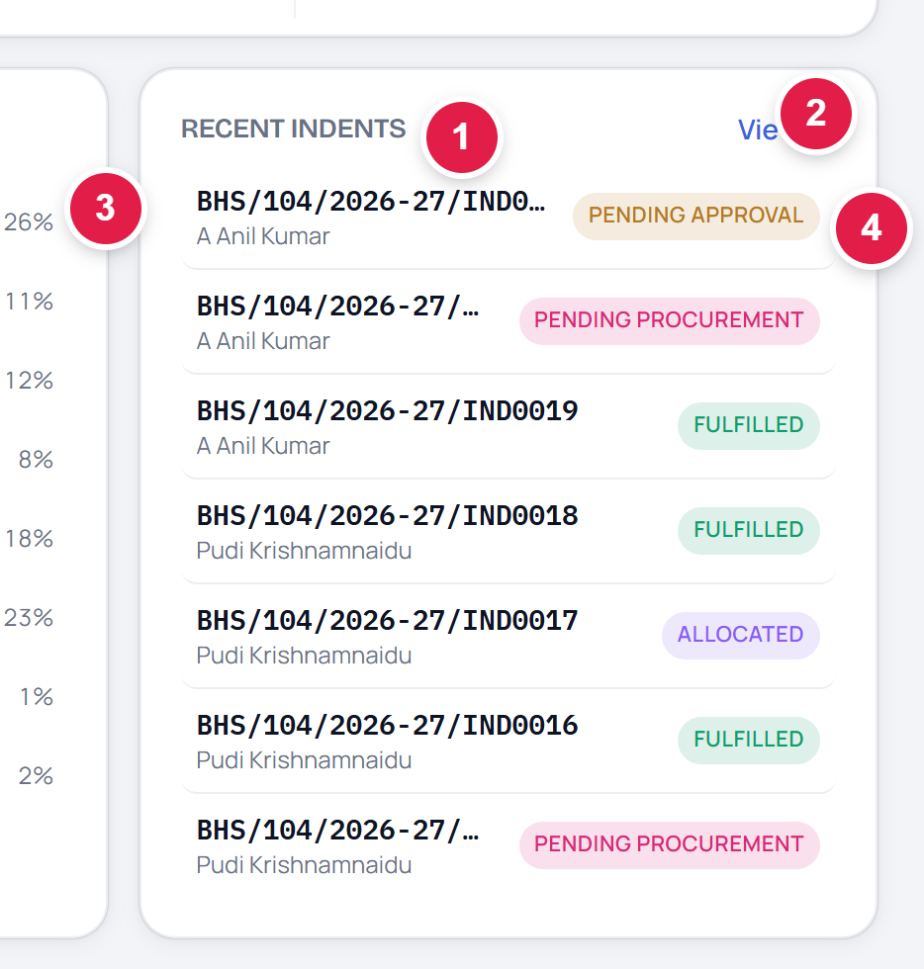
The Recent Indents card.
# | Part | What it does
1 | “RECENT INDENTS” heading | Names the card. The list always shows the newest indents first.
2 | View all | Opens the full All requests list, keeping any filters you have set.
3 | Indent row | Two lines: the indent number on top, and the requester's name underneath (the department name is shown instead if there is no requester name). Click anywhere on the row to open that indent's detail page.
4 | Status pill | The indent's current stage, in the same colour the donut chart uses for it.

If nothing matches, the card reads “Nothing here matches the filters.” instead of showing rows.
6.2 Where the tiles take you
Clicking a tile does not open a new kind of screen — it opens the All requests tab with the filter already applied. In the example below, the Awaiting approval tile was clicked.
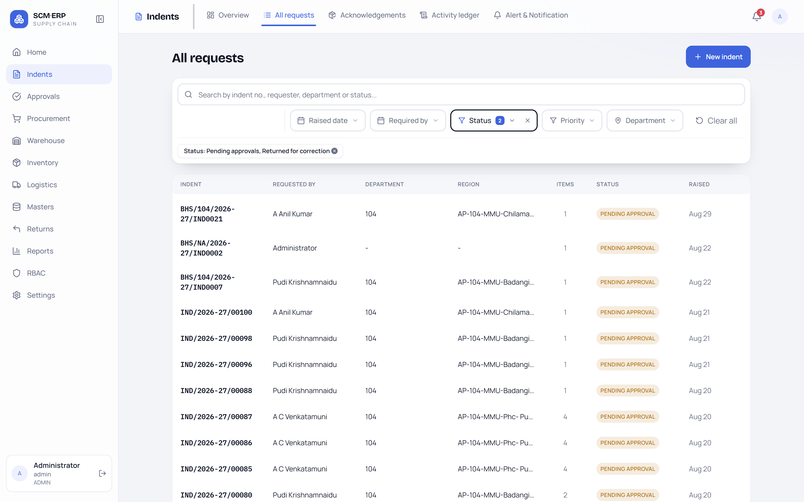
After clicking Awaiting approval: the All requests list, with the chip “Status: Pending approvals, Returned for correction” already applied.
From there you can widen or narrow the filter, open any row, or press Clear all to see everything again. Use the Overview tab to come back.
6.3 Around the page
Element | Where it is | What it does
Module rail | Far left, full height | Switches modules. The current module (Indents) is highlighted.
Collapse arrow | Top-left, beside the SCM·ERP logo | Folds the left menu away to give the page more width.
Indents tab strip | Top bar, right of the word “Indents” | Overview · All requests · Acknowledgements · Activity ledger · Alert & Notification. You only see the tabs your login is allowed to open.
Notification bell | Top-right | The red number is your count of unread alerts. Opens your notifications.
Profile avatar | Top-right corner, and bottom-left | Your account. The bottom-left panel shows your name, login and role, with a sign-out arrow.
New indent | Top-right of the page body | Starts a new indent. It only appears if you are allowed to raise indents.

7. How to Use This Page — Step by Step
Example A — “What is waiting for my approval today?”
1. Open Indents from the left menu. The Overview tab opens by default.
2. Look at the first tile, Awaiting approval.
3. Click that tile. The All requests list opens, already filtered.
4. Click any row to open the indent and take your decision there.
5. Click the Overview tab to come back.
Example B — “Find one specific indent”
1. Click into the Search box in the filter bar.
2. Type any part of the indent number, the requester's name or the department — for example IND0021.
3. The whole page narrows to that one indent while you type.
4. Open it from the Recent Indents card on the right.
5. Press Clear all (or the × in the search box) when you are done.
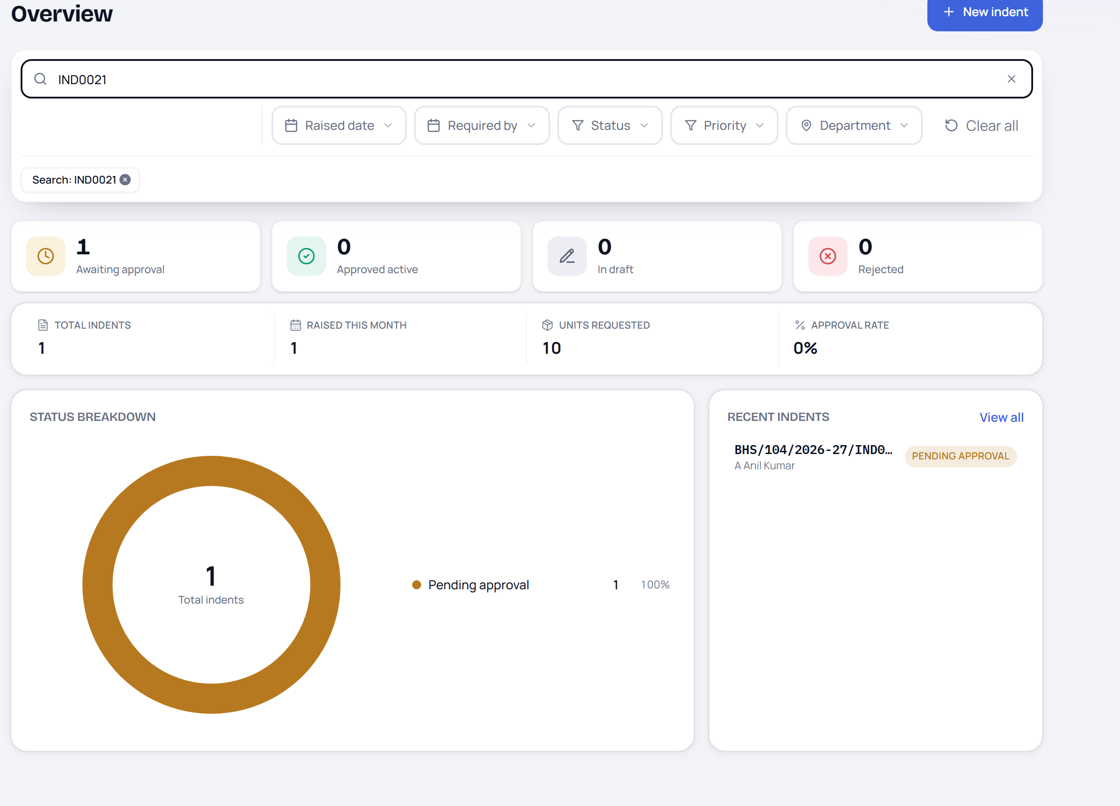
Searching for “IND0021”: every tile, the summary strip, the chart and the Recent Indents card all narrow to that single indent.
Example C — “How did my department do this month?”
1. Open the Department filter and tick your department.
2. Open Raised date and choose This month, then press Apply.
3. Read the summary strip for the totals and the Approval rate.
4. Read the donut legend to see exactly where those indents are stuck.
5. Hover any slice to confirm the count, or click Total indents to see the full list.
6. Press Clear all to return the page to normal.
8. Important Notes & Tips
✓ Good habits
• Start every day on the Overview tab — the four tiles tell you in one glance whether anything is waiting on you.
• Filter first, read second. Every number obeys the filter bar.
• Hover before you click. The tooltip on a slice gives the exact count without leaving the page.
• Use Clear all whenever the page looks unexpectedly empty.
• The donut centre and the Total indents card should always match. They are the same number.

! Things people commonly misread
• Units requested is a quantity, not a value in rupees.
• Approval rate ignores indents that are still in draft or still awaiting a decision — it only counts decided ones.
• In draft counts unsubmitted requests. They are invisible to approvers until submitted.
• A tile's count and the list it opens can differ slightly (see the note in section 3.1).
• An empty legend row is never shown — a status you cannot see simply has zero indents right now.

If something does not look right
What you see | Most likely reason | What to do
Numbers are all 0 or the list is empty | A filter is still applied from earlier | Press Clear all in the filter bar
A tab you expect is missing | Your login is not granted that screen | Ask your administrator for access
The New indent button is missing | Your login cannot raise indents | Ask your administrator for access
A number will not load and a red message appears | The page could not reach the server | Refresh the page; if it repeats, report it to IT
A colleague sees different numbers | You each see only what you are allowed to see | This is normal — no action needed

On a phone or tablet
The same page reflows into a single column: the tiles stack two-by-two, the summary strip splits into two rows, and the chart, legend and Recent Indents list follow underneath. Every button and row stays tappable.
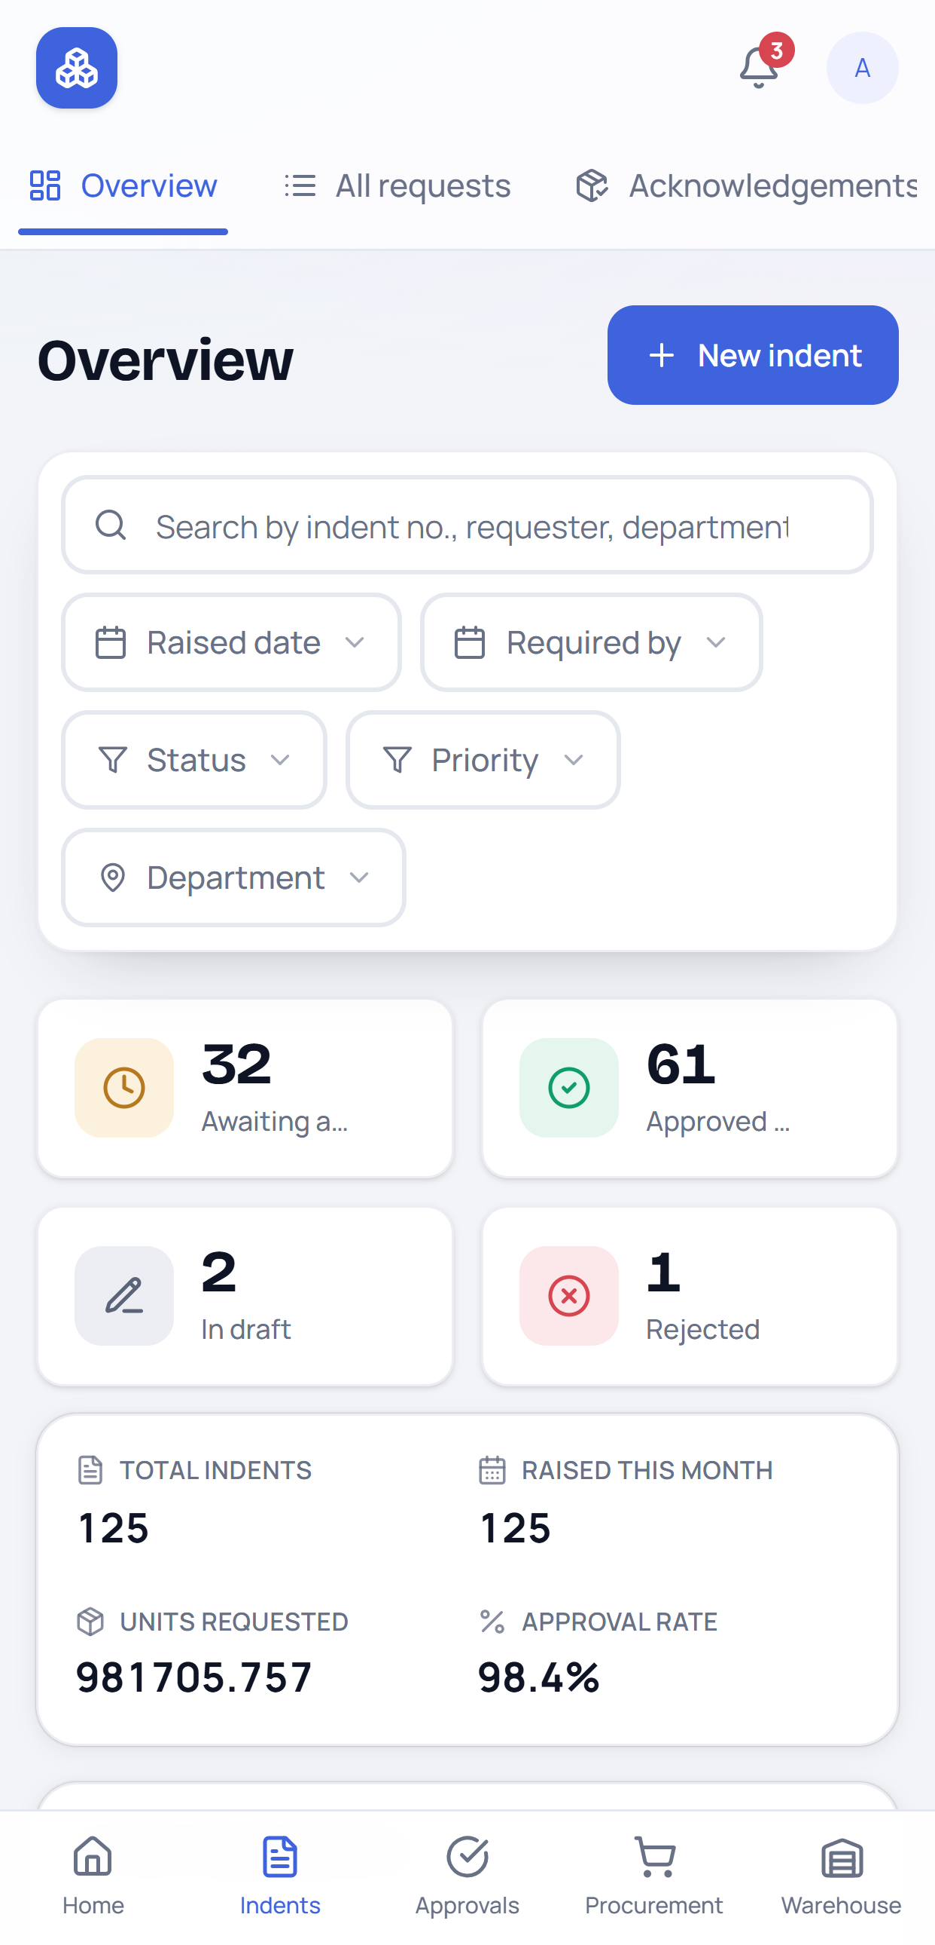 | 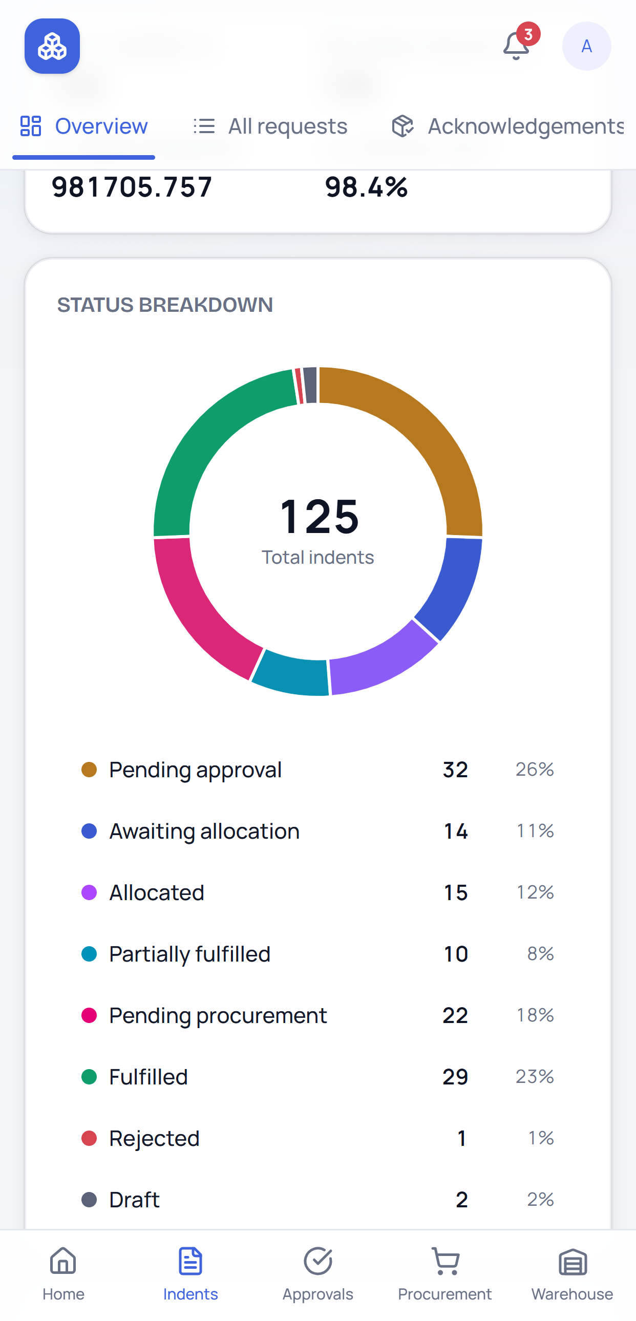
Top of the page: tabs, filters, the four tiles and the summary strip. | Scrolled down: the donut chart, legend and Recent Indents.

On a phone the module tabs scroll sideways across the top, and a bar along the bottom of the screen gives one-tap access to Home, Indents, Approvals, Procurement and Warehouse.

