**String Tokenizer**

**1.**

import java.util.StringTokenizer;

public class Tokenizer {

public static void main(String[] args) {

    StringTokenizer st = new StringTokenizer("My name is Naveen"," ");

    while(st.hasMoreTokens()){

        System.out.println(st.nextToken());

    }

}

}

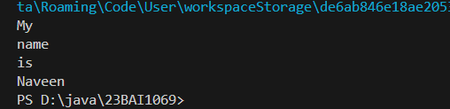

**2.**

import java.util.*;

public class Tokenizer2 {

public static void main(String[] args) {

    StringTokenizer st = new StringTokenizer("My,name,is,Naveen");

    System.out.println("Next token is: "+st.nextToken(","));

}

}

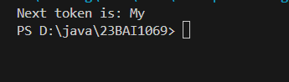

**3.**

import java.util.StringTokenizer;

public class t3 {

    public static void main(String[] args) {

    StringTokenizer st = new StringTokenizer("Sample statement to analyze and understand methods from tokenizer class in java"," ");

    while(st.hasMoreTokens()){

        System.out.println(st.nextToken());

    }

}

}

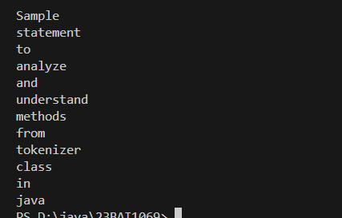

**4.**

import java.util.StringTokenizer;

public class t3 {

    public static void main(String[] args) {

    StringTokenizer st = new StringTokenizer("Sample/statement/to/analyze/methods/from/tokenizer/class/in/java","/");

    while(st.hasMoreTokens()){

        System.out.println(st.nextToken());

    }

}

}

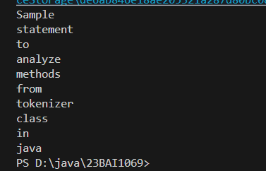

**5.**

import java.util.StringTokenizer;

public class t4 {

    public static void main(String[] args) {

    StringTokenizer st = new StringTokenizer("Sample/statement/to/analyze/methods/from/tokenizer/class/in/java","/");

    while(st.hasMoreTokens()){

        System.out.println(st.nextElement());

    }

}

}

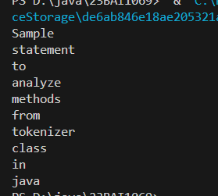

**6.**

import java.util.StringTokenizer;

public class t5 {

     public static void main(String[] args) {

    StringTokenizer st = new StringTokenizer("Hello everyone have a nice day"," ");

   System.out.println("Total number of tokens: "+ st.countTokens());

}

}



**7.**

import java.util.Scanner;

public class array {

    public static void main(String[] args){

        Scanner myobj = new Scanner(System.in);

        int[] arr;

        arr= new int[10];

        for(int i=0;i<10;i++){

            arr[i]= myobj.nextInt();

        }

        int[] harr;

        harr= new int[5];

        harr[0]=9;

        harr[1]=8;

        harr[2]=7;

        harr[3]=6;

        harr[4]=5;

        for(int i=0;i<arr.length;i++){

            System.err.printf("%d ",arr[i]);

        }System.out.println("\n");

        for(int i=0;i<5;i++){

            System.err.printf("%d ",harr[i]);

        }

        }

}

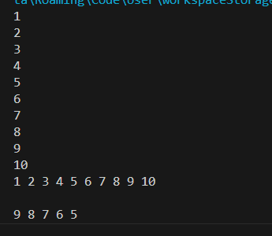

**8.**

class Student{

    public int roll_no;

    public String name;

    Student(int roll_no, String name){

        this.roll_no=roll_no;

        this.name=name;}

    }

public class ex2 {

public static void main(String[] args){

    Student[] arr = new Student[5];

    arr[0]= new Student(1,"aman");

    arr[1]= new Student(2,"rakesh");

    arr[2]= new Student(3,"sahil");

    arr[3]= new Student(4,"rahul");

    arr[4]= new Student(5,"ayush");

    for(int i=0;i<arr.length;i++){

        System.out.println("Element at "+i+": "+arr[i].roll_no+" "+arr[i].name);

    }

}

}

