**BCSE103E- JAVA**

**EXERCISE**

**23BAI1069- B S NAVEEN**

**01-10-2024**

**1.**

**1)Computing Area of Different Shapes:**

**Description:** The area is the two-dimensional amount of space that an object occupies. Area is measured along the surface of an object and has dimensions of length squared; for example, square feet of material, or centimetres squared. The area of a rectangle is equal to the height h times the base b; A = h * b The equation for the area of a trapezoid is one half the sum of the top t and bottom b times the height h; A = h * [t + b] / 2 The area of a circle is A = pi * r2, where pi = 3.14 and r = radius. Develop a program using Java using method overloading for computing the area of a rectangle, a trapezoid and a circle by a common function name ComputeArea() with different signature. Assume pi = 3.14. Print only two decimal places for all areas.

Note:

**Input Format:** Read the base and height of a rectangle. Read the top, bottom and height of a trapezoid. Read the radius of a circle.

**Output Format:** Display the area of a rectangle, trapezoid and circle each in one line

**Boundary Conditions:** You can give any valid integer or float values for inputs.

**Code:**

import java.util.Scanner;

public class Area {

    public static void main(String[] args) {

            Scanner input = new Scanner(System.in);

            double rectArea = ComputeArea(input.nextInt(), input.nextInt());

            double trapArea = ComputeArea(input.nextInt(), input.nextInt(), input.nextInt());

            double circArea = ComputeArea(input.nextInt());

            System.out.printf("%.2f\n", rectArea);

            System.out.printf("%.2f\n", trapArea);

            System.out.printf("%.2f\n", circArea);

            input.close();

        }

        public static double ComputeArea(int l, int b) {

            double area = (l * b);

            return area;

        }

        public static double ComputeArea(int t, int b, int h) {

            double area = h * (t + b) / 2.0;

            return area;

        }

        public static double ComputeArea(int r) {

            double area = 3.14 * r * r;

            return area;

    }

}

**Output:**

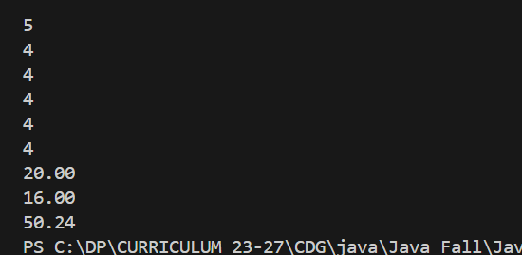

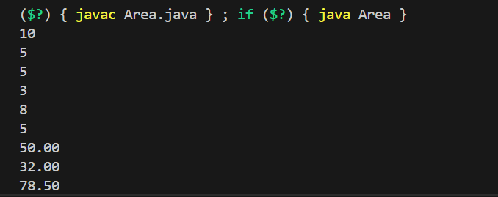

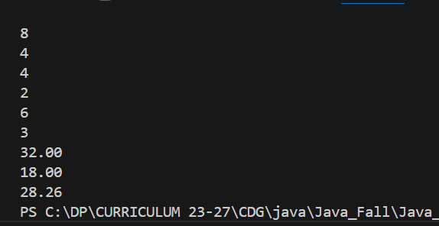

**2) Black Coin in Board game:**

**Description:** Colored coin game is a 8X8 board game which has many colored coins. Each coin has a weight and power. Power of a coin is defined by the moves that it can make. In a move, a black coin can move one step vertically upwards. A red coin can move one step either horizontally, vertically or diagonally. Given the current position of a black coin and list of movements made by it, print all possible next positions of the coin. If the total number of moves made by a black coin is greater than 6, then that coin should be treated as a red coin and the subsequent moves will be as that of the red coin. At any point of time, the coin cannot move outside the board. The rows and columns of the board are numbered as 1 to 8. Print the horizontal movement of coin in an increasing order of columns and print the vertical movement of coin in increasing order of rows. To print, the diagonal movement of the coin. If the current position of your coin is 4,4 then print P1, P2 ... P8 in order.

**Input Format**

Weight of black coin

Current row position of coin

Current column position of coin

Number of moves made by black coin

**Output Format**

Weight of black coin

List of possible next positions

One position in a line with row and column separated by a comma

**Code:**

import java.util.Scanner;

public class Blackcoin {

    public static void main(String[] args) {

            Scanner input = new Scanner(System.in);

            int weight = input.nextInt();

            int row = input.nextInt();

            int col = input.nextInt();

            int moves = input.nextInt();

            System.out.println(weight);

            if (moves<=6){

                if ((col+1)<=8){

                    System.out.println((row)+","+(col+1));

                }

            }

            else{

                if ((row-1)>=1){

                    System.out.println((row-1)+","+col);

                }

                if ((row+1)<=8){

                    System.out.println((row+1)+","+col);

                }

                if ((col-1)>=1){

                    System.out.println((row)+","+(col-1));

                }

                if ((col+1)<=8){

                    System.out.println((row)+","+(col+1));

                }

                if ((row-1)>=1 && (col-1)>=1){

                    System.out.println((row-1)+","+(col-1));

                }

                if ((row+1)<=8 && (col-1)>=1){

                    System.out.println((row+1)+","+(col-1));

                }

                if ((row-1)>=1 && (col+1)<=8){

                    System.out.println((row-1)+","+(col+1));

                }

                if ((row+1)<=8 && (col+1)<=8){

                    System.out.println((row+1)+","+(col+1));

                }

            }

            input.close();

        }

    }

**Output:**

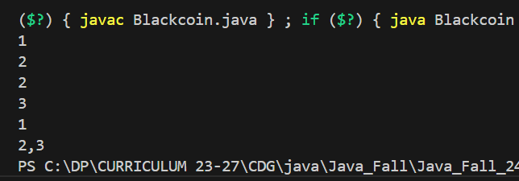

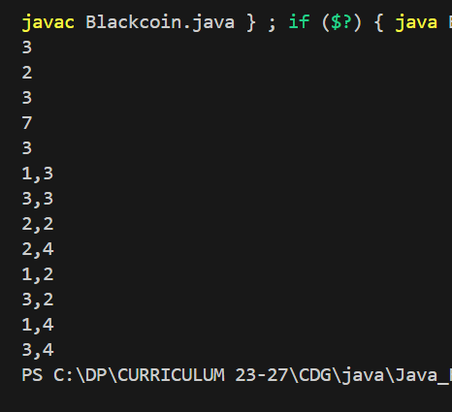

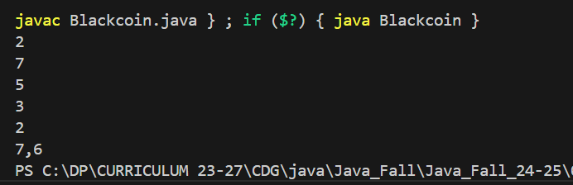

**3.Description:** Pizza is a delicious circular food item that is a favorite for manypeople. Given the radius of the pizza, ingredients required for the preparation of the pizza, per square cm (cm2) area of the pizza and cost of its ingredients per 100 grams, design an OOP model and

write a Java program to calculate the cost of the pizza. Add Rs 50 for veg pizza and Rs 100 for chicken pizza. Use 3.14 for pi. Your program should get all the ingredients available in the kitchen with their cost per 100 grams, as an input. Assume that all the ingredients required for the preparation of the pizza is available in the kitchen.

**Input Format**

Give 0 for veg pizza and 1 for chicken pizza

Radius of pizza

Number of ingredients required for the preparation of the pizza

Name of ingredient1

Quantity of ingredient1 required (in grams)

Name of ingredient2

Quantity of ingredient2 required

....

Name of ingredient-n

Quantity of ingredient-n required

Number of ingredients available in the kitchen.

Name of ingredient-1 available in the kitchen

Cost of 100 gm of ingredient1 available in kitchen

Name of ingredient-2 in kitchen

Cost of 100 gm of ingredient2 in kitchen

....

Name of ingredient-n in kitchen

Cost of 100 gm of ingredient-n in kitchen

**Output Format**

Cost of pizza

**Code:**

import java.util.Scanner;

class Pizza{

    int type;

    int rad;

    int n;

    String[] name;

    int[] costph;

    int nr;

    String[] namer;

    int[] reqq;

    double total_cost;

    final double pi = 3.14;

    public Pizza(){

        Scanner input = new Scanner(System.in);

        type = Integer.parseInt(input.nextLine());

        rad = Integer.parseInt(input.nextLine());

        nr = Integer.parseInt(input.nextLine());

        namer = new String[nr];

        reqq = new int[nr];

        for (int i=0;i<nr;i++){

            namer[i] = input.nextLine();

            reqq[i] = Integer.parseInt(input.nextLine());

        }

        n = Integer.parseInt(input.nextLine());

        name = new String[n];

        costph = new int[n];

        for (int i=0;i<n;i++){

            name[i] = input.nextLine();

            costph[i] = Integer.parseInt(input.nextLine());

        }

        input.close();

    }

    public double calculateCost(){

        if(type == 0){

            total_cost+=50;

        }

        else{

            total_cost+=100;

        }

        double ing_cost=0;

        for (int i=0;i<nr;i++){

            for (int j=0;j<n;j++){

                if (namer[i].equalsIgnoreCase(name[j])){

                    ing_cost+=(reqq[i]*((costph[j])/100.0));

                }

            }

        }

        total_cost += (pi*rad*rad*(ing_cost));

        return total_cost;

    }

}

public class clc {

    public static void main(String[] args) {

        Pizza pizza = new Pizza();

        System.out.printf("%.2f\n",pizza.calculateCost());

    }

}

**Output:**

