**1.**

interface FirstInterface{

    public void myMethod();

}

interface SecondInterface{

    public void myOtherMethod();

}

interface ThirdInterface{

    public void myThirdMethod();

}

class DemoClass implements FirstInterface, SecondInterface, ThirdInterface{

public void myMethod(){

    System.out.println("Some text for first one.");

}

public void myOtherMethod(){

    System.out.println("Some other text for second one.");

}

public void myThirdMethod(){

    System.out.println("Some other text again for third one.");

}

}

public class MultipleInterface {

    public static void main(String[] args){

        DemoClass dc = new DemoClass();

        dc.myMethod();

        dc.myOtherMethod();

        dc.myThirdMethod();

    }

}

**Output:**

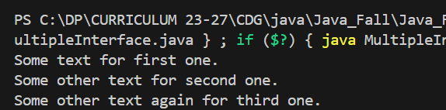

**2.**

enum Level{

    LOW,

    MEDIUM,

    HIGH

}

public class Enumeration {

    public static void main(String[] args) {

        Level myVar = Level.MEDIUM;

        System.out.println(myVar);

    }

}

**Output:**

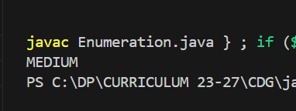

**3.**

enum Level{

    LOW,

    MEDIUM,

    HIGH

}

public class Switch {

    public static void main(String[] args) {

        Level myVar = Level.MEDIUM;

        switch(myVar){

            case LOW:

            System.out.println("Low level");

            break;

            case MEDIUM:

            System.out.println("Medium level");

            break;

            case HIGH:

            System.out.println("High level");

            break;

        }

    }

}

**Output:**

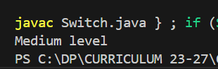

**4.**

 enum Level{

        LOW,

        MEDIUM,

        HIGH

    }

    public class Loopenum {

        public static void main(String[] args) {

            for(Level myVar : Level.values()){

            System.out.println(myVar);

            }

        }

    }

**Output:**

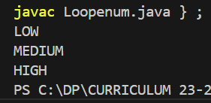

**5.**

import java.time.LocalDate;

public class Date{

    public static void main(String[] args){

        LocalDate ld = LocalDate.now();

        System.out.println(ld);

    }

}

**Output:**

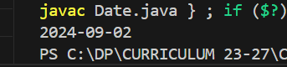

**6.**

import java.time.LocalTime;

public class Date{

    public static void main(String[] args){

        LocalTime lt = LocalTime.now();

        System.out.println(lt);

    }

}

**Output:**

