**1.**

public class Main {

int x =5;

public static void main(String[] args){

Main myObj= new Main();

System.out.println(myObj.x);

}

}

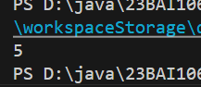

**2.**

public class Main {

int x =5;

public static void main(String[] args){

Main myObj1= new Main();

Main myObj2= new Main();

System.out.println(myObj1.x);

System.out.println(myObj2.x);

}

}

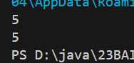

**3.**

**A.**

public class Main1 {

    int x =10;

}

**B.**

public class Second {

    public static void main(String[] args){

        Main1 MyObj = new Main1();

        System.out.println(MyObj.x);

    }

}

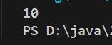

**4.**

public class Assign {

    int x;

    public static void main(String[] args){

        Assign a = new Assign();

        a.x = 40;

        System.out.println(a.x);

    }

}

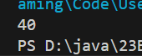

**5.**

public class Override {

    int x = 10;

    public static void main(String[] args) {

        Override o = new Override();

        o.x =25;

        System.out.println(o.x);

}

}



**6.**

public class Override {

   final int x = 10;

    public static void main(String[] args) {

        Override o = new Override();

        o.x =25;

        System.out.println(o.x);

}

}

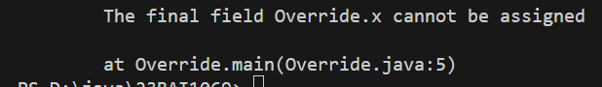

**7.**

public class TwoObj {

    int x=10;

    public static void main(String[] args) {

    TwoObj t1 = new TwoObj();

    TwoObj t2 = new TwoObj();

    t2.x=25;

    System.out.println(t1.x);

    System.out.println(t2.x);

    }

}

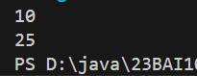

**8.**

public class MultiAttr {

    int age = 24;

    String fname= "John";

    String lname = "Doe";

    public static void main(String[] args) {

        MultiAttr ma = new MultiAttr();

        System.out.println("Name: "+ma.fname+" "+ma.lname);

        System.out.println("Age: "+ma.age);

    }

}

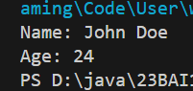

**9.**

public class Method {

    static void myMethod(){

        System.out.println("Hello, World!");

    }

    public static void main(String[] args) {

        myMethod();

    }

}



**10.**

public class PS {

    //static method

    static void myStaticMethod(){

        System.out.println("Static method can be called without creating objects");

    }

    //public method

    public void myPublicMethod(){

        System.out.println("Public method must be called by creating objects");

    }

    public static void main(String[] args) {

        myStaticMethod();

        PS obj = new PS();

        obj.myPublicMethod();

    }

}



**11.**

public class Car {

    public void fullThrottle(){

        System.out.println("The car is going as fast as it can!");

    }

    public void speed(int maxSpeed){

        System.out.println("Max speed is: "+maxSpeed);

    }

    public static void main(String[] args) {

        Car mycar = new Car();

        mycar.fullThrottle();

        mycar.speed(100);

    }

}

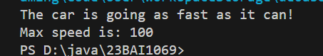

**12.**

public class Cnstrtr {

    int x ;

    public Cnstrtr(){

        x=15;

    }

    public static void main(String[] args) {

        Cnstrtr obj = new Cnstrtr();

        System.out.println(obj.x);

    }

}

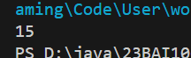

**13.**

public class Parameter {

    int x;

    public Parameter(int y){

        x=y;

    }

    public static void main(String[] args) {

        Parameter p = new Parameter(5);

        System.out.println(p.x);

    }

}

