**1.**

public class Multipara{

    int modelYear;

    String modelName;

    public Multipara(int year, String name){

        modelYear=year;

        modelName= name;

    }

    public void print(){

        System.out.println(modelYear +" " +modelName);

    }

    public static void main(String[] args){

        int n = 2005;

        String name = "Porsche";

        Multipara o1 = new Multipara(n,name);

        o1.print();

    }

}

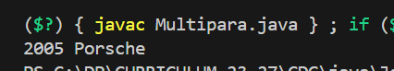

**2.**

a-

abstract class Main {

    public String fname = "John";

    public int age = 24;

    public abstract void study();

}

class Main2 extends Main {

    public int graduationYear = 2018;

    public void study(){

        System.out.println("Studying all day long");

    }

}

b-

class Second{

    public static void main(String[] args){

        Main2 myObj = new Main2();

    System.out.println("Name "+myObj.fname);

    System.out.println("Age: "+myObj.age);

    System.out.println("Graduation Year: "+myObj.graduationYear);

    myObj.study();

    }

}

