**JAVA PROGRAMMING- BCSE103E**

**NAME: B S NAVEEN**

**REGST. NO: 23BAI1069**

**GITHUB:** [**https://github.com/naveen-orb26/Java_Fall_24-25.git**](https://github.com/naveen-orb26/Java_Fall_24-25.git)

**1.**

public class Print{

public static void main(String[] args){

System.out.println("Hello World!");

}

}

**OUTPUT:**

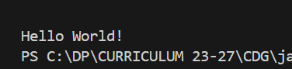

**2.**

public class Variable {

    public static void main(String[] args) {

        final int b = 12;

        int a=25;

        a+=10;

        //b+=5;

        String str= "Hello world";

        System.out.println(a);

        System.out.println(b);

        System.out.println(str);

    }

}

**OUTPUT:**

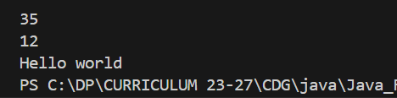

**3.**

public class Comments {

    public static void main(String[] args) {

        final int b = 12;

        int a=25;

        a+=10;

        //b+=5; This is a single line comment (final variable cannot be assigned a value)

        /* This is a

        multiline

        comment*/

        //comments will not be executed

        String str= "Hello world";

        System.out.println(a);

        System.out.println(b);

        System.out.println(str);

    }

}

**OUTPUT:**

