**1.**

import java.util.Scanner;

public class Food {

    public static void main(String[] args) {

        Scanner sc = new Scanner(System.in);

        int tt = sc.nextInt();

        for(int i=0;i<tt;i++){

            int xx = sc.nextInt();

            int yy = sc.nextInt();

            System.out.println(xx*yy);

        }

    }

}

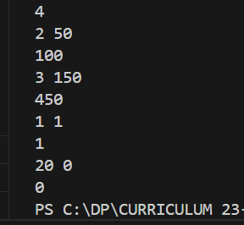

**2.**

class Animal {

    String color="white";

}

class dog extends Animal{

    String color = "Black";

    void printcolor(){

        System.out.println(color);

        System.out.println(super.color);

    }

}

class Animals{

    public static void main(String[] args){

        dog d = new dog();

        d.printcolor();

    }

}

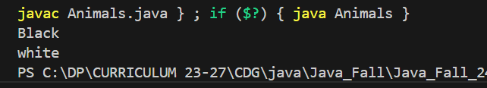

**3.**

class Animal{

    void eat(){System.out.println("Eating...");}

}

class Dog extends Animal{

    void eat(){System.out.println("Eating bread...");}

    void bark(){System.out.println("Barking..");}

void work(){

    super.eat();

    eat();

    bark();

}

}

public class Testsuper {

    public static void main(String[] args){

        Dog d = new Dog();

        d.work();

    }

}

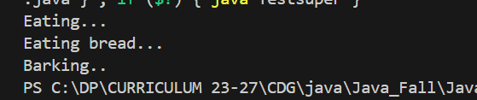

**4.**

class Animal{

    Animal(){

        System.out.println("The animal is created");

    }

}

class dog extends Animal{

    dog(){

        super();

        System.out.println("The dog is created");

    }

}

public class Testsuper3 {

    public static void main(String[] args) {

        dog dg = new dog();

    }

}

