18/07

**TypeCasting**

Widening

CODE:

public class tc{

public static void main(String[] args){

int myInt= 8;

double myDouble=myInt;

System.out.println(myInt);

System.out.println(myDouble);

}

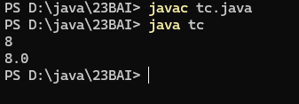}

OUTPUT:

Narrowing

CODE:

public class tcn{

public static void main(String[] args){

double myDouble=9.78d;

int myInt=(int) myDouble;

System.out.println(myDouble);

System.out.println(myInt);

} }

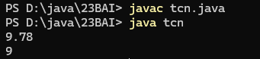OUTPUT:

**Operators**

**Sum**

public class operators{

public static void main(String[] args){

int sum1= 150;

string str1= "check";

int sum2 =sum1 +150;

int sum3= sum1+sum2;

int sample = sum1 + str1;

string sample2 = sum1 + str1;

string sample3 = "new " +str1;

System.out.println(sum2);

System.out.println(sum3);

System.out.println(sample);

System.out.println(sample2);

System.out.println(sample3);

}

}



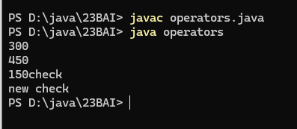

**Ternary operator:**

public class TernaryOp{

public static void main(String args[]){

int x,y;

x=20;

y=(x==1)?48:81;

System.out.println("Value of y is "+y);

y=(x==20)?48:81;

System.out.println("Value of y is: "+y);

}

}

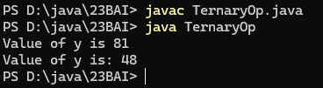

**Strings**

public class str{

public static void main(String[] args){

String txt= "ABCDEFGHIJKLMNOPQRSTUVWXYZ";

System.out.println("The length of the text string is: "+ txt.length());

}}

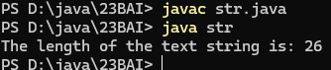

public class Case{

public static void main(String[] args){

String word="Hello World";

System.out.println(word.toUpperCase());

System.out.println(word.toLowerCase());

}}

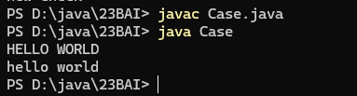

public class Locate{

public static void main(String[] args){

String test="Please locate where 'locate' occurs!";

System.out.println(test.indexOf("locate"));

}}

