1. **Concatenation**

public class concat{

    public static void main(String args[]){

        String Fname = "Naveen";

        String Sname = "B S";

        System.out.println(Fname + " " + Sname);

    }

}

**Output:**

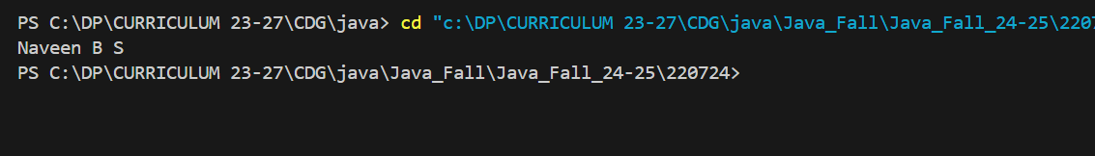

1. **Concatenation method**

public class concat2 {

public static void main(String args[]){

String Fname = "Naveen";

String Sname = " B S";

System.out.println(Fname.concat(Sname));

}

}

**Output:**

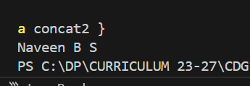

**3.**

public class strint {

    public static void main(String[] args){

        String x= "10";

        int y = 20;

        String z = x+y;

        System.out.println(z);

    }

}

**Output:**

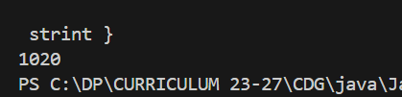

**4.**

public class Specialchar {

    public static void main(String[] args){

        String txt1= "We are the so called \"Vikings\" from the north ";

        String txt2 = "We are the so called \'Vikings\' from the north";

        String txt3= "We are the so called \\ Vikings \\ from the north";

        System.out.println(txt1);

        System.out.println(txt2);

        System.out.println(txt3);

    }

}

**OUTPUT:**

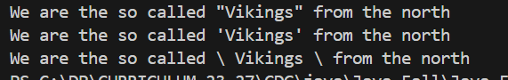

**5.**

public class max {

    public static void main(String[] args){

        System.out.println(Math.max(5,10));

    }

}

**OUTPUT:**

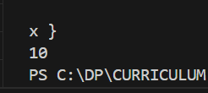

**6.**

public class min {

    public static void main(String[] args){

        System.out.println(Math.min(5,10));

    }

}

**OUTPUT:**

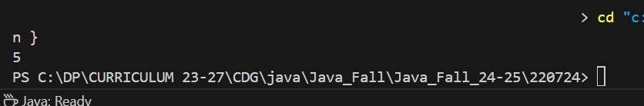

**7.**

public class sqrt {

    public static void main(String[] args) {

        System.out.println(Math.sqrt(64));

    }

}

**OUTPUT:**

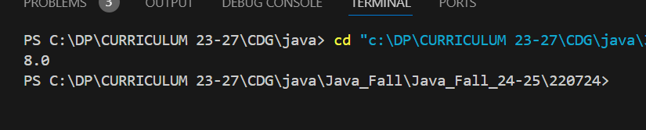

**8.**

public class abs {

    public static void main(String[] args) {

        System.out.println(Math.abs(-4.7));

    }

}

**OUTPUT:**

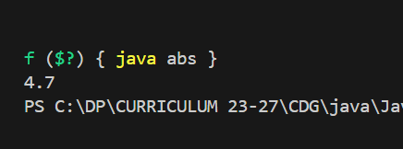

**9.**

public class random {

    public static void main(String[] args) {

        System.out.println(Math.random());

    }

}

**OUTPUT:**

