Exercise
- Create a directory "exercise" inside your home directory and create nested(dir1/dir2/dir3) directory structure inside "excerise" with single command.

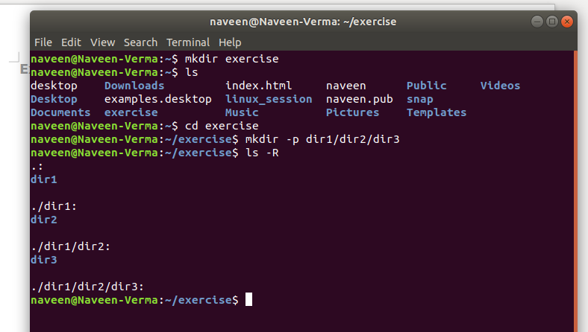
2. Create two empty files inside dir2 directory: emptyFile1,emptyFile2 in single command

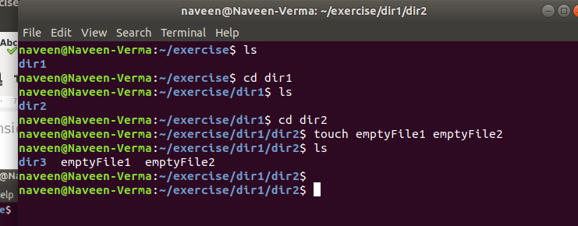

3. Create one file file1.txt containing text "hello world" and save it.

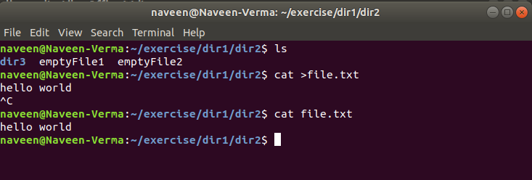
4. Find a "passwd" file using find command inside /etc. copy this files as passwd_copy and then rename this file as passwd_backup.

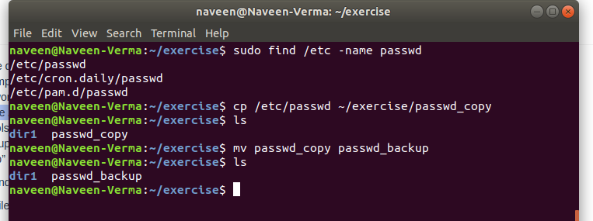
5. Try reading passwd_backup file in multiple tools: less,more,cat,strings etc and find the difference in their usage.
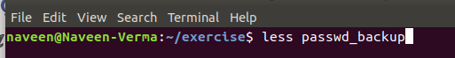

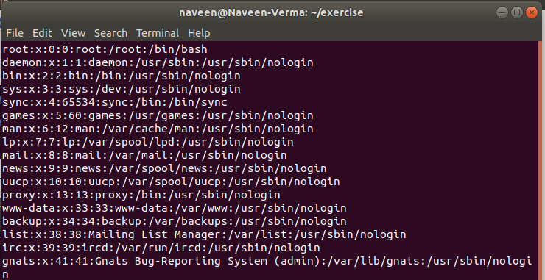

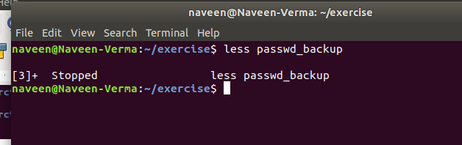
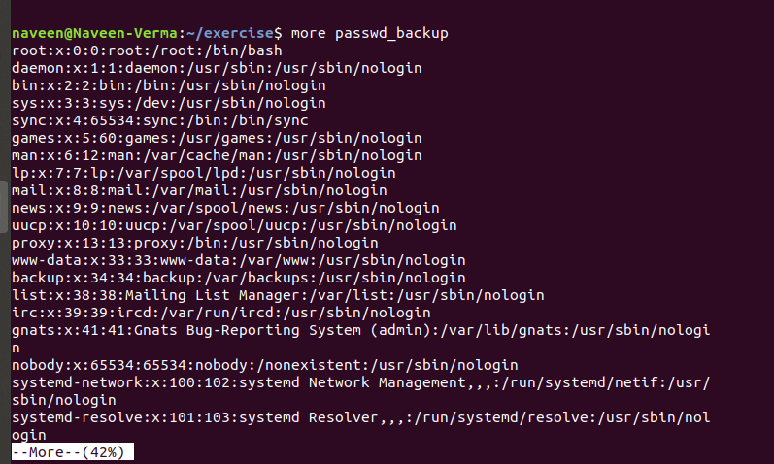

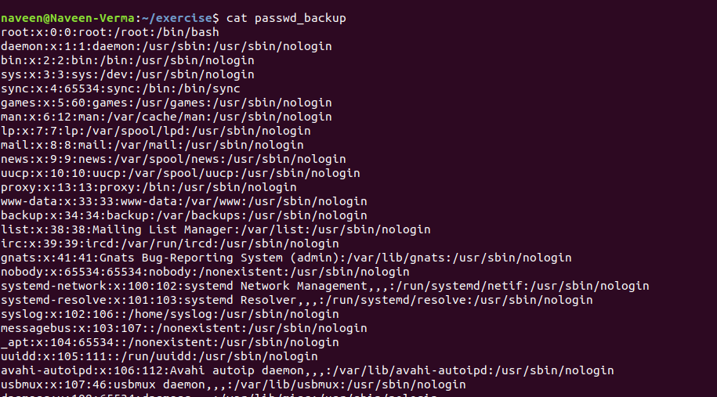

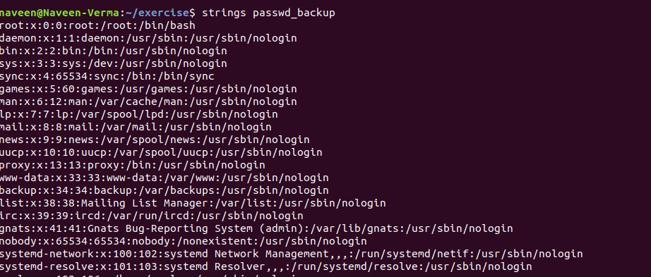
- Less shows the content one screen at a time and navigation using enter or spacebar.
- While, cat is short for concatenate that is use to show the content of the file also use to create, modify, append, etc.
- More shows the file content one screen at a time and navigation is done using up and down keys.

- Strings is use to print the printable characters.

6. Find out the number of line in password_backup containing "/bin/false".
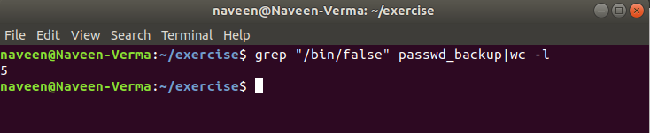
7. Get the first 5 lines of a file “password_backup” and Redirect the output of the above commands into file "output".

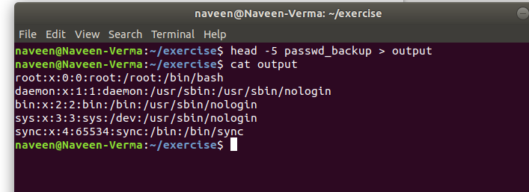

8. Create a "test" user,create its password and find out its uid and gid.

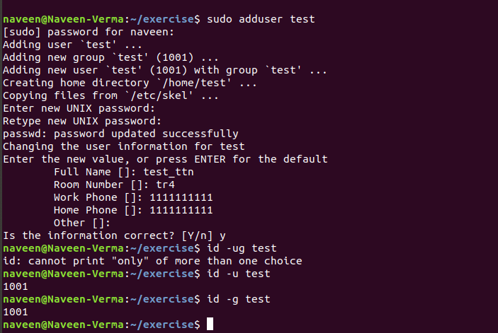

9. Change the timestamp of emptyFile1,emptyFile2 which are exist in dir2

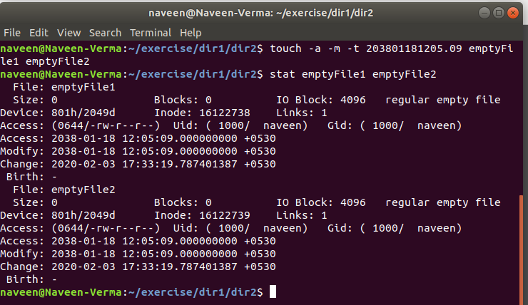
10. Login as test user and edit the "output" file created above. Since the permission wont allow you to save the changes. Configure such that test user can edit it.
- Add group owner of the "output" file as the secondary group of testuser and check/change the "output" file permission if it is editable by group. Once done revert the changes.
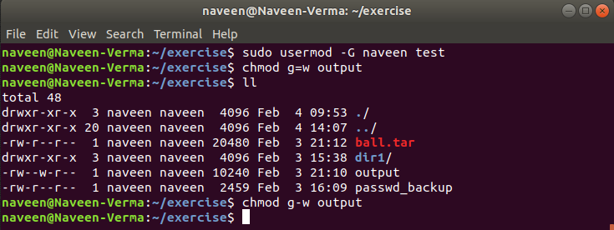

2. Make the file editable to the world so that test user can access it. Revert the changes after verification
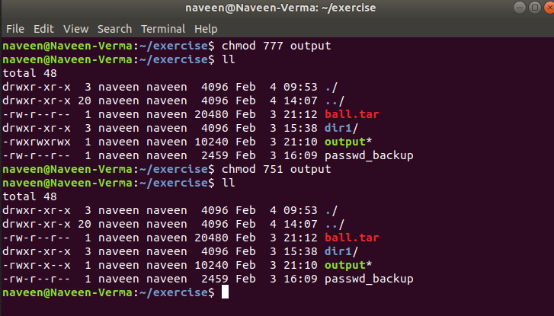
3. Change the ownership to edit the file.
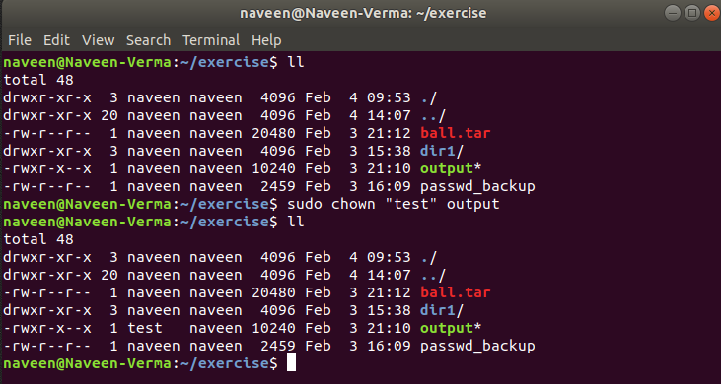

11. Create alias with your name so that it creates a file as "/tmp/aliastesting".
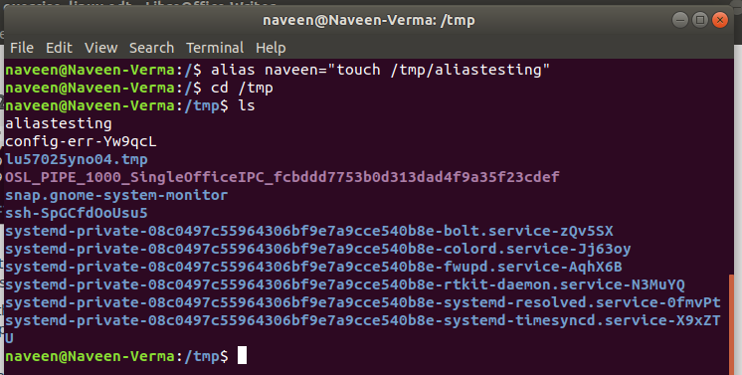

12. Edit ~/.bashrc file such that when you change to "test" user it should clear the screen and print "Welcome".

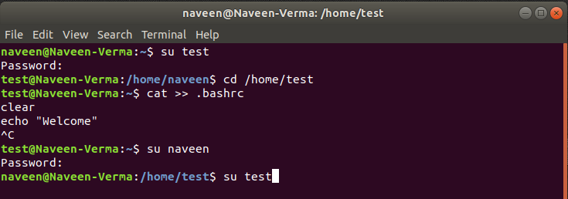
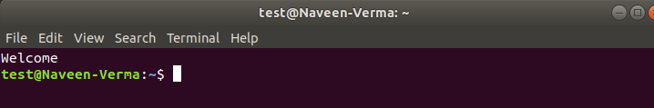

13. Install “zip” package.

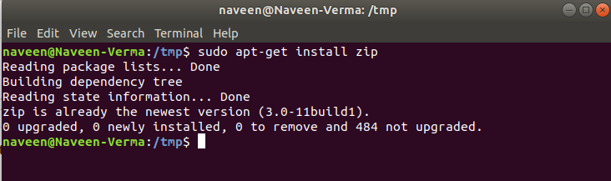
14. Compress "output" and "password_backup" files into a tar ball. List the files present inside the tar created.

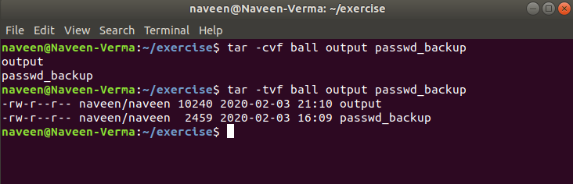
15. scp this file to test user
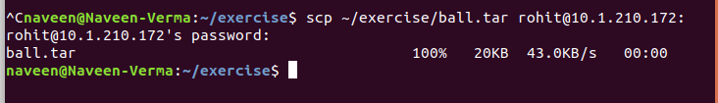

16. Unzip this tar bar by logging into the remote server
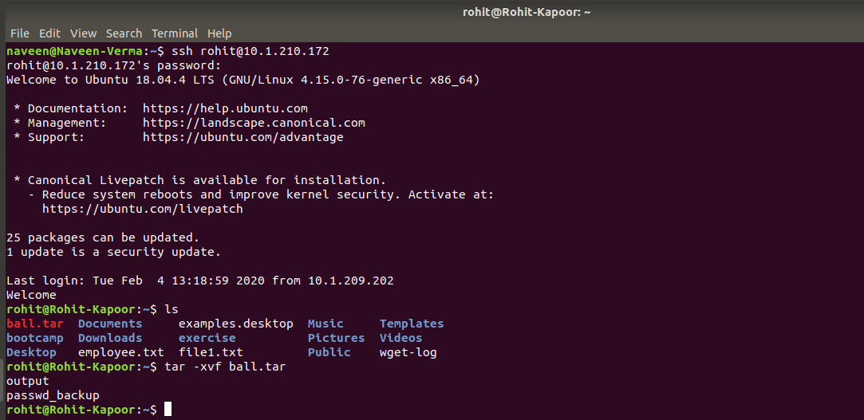
17. Download any image from web and move to desktop

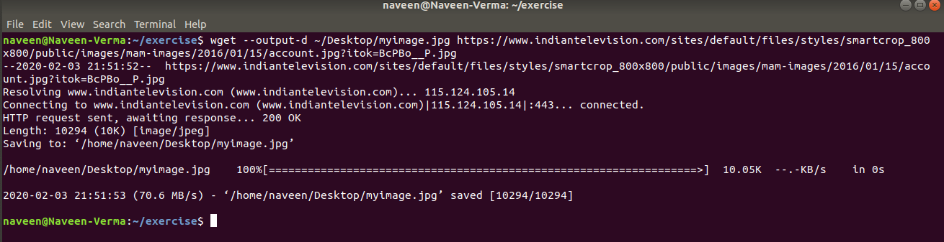
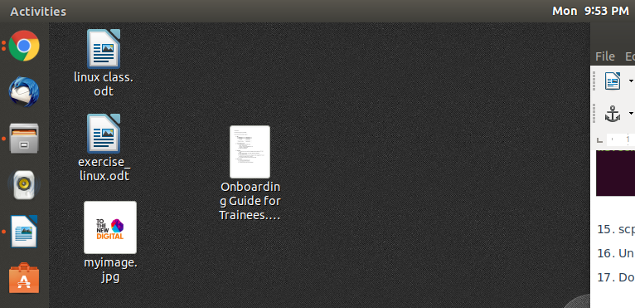
18. How to get help of commands usages.

Ans: We can use the following to get the help:
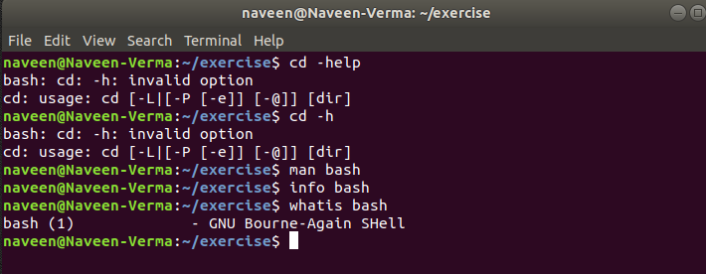

19. Create a symlink of /etc/services into /tmp/ports-info
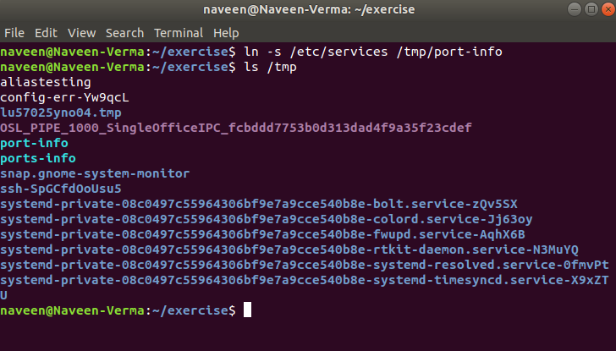

20. You are appointed as a Software/DevOps Engineer in ABC media services. On your first day you need to troubleshoot a problem. There is a command “xyz” somewhere installed in that linux system. But as a new joinee you do not have any idea about where is that Installed. How can you check that?

Ans: We an use type command to check for the specific command.
Like i created the alias “naveen” in question 11
so, we can find the command usage as follows:

