Exercise
Problem Statement: There can be multiple customers, who can place multiple orders on the site. Now a sales person can handle these orders will distribute into multiple sales persons (One order will be assign to one salesperson only). So a sales person can have multiple orders of multiple customers
- Create Database
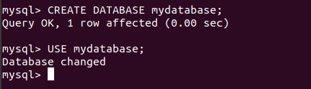

- Design Schema

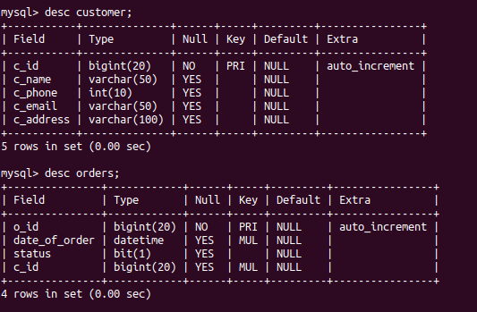
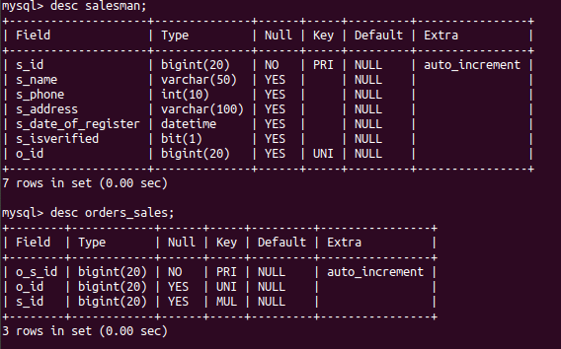
- Create tables

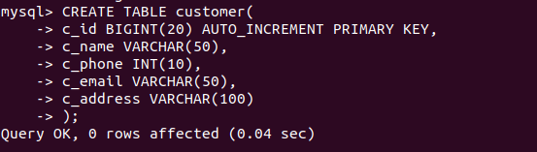
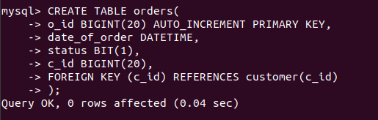

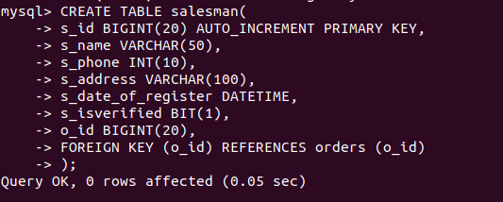

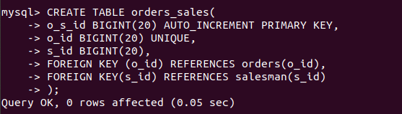

- Insert sample data
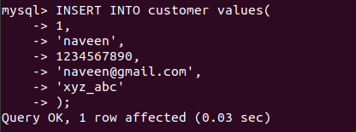

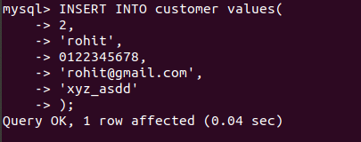

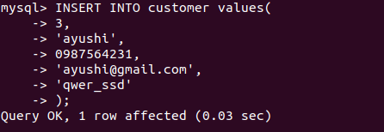

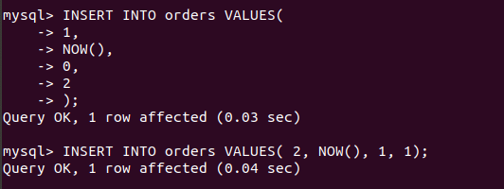
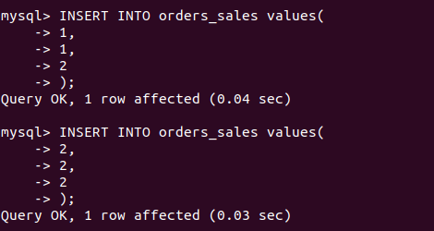

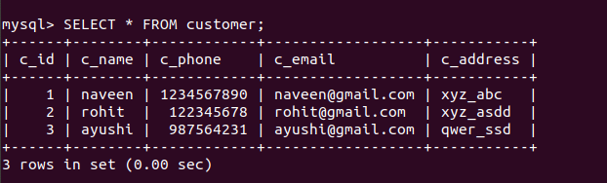
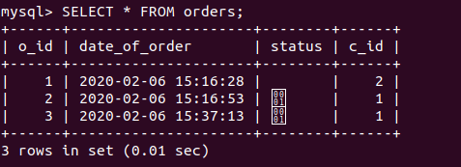

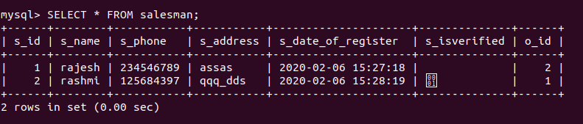
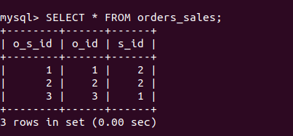

- Find the sales person have multiple orders.
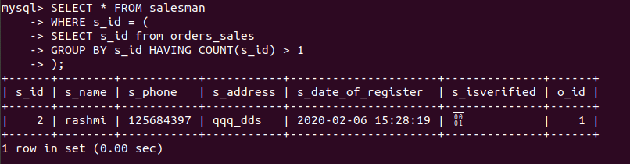
- Find the all sales person details along with order details
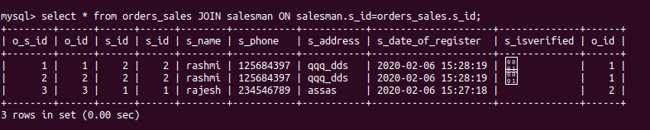
- Create index
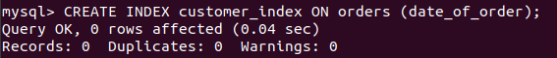
- How to show index on a table

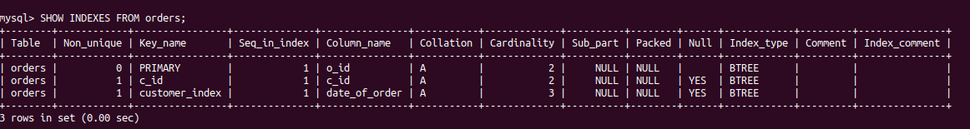
- Find the order number, sale person name, along with the customer to whom that order belongs to.
