**SQL Preparation**

**Functions:**

1. **What is Function? Why we use it? What are different Types?**

A function is a set of SQL statements frequently used are grouped together to perform a task. It accepts input parameters, perform calculations and miniplate the data to return the required result.

They help to improve the code readability and reusability.

We have 2 types of functions

**Aggregate Functions:** operate on a set of values and return a single value.

**Scalar Functions:** operate on a set of values and return a single value.

On the other hand, functions defined by users known as user defined functions. Functions defined by system are known as build-in functions.

### **Key Differences**

|  |  |  |
| --- | --- | --- |
| **Aspect** | **Scalar Functions** | **Aggregate Functions** |
| **Input** | Single value | Set of values |
| **Output** | Single value | Single summary value for the set |
| **Context of Use** | Individual data manipulation | Data summarization or aggregation |
| **Common Examples** | LEN (), ROUND (), GETDATE () | SUM (), AVG (), COUNT () |

Ex of Aggregate Functions:

**Avg** (): Returns the average value

**Sum** (): Returns sum of values

**Min** (): Returns the minimum value

**Max** (): Returns maximum value

**Count** (): Returns the no of rows including those having NULL values.

**First** (): Returns the first value from a column

**Last** (): Return the last value from a column.

**STDEV** () - Returns the standard deviation.

**VAR** () - Calculates the variance.

**GROUPING** () - Indicates whether a column in a GROUP BY is aggregated.

**COUNT_BIG** () - Counts rows but returns a BIGINT result.

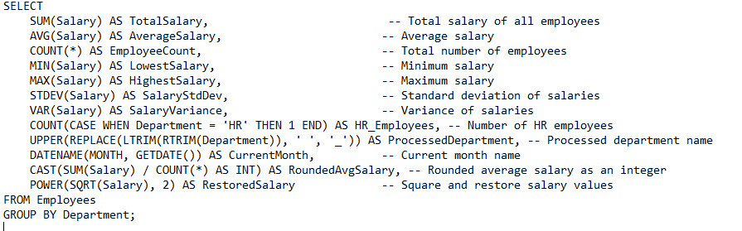

**GROUPING ()**: Used with GROUP BY to indicate whether a column is included in the grouping.

* It returns:
  + 0 if the column is part of the grouping.
  + 1 if the column is not included in the grouping and represents aggregated data.

SELECT Department, GROUPING(Department) AS IsAggregated, SUM(Salary) AS TotalSalary FROM Employees GROUP BY GROUPING SETS ((Department), ());  
-- Identifies which rows are aggregated totals (IsAggregated = 1).

* **COUNT_BIG ()**: Functions like COUNT (), but it returns a BIGINT (useful for very large datasets).

SELECT COUNT_BIG (*) AS TotalRows FROM LargeDataset;  
-- Counts the total number of rows in a large dataset and returns the r

Ex of Scalar Functions:

* **String Functions**:
  + LEN () - Returns the length of a string.
  + UPPER () - Converts a string to uppercase.
  + LOWER () - Converts a string to lowercase.
  + SUBSTRING () - Extracts a substring from a string.
  + LTRIM (), RTRIM () - Removes leading/trailing spaces.
  + REPLACE () - Replaces occurrences of a substring.
  + CHARINDEX () - Returns the position of a substring.
  + CONCAT () - Concatenates two or more strings.
  + INIT
* **Date and Time Functions**:
  + GETDATE () - Returns the current date and time.
  + DATEADD () - Adds a specified time interval to a date.
  + DATEDIFF () - Returns the difference between two dates.
  + DATENAME () - Returns a part of a date as a string (e.g., month name).
  + YEAR (), MONTH (), DAY () - Extract specific date parts.
* **Mathematical Functions**:
  + ABS () - Returns the absolute value.
  + CEILING (), FLOOR () - Rounds a number up or down to the nearest integer.
  + ROUND () - Rounds a number to a specified precision.
  + POWER () - Returns a value raised to a power.
  + SQRT () - Returns the square root.
* **System Functions**:
  + ISNULL () - Replaces NULL with a specified value.
  + CAST (), CONVERT () - Converts data types.
  + COALESCE () - Returns the first non-NULL value.

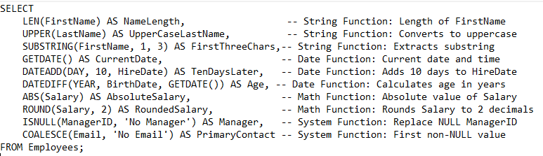

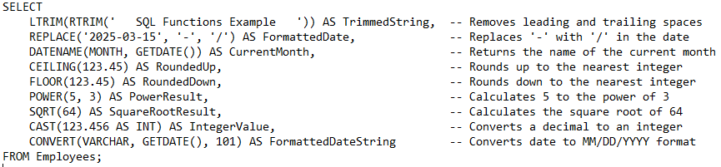

**Questions on functions:**

* What is a function in SQL Server, and why is it used?
* What are the different types of functions in SQL Server?
* Explain the difference between scalar functions and aggregate functions.
* What is the purpose of the GETDATE() function? Provide an example.
* How does the LEN() function work? Can it handle NULL values?
* What is the difference between CAST() and CONVERT()? When would you use each?
* Explain the use of GROUPING() in SQL Server. Provide an example.
* How can you use SUBSTRING() to extract a portion of a string? Provide an example.
* What are table-valued functions? How are they different from scalar functions?

**Table-Valued Functions (TVFs)**: Return a table instead of a single value.

Can be inline or multi-statement.

**Scalar Functions:** Return a single value.

**Example of inline TVF:**

CREATE FUNCTION GetEmployeesByDepartment (@Department NVARCHAR(50))

RETURNS TABLE

AS

RETURN (

SELECT * FROM Employees WHERE Department = @Department

);

* How do you calculate the standard deviation and variance of a column using SQL Server functions?
* What are inline table-valued functions, and how do they differ from multi-statement table-valued functions?

**Inline Table-Valued Functions:**

* Contain a single SELECT statement.
* Simpler and faster.

**Multi-Statement Table-Valued Functions:**

* Can have multiple statements with complex logic.
* Use a declared table variable to return rows.
* How can you create a custom user-defined function in SQL Server? Provide an example.

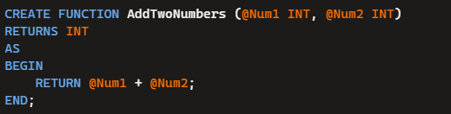

* What is the difference between deterministic and non-deterministic functions in SQL Server?

Deterministic functions provide consistency and are suitable for scenarios requiring repeatable results, while non-deterministic functions are dynamic and adapt to changing system states or conditions. Let me know if you’d like examples of specific use cases!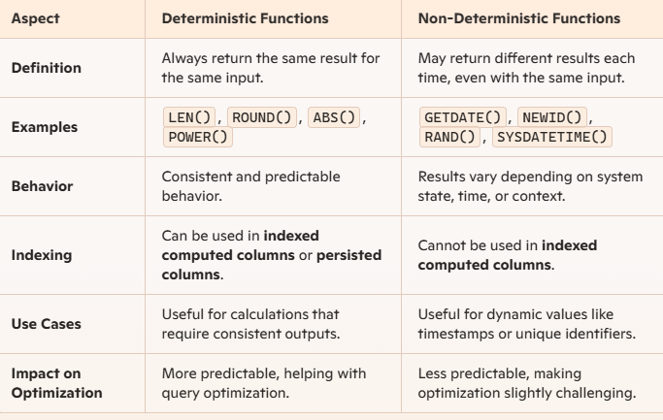

* How does the ROW_NUMBER() function work, and how is it different from RANK() and DENSE_RANK()?

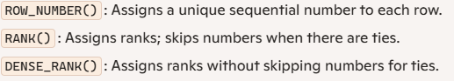

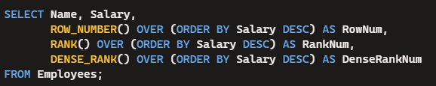

* Explain the use of window functions in SQL Server. Provide an example using OVER().

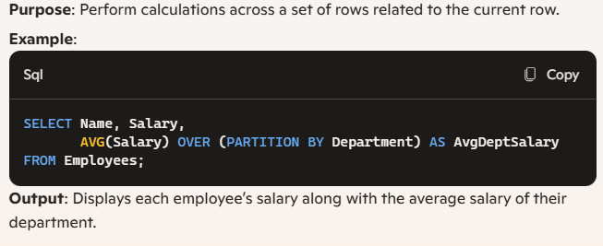

* Write a query to calculate the average salary of employees in each department using aggregate functions.
* How would you use ISNULL() or COALESCE() to handle NULL values in a dataset?
* Write a query to extract the first three characters of a string using SQL Server functions.
* How can you use DATEADD() and DATEDIFF() to calculate the number of days between two dates?
* Write a query to capitalize the first letter of each word in a string (similar to INITCAP).



* what are case manipulation and character manipulation functions

Case manipulation functions deal with altering the capitalization of strings. These are primarily used to convert text to uppercase or lowercase. EX: UCASE, LCASE

Character manipulation functions allow you to modify, extract, or replace characters in a string. EX: SUBSTRING(), Len(), CHARINDEX()- (case-sensitive)

LTRIM(), RTRIM(), REPLACE()

