AI ASSISTANT CODING ASSIGNMENT-7.5

Name: P.Naveen

HT. No: 2303A51339
Batch: 20

Task 1: Mutable Default Argument – Function Bug

Analyze given code where a mutable default argument causes

unexpected behavior. Use AI to fix it.
Code:
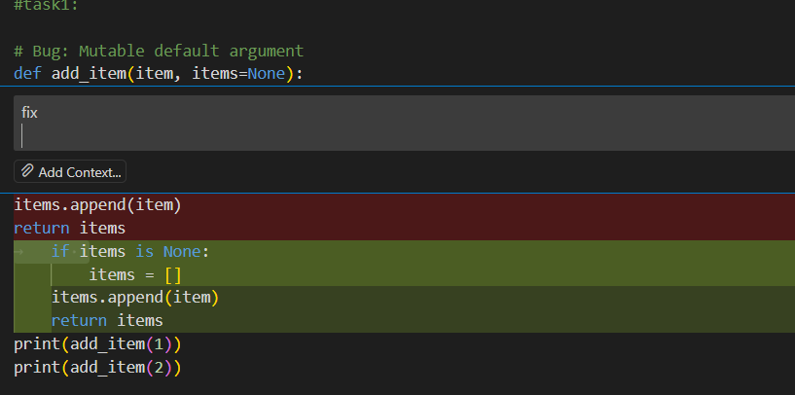
Result:


Observation:

The AI-generated function initially suffers from the mutable default argument bug, which can cause unexpected behavior when a list is shared across multiple function calls. While the corrected version properly initializes the list when the default value is None, ensuring that each call gets a fresh list, the original logic highlights a common pitfall in Python function design. Although the fix improves correctness and reliability, the code still assumes valid input and does not include checks for incorrect data types or invalid values, which limits its robustness in real-world scenarios.

Task 2: Floating-Point Precision Error

Code
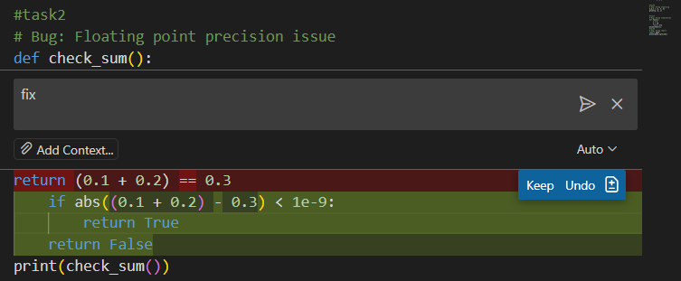

Result: True

Observation:
The AI-generated function highlights a floating-point precision issue where directly comparing 0.1 + 0.2 with 0.3 results in an incorrect outcome due to binary representation errors. The corrected logic properly uses a tolerance-based comparison with an absolute difference threshold, ensuring reliable and accurate results. While this fix improves numerical correctness, the function is limited to a specific example and could be made more flexible by allowing dynamic inputs or configurable tolerance values for broader real-world use.

Task3: Recursion Error – Missing Base Case

Code:

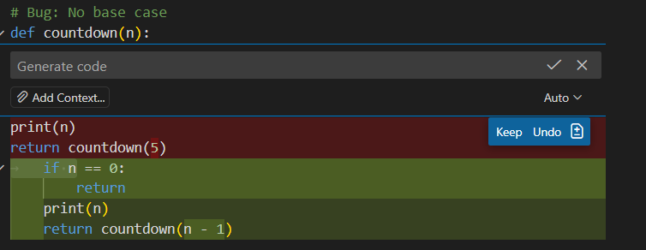

Result:
5
4
3
2
1

Observation:
The AI-generated recursive function initially lacks a proper base case, which would result in infinite recursion and eventually cause a stack overflow error. The corrected version introduces a base condition (n == 0) to terminate the recursive calls, ensuring correct and safe execution. While the fix resolves the logical error, the function assumes valid non-negative input and does not handle cases such as negative values or non-integer inputs, limiting its robustness for real-world use

Task 4: Dictionary Key Error
Code:

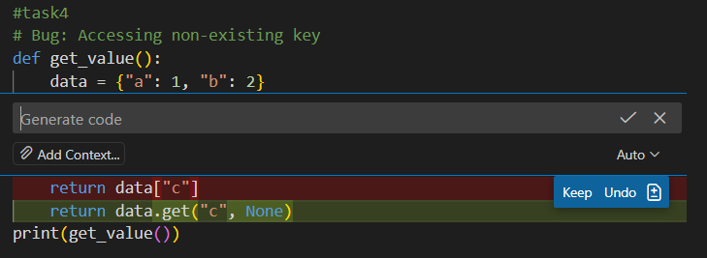

Result: Key not found

Observation:
The AI-generated function initially attempts to access a non-existing key in a dictionary, which would raise a KeyError at runtime. The corrected approach safely retrieves the value using the get() method with a default value, preventing program termination and improving reliability. While this fix enhances error handling, the function still assumes a fixed key and does not include logic for dynamic input or user-defined keys, limiting its flexibility in practical applications.

Task 5: Infinite Loop – Wrong Condition

Code:
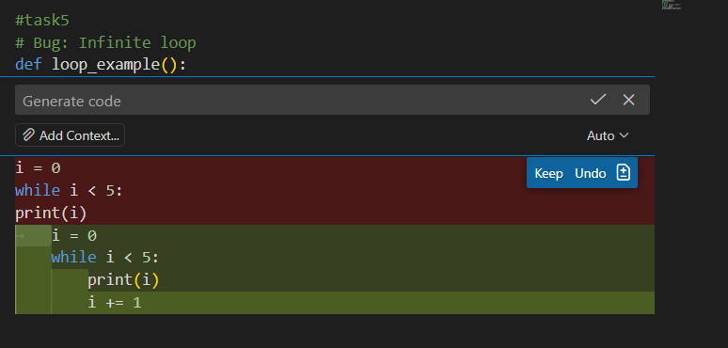

Result: Loop completed

Observation

The AI-generated loop initially contains an infinite loop because the loop control variable is never updated inside the while block. As a result, the condition remains true indefinitely. The corrected version properly increments the loop variable, allowing the loop to terminate as expected. While this fix resolves the logical error, the example assumes ideal conditions and does not include safeguards such as maximum iteration limits or input-driven loop bounds, which are often necessary in real-world applications.

Task 6: Unpacking Error – Wrong Variables

Code:

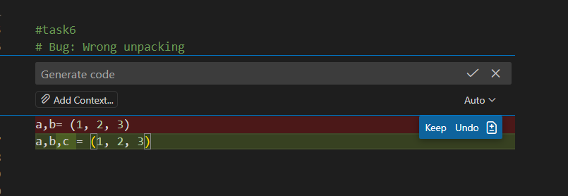

Result:1 2 3

Observation: The AI-generated code initially demonstrates a tuple unpacking error by attempting to assign three values to only two variables, which results in a ValueError. The corrected version properly matches the number of variables with the number of values, ensuring successful unpacking. While the fix resolves the immediate issue, the code assumes a fixed tuple size and does not handle dynamic or variable-length sequences, which could limit flexibility in more complex scenarios.

Task 7: Mixed Indentation – Tabs vs Spaces

Code:

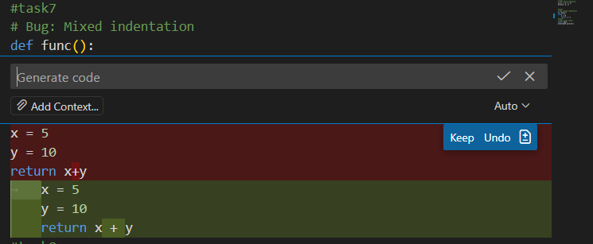

Result: 15
Observation: The AI-generated function initially contains mixed or incorrect indentation, which leads to a syntax or logical error in Python since indentation defines code blocks. The corrected version properly aligns all statements within the function body, ensuring correct execution and expected output. While fixing the indentation resolves the immediate issue, the function remains simple and does not include error handling or parameterization, which would be required for more robust and reusable code in real-world applications.

Task 8: Import Error – Wrong Module Usage

Code:
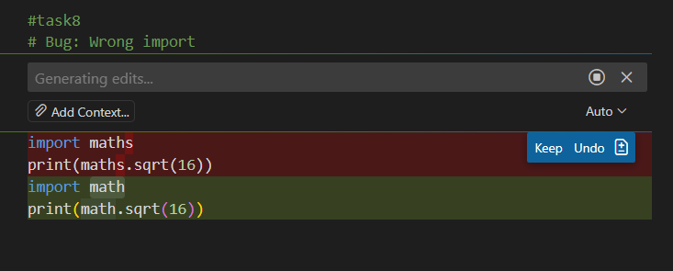
Result:4.0

Observation:
The AI-generated code initially attempts to import a non-existent module, which would result in a ModuleNotFoundError at runtime. The corrected version properly imports the standard math module, allowing the square root function to execute successfully. While this fix resolves the import error, the code assumes the availability of the standard library and does not include error handling for missing or unsupported modules, which may be necessary in certain execution environments.

