**MongoDB Crud Task**

**1.Create Opeartion**

**Task 1: Create a new database and switch to it by using use Library**

**Command- Use**

**Task 2 : Create a collection called books**



**Task 4** : Insert a document into the "books" collection



**2. Read Opeartion**

**Task 1: Retrieve all documents from the "books" collection using find command**

Find()

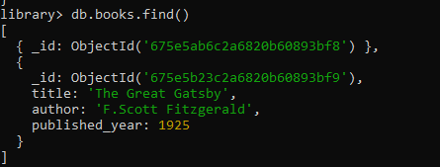

**Task 2 :** Find documents where the author is "J.K. Rowling"

* These can find by using command - db.books.find({ author: "J.K. Rowling" })



**Task 3 :**  **Fetch the document with the earliest published year**

* To fetch the document with earliest published year

We use Sort()



**3. Update Opeartion**

**Task 1: Update the published year of "The Catcher in the Rye" to the current year**

* To do this we use updateOne method updates the first document matching the query filter. The $set operator modifies the specified field.

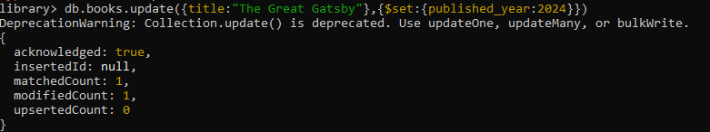

**Task 2 : Add a new field "genre" with the value "Mystery" to all documents**

* The update method updates all documents inthecollection. The $set operator adds or updates the
* specified field.

db.books.update({}, { $set: { genre: "Adventure" } }, { multi: true })

\

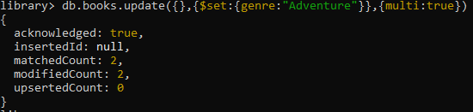

**4. Delete Opeartion**

**Task 1: Remove the document with the title "1984"**

* To do this we use Delete command



**Task 2 : Delete all documents where the published year is before 2000**



* The deleteMany command in MongoDB is used to delete all documents in a collection that match a specified filter condition

**4. Advanced Query**

#### Task 1: **Find the top 3 recently published books.**

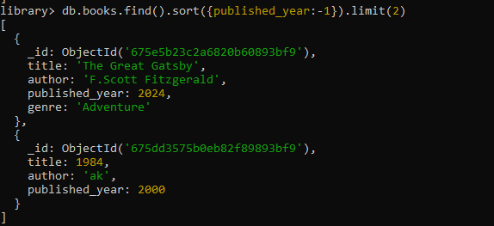

**Task 2:** Retrieve documents where the title contains "MongoDB" or "NoSQL".

db.books.find({ title: { $regex: "MongoDB|NoSQL", $options: "i" } })

* The $regex operator matches documents where the title field contains the specified pattern.