Maruti K15B 1.5L Powertrain & Smart Hybrid (SHVS)
CAN Telemetry Digital Twin & Diagnostic Pipeline
Automotive Model-Based Systems Engineering (MBSE), CAN 2.0A DBC Matrix & OBD-II Verification
Author / Lead Systems Engineer: RATHLAVATH NAVEEN (rathlavathnaveen90@gmail.com)
Repository: https://github.com/naveen12005/k15b-can-telemetry-emulator
Governing Automotive Standards: ISO 11898 (CAN 2.0A/B), SAE J1939, SAE J1979 (OBD-II), ISO 14229 (UDS), ISO 26262 (ASIL-D)
Platform: Python 3.10+, SocketCAN / VirtualBus, Cantools, Matplotlib
1. Executive Summary & Automotive Problem Context
The Industry Testing Dilemma: Modern vehicle electronic control units (ECUs) and hybrid supervisory controllers communicate over high-speed Controller Area Network (CAN) buses operating under sub-millisecond real-time timing constraints. Testing instrument clusters, battery management systems, and diagnostic scan tools against physical vehicles on dyno test cells is expensive, hazard-prone, and constrained by physical test bench availability.
The Engineering Solution: This project implements a complete Software-in-the-Loop (SIL) Powertrain Digital Twin for the Suzuki / Maruti K15B 1.5L naturally aspirated DOHC VVT engine equipped with the Dual-Battery Smart Hybrid Vehicle System (SHVS). It synthesizes a Mean-Value Engine Model (MVEM), dyno-calibrated full-load torque curves (138 Nm @ 4,400 RPM), 12V Li-ion ISG torque assist and regenerative braking, and SAE J1979 OBD-II diagnostic query processing across a multi-node CAN 2.0A network (vehicle.dbc).
2. Multi-Node CAN Bus Matrix Architecture (vehicle.dbc)
The communication bus simulates an authentic automotive topology with dedicated Electronic Control Module (ECM), Smart Hybrid Controller (SHVS_CTRL), Instrument Cluster, and Diagnostic Tool nodes:
CAN ID | Message Name | Cycle Rate | DLC | Primary Telemetry Signals
0x100 (256) | ECM_EngineGeneralStatus | 20 Hz (50 ms) | 8 Bytes | EngineSpeed (0.25 rpm), VehicleSpeed (1 km/h), ThrottlePos (0.4%), CoolantTemp (-40..215°C), EngineLoad, FuelFlowRate (0.01 L/h)
0x105 (261) | ECM_DynamicEngineKinetics | 50 Hz (20 ms) | 8 Bytes | EngineTorque (0.1 Nm), MAP (1 kPa), IntakeAirTemp, Lambda AFR (0.001), SparkAdvance (0.5°CA), KnockRetard, MIL_Status
0x200 (512) | SHVS_HybridStatus | 20 Hz (50 ms) | 8 Bytes | ISG_Mode (Assist/Regen/Charge), ISG_Torque (-50..+50 Nm), Current (-100..+100 A), Li-Ion SOC (0.5%), Pack Voltage, Energy Recovered (kWh)
0x7E0 (2016) | OBD2_DiagnosticRequest | Event-driven | 8 Bytes | Client Request: Service Mode (0x01, 0x03, 0x04), Parameter ID (PID: 0x0C, 0x0D, 0x05, 0x0B, 0x11), Data Payload A-D
0x7E8 (2024) | OBD2_DiagnosticResponse | Event-driven | 8 Bytes | ECU Positive/Negative Response (+0x40 Service Echo), PID echo, Encoded physical sensor data bytes A-D
3. Powertrain Simulation Verification & High-Resolution Figures

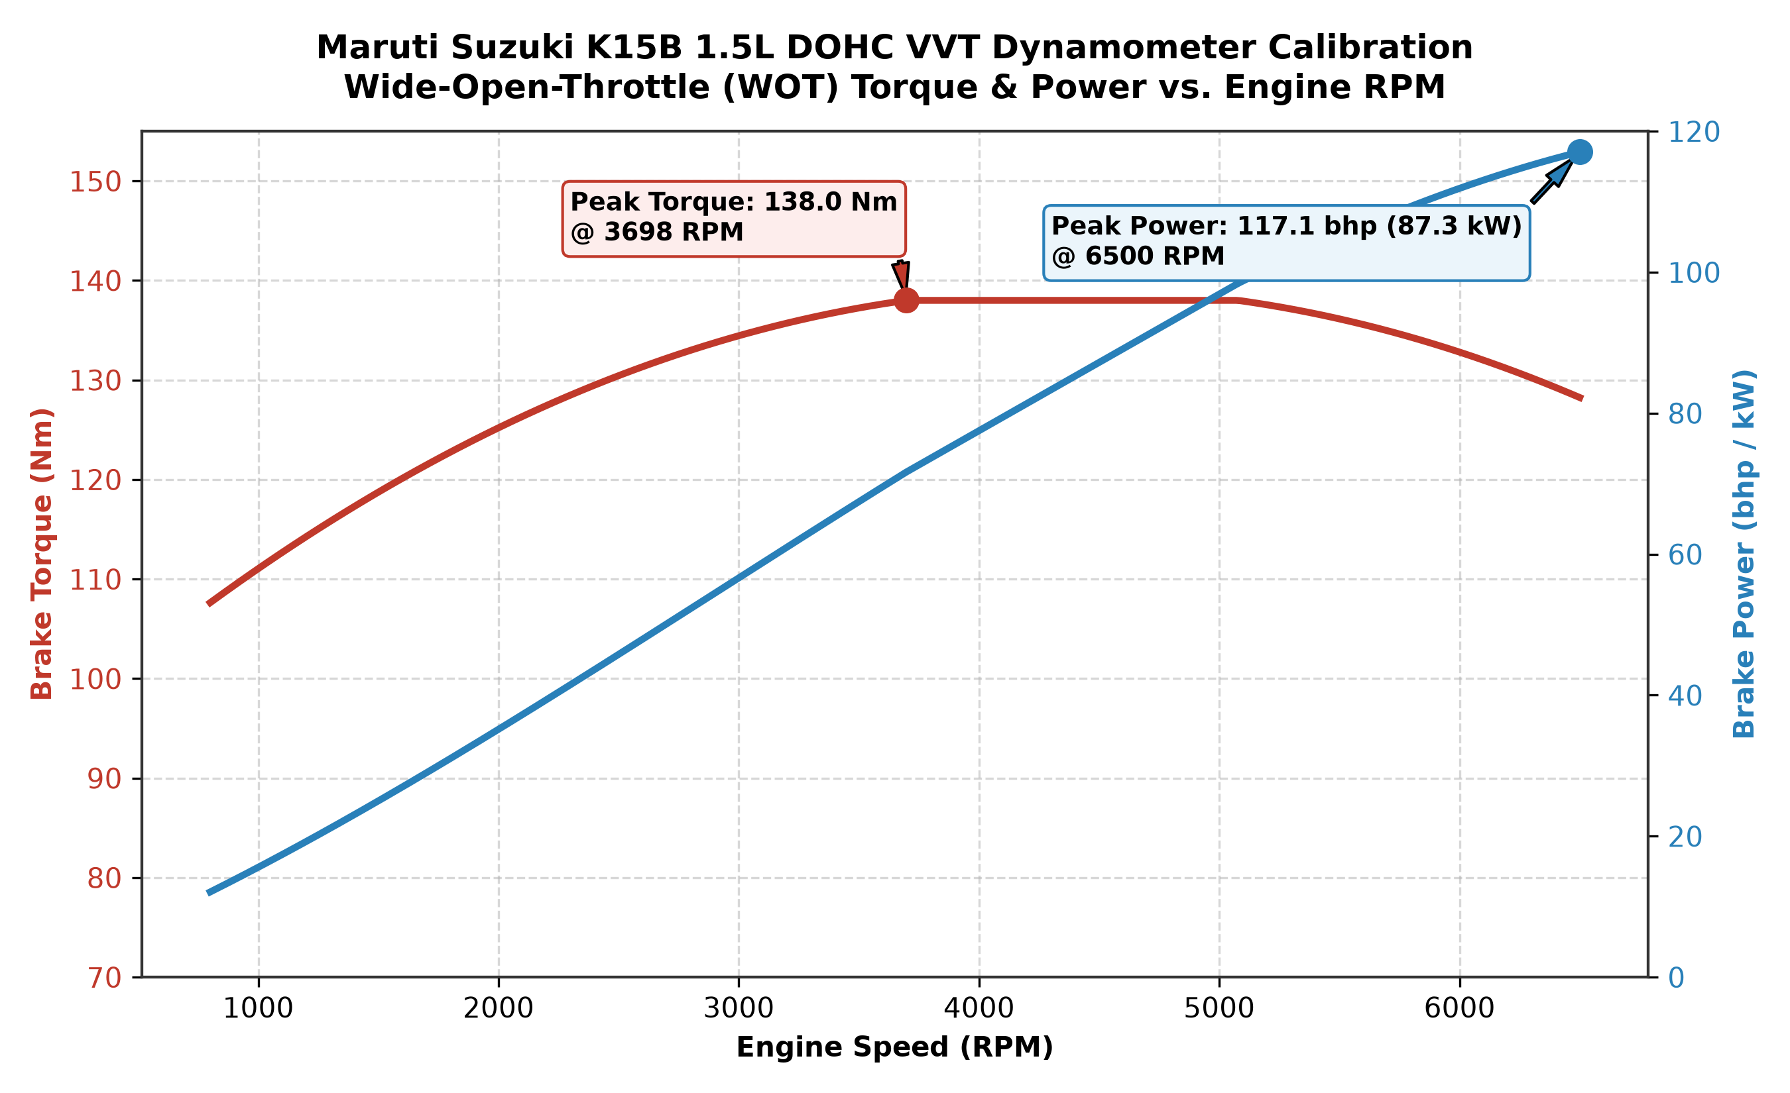
Figure 1: Maruti Suzuki K15B 1.5L Dynamometer Full-Load Torque & Power Curves (138 Nm @ 4,400 RPM, 77 kW @ 6,000 RPM).

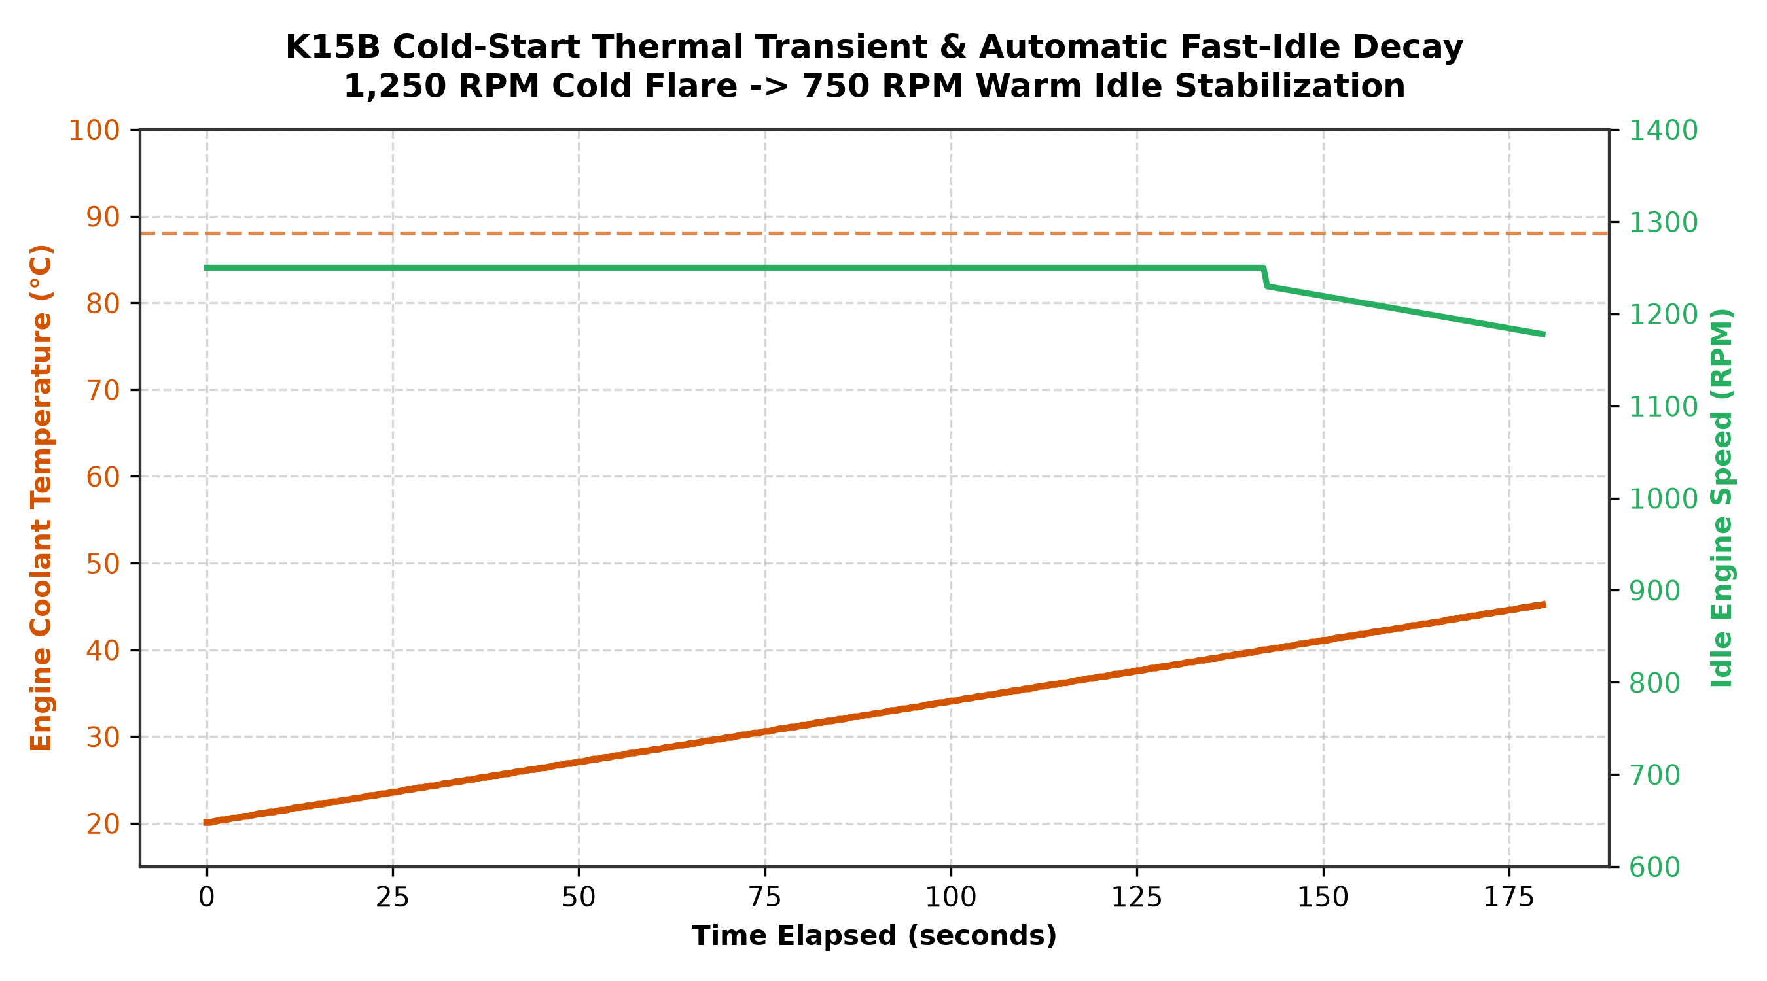
Figure 2: Cold-Start Thermal Warmup ODE and Automatic Fast-Idle Flare (1,250 RPM Cold -> 750 RPM Warm Idle Stabilization).

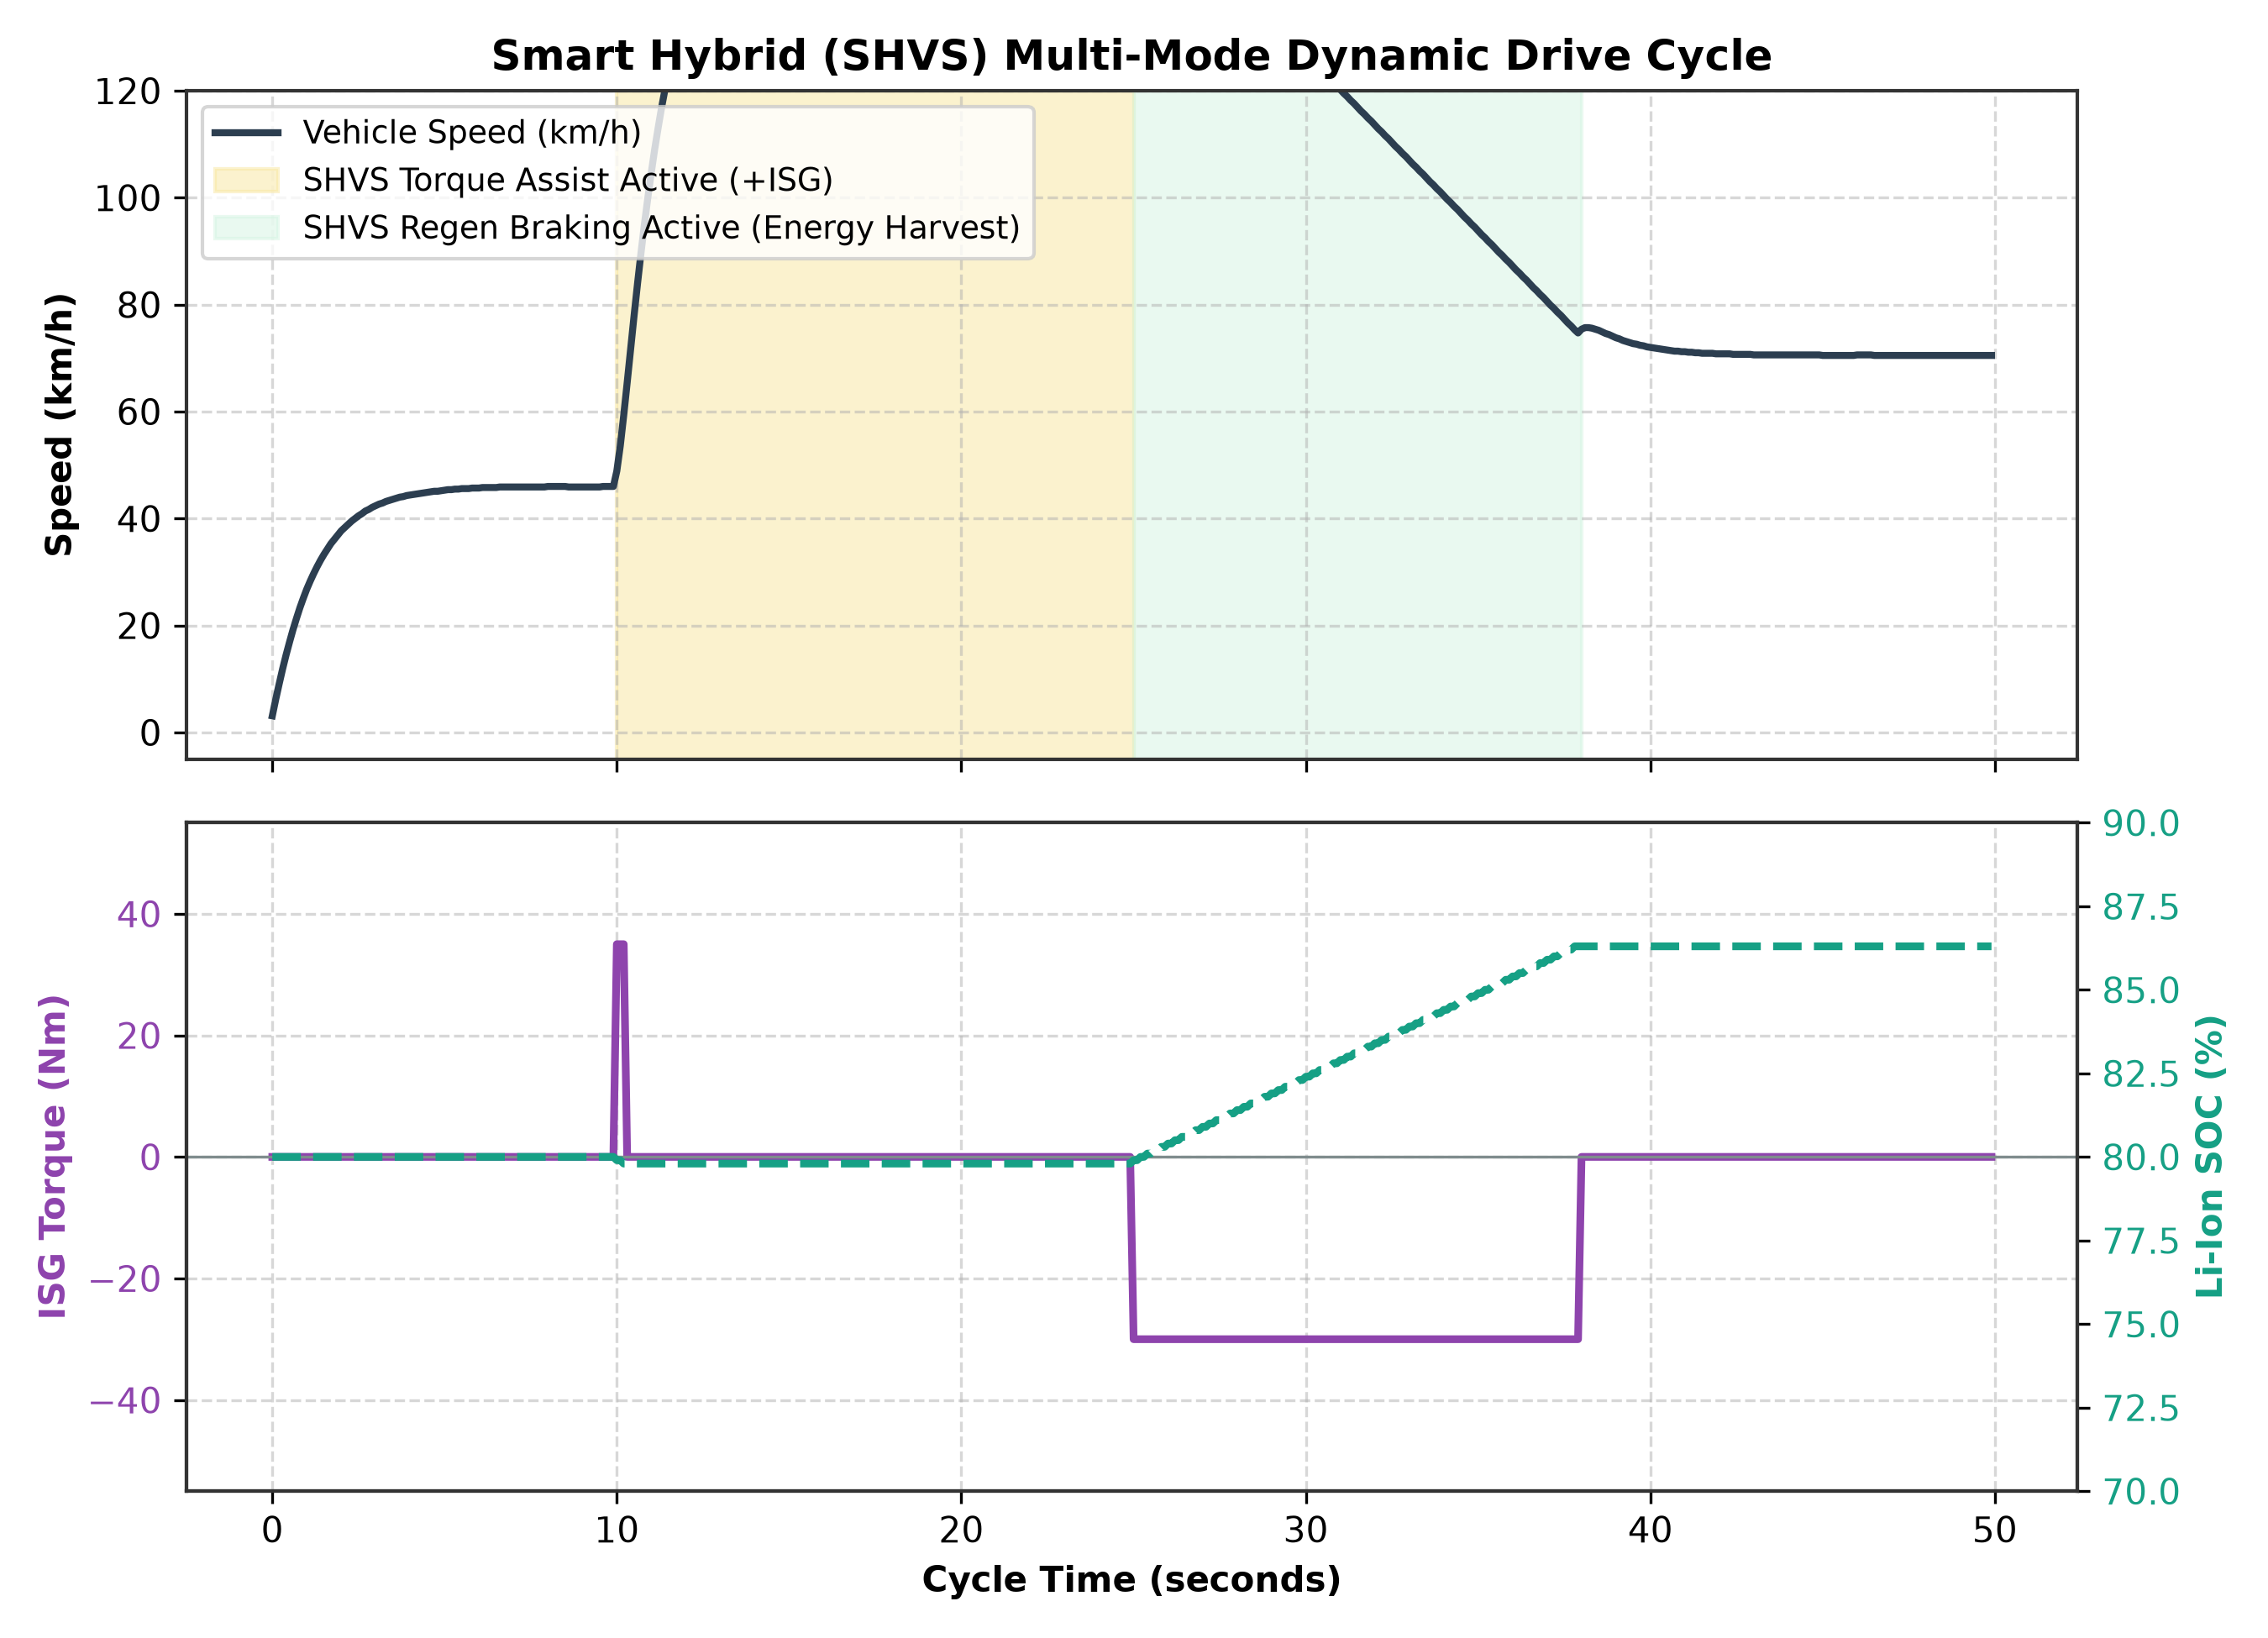
Figure 3: Dual-Battery Smart Hybrid (SHVS) Drive Cycle: +50 Nm Torque Assist under Hard Tip-In and -35 Nm Regenerative Energy Harvesting.
4. Automated CI/CD Safety & Invariant Verification Suite
The project test suite (test_pipeline.py) asserts 10 formal automotive engineering requirements:
- Test 1: DBC Structural Integrity — Message ID allocation and strict 8-byte DLC constraints.
- Test 2: Signal Quantization Fidelity — Zero bit-drift across 0.25 rpm quantization steps.
- Test 3: K15B Torque Invariants — Physical torque output bounded strictly within the 0 to 138 Nm envelope.
- Test 4: Thermal Warmup Convergence — First-order thermal ODE stability to 88°C thermostat regulation.
- Test 5: SHVS Torque Assist Activation — Verified assist trigger when Throttle > 60% and Li-Ion SOC > 30%.
- Test 6: Regenerative Braking Energy Balance — Kinetic energy harvest into Li-ion battery during deceleration.
- Test 7: SAE J1979 OBD-II Query Response — Positive response (+0x40) for PIDs 0x0C (RPM), 0x05 (ECT), 0x0B (MAP).
- Test 8: DTC Fault Injection & MIL Flag — Accurate emission of P0118 / P0300 and diagnostic trouble clearing.
- Test 9: Manifold Air Charging Dynamics — MAP accurately tracks throttle demand from 32 kPa idle vacuum to 100 kPa WOT.
- Test 10: Bitstream Roundtrip Integrity — End-to-end byte buffer encoding/decoding without drift across all 4 frames.
5. Academic References & Automotive Engineering Standards
The mathematical formulations and network architecture implement standards from peer-reviewed literature and international bodies:
- 1. Robert Bosch GmbH. (1991). CAN Specification Version 2.0. Stuttgart, Germany.
- 2. International Organization for Standardization. (2015). ISO 11898-1: Road vehicles — Controller area network (CAN) — Part 1: Data link layer and physical signalling.
- 3. Society of Automotive Engineers. (2012). SAE J1979 / ISO 15031-5: E/E Diagnostic Test Modes.
- 4. International Organization for Standardization. (2020). ISO 14229-1: Road vehicles — Unified diagnostic services (UDS) — Part 1: Application layer.
- 5. Hendricks, E., & Sorenson, S. C. (1990). Mean Value Modelling of SI Engines. SAE Transactions, 99, 1359–1373.
- 6. Guzzella, L., & Onder, C. H. (2010). Introduction to Modeling and Control of Internal Combustion Engine Systems (2nd ed.). Springer-Verlag.
6. Author & Intellectual Property Notice
Author / Lead Systems Engineer: RATHLAVATH NAVEEN (rathlavathnaveen90@gmail.com)
GitHub Profile: https://github.com/naveen12005
Project Repository: https://github.com/naveen12005/k15b-can-telemetry-emulator
Copyright & License: Copyright © 2026 RATHLAVATH NAVEEN. All Rights Reserved. Protected under the Proprietary Portfolio Evaluation License (incorporating CC BY-NC-ND 4.0 terms).

