AIM:
8-Puzzle Problem

LANGUAGE USED:
Python

PROGRAM:
from collections import deque
start = (1, 2, 3, 4, 0, 6, 7, 5, 8)
goal = (1, 2, 3, 4, 5, 6, 7, 8, 0)
q = deque([(start, [])])
visited = {start}

while q:
state, path = q.popleft()
if state == goal:
for s in path + [state]:
print(s[:3], s[3:6], s[6:])
break

z = state.index(0)
r, c = divmod(z, 3)

for dr, dc in [(-1,0),(1,0),(0,-1),(0,1)]:
nr, nc = r + dr, c + dc
if 0 <= nr < 3 and 0 <= nc < 3:
nz = nr * 3 + nc
new = list(state)
new[z], new[nz] = new[nz], new[z]
new = tuple(new)

if new not in visited:
visited.add(new)
q.append((new, path + [state]))

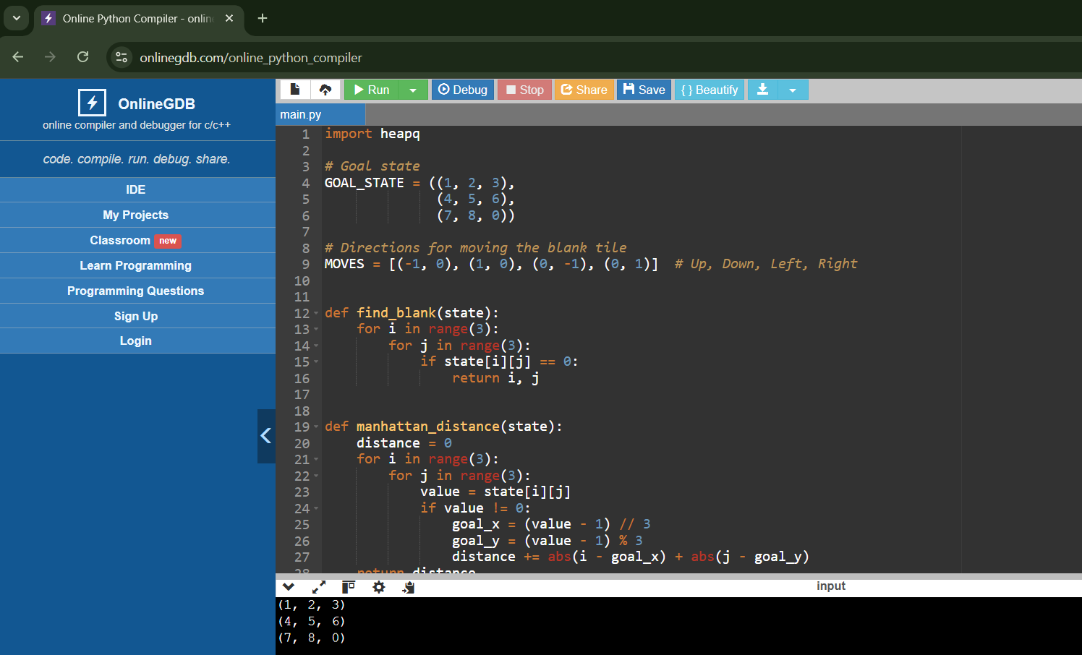
OUTPUT:

