**EXPERIMENT-11**

**DATE: 02-10-2025**

**AIM:**

To Change Hardware compatibility of a VM (Either by clone/create new one) which is already created and configured.

**PROCEDURE:**

**STEP 1:** GO TO VM WARE WORKSTATION.

**STEP2:** RIGHT CLICK THE VM AND GOTO THE SETTINGS.

**STEP 3:** ADD HARDWARE WIZARD AND SELECT SCSI AND CLICK NEXT.

**STEP 4:** CREATE NEW VIRTUAL DISK.

**STEP 5:** SELCT THE DISK SIZE AS 2.0. AND SELCT SPLIT VIRTUAL DISK INTO MULTIFILES.

**STEP 6:** GIVE NAME AND CLICK THE FINISH.

**IMPLEMENTATION:**

**STEP 1: GO TO VM WARE WORKSTATION**

**STEP2: RIGHT CLICK THE VM AND GOTO THE SETTINGS**

**STEP 3: ADD HARDWARE WIZARD AND SELECT SCSI AND CLICK NEXT** 

**STEP 4: CREATE NEW VIRTUAL DISK**

**STEP 5: SELCT THE DISK SIZE AS 2.0. AND SELCT SPLIT VIRTUAL DISK INTO MULTIFILES.**

**STEP 6: GIVE NAME AND CLICK THE FINISH**

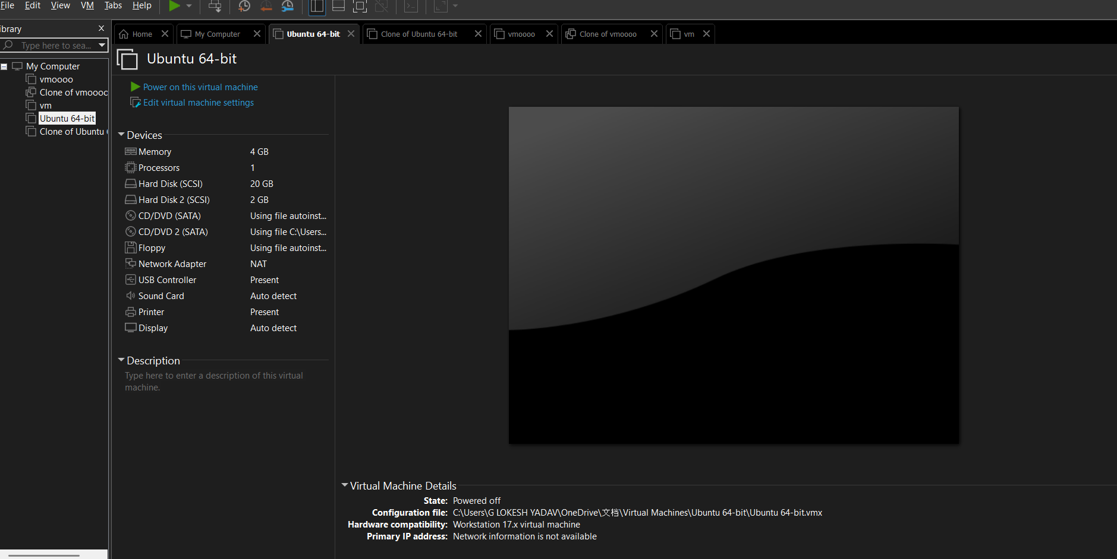

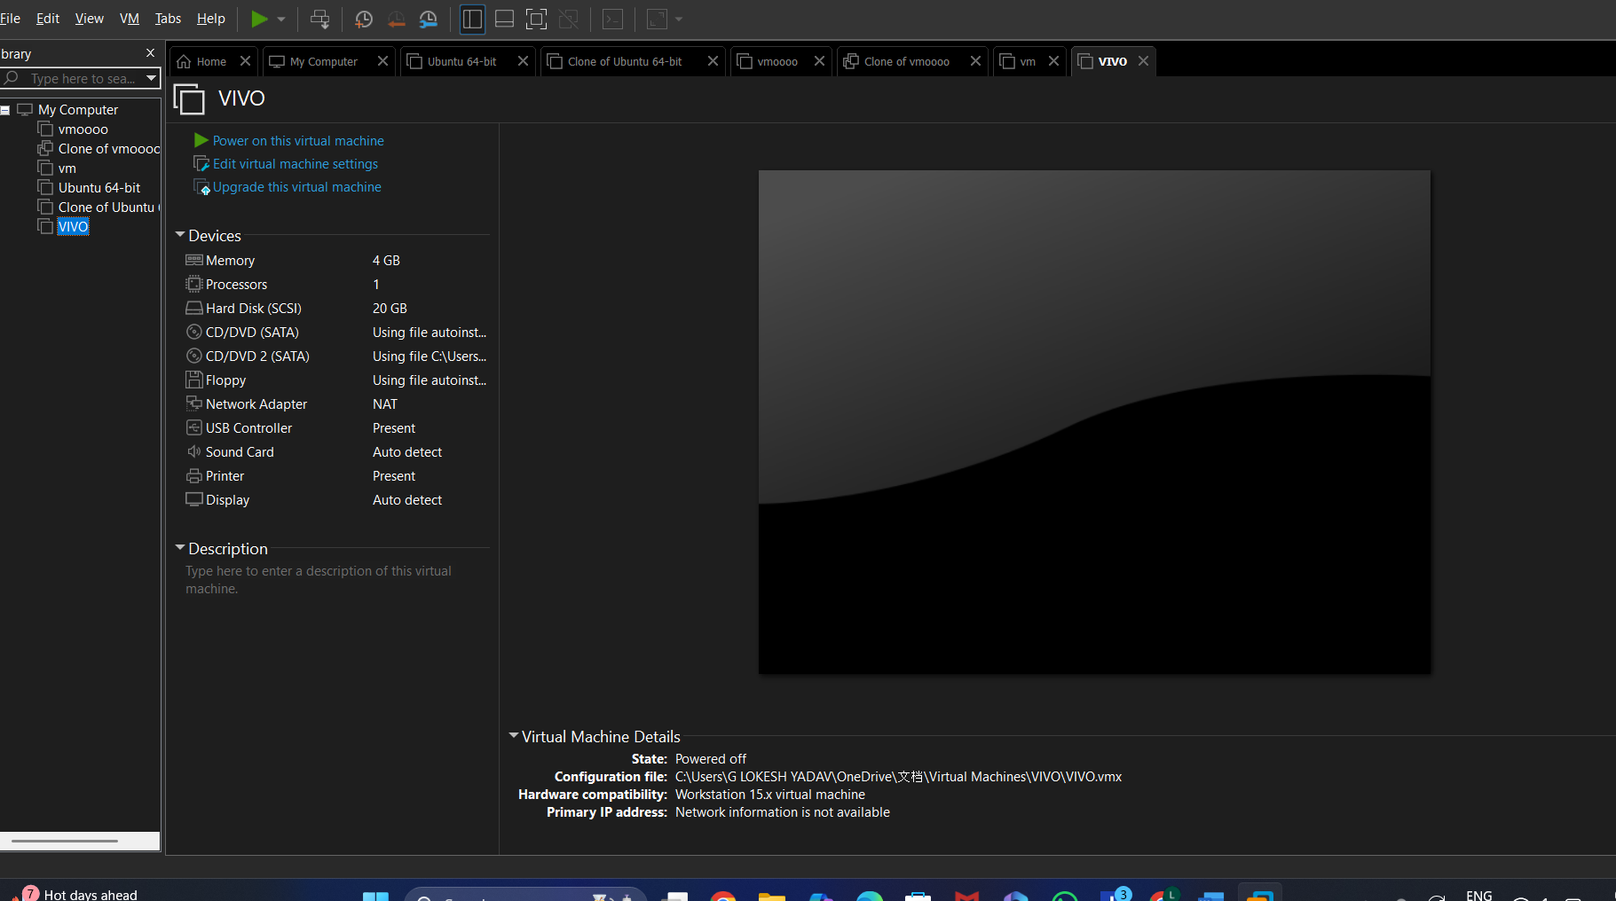

**RESULTS;** successfully Changed Hardware compatibility of a VM (Either by clone/create new one) which is already created and configured.