# AIM:

**INFRASTRUCTURE AS A SERVICE (IAAS) EXPERIMENT – 20**

To demonstrate Infrastructure as a Service (IaaS) by establishing a remote

connection, launching the created VM image, and running it on a desktop using Microsoft Azure.

# PROCEDURE:

1. Log in to the Microsoft Azure portal using your credentials.
2. Go to "Create a resource" and select "Virtual Machine" from the Compute section.
3. Provide the basic configuration details such as virtual machine name, region, image type (Windows/Linux), size, authentication type, and username/password.
4. Proceed through the networking and management tabs and keep the default settings or customize as per requirements.
5. Review and create the virtual machine, then wait for the deployment to complete.
6. After the VM is created, navigate to the resource and note down the public IP address.
7. Open Remote Desktop Connection (for Windows) or use SSH (for Linux) on your desktop.
8. Enter the public IP address of the virtual machine and log in using the credentials set during VM creation.
9. Once connected, confirm that the virtual machine is accessible and operational.

# OUTPUT:

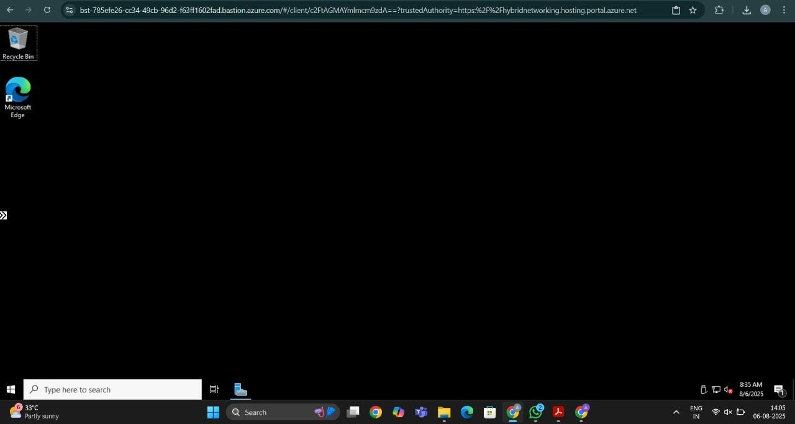

**RESULT:**

A virtual machine was successfully created and accessed remotely using Azure, demonstrating the use of Infrastructure as a Service (IaaS).