

**KGiSL Institute Of Technology**

**NAAN MUDHALVAN**

**Project Title:**

**Website Traffic Analysis**

**Team Members:**

**1.NAVEEN S.G**

**2.RAVINDRANATH.M**

**3.BALAGANESH.M**

**4.LOKESH K.V**

**PROJECT OVERVIEW:**

**OBJECTIVE:**

**The project's primary goal is to extract valuable insights from website traffic data to inform decision-making and improve the website's performance.**

**DESIGN THINKING PROCESS:**

* **Understand**
* **Explore**
* **Ideate**
* **Prototype**
* **Test**

**DEVELOPMENT PHASES:**

1. **Data Collection.**
2. **Visualizations.**
3. **Python Integration**

**ANALYSIS OBJECTIVES AND PROCESS:**

**OBJECTIVE:**

* + - * **Identify Popular Pages.**
      * **Analyze Traffic Trends.**
      * **User Engagement Metrics.**
      * **Referral Sources.**
      * **Machine Learning Integration.**

**DATA COLLECTIONS:**

* **Data collected from: https://www.kaggle.com/datasets/bobnau/daily-website-visitors**
* **Cleaned and preprocessed for analysis(removing duplicates)**

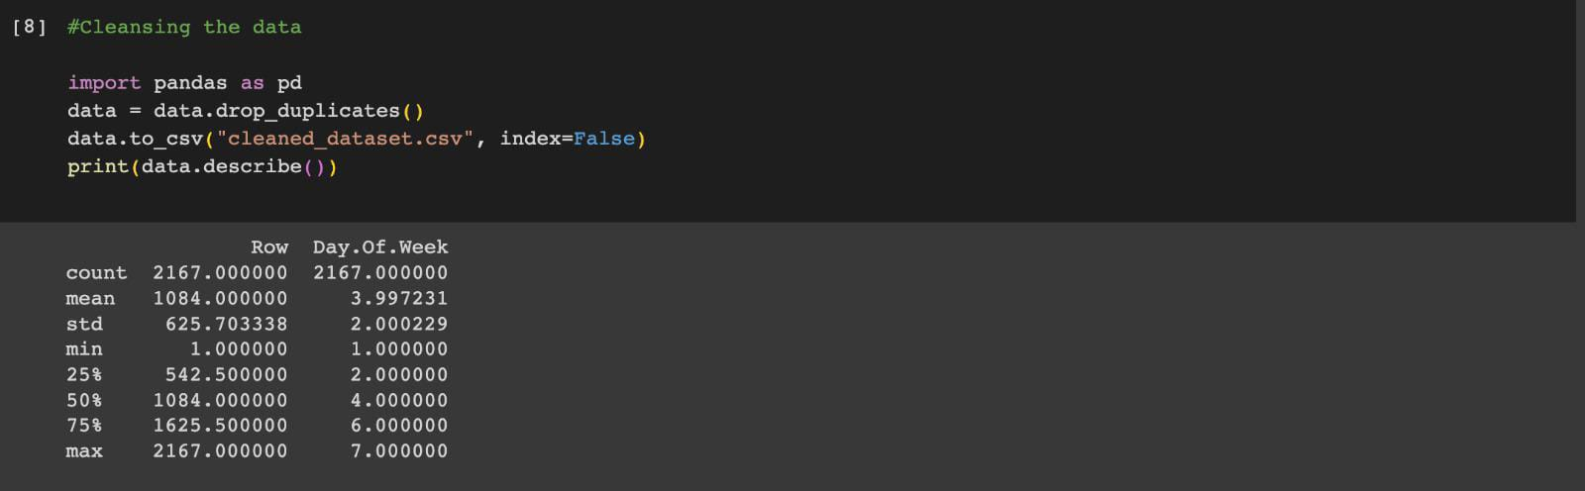

**DATA VISUALIZATION USING IBM COGNOS:**

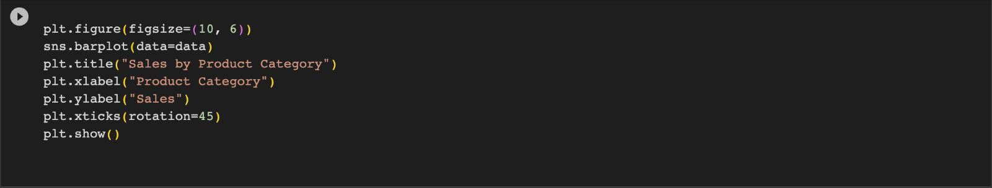

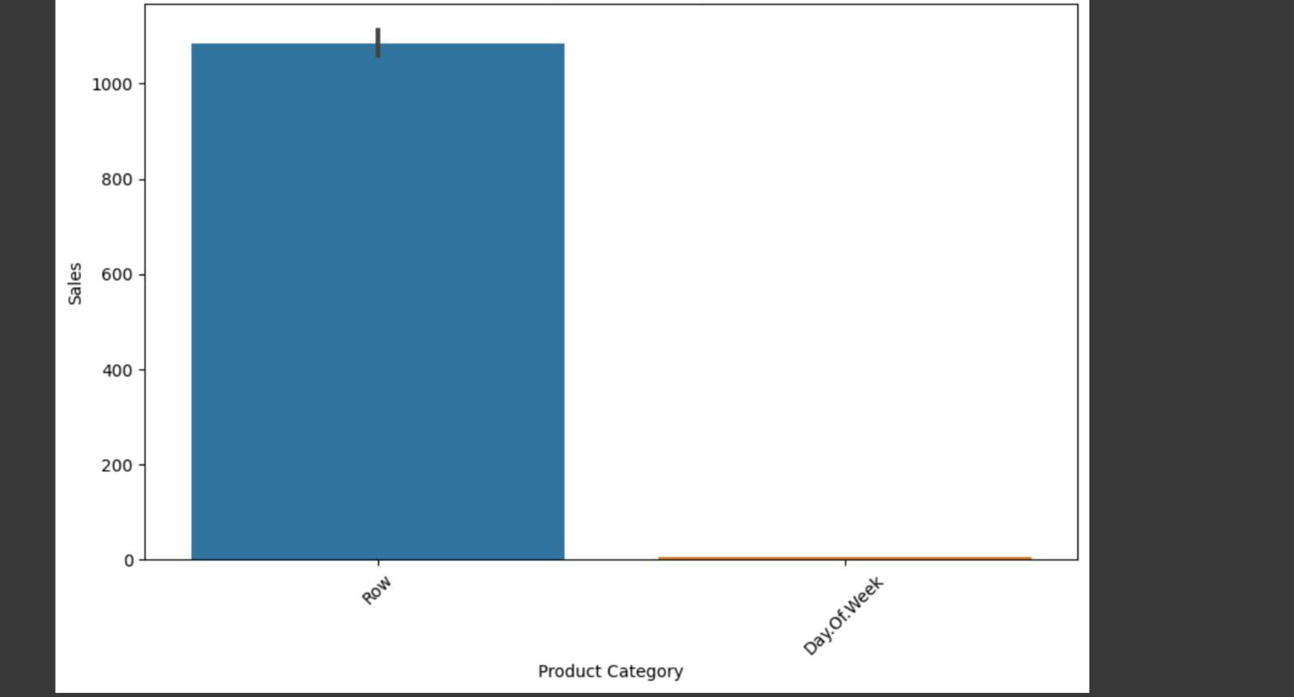

**CORRELATIONS:**

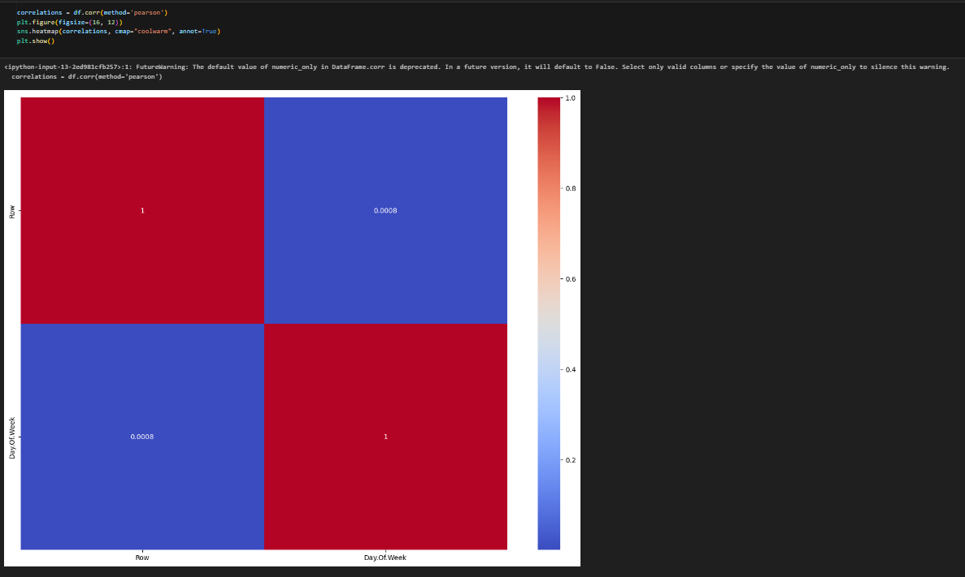

**CONCLUSION:**

**Utilizing IBM Cognos, the analysis revealed critical insights into website traffic analysis.**