# Wireframe

Wireframe

# 

CLUSTERING FOR CUSTOMER SEGMENTATION AND UNDERSTANDING

Revision Number – 1.3

Last Date of Revision – 15/05/2022

Naveen Gupta

Document Version Control

Wireframe

|  |  |  |  |
| --- | --- | --- | --- |
| Date | Version | Description | Author |
| 13-05-2022 | 1.0 | Abstract, User Interface | Naveen |
| 14-05-2022 | 1.1 | User Input | Naveen |
| 14-05-2022 | 1.2 | Result Page | Naveen |

**Contents**

Wireframe

[**Abstract** 4](https://docs.google.com/document/d/1ZLlZEVdMuxYl3o0PziQjZcUbNmAcz-PR/edit#heading=h.gjdgxs)

**Web Interface 5**

**User Input 5**

**Result Page 6**

**Abstract**

Wireframe

Customer Segmentation Prediction web app just contains one home page after entering data when user press the Submit button the prediction is shown on the same page as well.

**1. Web Interface**

Wireframe

This is the homepage for the app. Here we will ask the user for the input file , Column names , Period.

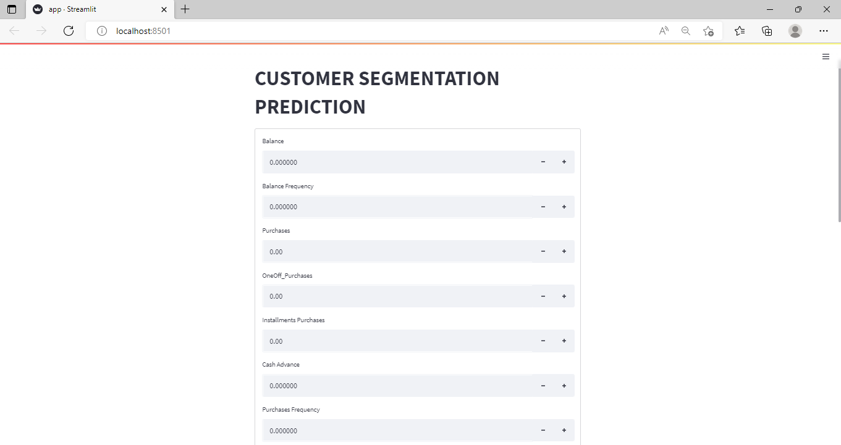

**2. User Input**

Whenever the user hits our url , they first see the user input page here they have to provide the information like:

* Every user input has its own dropdown where the user can select their input.
* After providing the required input and pressing the submit button, the page refreshes and displays the output

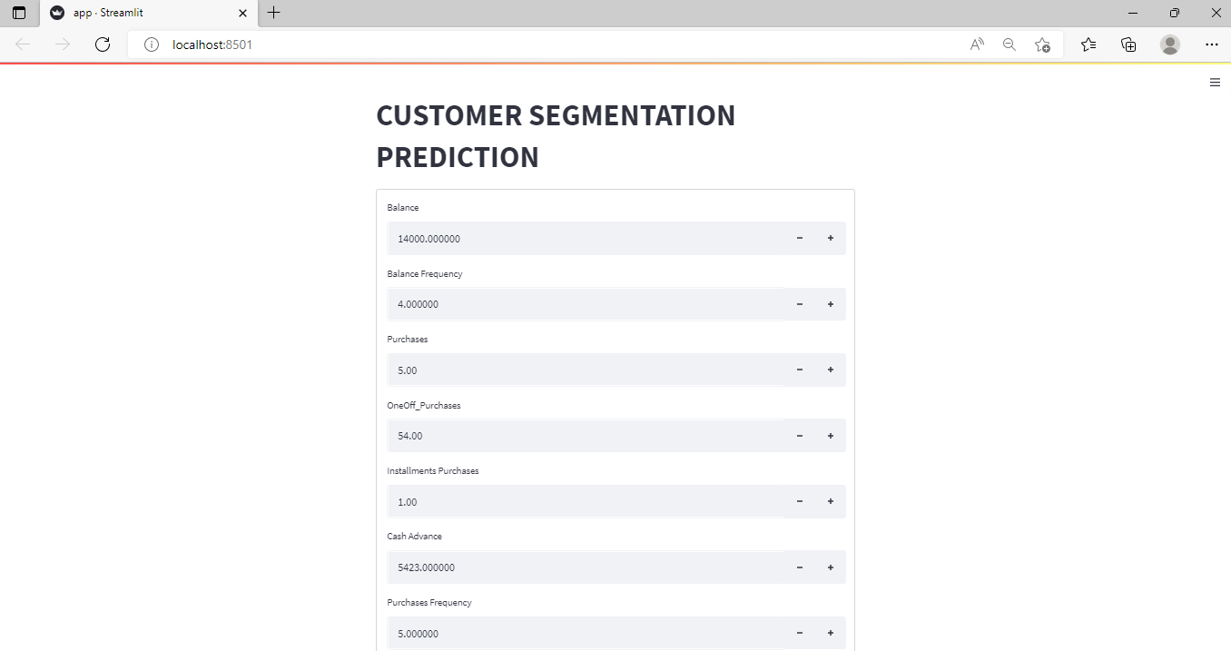

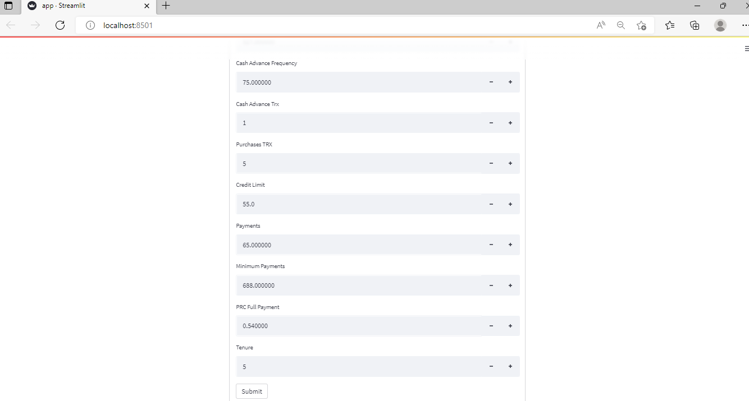

**3. Result Page**

Wireframe

After the user hits the SUBMIT button the page gets refreshed and the results are being displayed in the highlighted area in the above frame.

The user can refill all the inputs in same page and get the results in the same way.

