# Wireframe

Wireframe

# FLIGHT FARE PREDICTION

Revision Number – 1.3

Last Date of Revision – 23/02/2022

Naveen Gupta

Document Version Control

Wireframe

|  |  |  |  |
| --- | --- | --- | --- |
| Date | Version | Description | Author |
| 21-02-2022 | 1.0 | Abstract, User Interface | Naveen |
| 22-02-2022 | 1.1 | User Input | Naveen |
| 22-02-2022 | 1.2 | Result Page | Naveen |

**Contents**

Wireframe

[**Abstract** 4](https://docs.google.com/document/d/1ZLlZEVdMuxYl3o0PziQjZcUbNmAcz-PR/edit#heading=h.gjdgxs)

**Web Interface 5**

**User Input 5**

**Result Page 6**

**Abstract**

Wireframe

The recent international things had a large impact on the aviation sector because of several reasons. This documentation is all about the user interface wireframe; here the home page of our flight fare prediction project is explained.

**1. Web Interface**

Wireframe

Our web page is one single interface where both input from the user and the prediction is displayed.

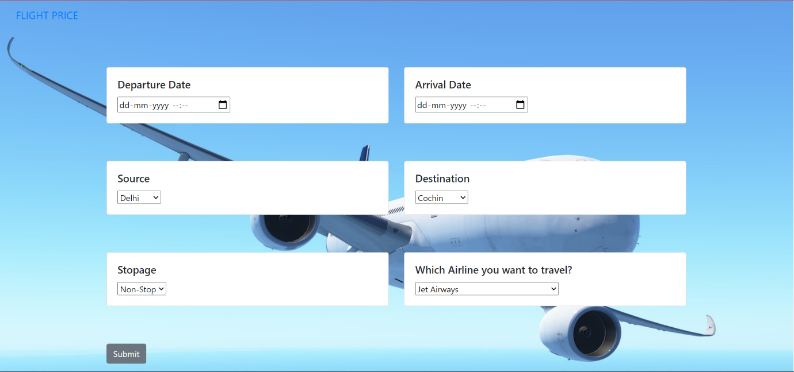

**2. User Input**

Whenever the user hits our url , they first see the user input page here they have to provide the information like:

* Every user input has its own dropdown where the user can select their input.
* After providing the required input and pressing the submit button, the page refreshes and displays the output

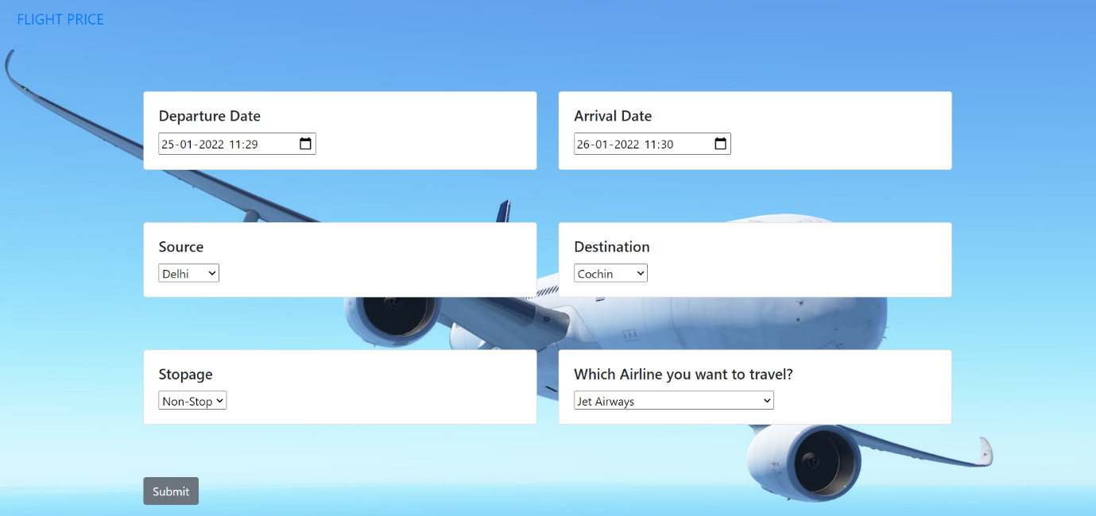

**3. Result Page**

Wireframe

After the user hits the submit button the page gets refreshed and the results are being displayed in the highlighted area in the above frame.

The user can refill all the inputs in same page and get the results in the same way.

