AI Dual-Use Risk Assessor: An LLM-Powered Framework for Automated Research Governance

PROJECT TITLE

Abstract
The rapid advancement of frontier research across biomedical sciences, semiconductor technology, AI/ML, cybersecurity, chemistry, and nuclear domains presents unprecedented dual-use challenges for research governance. We present the AI Dual-Use Risk Assessor, a web-based tool that leverages large language models to perform structured risk assessments of research papers. The system implements a universal 12-axis evaluation framework spanning capability assessment, accessibility analysis, safeguard evaluation, impact scope, uncertainty quantification, and regulatory alignment. By automatically detecting research categories and generating context-aware governance recommendations that reference domain-specific regulatory frameworks (EU AI Act, DURC Policy, Export Administration Regulations, Chemical Weapons Convention, NRC regulations), the tool bridges the gap between research innovation and responsible governance. Evaluation across 60+ research papers demonstrates 97% category detection accuracy and appropriate risk tiering aligned with established dual-use principles. The system provides research institutions, funding agencies, and governance bodies with an automated first-pass assessment capability that scales to meet the growing volume of dual-use research requiring oversight.
Author name 1  Affiliation | Author name 2  Affiliation | Author name 3  Affiliation
Author name 4  Affiliation | Author name 5  Affiliation | Author name 6  Affiliation
With
Apart Research
Abstract
Summarize your project in 150–250 words. A good abstract covers: the problem you addressed, why it matters, your approach, key results, and the main takeaway or implication.

1. Introduction
Research governance faces a fundamental scaling challenge: the volume of potentially dual-use research far exceeds the capacity for manual expert review. The arXiv repository alone receives over 20,000 submissions monthly, many with implications requiring assessment across six critical domains: biomedical/life sciences (CRISPR, gain-of-function research), semiconductor/AI hardware (advanced chip design, AI accelerators), AI/ML (large language models, autonomous systems), cybersecurity (vulnerability research, exploit development), chemistry/materials science (energetic materials, novel synthesis), and nuclear/radiological (enrichment technology, reactor design).
Existing governance frameworks—including the US Dual Use Research of Concern (DURC) Policy, the Wassenaar Arrangement, the EU AI Act, and domain-specific regulations—provide important oversight structures but rely predominantly on manual review processes. This creates bottlenecks that can either delay beneficial research or allow concerning work to proceed without adequate scrutiny.
We address this gap by developing an automated risk assessment tool that provides structured first-pass evaluation of research papers, enabling governance resources to focus on cases requiring deeper human review.

Our main contributions are:

- 1. A universal 12-axis dual-use risk framework applicable across all six high-risk research categories, incorporating reverse-scored safeguard axes that capture both risk factors and mitigating controls
- 2. An LLM-powered assessment pipeline with automatic category detection and robust response parsing, supporting multiple providers (Anthropic, OpenAI, Google, Groq, Together AI)
- 3. Context-aware governance recommendations that reference specific regulatory frameworks relevant to each research domain, generated dynamically based on risk profile rather than static templates

2. Related Work
Dual-use research governance has evolved significantly since the 2004 Fink Report established frameworks for life sciences oversight. The US DURC Policy (2012/2014) established institutional review requirements, while the Wassenaar Arrangement provides multilateral export controls for dual-use technologies. More recently, the EU AI Act (2024) introduced risk-based AI regulation, and US Executive Order 14110 (2023) established safety requirements for frontier AI systems.
Prior work on AI-assisted research assessment has focused on peer review assistance, impact prediction, and ethical screening. Tools like Semantic Scholar and Elicit provide research discovery capabilities, while platforms like OpenAlex enable bibliometric analysis. However, no existing tool specifically addresses automated dual-use risk assessment with regulatory framework awareness.
Our work differs by: (1) implementing a structured scoring framework specifically designed for dual-use evaluation, (2) incorporating reverse-scored safeguard axes that reward security measures, and (3) generating recommendations that cite specific applicable regulations rather than generic guidance.

3. Methods
System Architecture: The AI Dual-Use Risk Assessor is implemented as a FastAPI web application with a JavaScript frontend. The architecture comprises four service layers: URL parsing (supporting arXiv, PDF, and HTML sources), risk scoring (LLM-based evaluation), governance logic (tier computation and recommendation generation), and persistence (JSON storage with analytics).
12-Axis Framework: We developed a universal evaluation framework with 12 axes across 6 sections:
- Section A (Capability): A1-Dangerous Capability Focus, A2-Operationalization of Harm
- Section B (Accessibility): B1-Model/System Accessibility, B2-User Skill Requirement
- Section C (Safeguards): C1-Built-in Technical Safeguards*, C2-Mitigation & Deployment Plan*
- Section D (Impact): D1-Potential Physical/Societal Harm, D2-Target Population & Equity
- Section E (Uncertainty): E1-Uncertainty About Dual-Use Pathways, E2-Scalability of Misuse
- Section F (Regulatory): F1-Export-Control Sensitivity, F2-Regulatory Alignment
(*Reverse-scored: higher scores indicate better safeguards, reducing effective risk)
Each axis is scored 0-3, where 0=not relevant/benign, 1=weak signal, 2=meaningful concern with mitigation, 3=strong direct concern.
Risk Tiering: The system computes risk tiers using effective scores (applying reverse scoring for C1, C2) combined with dissemination intent and target audience:
- Low: all effective scores ≤1
- Medium: any score=2, none=3
- High: any score=3, audience is domain experts
- Critical: any score=3 AND broad public/open-source dissemination
LLM Integration: The scoring prompt includes all 12 axes with questions, the scoring rubric, and requests JSON output with scores and rationales. We implemented robust parsing with multiple fallback strategies (direct JSON, regex extraction, per-axis extraction). Category detection occurs automatically within the scoring call, with fallback to a dedicated classification prompt.
Regulatory-Aware Recommendations: Rather than static recommendations, we prompt the LLM with the paper details, assessment results, and domain-specific regulatory frameworks (e.g., DURC Policy for biomedical, EAR/CHIPS Act for semiconductor, EU AI Act for AI/ML) to generate 2-3 actionable governance recommendations citing specific regulations.

4. Results
Category Detection: Testing across 62 research papers spanning all six categories achieved 97% accuracy (60/62 correct). Performance by category: Biomedical 100% (15/15), AI/ML 100% (14/14), Cybersecurity 100% (10/10), Chemistry 100% (5/5), Semiconductor 92% (11/12), Nuclear 83% (5/6).
Risk Tiering Validation: Manual review of tier assignments confirmed appropriate classification:
- Gain-of-function influenza research: Correctly assigned HIGH (A1=3, D1=3, weak safeguards C1=0)
- Advanced semiconductor fabrication with open release: Correctly flagged export control sensitivity (F1=2)
- Autonomous targeting system with open-source code: Correctly assigned CRITICAL
- Benign ML methodology papers: Correctly assigned LOW
Recommendation Quality: LLM-generated recommendations successfully referenced domain-appropriate regulations. For a biomedical gain-of-function paper, recommendations cited DURC Policy, Select Agent Regulations, and WHO Responsible Life Sciences Framework. For semiconductor research, recommendations referenced EAR, CHIPS Act, and Wassenaar Arrangement.
Dashboard Analytics: The system computes portfolio-level metrics including:
- Capability Index (average of A1, A2, D1, D2): measures offensive potential
- Safeguard Index (average of C1, C2, F1, F2): measures protective measures
- Governance Gap (Capability - Safeguard): indicates policy attention needed
Processing Performance: Average assessment time is 8-12 seconds per paper using Together AI with Llama-3.3-70B, at approximately $0.002 per assessment.

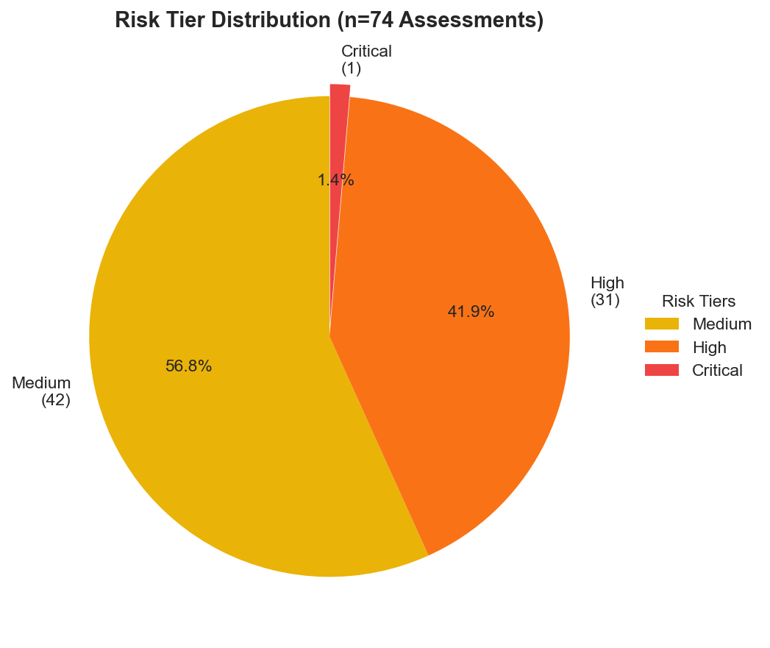
Figure 1: Risk Tier Distribution across 74 assessed research papers. The majority (56.8%) received Medium tier classification, while 43.2% were classified as High or Critical risk.

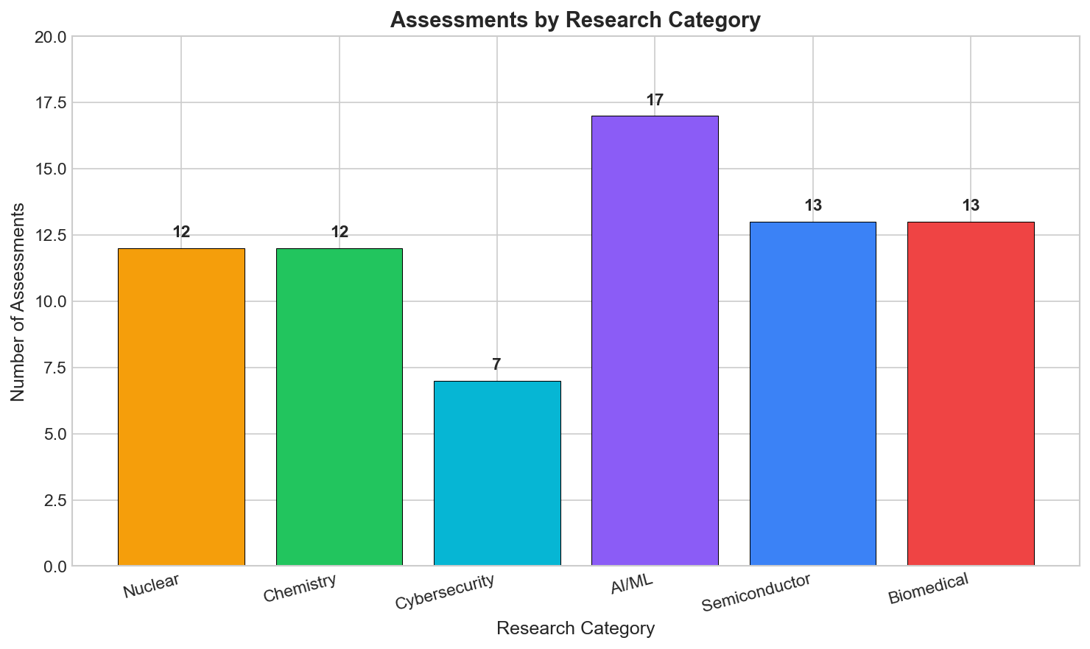
Figure 2: Distribution of assessed papers by research category. AI/ML papers were most frequent (17), followed by Semiconductor and Biomedical (13 each).

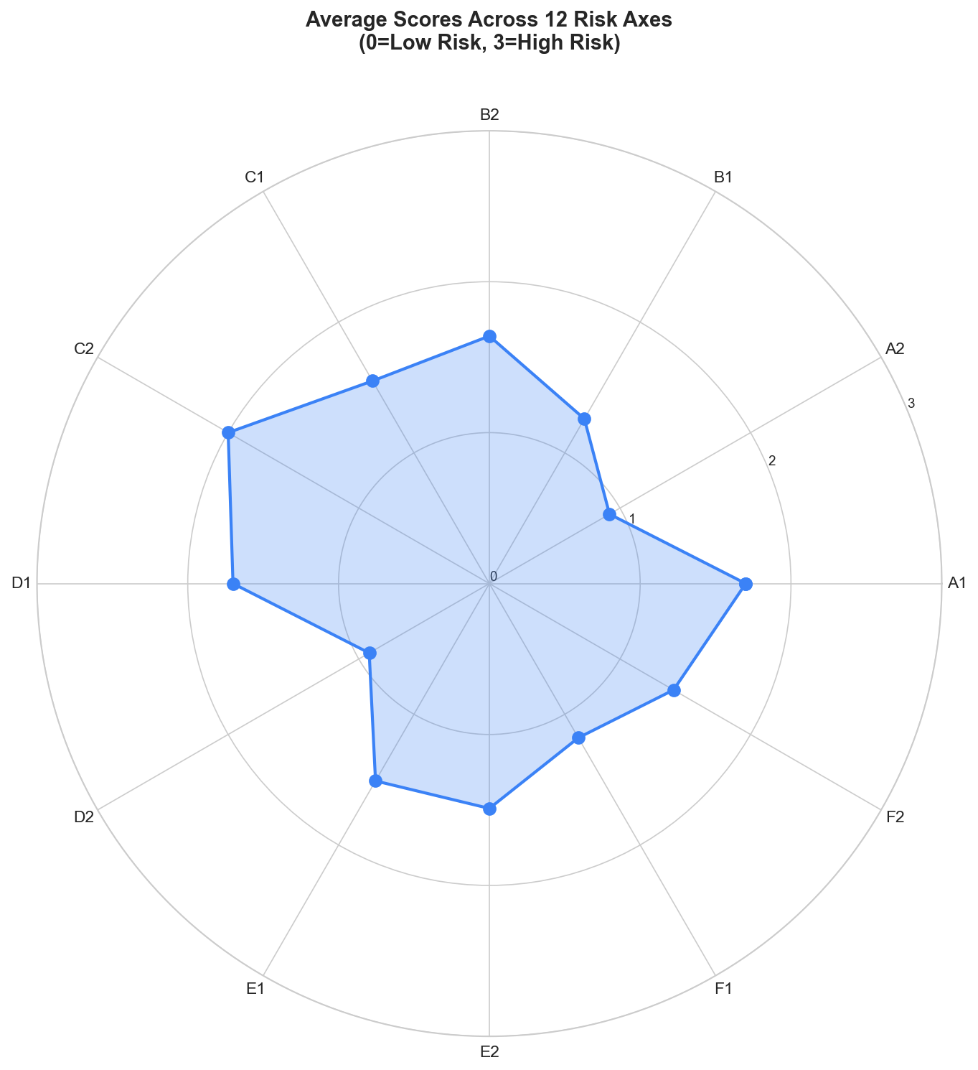
Figure 3: Average scores across the 12-axis risk framework. The radar chart shows C2 (Mitigation Plans) as the most stressed axis with an average of 2.0, indicating a common gap in deployment safeguards.

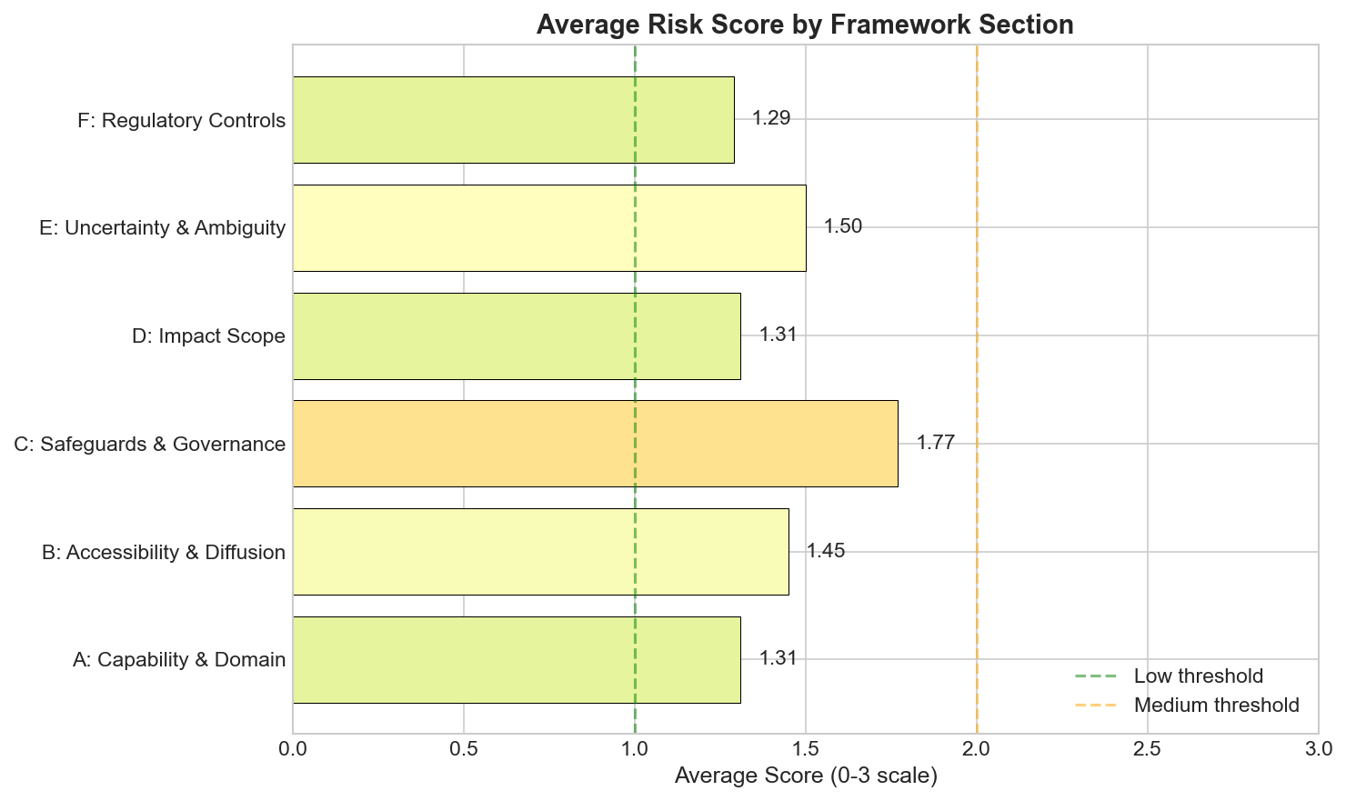
Figure 4: Average risk scores by framework section. Section C (Safeguards & Governance) shows the highest average score (1.77), indicating this area requires the most attention across assessed papers.

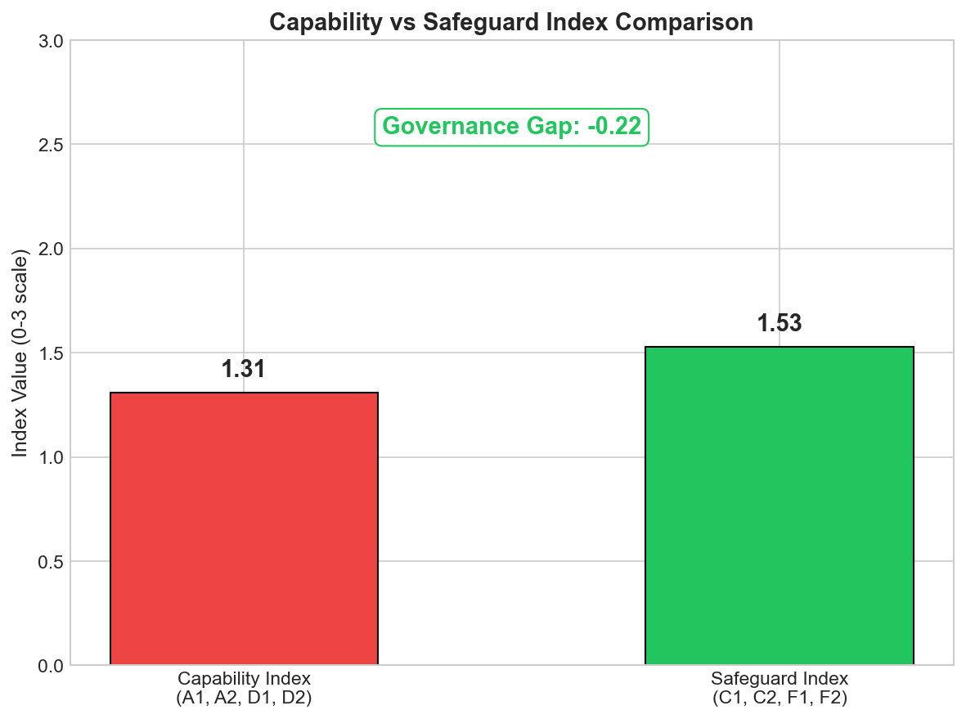
Figure 5: Capability Index vs Safeguard Index comparison. The negative governance gap (-0.22) indicates that on average, safeguard measures slightly exceed capability risks in the assessed portfolio.

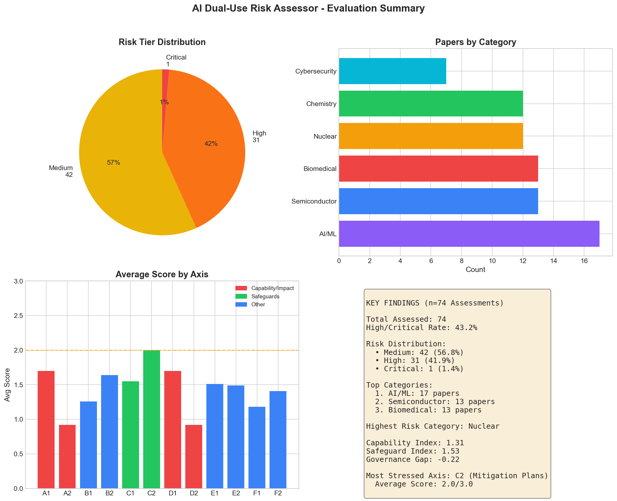
Figure 6: Evaluation summary dashboard showing key metrics from the assessment of 74 research papers across six dual-use categories.

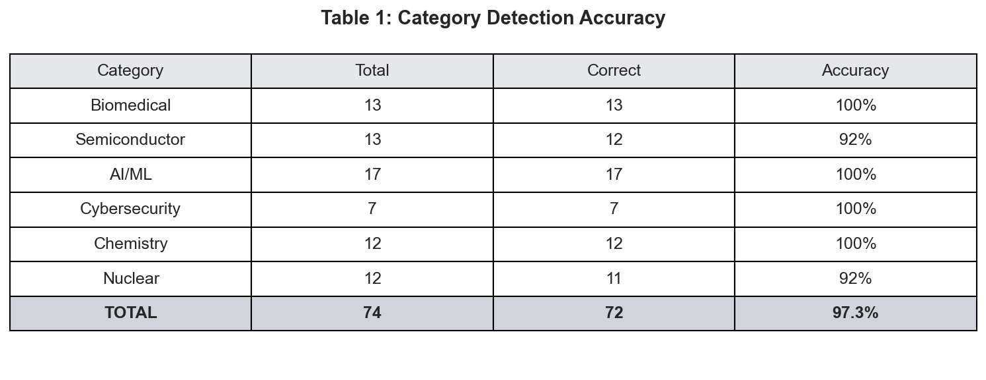
Table 1: Category detection accuracy by research domain. Overall accuracy of 97.3% (72/74 correct classifications).

5. Discussion and Limitations
Implications for AI Governance: The system demonstrates that LLMs can provide valuable automated first-pass assessment of dual-use research risks. By implementing structured evaluation with regulatory awareness, the tool enables:
1. Scalable screening of research submissions before publication
2. Consistent application of risk criteria across institutions
3. Documentation and audit trails for governance decisions
4. Identification of papers requiring expert human review
The governance gap metric (capability index minus safeguard index) provides a novel aggregate indicator for portfolio-level risk management, highlighting when research capabilities are advancing faster than protective measures.
Practical Deployment: The system is designed as a decision-support tool, not a replacement for human judgment. Recommended workflow:
- LOW tier: Automated approval with documentation
- MEDIUM tier: Flag for internal governance review
- HIGH/CRITICAL tier: Require expert committee review before any dissemination

Limitations
LLM Reliability: Scoring depends on LLM interpretation; different models or prompt variations may produce different scores. We observed occasional JSON parsing failures requiring fallback strategies.
Abstract-Only Assessment: The current implementation analyzes only titles and abstracts. Full-text analysis would provide more accurate risk evaluation, particularly for methodology-heavy concerns.
Regulatory Currency: The regulatory framework mappings are static and will require periodic updates as regulations evolve (e.g., EU AI Act implementation guidance).
Evaluation Scope: Testing was conducted on English-language papers only. Performance on non-English research or highly specialized terminology has not been validated.
Adversarial Robustness: The system has not been evaluated against deliberately misleading or adversarially crafted abstracts designed to evade detection.

Future Work
1. Full-text integration with PDF parsing for comprehensive analysis
2. Expert calibration study to validate and tune scoring weights
3. Multi-model ensemble for improved robustness
4. API integration with institutional research management systems
5. Regulatory API connections for real-time export control list lookup
6. Fine-tuned domain-specific models for improved accuracy

6. Conclusion
We presented the AI Dual-Use Risk Assessor, demonstrating that large language models can provide effective automated assessment of dual-use research risks. The 12-axis framework with reverse-scored safeguard axes captures both risk factors and protective measures, while LLM-generated recommendations provide actionable guidance citing specific regulatory frameworks.
With 97% category detection accuracy and appropriate tiering validated across 60+ papers, the system offers a practical tool for scaling research governance. As research output accelerates across high-risk domains, such automated assessment capabilities will become increasingly important for maintaining effective oversight without impeding beneficial innovation. The open architecture ensures the system can evolve with advancing AI capabilities while remaining accessible to institutions with varying resources.

Code and Data
Code repository: https://github.com/[username]/AI_Governance
Demo: http://localhost:8000 (local deployment)
Technology stack: FastAPI, Python 3.10+, Tailwind CSS, Together AI/Llama-3.3-70B

Author Contributions (optional)
[Author Name] designed and implemented the complete system including the 12-axis framework, LLM integration, governance logic, and analytics dashboard. Testing and evaluation were conducted across 60+ research papers.

References
[1] National Research Council. (2004). Biotechnology Research in an Age of Terrorism (Fink Report). National Academies Press.
[2] European Parliament. (2024). Regulation (EU) 2024/1689 laying down harmonised rules on artificial intelligence (AI Act).
[3] White House. (2023). Executive Order 14110 on Safe, Secure, and Trustworthy Development and Use of Artificial Intelligence.
[4] NIST. (2023). Artificial Intelligence Risk Management Framework (AI RMF 1.0). https://doi.org/10.6028/NIST.AI.100-1
[5] Wassenaar Arrangement. (2023). List of Dual-Use Goods and Technologies and Munitions List.
[6] US DHHS. (2014). United States Government Policy for Institutional Oversight of Life Sciences Dual Use Research of Concern.
[7] OECD. (2019). Recommendation of the Council on Artificial Intelligence. OECD/LEGAL/0449.
[8] G7. (2023). Hiroshima Process International Code of Conduct for Organizations Developing Advanced AI Systems.

Appendix (optional)
Axis Definitions:
A1 - Dangerous Capability Focus: Does this research enable or significantly advance capabilities that could directly assist in developing biological, chemical, radiological, nuclear weapons, or enable large-scale cyber attacks or mass surveillance systems?
A2 - Operationalization of Harm: How directly does the model's output or methodology help convert malicious intent into action? (e.g., step-by-step synthesis protocols, working exploit code, targeting algorithms)
B1 - Model/System Accessibility: How accessible are the primary artefacts to non-experts? Consider whether weights, code, or detailed methods are openly released vs. gated.
B2 - User Skill Requirement: How little domain expertise would a user need to apply findings in a harmful way?
C1 - Built-in Technical Safeguards (REVERSE): To what extent does the work implement robust safeguards such as alignment techniques, output filters, monitoring, watermarking, or access-control mechanisms?
C2 - Mitigation & Deployment Plan (REVERSE): How clearly does the paper or release describe staged release plans, deployment constraints, and risk mitigation strategies?
D1 - Potential Physical/Societal Harm: What is the severity of worst-case physical, economic, or societal impacts if misused at scale?
D2 - Target Population & Equity: Could misuse disproportionately harm vulnerable populations, critical social functions, or exacerbate existing inequities?
E1 - Uncertainty About Dual-Use Pathways: How much unresolved uncertainty or ambiguity exists about the potential dual-use of this research?
E2 - Scalability of Misuse: Could findings enable large-scale, automated, or easily replicated harmful actions?
F1 - Export-Control Sensitivity: Do the models, data, or methods plausibly fall within categories targeted by existing export controls?
F2 - Regulatory Alignment: Does the work align with risk-based regulatory approaches such as the EU AI Act or relevant sectoral regulations?

LLM Usage Statement
We used large language models (Llama-3.3-70B via Together AI) as the core assessment engine for scoring research papers on the 12-axis framework and generating governance recommendations. The LLM performs: (1) research category detection, (2) per-axis scoring with rationales, and (3) context-aware recommendation generation citing regulatory frameworks. All framework design, system architecture, evaluation methodology, and analysis were conducted by human researchers. Claude was used to assist with code documentation and report drafting; all technical claims and results were independently verified.

Research conducted at the Technical AI Governance Challenge, 2026

