SIMATS ENGINEERING
ASSESSMENT TOOL 2

COURSE NAME: INTERNET PROGRAMMING COURSE CODE: CSA43

COURSE OUTCOME COVERED
CO -2 : Apply CSS layout and styling techniques to create visually appealing and responsive web interfaces, and use JavaScript to enable interactive client-side behavior. (L3)
Assessment Tool : Design Task
Weightage: 20%

QUESTIONS: Total Marks: 20
Question 1: Responsive Navigation Bar Design - Marks(4)
Suppose that an e-commerce website requires a responsive navigation bar that adapts across desktop, tablet, and mobile devices.
- Identify key components required in a navigation bar for an e-commerce website.
- Design a responsive navigation bar using appropriate CSS techniques.
- Demonstrate how the navigation adapts to smaller screens (e.g., hamburger menu).
- Evaluate the usability and suggest improvements for better user experience.

Question 2: Product Hover Effect - Marks(4)
Suppose that an e-commerce website wants to enhance user interaction through visual effects on product items.
- Identify suitable CSS properties for hover effects.
- Suggest appropriate CSS animation or transition for product interaction.
- Design a hover effect for a product card.
- Evaluate performance and user experience considerations.
Question 3: Layout Selection (Flexbox vs Grid) - Marks(4)
Suppose that a dashboard layout needs to be designed for a web application.
- Identify layout requirements of a dashboard (rows, columns, alignment).
- Compare Flexbox and Grid based on layout needs.
- Choose the most suitable layout technique and justify your choice.
- Evaluate the scalability and responsiveness of the chosen approach.

Question 4: Mobile-First Blog Layout - Marks(4)
Suppose that a blog page must be designed following a mobile-first approach.
- Identify key sections of a blog layout.
- Design a mobile-first layout using CSS.
- Demonstrate how the layout scales for larger screens using media queries.
- Evaluate accessibility and readability of the design.

Question 5: JavaScript Event Handling for Dynamic Menu - Marks(4)
Suppose that a website includes a dynamic menu that responds to user interactions.
- Identify appropriate JavaScript events for menu interaction.
- Design event handling logic for menu toggle functionality.
- Implement interaction for user actions (click/hover). (d) Evaluate performance and suggest improvements.
Code of Conduct:
I MS Naveen(192371002) certify that this submission is my original work and that I have adhered to the guidelines specified for this assessment. I understand that any violation of academic integrity rules will result in disciplinary action.
Signature of the student:
Naveen ms
RUBRICS FOR CALCULATION:
Criteria | Weightage (%) | Level 4 –  Exemplary (4) | Level 3 –  Proficient (3) | Level 2 –  Developing  (2) | Level 1 –  Beginning (1)
Understanding of Concept | 25 | Demonstrates complete understanding of design requirements | Good understanding  with minor gaps | Basic understanding with some errors | Poor understanding  or incorrect concepts

 |  | and concepts
Design /  Implementation | 30 | Well-structured,  efficient, and responsive design implementation | Correct implementation with minor issues | Basic implementation  with inconsistencies | Incorrect or incomplete implementation
Use of Tools (CSS/JS) | 20 | Effective and  advanced use  of  tools/technique s | Appropriate use of tools | Limited or  inconsistent use | Incorrect or minimal use
Analysis & Evaluation | 15 | Insightful analysis with strong justification and optimization | Good analysis  with justification | Basic analysis  with limited depth | Poor or no analysis
Documentation  / Clarity | 10 | Clear, wellstructured, and properly presented solution | Mostly clear with minor issues | Basic clarity, missing details | Poor or unclear documentation

DETAILED ANSWERS AND IMPLEMENTATION

A2 – Design Task | Internet Programming (CSA43)
The following answers address every question, include implementation examples, and provide illustrative output screenshots. Code snippets are teaching examples; place each snippet in the corresponding HTML file to run it in a browser.

Question 1 – Responsive E-commerce Navigation
(a) Key components include brand/logo, primary category links, search, account/sign-in, cart with item count, and optionally wishlist/help. Navigation labels should be familiar and concise. (b) Flexbox is suitable for aligning items horizontally and allowing gaps/wrapping. (c) On narrow screens, a hamburger button toggles a compact menu. (d) Improve usability with visible focus, accessible labels, large touch targets, search access, and an indicator such as aria-expanded.

CSS / JavaScript implementation
<meta name="viewport" content="width=device-width, initial-scale=1">
<header class="bar">
<a class="logo" href="/">ShopEase</a>
<button id="toggle" aria-expanded="false" aria-controls="links">☰ Menu</button>
<nav id="links" class="links">
<a href="#">Home</a><a href="#">Shop</a><a href="#">Offers</a>
<a href="#">Account</a><a href="#">Cart (2)</a>
</nav>
</header>
<style>
.bar { display:flex; align-items:center; justify-content:space-between; gap:1rem; flex-wrap:wrap; } .links { display:flex; gap:1rem; }
#toggle { display:none; }
@media(max-width:650px) {
#toggle { display:block; }
.links { display:none; flex-direction:column; width:100%; }
.links.open { display:flex; }
}
</style> <script> const btn = document.querySelector('#toggle'); const nav = document.querySelector('#links'); btn.addEventListener('click', () => { const open = nav.classList.toggle('open');
btn.setAttribute('aria-expanded', String(open));
});
</script>
CSS handles layout and breakpoint; JavaScript only toggles the menu state. Ensure the menu remains usable with keyboard, use a descriptive button label, and do not hide key purchase actions unnecessarily.

Figure 1. E-commerce navigation concept.

Question 2 – Product Hover Effect
(a) Suitable properties: transform, box-shadow, border-color, opacity and background-color. (b) Use a short transition (about 150–250ms) for a smooth response. (c) A product card can lift slightly and gain a stronger shadow when hovered or when its child receives keyboard focus. (d) Keep effects subtle, avoid animating width/height, and support touch and reducedmotion preferences.

CSS / JavaScript implementation
.product {
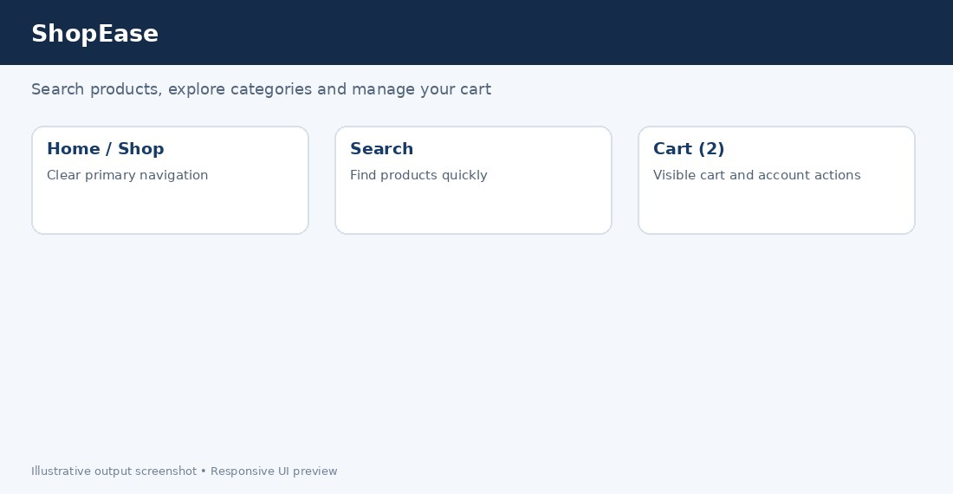
border: 1px solid #d9e1ea; border-radius: 14px; padding: 1rem; background: white; box-shadow: 0 3px 12px rgb(20 40 70 / 8%);
transition: transform .2s ease, box-shadow .2s ease, border-color .2s ease; }
.product:hover, .product:focus-within { transform: translateY(-4px); border-color: #6b91c7;
box-shadow: 0 10px 24px rgb(20 40 70 / 16%);
}
@media (prefers-reduced-motion: reduce) {
.product { transition: none; }
}
Use a consistent hover style across cards, preserve text contrast and ensure actions are still visible on touch devices. Transform and shadow are generally preferable to repeatedly changing layout dimensions.
Figure 2. Product cards with hover interaction styling.

Question 3 – Flexbox vs Grid for Dashboard
(a) A dashboard usually has metric cards, charts, filters and recent activity arranged in rows and columns. It needs consistent gaps, alignment and responsive rearrangement. (b) Flexbox is one-dimensional and works best for a row or column of items; Grid is twodimensional and controls rows and columns together. (c) CSS Grid is the best primary choice for a dashboard card matrix; Flexbox can still align controls within each card. (d) Grid scales well when columns use repeat(), minmax() and auto-fit.

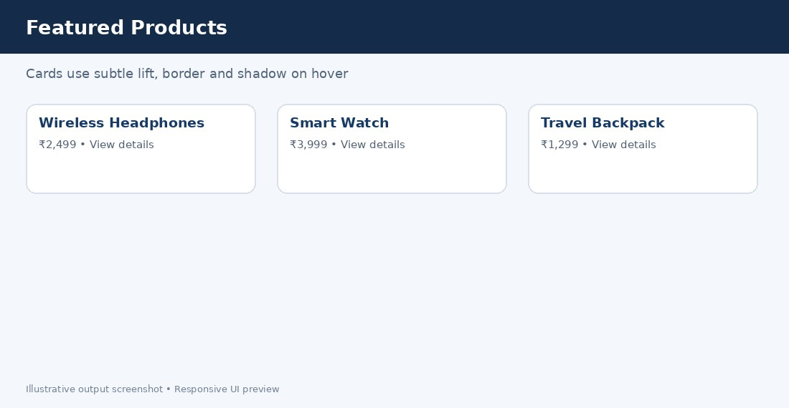
CSS / JavaScript implementation
.dashboard {
display: grid;
grid-template-columns: repeat(auto-fit, minmax(min(100%, 15rem), 1fr)); gap: 1rem;
}
.metric {
min-width: 0; padding: 1.25rem;
border: 1px solid #dce4ee; border-radius: 12px; background: white;
}
.metric header { display:flex; justify-content:space-between; gap:.5rem; }
Grid automatically fits the number of cards to the available width. Use semantic headings, avoid fixed card heights, make charts responsive, and check reading order when the layout collapses. Use Flexbox inside cards for labels and values.
Figure 3. Dashboard metric cards using a responsive grid.

Question 4 – Mobile-First Blog Layout
(a) Typical sections are site header, navigation, main article list, featured article, category/sidebar area and footer. (b) Write the base CSS for a narrow screen first, with one readable column. (c) Add columns at larger breakpoints. (d) Improve readability with appropriate line length, headings, contrast, image alt text, semantic landmarks and keyboard-accessible links.

CSS / JavaScript implementation
<main class="blog">
<header><h1>The Daily Byte</h1><p>Stories for curious readers</p></header>
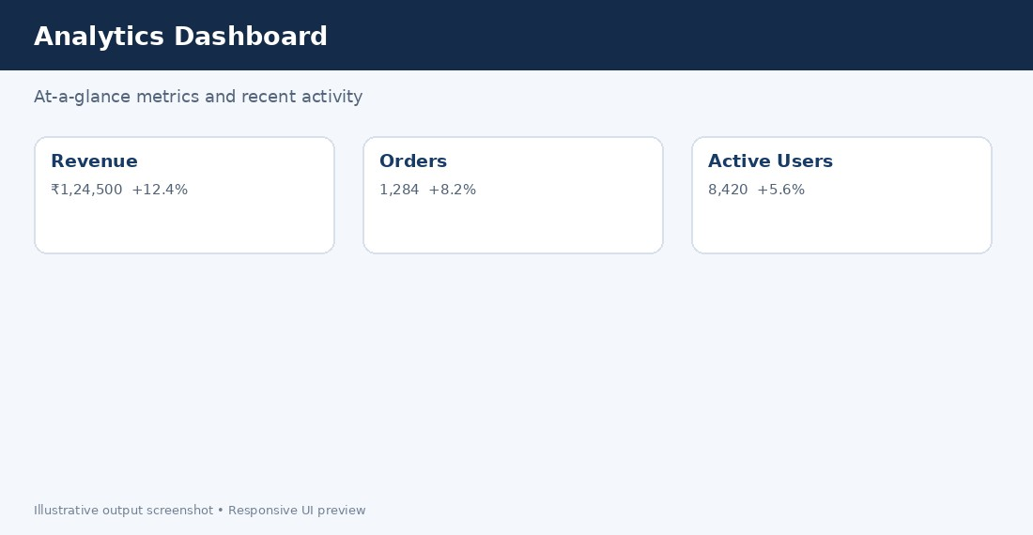
<section class="stories">
<article><h2>Digital habits that last</h2><p>Practical ideas for a calmer online day.</p></article>
<article><h2>Designing for everyone</h2><p>Accessibility starts with small decisions.</p></article> </section>
</main>
<style>
.blog { width:min(100% - 2rem, 68rem); margin:auto; } .stories { display:grid; grid-template-columns:1fr; gap:1rem; } article { padding:1.25rem; border-radius:12px; background:#fff; }
@media(min-width:760px) {
.stories { grid-template-columns:repeat(2,minmax(0,1fr)); } }
</style>
Mobile-first design minimizes initial complexity and prioritizes the most important content. At wider widths, two columns improve scanning. Avoid tiny text, use comfortable line height, and ensure zoom does not cause horizontal scrolling.
Figure 4. Mobile-first blog layout.

Question 5 – JavaScript Event Handling for Dynamic Menu
(a) Click is reliable for touch and mouse; keydown can support Escape; pointer/hover events may enhance desktop but should not be the only interaction. (b) A click listener toggles a CSS class and synchronizes aria-expanded. (c) Hover can be an optional enhancement, while click remains the core behavior. (d) Use event delegation for many items, avoid excessive listeners, and test keyboard and screen-reader behavior.

CSS / JavaScript implementation
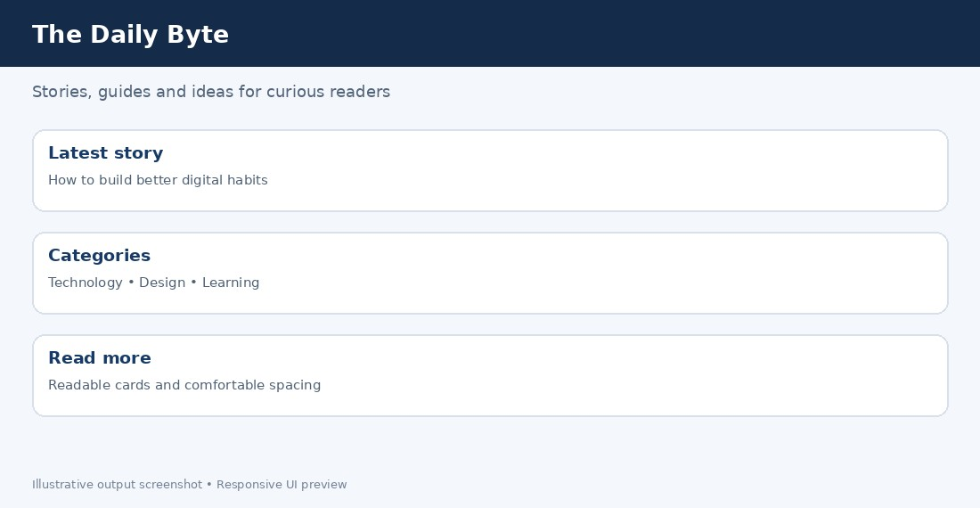
const menuButton = document.querySelector('#menuButton'); const menu = document.querySelector('#siteMenu'); menuButton.addEventListener('click', () => {
const expanded = menuButton.getAttribute('aria-expanded') === 'true'; menuButton.setAttribute('aria-expanded', String(!expanded)); menu.hidden = expanded;
});
document.addEventListener('keydown', event => { if (event.key === 'Escape' && !menu.hidden) { menu.hidden = true;
menuButton.setAttribute('aria-expanded', 'false'); menuButton.focus();
}
});
Corresponding HTML should include a button with aria-controls='siteMenu' and ariaexpanded='false', plus a nav with id='siteMenu'. The initial hidden state should match the attribute. Focus returns to the toggle on Escape, and the menu remains usable without hover.
Figure 5. Dynamic navigation menu concept.

Testing checklist
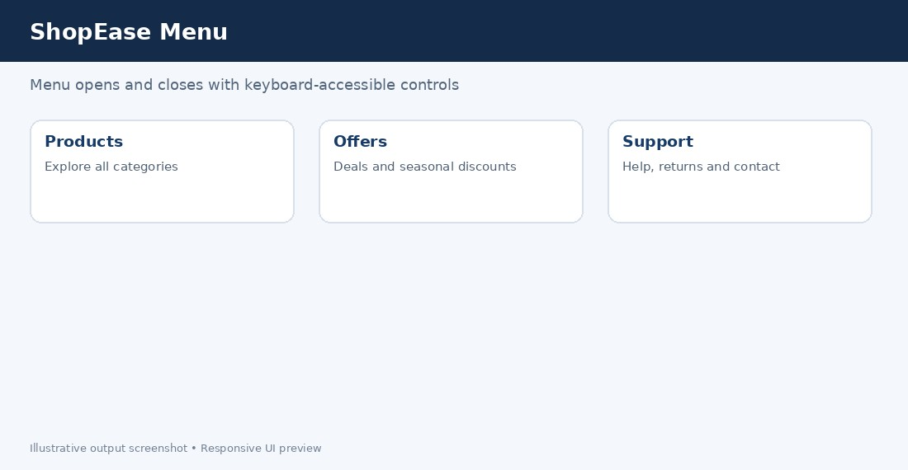
- Test at phone, tablet and desktop widths; verify no horizontal overflow.
- Use keyboard-only navigation and check visible focus states.
- Check browser console for JavaScript errors and validate HTML/CSS.
- Use server-side validation for security-sensitive input and recompute prices on the server.
- Use semantic HTML, labels, sufficient contrast, and reduced-motion support.

