SIMATS ENGINEERING
ASSESSMENT TOOL 1

COURSE NAME: INTERNET PROGRAMMING COURSE CODE: CSA43

COURSE OUTCOME COVERED

CO-1: Develop well-structured, standards-compliant web pages using HTML/XHTML and XML, and apply Internet protocols and HTTP communication mechanisms for web content delivery. (L2)

Assessment Tool: Application-Based Questions

Weightage: 40%

QUESTIONS: Total Marks: 30

1: Online Symposium Portal
A college is developing an online symposium registration portal. The following HTML structure and HTTP interaction is observed:
<form action="/register" method="POST">
<input type="text" name="name">
<input type="email" name="email">
<button>Submit</button>
</form>
When a student submits the form, the browser sends an HTTP request to the server, and the server responds accordingly. Questions:
- Identify appropriate HTML5 semantic elements missing in the structure.
- Modify the structure to make it standards-compliant.
- Interpret the HTTP request generated during form submission.
- Analyze the HTTP response cycle from server to browser.
- Suggest improvements for usability and accessibility.

2: Cross-Browser Compatibility Issue
A company website shows inconsistent layout across browsers. The following HTML snippet is used:
<html>
<head>
<title>Company</title>
</head> <body>
<div>
<h1>Welcome
<p>About us
</div>
</body> </html>
Questions:
- Identify improper nesting and missing closing tags.
- Analyze how different browsers may interpret this structure.
- Identify missing semantic elements (e.g., header, section).
- Provide a corrected W3C-compliant HTML structure.
- Suggest techniques to ensure cross-browser compatibility.

3: Form Submission Failure
A web application fails to send form data to the server. The following configuration is observed:
<form action="/submit" method="GET">
<input type="text" name="username">
<input type="password" name="password">
<button type="button">Login</button>
</form>
Questions:
- Identify issues in the form configuration.
- Analyze why the HTTP request is not triggered.
- Interpret the role of GET method in this scenario.
- Propose a corrected implementation.
- Suggest improvements for secure data transmission.

Code of Conduct:

I MS Naveen(192371002) certify that this submission is my original work and that I have adhered to the guidelines specified for this assessment. I understand that any violation of academic integrity rules will result in disciplinary action.

Signature of the student:
Naveen ms

RUBRICS FOR CALCULATION:

Criteria | Weig  htage | Level 4 –  Exemplary | Level 3 –  Proficient | Level 2 –  Developing | Level 1 –  Beginning
Understanding of Concepts | 25% | Demonstrates thorough, accurate  understanding of concepts | Good understanding with minor gaps | Basic understanding with some  misconception  s | Poor understandin g; major  misconceptio ns
Explanation | 25% | Detailed, well-explained  answers with relevant examples | Clear explanation with adequate details | Limited explanation; lacks depth | Poor or unclear explanation
Application | 20% | Effectively applies concepts with strong analytical ability | Applies concepts with minor errors | Limited application with weak analysis | No  application or incorrect analysis
Organization | 15% | Well-structured answers with logical flow and coherence | Organized with minor issues in flow | Basic structure, lacks clarity | Poor organization,  incoherent answers
Accuracy | 10% | Completely accurate and covers all required points | Mostly accurate with minor omissions | Partially correct with missing points | Incorrect answers with major gaps
Clarity | 5% | Clear, neat, professional presentation | Understandable with minor issues | Limited clarity, readability issues | Poorly written,  difficult to  understand

https://docs.google.com/spreadsheets/d/1YxbIZd9p1Dt05a1GKf6_1khTIAGSW9_Ytb
0oXPkEgnk/edit?usp=sharing

Below are the answers to all 15 questions in your uploaded assessment PDF, organized according to the three scenarios. The answers include explanations, corrected HTML code, and practical examples to help you score well based on the assessment rubrics.

Scenario 1: Online Symposium Portal
1. Identify appropriate HTML5 semantic elements missing in the structure.
The given form contains input fields and a submit button, but it does not include important semantic HTML5 elements.
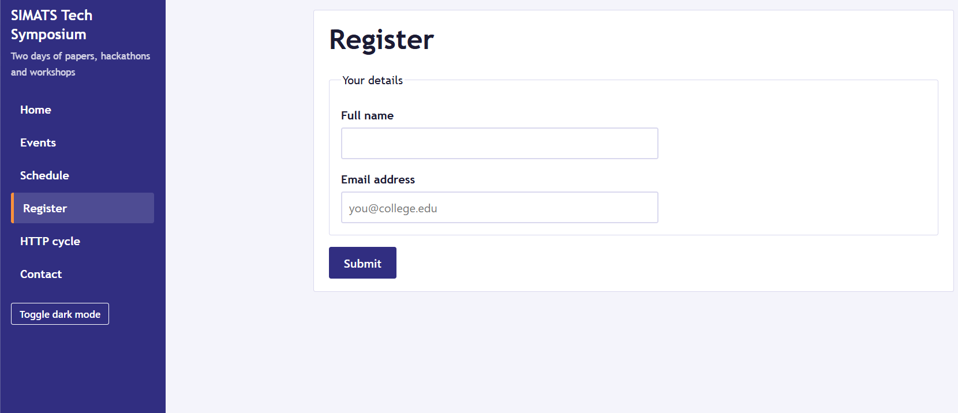

The missing semantic elements are:
- <header> – Defines the introductory section of the webpage, including the title or logo.
- <nav> – Defines the navigation links of the website.
- <main> – Identifies the main content of the webpage.
- <section> – Groups related content, such as symposium registration details.
- <footer> – Contains footer information, such as contact details and copyright.
These elements improve the structure, accessibility, readability, and maintainability of the webpage.
2. Modify the structure to make it standards-compliant.
The following HTML5 code provides a properly structured and accessible symposium registration form.

<!DOCTYPE html>
<html lang="en">
<head>
<meta charset="UTF-8">
<meta name="viewport" content="width=device-width, initial-scale=1.0">
<title>Symposium Registration</title>
</head>
<body>
<header>
<h1>Online Symposium Portal</h1>
</header>

<nav aria-label="Main navigation">
<a href="/">Home</a>
<a href="/about">About</a>
<a href="/contact">Contact</a>
</nav>

<main>
<section aria-labelledby="registration-title">
<h2 id="registration-title">Student Registration</h2>

<form action="/register" method="POST">
<label for="name">Name:</label>
<input type="text" id="name"
name="name" required>

<label for="email">Email:</label>
<input type="email" id="email"
name="email" required>

<button type="submit">Submit</button>
</form>
</section>
</main>

<footer>
<p>Online Symposium Portal</p>
</footer>
</body>
</html>
Explanation: The code uses semantic elements, properly associated labels, required fields, and a submit button. The POST method sends the form data in the HTTP request body. For secure transmission, the website must use HTTPS.
3. Interpret the HTTP request generated during form submission.
When a student submits the form, the browser generates an HTTP POST request to the /register endpoint.
Example request:
POST /register HTTP/1.1
Host: example.com
Content-Type: application/x-www-form-urlencoded

name=Arun&email=arun%40example.com
Explanation:
- POST: Specifies that the form data is being submitted to the server.
- URL: /register identifies the server endpoint that processes the registration.
- Content-Type: Indicates the format of the submitted form data.
- Request body: Contains the student's name and email address.
The server receives the request, validates the submitted data, and processes the registration. The exact headers and body format may vary depending on the form configuration.
4. Analyze the HTTP response cycle from server to browser.
The HTTP response cycle involves the following steps:
- The browser sends the registration form data to the server using an HTTP POST request.
- The server receives the request and validates the submitted information.
- The server processes the registration and generates an appropriate HTTP response.
- The response contains a status code, headers, and optionally a response body.
- The browser interprets the response and displays a success message, an error message, or another page.
Example response:
HTTP/1.1 200 OK
Content-Type: text/html; charset=UTF-8

<h1>Registration Successful</h1>
Here, 200 OK indicates that the request was successfully handled. A real application may instead use 201 Created or a redirect such as 303 See Other after successful registration.
5. Suggest improvements for usability and accessibility.
The following improvements can make the registration portal easier to use and more accessible:
- Labels: Associate every input field with a <label> so screen readers can identify the fields.
- Validation: Use attributes such as required and type="email" to detect missing or incorrectly formatted data.
- Keyboard accessibility: Ensure that users can navigate the form and submit it using a keyboard.
- Error messages: Display clear, helpful messages when the submitted information is invalid.
- Responsive design: Use CSS media queries and a viewport declaration to support mobile devices.
- Security: Use HTTPS, server-side validation, and appropriate protection against common web attacks.
These improvements increase usability, accessibility, reliability, and data protection.
Scenario 2: Cross-Browser Compatibility Issue

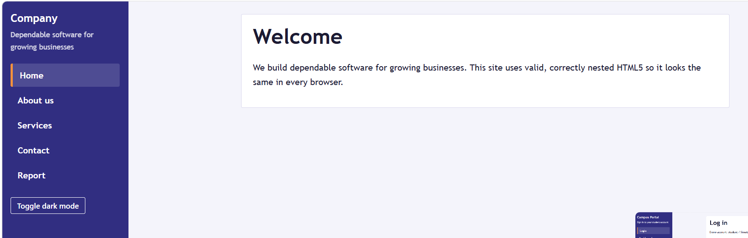
1. Identify improper nesting and missing closing tags.
The given HTML code contains the following errors:
<div>
<h1>Welcome
<p>About us
</div>
- The <h1> heading is not explicitly closed using </h1>.
- The <p> paragraph is not explicitly closed using </p>.
- Although browsers may automatically close some elements during HTML parsing, relying on this behavior can make the code difficult to maintain.
- The document is missing the <!DOCTYPE html> declaration.
- The <div> element is generic and does not describe the meaning of the content.
Correcting these issues helps the document follow HTML5 standards and improves consistency across browsers.
2. Analyze how different browsers may interpret this structure.
Different browsers use HTML parsing rules to recover from malformed markup. As a result, the page may still appear, but its document structure might not match the developer's intention.
- Browsers may automatically insert missing closing tags for certain elements.
- The resulting Document Object Model (DOM) may be different from what the developer expects.
- CSS selectors and JavaScript code may behave unexpectedly when the document structure is incorrect.
- Differences in browser defaults can affect margins, spacing, and the appearance of headings and paragraphs.
Therefore, developers should use valid HTML and test their websites in multiple browsers to achieve consistent rendering.
3. Identify missing semantic elements (e.g., header, section).
The following semantic elements could improve the webpage structure:
- <header> – Contains the page title or introductory content.
- <main> – Identifies the primary content of the page.
- <section> – Groups related content under a meaningful heading.
- <footer> – Contains copyright information or contact details.
The original <div> can be replaced with suitable semantic elements when their meanings match the content. This improves accessibility and makes the webpage easier to understand.
4. Provide a corrected W3C-compliant HTML structure.
The corrected HTML5 structure is shown below.

<!DOCTYPE html>
<html lang="en">
<head>
<meta charset="UTF-8">
<meta name="viewport" content="width=device-width, initial-scale=1.0">
<title>Company Website</title>
</head>
<body>
<header>
<h1>Welcome</h1>
</header>

<main>
<section aria-labelledby="about-title">
<h2 id="about-title">About Us</h2>
<p>Learn more about our company
and its services.</p>
</section>
</main>

<footer>
<p>&copy; 2026 Company Website</p>
</footer>
</body>
</html>
Explanation: The code includes the HTML5 doctype, language declaration, character encoding, viewport settings, and semantic elements. All elements are correctly nested and closed. This makes the webpage more standards-compliant, accessible, and maintainable.
5. Suggest techniques to ensure cross-browser compatibility.
The following techniques help maintain consistent behavior across different browsers:
- Use valid HTML and CSS: Follow web standards and close elements correctly.
- Validate the code: Use the W3C Markup Validation Service to identify markup errors.
- Use CSS resets or normalization: Reduce differences in default browser styling.
- Test across browsers: Check the website in Chrome, Firefox, Edge, and Safari where available.
- Use responsive design: Apply flexible layouts, relative units, and media queries for different screen sizes.
- Avoid unsupported features: Check browser compatibility before using newer HTML, CSS, or JavaScript features.
These techniques improve consistency, usability, and reliability across browsers and devices.
Scenario 3: Form Submission Failure

1. Identify issues in the form configuration.
The given form is:
<form action="/submit" method="GET">
<input type="text" name="username">
<input type="password" name="password">
<button type="button">Login</button>
</form>
The main issues are:
- Incorrect button type: type="button" does not submit the form by default.
- Inappropriate HTTP method: GET places submitted form values in the URL, making it unsuitable for transmitting passwords.
- Missing labels: The inputs do not have associated labels, reducing accessibility.
- Missing validation: The fields do not use attributes such as required.
- Security concerns: Passwords must not be transmitted over unencrypted HTTP.
The most direct cause of the submission failure is the button type. A button with type="button" does not trigger normal form submission unless JavaScript explicitly handles the click.
2. Analyze why the HTTP request is not triggered.
The HTTP request is not triggered because the button is defined as:
<button type="button">Login</button>
A button of type button performs no form-submission action by default. Therefore, clicking it does not automatically send the form data to /submit.
To trigger normal form submission, the developer should use:
<button type="submit">Login</button>
When the user clicks this button, the browser submits the form according to the action and method attributes, provided that any applicable validation succeeds.
3. Interpret the role of GET method in this scenario.
The GET method is used to request a resource from a server. When a form uses GET, its successful control values are generally appended to the URL as query parameters.
For example:
GET /submit?username=arun&password=example123 HTTP/1.1
Host: example.com
This is an illustration of the request that could result if the form were submitted with GET; the original type="button" prevents normal submission.
The GET method is inappropriate for a login form because:
- Passwords may appear in URLs and browser history.
- URLs can be recorded in server logs or exposed through other mechanisms.
- Query parameters may be shared or retained unintentionally.
- GET requests are intended primarily for retrieving resources, not submitting sensitive login credentials.
Therefore, POST should be used for login form submission, together with HTTPS to protect the credentials during transmission.
4. Propose a corrected implementation.
The following code corrects the button type, uses POST, and adds labels and validation.

<!DOCTYPE html>
<html lang="en">
<head>
<meta charset="UTF-8">
<meta name="viewport" content="width=device-width, initial-scale=1.0">
<title>Login Form</title>
</head>
<body>
<main>
<h1>User Login</h1>

<form action="/submit" method="POST">
<label for="username">Username:</label>
<input type="text" id="username"
name="username" required>

<label for="password">Password:</label>
<input type="password" id="password"
name="password" required>

<button type="submit">Login</button>
</form>
</main>
</body>
</html>
Explanation:
- action="/submit" specifies the endpoint that processes the login form.
- method="POST" sends the submitted values in the request body.
- type="password" masks the password on the screen; it does not encrypt the password.
- required ensures that both fields must be completed before normal browser submission.
- type="submit" triggers the form submission.
The server must validate the credentials and handle authentication securely.
5. Suggest improvements for secure data transmission.
The following improvements help protect user credentials:
- Use HTTPS: Encrypt data exchanged between the browser and server using TLS.
- Use POST: Submit login credentials in the request body instead of placing them in the URL.
- Validate on the server: Verify credentials and reject invalid or malicious input.
- Hash passwords securely: Store passwords using a suitable password-hashing algorithm, such as Argon2id, rather than storing plaintext passwords.
- Implement secure sessions: Use appropriately configured session cookies with Secure, HttpOnly, and suitable SameSite attributes.
- Prevent brute-force attacks: Apply rate limiting and other appropriate login protections.
- Avoid exposing sensitive information: Do not log passwords or include them in error messages.
These measures improve the confidentiality and security of user authentication.
Overall Conclusion
- Semantic HTML5 elements and properly structured markup improve accessibility, maintainability, and standards compliance.
- Understanding HTTP methods and the request-response cycle helps developers build reliable web applications.
- Correct form configuration, XML/HTML validation, and cross-browser testing prevent common development errors.
- HTTPS, server-side validation, and secure authentication practices protect sensitive user data.
Before submission: Fill in your name and registration number, and add your signature in the code-of-conduct section of the assessment.

