SIMATS ENGINEERING
ASSESSMENT TOOL 3

COURSE NAME: INTERNET PROGRAMMING COURSE CODE: CSA43

COURSE OUTCOME COVERED
CO-2 : Apply CSS layout and styling techniques to create visually appealing and responsive web interfaces, and use JavaScript to enable interactive client-side behavior. (L3)
Assessment Tool : Short Answer Test

Weightage: 10%

QUESTIONS: Total Marks: 50
Code of Conduct:
I MS Naveen(192371002) certify that this submission is my original work and that I have adhered to the guidelines specified for this assessment. I understand that any violation of academic integrity rules will result in disciplinary action.
Signature of the student:
A3- Short Answer Test
Question 1 (5 Marks)
Suppose that a company wants its website to work seamlessly on mobile, tablet, and desktop devices. Explain the concept of responsive web design and its importance. Describe the key CSS techniques used to achieve responsiveness, and explain how CSS Flexbox or Grid can be used to design adaptive layouts. Illustrate your answer with a simple example layout and suggest improvements to enhance user experience across different devices.
Question 2 (5 Marks)
Suppose that a webpage contains a form where user input must be validated before submission. Explain the concept of client-side validation and its purpose. Describe how JavaScript event handling is used in validation and explain the role of regular expressions in validating inputs such as email or phone numbers. Provide a suitable example and suggest improvements for better usability and security.
Question 3 (5 Marks)
Suppose that a webpage layout breaks when the browser window is resized. Explain the CSS box model and its components, and describe how CSS positioning techniques affect layout structure. Identify possible causes of layout breaking and explain how media queries can be used to resolve these issues. Suggest best practices to ensure a stable and responsive layout.
Question 4 (5 Marks)
Suppose that a website requires dynamic content updates without reloading the entire page. Explain the concept of the Document Object Model (DOM) and its role in web development. Describe how JavaScript can be used to manipulate the DOM for updating webpage content dynamically. Provide an example and suggest improvements to enhance performance and user experience.
Question 5 (5 Marks)
Responsive Layout: A college website must display properly on desktops, tablets, and mobile phones. How would you use CSS media queries and flexible layouts to achieve responsiveness?
Question 6(5 Marks)
CSS Styling: An online shopping website has plain product cards. How would you apply CSS colors, borders, shadows, and spacing to improve its visual appearance? Question 7 (5 Marks)
Navigation Menu: A website navigation menu overlaps its content on smaller screens. How would you use CSS layout techniques to correct the problem?
Question 8 (5 Marks)
JavaScript Validation: A registration form accepts empty fields. How would you use JavaScript to validate the form before submission?
Question 9 (5 Marks)
Interactive Button: An e-learning website requires a button that displays a welcome message when clicked. How would you implement this functionality using JavaScript? Question 104 (5 Marks)
. Dynamic Content: A shopping website needs to update the total price when a user changes the quantity of a product. How would you use JavaScript to calculate and display the updated price?
RUBRICS FOR CALCULATION:
Criteria | Weighta ge | Level 4 –  Exemplary (5 Marks) | Level 3 –  Proficient (4  Marks) | Level 2 – Developing  (2–3 Marks) | Level 1 – Beginning  (0–1 Mark)
Conceptual Understandi ng | 30 | Demonstrates clear and complete understanding of the concept | Good understandin g with minor gaps | Basic understandin g with some misconceptio ns | Poor or incorrect  understandi ng
Accuracy of  Answer | 25 | Completely correct answer with no errors | Mostly correct with minor errors | Partially correct with noticeable errors | Incorrect or  irrelevant answer
Application of  Knowledge | 20 | Correctly applies concepts to solve the  question/proble  m | Applies concepts with minor mistakes | Limited or partially correct application | No or incorrect application
Completenes  s of  Response | 15 | Covers all required parts of the question | Covers most parts with minor omissions | Covers only some parts | Incomplete or missing response
Clarity & Presentation | 10 | Clear, concise, and wellorganized answer | Understandab le with minor issues | Somewhat  unclear or poorly structured | Difficult to understand

DETAILED ANSWERS AND IMPLEMENTATION

A3 – Short Answer Test | Internet Programming (CSA43)
The following answers address every question, include implementation examples, and provide illustrative output screenshots. Code snippets are teaching examples; place each snippet in the corresponding HTML file to run it in a browser.

Question 1 – Responsive Web Design
Responsive web design (RWD) is an approach in which a webpage automatically adjusts its layout, text, images and controls to the available screen size and orientation. The goal is one website that remains usable on phones, tablets, laptops and large monitors, rather than separate fixed-width pages. It improves readability, accessibility, navigation, and reduces horizontal scrolling and maintenance effort.

Example implementation
<meta name="viewport" content="width=device-width, initial-scale=1">
<div class="layout">
<header>CampusConnect</header>
<main class="cards">
<article>Courses</article><article>Announcements</article>
<article>Student Support</article>
</main>
</div>
<style>
* { box-sizing: border-box; }
.cards { display: grid; grid-template-columns: repeat(3, 1fr); gap: 1rem; } article { padding: 1.25rem; border-radius: 12px; background: #fff; }
@media (max-width: 800px) {
.cards { grid-template-columns: repeat(2, 1fr); }
}
@media (max-width: 520px) {
.cards { grid-template-columns: 1fr; }
}
</style>
Key techniques: viewport meta tag; fluid widths (%, max-width); flexible images (maxwidth:100%); media queries; Flexbox for one-dimensional alignment; Grid for twodimensional layouts; relative units (rem, %, vw) and box-sizing:border-box. The example uses three columns on desktop, two on tablets and one on small phones. Improvements include testing real breakpoints, readable font sizes, touch targets around 44px, sufficient contrast, alt text, and avoiding fixed heights.

Illustrative browser output
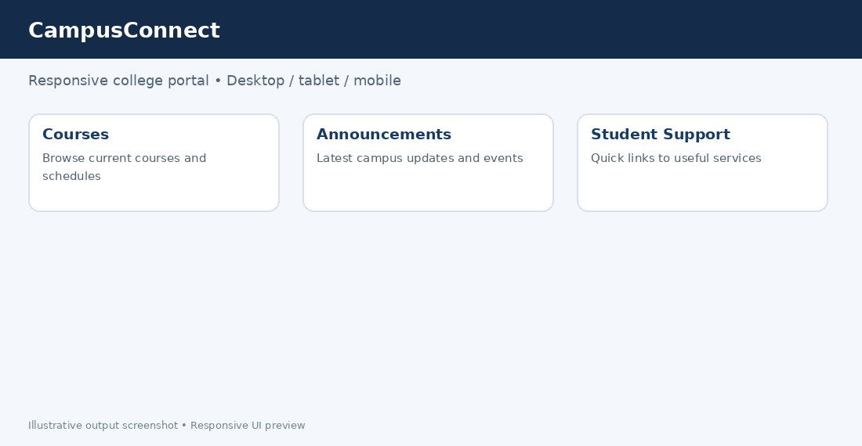
Figure 1. Responsive college portal cards (illustrative output).

Question 2 – Client-Side Form Validation
Client-side validation checks form values in the browser before the form is sent to a server. It catches common mistakes early, provides immediate feedback, reduces avoidable server requests and helps users correct errors. JavaScript event handling commonly uses the submit event; preventDefault() stops submission when data is invalid. Regular expressions (regex) describe text patterns, such as a basic email format or a phone number containing 10 digits. Regex is a format check, not proof that an address or number exists.

Example implementation
<form id="signup">
<label>Email <input id="email" type="email" required></label>
<label>Phone <input id="phone" inputmode="numeric" required></label>
<button type="submit">Create account</button>
<p id="message" aria-live="polite"></p>
</form> <script> document.querySelector('#signup').addEventListener('submit', e => { const email = document.querySelector('#email').value.trim(); const phone = document.querySelector('#phone').value.trim(); const emailOK = /^[^\s@]+@[^\s@]+\.[^\s@]+$/.test(email); const phoneOK = /^\d{10}$/.test(phone); if (!emailOK || !phoneOK) { e.preventDefault(); document.querySelector('#message').textContent = 'Enter a valid email and a 10-digit phone number.';
}
});
</script>
Use labels, required attributes, clear inline messages, focus the first invalid field and preserve entered values. Never rely only on client-side checks: users can disable or bypass JavaScript, so repeat validation on the server and use HTTPS. Avoid exposing sensitive details in error messages.

Illustrative browser output
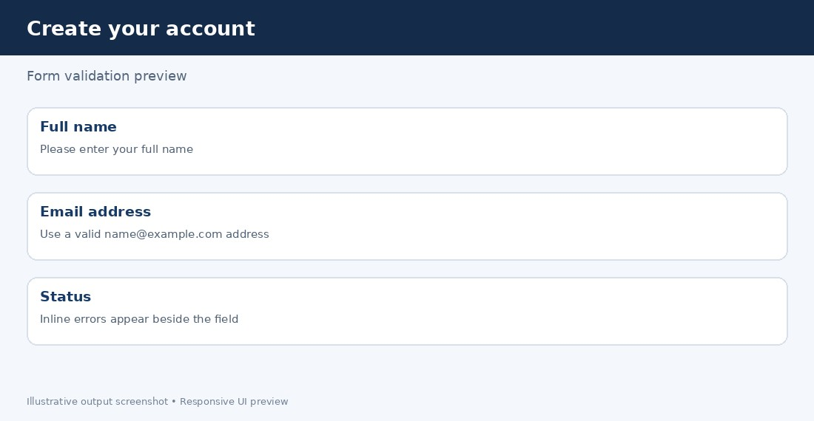
Figure 2. Form validation feedback concept (illustrative output).

Question 3 – CSS Box Model, Positioning and Layout Breakage
The CSS box model describes each element as content, padding, border and margin. Content holds text or media; padding creates inner space; border surrounds padding and content; margin creates outer separation. With content-box, declared width excludes padding and border. With border-box, width includes them, making sizing more predictable. Positioning modes include static (normal flow), relative (offset from normal position), absolute (positioned against a containing block), fixed (relative to viewport) and sticky (sticks after a scroll threshold).

Example implementation
* { box-sizing: border-box; }
.page { display: grid; grid-template-columns: 16rem minmax(0, 1fr); gap: 1rem; }
.sidebar { position: static; } .content { min-width: 0; }
img, video { max-width: 100%; height: auto; }
@media (max-width: 700px) {
.page { grid-template-columns: 1fr; }
.sidebar { order: 2; }
}
Common causes of breakage are fixed pixel widths, oversized images, floats not cleared, absolute positioning used for entire layouts, unexpected margins, and long unbreakable text.
Use responsive Grid/Flexbox, minmax(0,1fr), max-width:100%, consistent spacing, and media queries. Keep absolute positioning for overlays or small anchored elements, not main page structure. Test zoom, narrow widths and long content.

Question 4 – DOM and Dynamic Content
The Document Object Model (DOM) is the browser’s tree representation of HTML.
JavaScript can select nodes, read or change text and attributes, create or remove elements, and react to events. DOM updates let a page refresh a small section without reloading the whole document. Prefer textContent for plain text and createElement for user-provided content; assigning untrusted input to innerHTML can introduce cross-site scripting (XSS).

Example implementation
<h2 id="welcome">Welcome to your dashboard</h2>
<button id="update">Show latest notice</button>
<p id="notice" aria-live="polite">No new notices.</p>
<script>
document.querySelector('#update').addEventListener('click', () => { document.querySelector('#notice').textContent =
'A new lesson has been added to your course.';
});
</script>
Performance and UX improvements: update only the necessary node, batch repeated changes, use event delegation for many similar controls, avoid unnecessary layout reads/writes, announce status with aria-live, and provide a loading or error state for network requests. For remote data, fetch() can retrieve JSON asynchronously while the rest of the page remains available.

Illustrative browser output
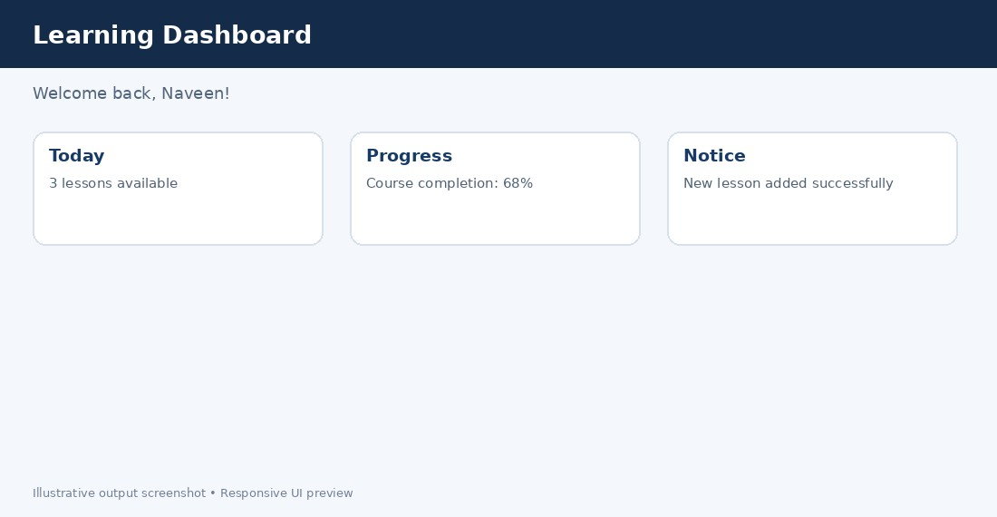
Figure 3. Dynamic dashboard content (illustrative output).

Question 5 – Responsive College Layout
Start with a single-column layout for phones, then progressively add columns when there is enough space. Use a viewport meta tag, fluid containers, CSS Grid or Flexbox, flexible media, and media queries. A breakpoint should be chosen when content becomes cramped, not only for a specific device brand.

Example implementation
.container { width: min(100% - 2rem, 72rem); margin-inline: auto; } .course-list { display: grid; grid-template-columns: 1fr; gap: 1rem; }
.course img { width: 100%; height: auto; }
@media (min-width: 600px) {
.course-list { grid-template-columns: repeat(2, minmax(0, 1fr)); } }
@media (min-width: 960px) {
.course-list { grid-template-columns: repeat(3, minmax(0, 1fr)); } }
Mobile: one card per row; tablet: two; desktop: three. Validate by resizing the browser and testing portrait/landscape. Keep touch controls large, navigation concise and content order logical.

Question 6 – Improving Product Card Styling
Use a consistent visual hierarchy: a neutral card background, a brand color for actions, a subtle border, rounded corners, sufficient whitespace and a soft shadow. Use spacing consistently (for example, 8/16/24px). Hover effects should not be the only way to communicate information because touchscreens do not have hover.

Example implementation
.product-card { padding: 1rem; border: 1px solid #dbe3ec; border-radius: 14px; background: #fff; box-shadow: 0 3px 12px rgb(20 40 70 / 8%);
transition: transform .18s ease, box-shadow .18s ease; }
.product-card:hover, .product-card:focus-within { transform: translateY(-3px);
box-shadow: 0 8px 22px rgb(20 40 70 / 15%);
}
.product-card button { padding: .7rem 1rem; border-radius: 8px; }
Use adequate text/background contrast, clear prices and buttons, consistent image ratios, and visible keyboard focus. Prefer lightweight shadows and transform/opacity animations to avoid expensive layout recalculations. Respect prefers-reduced-motion.

Question 7 – Fixing an Overlapping Navigation Menu
Overlap often comes from fixed widths, absolute positioning, excessive z-index, or a menu that does not wrap. Use Flexbox with flex-wrap or a mobile breakpoint that changes the layout to a vertical menu. Keep the navigation in normal document flow unless it is intentionally a fixed overlay.

Example implementation
.nav { display: flex; align-items: center; gap: 1rem; flex-wrap: wrap; }
.nav a { display: block; padding: .75rem; }
@media (max-width: 600px) {
.nav { flex-direction: column; align-items: stretch; }
.nav a { width: 100%; }
}
main { min-width: 0; }
Ensure the menu does not cover headings or form controls, set a logical tab order, provide a clear focus indicator, and test at 320px width and 200% zoom. If a hamburger menu is used, its button should expose aria-expanded and control the menu visibility.

Question 8 – Validating Empty Registration Fields
Attach a submit listener to the form, trim whitespace, check required fields, show a clear error and prevent submission when invalid. Native HTML attributes such as required, type=email and minlength provide useful baseline checks, while JavaScript can coordinate cross-field rules. Server-side validation remains mandatory.

Example implementation
const form = document.querySelector('#register'); form.addEventListener('submit', event => { const name = document.querySelector('#name').value.trim(); const password = document.querySelector('#password').value;
if (!name || password.length < 8) { event.preventDefault();
document.querySelector('#error').textContent =
'Enter your name and a password of at least 8 characters.';
}
});
Add matching HTML fields with labels and required attributes. Associate error text using aria-describedby, move focus to the first invalid input, and do not clear all fields after a mistake. Never store passwords in client-side code or treat browser validation as a security boundary.

Question 9 – Interactive Welcome Button
Select the button and message element, then register a click event listener. When clicked, update the message’s textContent. This separates behavior from HTML and avoids inline JavaScript handlers.

Example implementation
<button id="welcomeBtn" type="button">Welcome</button>
<p id="welcomeMessage" aria-live="polite"></p> <script> document.querySelector('#welcomeBtn').addEventListener('click', () => { document.querySelector('#welcomeMessage').textContent =
'Welcome to the e-learning portal!';
});
</script>
Use a real button for keyboard support, provide a visible focus style and use aria-live so assistive technologies can announce the new message. If the action takes time, show progress and prevent duplicate submissions.

Question 10 – Dynamic Shopping Total
Calculate the total as unit price multiplied by quantity. Listen for the input event so the result updates as quantity changes, validate that quantity is a positive integer, and format the amount as currency. In a real checkout, the server must recalculate the total and verify prices.

Example implementation
const unitPrice = 799; const quantity = document.querySelector('#quantity'); const total = document.querySelector('#total'); function updateTotal() {
const qty = Math.max(1, Number.parseInt(quantity.value, 10) || 1); total.textContent = new Intl.NumberFormat('en-IN', {
style: 'currency', currency: 'INR'
}).format(unitPrice * qty);
}
quantity.addEventListener('input', updateTotal); updateTotal();
Use an input type=number with min=1 and step=1, show the unit price and total clearly, and update an aria-live status if useful. Avoid trusting a price sent from the browser; calculate authoritative totals on the server. Illustrative browser output
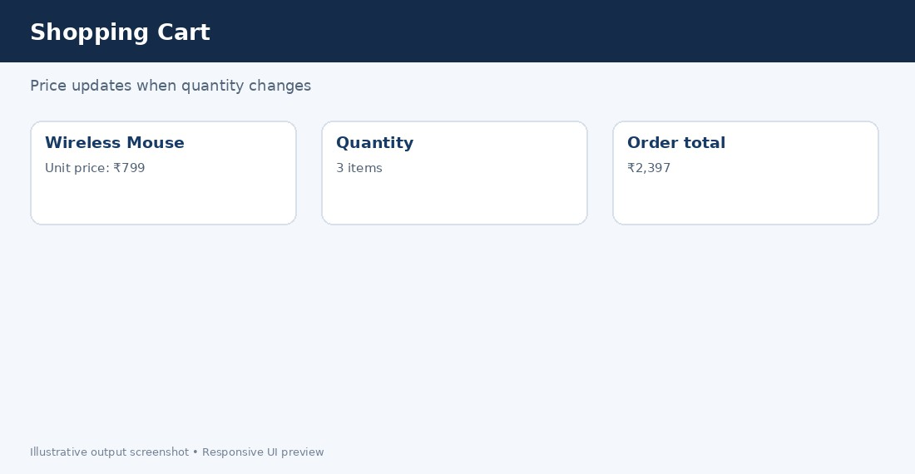
Figure 4. Shopping total updated from quantity (illustrative output).

Testing checklist
- Test at phone, tablet and desktop widths; verify no horizontal overflow.
- Use keyboard-only navigation and check visible focus states.
- Check browser console for JavaScript errors and validate HTML/CSS.
- Use server-side validation for security-sensitive input and recompute prices on the server.
- Use semantic HTML, labels, sufficient contrast, and reduced-motion support.

