|  |
| --- |
|  |
| **Acquisition of Locomotives** |
| **Attachment RS-A-6**  **Banedanmark interfaces to the Purchase Agreement** |

Instructions to Tenderers: 3

1 Banedanmark interfaces 4

2 Infrastructure 4

3 Electrification 5

4 Train control 6

**Appendices (inserted below):**

Appendix A Banedanmark’s reference line for rolling stock

Appendix B Banedanmark guideline overview of maximum axle load

Appendix C Banedanmark guideline overview of maximum meter load

Appendix D Banedanmark maximum line speeds

Appendix E Banedanmark F160 & F200 Electrification Type Test Certificates

Appendix F Banedanmark infrastructure track magnets

|  |
| --- |
| Instructions to Tenderers: The Tenderer is required to review this document carefully and state whether the Tenderer complies with the requirements /provisions of this document in the Compliance Matrix. In doing so, please take note of the categorisation of the requirements, cf. Clause 9 of the Tender Conditions. |

# Banedanmark interfaces

This document provides information on the interfaces between the Locomotives and infrastructure in Denmark. It also includes infrastructure in depots which is DSB’s responsibility. Further information on the Banedanmark Infrastructure can be found in the Attachment RS-A-7 (Banedanmark Network Statement 2018). The locomotives are required to operate on the infrastructure of Banedanmark and DSB without operational limitations.

Please note that this does not define infrastructure in other countries which may be more restrictive. It is the Supplier’s responsibility to ascertain and comply with applicable requirements.

The Supplier is responsible for ensuring that their Locomotives shall be able to interface with the infrastructure in Denmark without restricting existing operational capabilities. (496)

# Infrastructure

## Track gauge

### The infrastructure has a track gauge of 1435 mm. (91)

## Structure gauge

### The maximum structure gauge is detailed in Appendix A. (357)

### The structure gauge may be more restrictive in countries other than Denmark, eg Germany.

### The Locomotives shall be able to operate in Denmark and Germany without modification. It is recognised that it will require a changeover between equipment needed to operate in different countries but this shall be automatic up to line speed. (107a)

## Operational Routes

### The Operational Routes are detailed in Attachment RS-A-5 (Operational Concept). (100 & 269)

## Axle load

### The maximum axle loads for the Operational Routes in Denmark are detailed in Appendix B. (92)

## Axle spacing

### The maximum axle spacing (meter load) for the Operational Routes in Denmark are detailed in Appendix C.

## Curvature

### The minimum horizontal curvature is 80 m radius on DSB infrastructure. The minimum S curve on DSB infrastructure comprises curves of 120 m radius with an intermediate straight of 10,78 m. The minimum horizontal curvature is 150 m radius on Banedanmark infrastructure. (201a)

### The minimum vertical curvature is 500 m radius. (201b)

### The maximum speed limits for the Operational Routes in Denmark are detailed in Appendix D.

## Cant deficiency

### The maximum cant deficiency is 153 mm. (980)

## Maximum gradient

### The maximum gradient for train operation and rescue is 35 promille. (93)

# Electrification

## Overhead power supply

### Denmark provides a 25 kV AC 50 Hz overhead power supply.

### The characteristics of existing (pre-TSI) overhead power supply are detailed in Appendix E. Please note that minimum contact wire height for Fl60 electrification is 4910 mm above rail level whereas Appendix E incorrectly defines it as 4920 mm. (1066)

### Germany provide a 15 kV AC 16 2/3 Hz overhead power supply. (103)

### A voltage changeover system is required to avoid any delays when crossing borders. (107b) Please note that the changeover for overhead power supply may be located in a different position to the changeover for train control.

## Track magnets

### Denmark uses track magnets to identify the location of neutral sections. Details of these track magnets are in Appendix G. The Great Belt tunnel (Storebælt) includes infrastructure magnets with opposite polarity for controlling tractive effort on EA locomotives. This information is subject to confirmation by Banedanmark. (322a)

### The Banedanmark Signalling Programme will include a function in the ETCS to perform a similar role and are transmitted to the EVC in the active cab. Detailed information has to be obtained from Banedanmark.

### These systems provide information to automatically remove the overhead power supply before the neutral section and reconnect it after passing the neutral section. (322b)

### Maximum energy efficiency is achieved when trains can use either system and only remove/reconnect the overhead power supply when the pantograph passes or is predicted to pass the magnet/balise. (322c & 636)

# Train control

## Radio Communication

### Banedanmark will use GSM-R Baseline 1 radio communication system for train voice communication. (724)

## Train Control

### Banedanmark will implement ETCS level 2 Baseline 3 software and hardware for train control :

#### Banedanmark requires version 3.4.0 in accordance with Table A 2.2 of 2016/919 CCS TSI to be installed on the Locomotive; and

The ETCS equipment shall comply with NNTR Bekendtgørelse 1465.

### There will also be areas of Banedanmark infrastructure that retain Zugbeeinflussungssystem (ZUB) 123 system for train control. Trains shall be fitted with STM DK hardware and software to allow the ETCS system to operate with this train control system. (217)

### Any cross border operation will require train control changeover equipment to avoid any delays. (107d) Please refer to 3.1.4 regarding the positioning of changeover equipment.

### The Operational Routes in Denmark include both track circuit, axle counter and loop train detection systems as detailed in 2014 LOC & PAS TSI §4.2.3.3.1. (154)

Appendix A

Banedanmark’s reference line for rolling stock

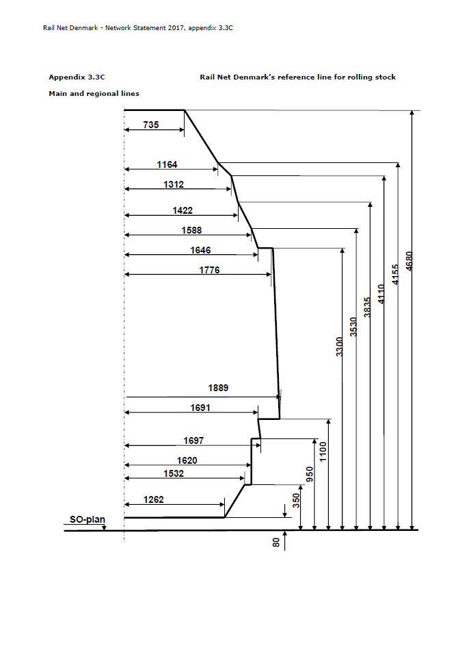Appendix B

Banedanmark guideline overview of maximum axle load

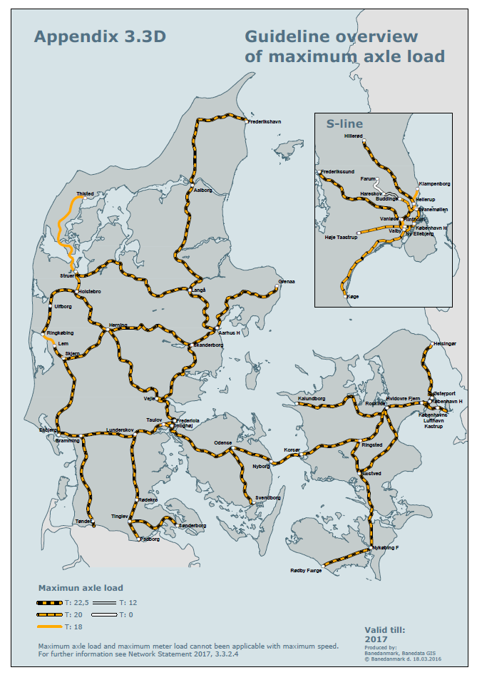Appendix C

Banedanmark guideline overview of maximum meter load

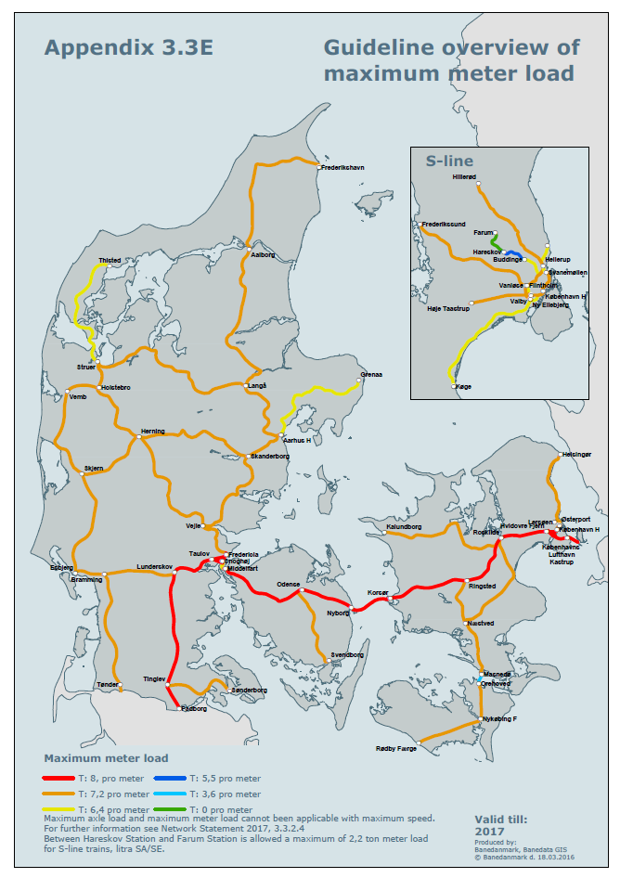Appendix D

Banedanmark maximum line speeds

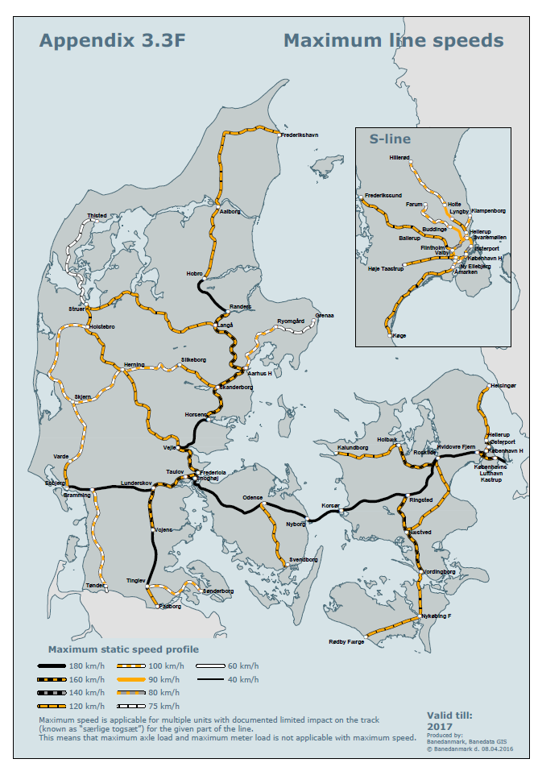Appendix E

Banedanmark F160 & F200 Electrification Type Test Certificates

**TYPE CERTIFICATE**

**BDK type certificate traction current**

1. **Year/designation/version/revision:** 2003/TCZ Fl60St/version 01/revision 02
2. **Type designation incl. any variant/version designation in which variants/versions require separate approval:**

Overhead catenary system Type Regional Railway BDK 160 St

1. **Sub-system designation:**

Overhead catenary system for the Regional Railway for 160 km/h with steel suspension

1. **Name and address of supplier:**

Not relevant

1. **Certifying body:**

Banedanmark

1. **Date of certification:**

Date of signature

1. **Reference to and any conclusion on the assessment report that recommends approval of the system type:**

Not relevant

1. **Use of certificate and any special conditions for or restrictions in the use of the system type:**

Driving with electric traction, v  160 km/h. See section 3.

1. **Procedures to be used for production/establishment of system/equipment/components of this system type to ensure conformity with the type certificate:**

The system is produced according to system drawings and the general work specification for installation (AAB-Montage).

1. **References to technical specification:**

Technical specifications in accordance with section 4

1. **Signature, see para. E:**

Date: 09.09.2008 Date:

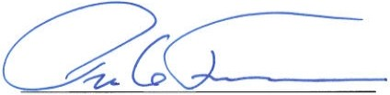

1. Banedanmark, Technical operation, Current, Head of Section

Danish Transport Authority

**Section overview for Type Certificate TCZ F160St**

Edition:

Version:Revision:Date:

01

1. 02

09.09.2008

Section Content

1. Introduction
2. Use
3. Restrictions on use
4. Type identification
5. User documentation
6. Storage of certificate and background documentation
7. **Introduction**

This certificate covers an overhead catenary system for the Regional Railway constructed with steel masts and steel overhead catenary suspension. Revision 02 includes a change of the static displacement, addition of neutral sections and an update of references to standards.

1. **Use**

The system type is used as overhead catenary system for electric locomotives and trains with speeds of up to 180 km/h and a maximum total current consumption of 500 A.

1. **Restrictions on use**

See Railway Standard BN2-74, “Provision of Declaration of Conformity for rolling stock”, EN 50367 and EN 50388. For driving of ER train sets it applies that ER train sets with a maximum of five current collectors of type WBL85, which have been modified, must not exceed a speed of 180 km/h.ET train sets have been approved for max. 180 km/h with a maximum of five current collectors.

1. **Type identification**

The type is identified according to the following technical specifications:

|  |  |
| --- | --- |
| **System** | **Type F- railway BDK 160St** |
| **Design - speed** | 160 km/h |
| **Standards, general design and construction basis for overhead catenary system** | EN 50119, EN 50121, EN 50122,  EN 50163, EN 50367, TSI CR ENE when implemented in DK.  The Danish Heavy Current Executive Order, Fjernbanens Kørestrømsinstruks (FKI) and (Regional railway traction power instructions) and related Railway Standards. |
| **Current collectors**   * **quantity** * profile * Width * **pantograph width** | Max. 5 current collectors - conditions specified in BN2-74, para. 7.1.2  EN 50367, Fig. 83 (Type 1)  (UIC code 608E Anlage 4a/ORE A69/RP4 Fiche 608)  1950 mm  1030 mm |
| **Voltage** | 25 kV |
| **Frequency** | 50 Hz AC |
| **Mast distance** | 16 - 60 m |
| **Maximum change of mast distance at constant contact wire height** | 15 m |
| **Maximum change of mast distance in ramps** | 8 m |

|  |  |
| --- | --- |
| **System** | **Type F- railway BDK 160St** |
| **Mast type** | Closed masts of untreated, corrosion-resistant steel |
| **Foundation** | Prefabricated concrete piles with embedded bolts |
| **Overhead catenary suspension** | Hot-dip galvanised steel |
| **Contact wire** | RiS 100 mm2  (CuAg 0.l Ri l00)  EN 50149 |
| **Catenary wire** | 50 mm2 BZII  DIN 48201-5017-BZII |
| **Dropper** | 10 mm2 BZII  DIN 43138-10/49-BZII |
| **Return conductor** | 327 mm2 St Al  DOVE CSA-C49.l, 1975 |
| **Fixpoint cable** | 50 mm2 BZII  DIN 43141-5017-BZII |
| **Tensioning force:**   * **contact wire** * **catenary wire** * **fixpoint cable** | 12 kN  12 kN  11.5 kN |
| **Separate post-tensioning** | No |
| **Post-tensioning device with**  **ratio 1:3** | 1 x 8 kN |
| **Half post-tensioning length** | max. 750 m |
| **Zig-zag for used contact wire/catenary wire:**   * **straight track** * **curves**   **Fits and clearances** | ± 200 mm  ± 250 mm  ± 50 mm |
| **Maximum permitted static displacement** | 500 mm |
| **Vertical bend on contact wire** | 1:1200 |
| **Contact wire ramps at bridges etc.** | 1:600 |

|  |  |
| --- | --- |
| **System** | **Type F- railway BDK 160St** |
| **System height:**  **Open land**  **max.**  **normal**  **min.**  **Intersecting bridges**  **(suspension in bridge)**  **max.**  **normal**  **min.**  **Tunnels**  **max.**  **normal**  **min.** | 1400 mm  1000 mm  93 mm  1000 mm  93 mm  0 mm  1000 mm  380 mm  0 mm |
| **Contact wire height:**  **Open land**  **max.**  **normal**  **min.**  **Intersecting bridges**  **(suspension in bridge)**  **max.**  **normal**  **min.**  **Tunnels**  **max.**  **normal**  **min.** | 6000 mm  5500 mm  5000 mm (+50 mm) 1)  6000 mm  5125 mm  4920 mm (+50 mm) 1)  6000 mm  5125 mm  4920 mm (+50 mm) 1) |
| **Fits and clearances (contact wire height)**  **Free section**  **Under bridges and connecting ramps** | ±50 mm; however, max. ramp 1/1200  ±10 mm, min. contact wire height under bridges 4970 mm |
| **Front sag on contact wire compared to mast distance** | 1/1000 (1 30 m)  0 (130 m) |
| **Maximum permitted lift of contact wire** | 150 mm |
| **Dropper distance** | 4 - 12 m |

|  |  |
| --- | --- |
| **System** | **Type F- railway BDK 160St** |
| **Minimum dropper distance** | 0 mm |
| **Alternating fields** | 3 sections,  distance between parallel wires min. 270 mm/standard 360 mm, max. section length 44 m, max. elevation of unused wire 100 mm |
| **Separation fields** | 3 sections,  distance between parallel wires min. 270 mm/standard 360 mm, max. section length 44 m, max. elevation of unused wire 100 mm |
| **Booster transformer fields** | 3 sections,  distance between parallel wires min. 270 mm/standard 360 mm, max. section length 44 m, max. elevation of unused wire 100 mm |
| **Neutral sections** | Neutral sections with insulators subject to EN 50367 Fig. A4 – Neutral section with insulators |
| **Permitted continuous current** | 500 A |
| **Insulator**  **min. creepage distance** | 1000 mm |
| **Booster transformer distance** | 3000 m ± 300 m |
| **Fixed earth terminals** | In station areas |
| **Surge arrester** | Placed at cable terminal boxes, feed points, transition from one insulation level to another |

1. At least 50 mm must be added for future track adjustments
2. **User documentation**

The user documentation consists of:

* + - **System drawings**
    - Model drawings
    - Standard drawings
    - Assembly drawings
    - Technical specifications
    - **System documentation**
    - Tensioning plans
    - Cross sections
    - Installation list
    - K suspension list and dropper print

1. **Storage of certificate and background documentation**

Type certificate and background material, including the documentation material specified in section 5, are stored by Banedanmark.

**TYPE CERTIFICATE**

**BDK type certificate traction current**

1. **Year/designation/version/revision:**

2003/TCZ F200St/version 01/revision 01

1. **Type designation incl. any variant/version designation in which variants/versions require separate approval:**

Overhead catenary system Type Regional Railway BDK 200 st.

1. **Sub-system designation:**

Overhead catenary system for the Regional Railway for 200 km/h with steel suspension

1. **Name and address of supplier:**

Not relevant

1. **Certifying body:**

Banedanmark

1. **Date of certification:**

Date of signature

1. **Reference to and any conclusion on the assessment report that recommends approval of the system type:**

Not relevant

1. **Use of certificate and any special conditions for or restrictions in**

**the use of the system type:**

Driving with electric traction, v ≤ 200 km/h. See section 3.

1. **Procedures to be used for production/establishment of system/equipment/components of this system type to ensure conformity with the type certificate:**

The system is produced according to system drawings and the general work specification for installation (AAB-Montage).

1. **References to technical specification:**

Technical specifications in accordance with section 4

1. **Signature, see para. E:**

Date: 09.09.2008 Date:

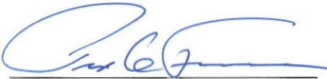

Banedanmark, Technical operation, Current, Danish Transport Authority

Head of section

**Section overview for Type Certificate TCZ F200St**

Edition: Version: 01

Revision: 01

Date: 09.09.2008

Section Content

1 Introduction

1. Use
2. Restrictions on use
3. Type identification
4. User documentation

6 Storage of certificate and background documentation

1. **Introduction**

This certificate covers an overhead catenary system for the Regional Railway constructed with steel masts and steel overhead catenary suspension. Revision 01 includes the addition of neutral sections and change and update of references to standards. In addition, Banestyrelsen (Danish National Railway Agency) has been changed to Banedanmark and BS to BDK.

1. **Use**

The system type is used as overhead catenary system for electric locomotives and train sets with speeds up to 200 km/h and a max. current consumption of 500 A.

1. **Restrictions on use**

See Railway Standard BN2-74, “Provision of Declaration of Conformity for rolling stock”, EN 50367 and EN 50388.

1. **Type identification**

Type identified according to the following technical specifications:

| **System** | **Type F- railway BDK 200St** |
| --- | --- |
| **Standards, general design and construction basis for overhead catenary system** | EN 50119, EN 50121, EN 50122,  EN 50163, EN 50367  TSI CR ENE when implemented in DK.The Danish Heavy Current Executive Order, Fjernbanens Kørestrømsinstruks (FKI) and (Regional railway traction power instructions) and related Railway Standards. |
| **Design speed** | 200 km/h |
| **Current collectors** | Max. 5 current collectors - conditions specified in BN2-74, para. 7.1.2  EN 50367, Fig. B3 (Type 1)  (UIC-kode 608E anlage 4a/ORE A69/RP4, Fiche 608) |
| **-** **quantity** |
| **-** |
| **-** **-** profile |
| **-** |
| **-** |
| **-** **-** width | 1950 mm |
| **-** |
| **-** **pantograph width** | 1030 mm |
|  |
| **Voltage** | 25 kV |
| **Frequency** | 50 Hz AC |
| **Mast distance** | 16 - 58 m |
| **Maximum change of mast distance at constant contact wire height** | 15 m |
| **Maximum change of mast distance in ramps** | 8 m |
| **Mast type** | Closed masts of untreated, corrosion-resistant steel |
| **Foundation** | Prefabricated concrete piles with embedded bolts |
| **Overhead catenary suspension** | Hot-dip galvanised steel |
| **Contact wire** | RiS 120 mm7  (CuAg 0.1 Ri 120) EN 50149 |
| **Catenary wire** | 70 mm2 BZII  DIN 48201-70/19-BZII |
| **Dropper** | 16 mm2 BZII  DIN 43138-16/49-BZII |
| **Return conductor** | 327 mm2 St Al  DOVE CSA-C49. l, 1975 |
| **Fixpoint cable** | 70 mm2 BZll  DIN 43141-70119-BZII |
| **Tensioning force:**  **-** **contact wire**  **-** **catenary wire**  **-** **fixpoint cable** | 15 kN  15 kN  11.5 kN |
| **Separate post-tensioning** | Yes |
| **Post-tensioning device with ratio 1:3** | 2 X 5 kN |
| **Half post-tensioning length** | max. 750 m |
| **Zig-zag for used contact wire/catenary wire:**  **-** **straight track**  **-** **curves** | ± 200 mm  ± 250 mm |
| **Maximum permitted static displacement** | 300 mm |
| **Vertical bend on contact wire** | 1:2000 |
| **Contact wire ramps at bridges etc.** | 1:1000 |
| **System height:**  **Open land**  **max.**  **normal**  **min.**  **Intersecting bridges**  **(suspension in bridge)**  **max.**  **normal**  **min.**  **Tunnels**  **max.**  **normal**  **min.** | 1400 mm   1000 mm   410 mm  1000 mm  410 mm  410 mm  1000 mm  410 mm  410 mm |
| **Contact wire height:**  **Open land**  **max.**  **normal**  **min.**  **Intersecting bridges**  **(suspensions in bridge)**  **max.**  **normal**  **min.**  **Tunnels**  **max.**  **normal**  **min.** | 5500 mm 5300 mm 5000 mm (+50 mm) 1)  5500 mm 5030 mm 5000 mm (+50 mm) 1)  5500 mm  5030 mm 5000 mm (+50 mm) 1) |
| **Fits and clearances (contact wire height)** | ±30 mm; however, max. ramp 1/2000 |
| **Front sag on contact wire compared to mast distance** | 1/1000 (1 > 28.5 m)  0 (1 > 28.5 m) |
| **Maximum permitted lift of contact wire** | 180/240 mm 2) |
| **Dropper distance** | 4-9.5 m |
| **Minimum dropper distance** | 318 mm |
| **Alternating fields** | 5 sections, distance between parallel wires min. 270 mm/standard 360 mm, max. section length 40 m, max. elevation of unused wire 100 mm |
| **Separation fields** | 5 sections, distance between parallel wires min. 270 mm/standard 360 mm, max. section length 40 m, max. elevation of unused wire 100 mm |
| **Booster transformer fields** | 5 sections, distance between parallel wires min. 270 mm/standard 360 mm, max. section length 40 m, max. elevation of unused wire 100 mm |
| **Neutral sections** | Neutral sections with insulators subject to EN 50367 Fig. A4 – Neutral section with insulators |
| **Permitted continuous current** | 880 A |
| **Insulator**  **min. creepage distance** | 1000 mm |
| **Booster transformer distance** | 3000 m ± 300 m |
| **Fixed earth terminals** | In station areas, by/in tunnels |
| **Surge arresters** | Placed at cable terminal boxes, feed points, transition from one insulation level to another |

1) At least 50 mm must be added for future track adjustments

2) With and without lifting restriction in suspension

1. **User documentation**

User documentation consists of:

* **System drawings**
  + Model drawings
  + Standard drawings
  + Assembly drawings
* **System documentation**
  + Tensioning plans
  + Cross sections Installation list
  + K-suspension list and dropper print

1. **Storage of certificate and background documentation**

Type certificate and background material, including the documentation material specified in section 5, are stored by Banedanmark.

Appendix F

Banedanmark infrastructure track magnets

**F1. Balises at neutral section**

To ensure that no traction current is used when passing a neutral section, a passive balise is placed in the track before and after the section.

It is necessary to place balises in the track due to the requirement for safe control of the tractive or brake power and disengagement of the main switch before the neutral section is passed.

To ensure problem-free passage of a neutral section, the traction unit must be de-energised, meaning that the main transformer must not be magnetised and condensers in the filter must be discharged.

Traction control is designed so that the distance between the balise and the neutral section must be at least 75 m on either side of the neutral section at a speed of 160 km/h.

For EA locomotives, other requirements may apply to other traction units, which must be clarified with the current operators.

The balise is placed at the centre of the track at the same height as top of rail (TOR) and requires no electric connection.

The balise is turned so that the north polarity faces to the right seen in the direction of travel. After the neutral section, another balise is placed facing in the opposite direction to ensure engagement after passage of the neutral section.

This will ensure proper function for left-track driving as well.

North polarity is ensured by the use of a compass.

Next to each balise, on the right side of the direction of travel, signs indicating the function of the balise seen from both directions of travel must be mounted 3.5 m from the centre of the track.

Signs are mounted for manual disengagement and engagement before and after the neutral section.

**F2 Balises for increased tractive power**

In places where increased traction power is wanted for the traction unit, balises are placed with the south polarisation facing the right rail set in the direction of travel. This will be relevant in cases where the traction unit has been designed for this, such as EA locomotives, which can increase traction power from 260 kN to 300 kN.

Traction increase is cancelled by opposite polarisation, e.g. on encountering a neutral section.

This solution is used for passing the Great Belt Link.

**F3 Balise details**

Further details of the Neutral section balise and their installation are included in the following drawings overleaf.

