**Fabrication of Green Composites Based On Soy Protein Isolate And Nano Titaniumdioxide**

Rekha Rose Koshy1,2*, Rincy Yohannan 1, Siji K.Mary1,2 ,Laly A Pothen1,2

*1 Bishop Moore College, Mavelikara, Kerala, ,690110, India*

*2CMS College, Kottayam, Kerala, India*

*Corresponding author: Tel: 8891619557, rekhakoshy2@gmail.com*

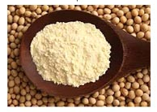 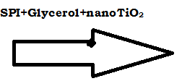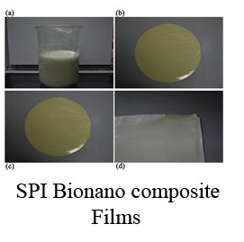

Packaging is a necessary step for preserving the nutritional and hygienic characteristics of food during storage and commercialization. Petroleum-based plastic packaging materials that we commonly use today have been designed with little regard for their environmental impact and the sustainability of resources. To overcome this problem, biopolymers produced from natural resources are regarded as attractive alternative since they are renewable and biodegradable. Soy protein is one such biodegradable matrices. It has received considerable attention due to several advantages including world wide availability as well as low cost. In this project, Soy Protein Isolate (SPI) based bio nano composites were prepared by incorporating different volume fractions of titaniumdioxide (TiO2) nanoparticles in soy protein isolate with glycerol as plasticizer. The effects of differently sized TiO2 nanoparticles on the morphological, physical, water barrier and thermal properties of the SPI-based films were investigated. Morphological analysis was done using Scanning Electron Microscope (SEM) and Atomic Force Microscopy (AFM).The X-ray diffraction, UV scanning spectrum, photoluminescence, FT-IR measurements, Differential Scanning Calorimetric analysis were done to characterize the nanoscaled composite structure of SPI/TiO2. An increase in concentration of TiO2 in SPI films were found to decrease the UV absorption and Fluorescence intensity of the films. Moisture content, water uptake and swelling ratio decreased with increased addition of TiO2. The environmental friendly, fully biodegradable green composites prepared with soy protein and nano TiO2 have excellent properties and great potential to replace the traditional petroleum based materials in food packaging.

**Keywords**: Soy Protein Isolate, Titanium Oxide, Nanocomposite films

**References**

Wang, S.-Y., Zhu, B.-B., Li, D.-Z., Fu, X.-Z., & Shi, L. (2012). Preparation and characterization of TIO2/SPI composite film. *Materials Letters*, *83*, 42–45. https://doi.org/10.1016/j.matlet.2012.05.104

**Biography:** The author is working as an Assistant Professor in Chemistry at Bishop Moore College, Mavelikara, Alapuzha Dist, Kerala, India. Her area of interest is soy protein based bionanocomposites**.**

**Publications:** Environment friendly green composites based on soy protein isolate–A review." *Food Hydrocolloids* 50 (2015): 174-192

Book Chapters: Published

1. Starch‐Based Bionanocomposite: Processing Techniques." *Biopolymer Nanocomposites: Processing, Properties, and Applications* (2013): 203-226.
2. Extraction and Characterization of Cellulose Nanofibers from Banana Plant." *Handbook of Polymer Nanocomposites. Processing, Performance and Application*. Springer Berlin Heidelberg, 2015. 65-80.
3. Soy Protein-and Starch-Based Green Composites/Nanocomposites: Preparation, Properties, and Applications." *Eco-friendly Polymer Nanocomposites*. Springer India, 2015. 433-467

Book Chapters (Under review)

1. Polysaccharide Based Composites and Nanocomposites, Springer
2. Biodegradation of aerogels in “Bio-based Aerogels” by Royal Society of Chemistry
3. Rheological Properties of Nanocomposites based on Cellulose Nanofibrils and Cellulose Nanocrystals in Handbook of Nanocellulose and Cellulose Nanocomposites. John Wiley & Sons

**Presenting author details**

**Full Name: Rekha Rose Koshy**

**Contact number: 8891619557**

**Session Name: Nanocomposites**

**Category: Oral presentation**