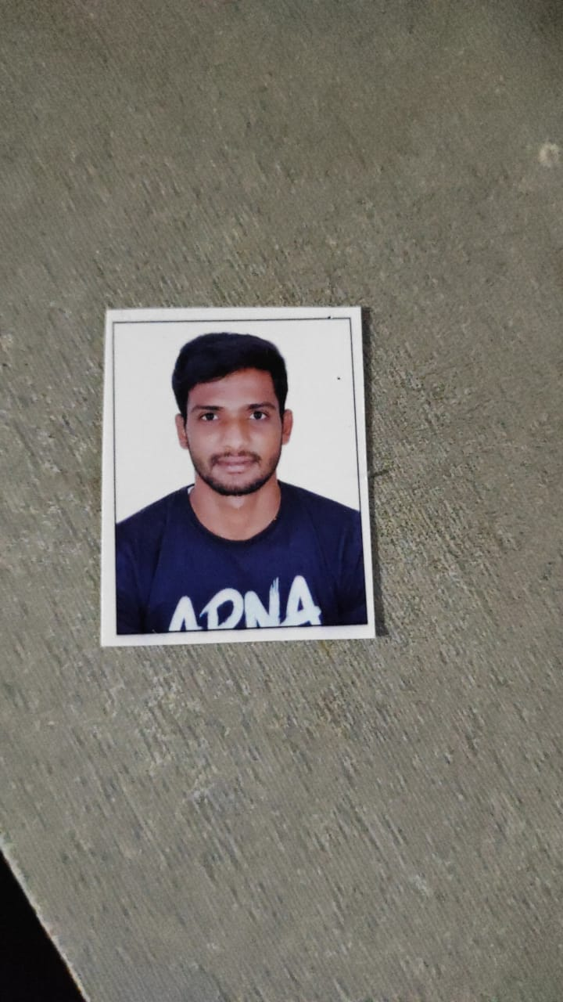

Resume

NAVEEN B

Mobile No. : +91 9535202165

Email ID : [naveenbn4923@gmail.com](mailto:naveenbn4923@gmail.com)

<https://www.linkedin.com/in/naveen-b-6a9505173>

https://github.com/naveen4923

|  |
| --- |
| **CAREER SUMMARY** |
| **To work in an organization which provides the opportunity to improve my skills and knowledge to grow along with the organization’s goals. An enthusiastic fresher, passionate about new technologies with good leadership, analytical and technical skills, pursuing bachelors of engineering degree in Computer Science.** |
| **ACADEMICS** |
| * **Pursuing in Computer Science and Engineering in Sea College Of Engineering And Technology, CGPA – 7.0/10(current)** * **Krupanidhi Residential PU college percentage – 67.5%** * **Golden International School percentage - 83.2%** |
| **PROJECTS** |
| * **Thick Shake Factory** Completed DBMS Project on the topic “Thick Shake Factory Management System”. Worked with CRUD operations. Created own user interface using apache netbeans as front end and PHP, MySQL as back end. Handled multiple inputs of data, used SQL, handled error detection and error correction in the project. * **Rocket Launching** Completed computer graphics project on the topic “Rocket Launching”. Worked with graphics libraries such as OpenGL , GLUT, GLU etc. Created objects and animated it using graphics concepts of transformations. |
| **TECHNICAL SKILLS** |
| * **Programming Languages : Python 3, C, C++, Java** * **Frontend Technologies : HTML, CSS, Javascript** * **Operating Systems : Linux, Windows** * **Database : MYSQL** |
| **CERTIFICATIONS** |
| * **JavaScript Essentials with LetsUpgrade** * **Python Essentials with LetsUpgrade** * **GoogleCloudComputing Workshop with LinuxWorld Technologies** |

|  |
| --- |
| **CORE COMPETENCIES** |
| * **Enthusiastic learner and excellent communication skills** * **Easily adapts to new environments** * **Accepts challenges as oppurtunities** * **Ability to establish and maintain effective working relationships with co-workers,students,other professionals and general public** * **Planned,organized and can manage people** |
| **PERSONAL DETAILS** |
| * **Date of Birth : 14/10/1999** * **Father’s Name : Balappa C** * **Mother’s Name : Nethravathi** * **Current Address : Ganagalur,Hosakote,Bangalore Rural,Karnataka 562114** * **Permanent Address : Ganagalur,Hosakote,Bangalore Rural,Karnataka 562114** * **Hobbies : Learning new Technologies, Travelling, Playing Cricket, Volleyball and kabbadi, PC Games, Music** * **Nationality : Indian** * **Languages Known : English, Kannada, Telugu, Hindi** |
| **DECLARATION** |
| **I hereby declare that all the above-mentioned information is true and correct to the best of my knowledge.** |
| **Place : Bangalore, India Signature/E-signature :** |