Task 3 : Perform a Basic Vulnerability Scan on Your PC.
Objective: Use free tools to identify common vulnerabilities on your computer.
Tools: OpenVAS Community Edition (free vulnerability scanner) or Nessus Essentials.
Deliverables: Vulnerability scan report with identified issues.

1.Install OpenVAS or Nessus Essentials.
Installation of Nessus Essentials is done and username and password are created.
2.Set up scan target as your local machine IP or localhost.
My localhost or local machine IP : “192.168.136.129” is given for Vulnerability scan.
3.Start a full vulnerability scan.
Started the vunlnerability scan for mu local IP address
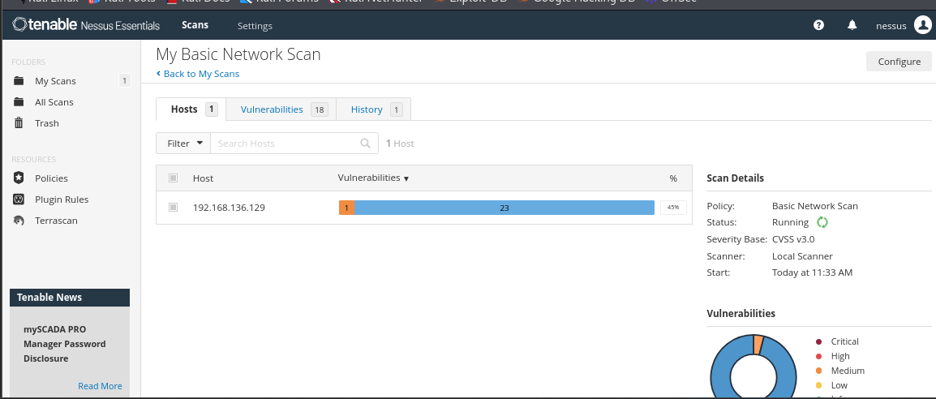
4.Wait for scan to complete (may take 30-60 mins).
The Scan was done and shows the result as :
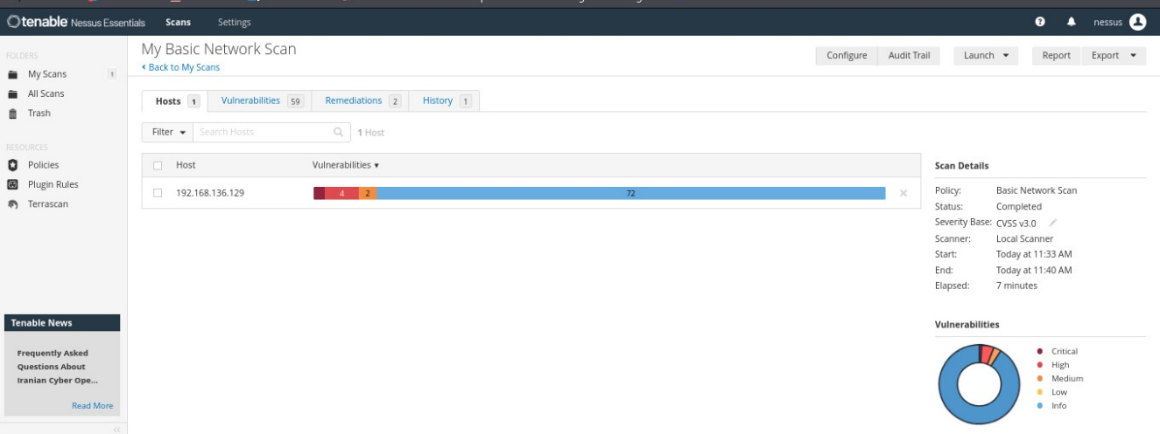
5.Review the report for vulnerabilities and severity.
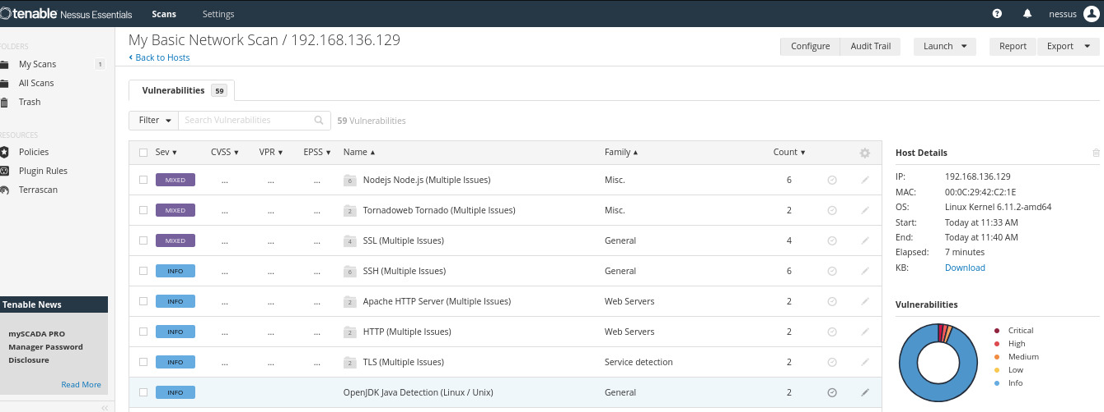
6.Research simple fixes or mitigations for found vulnerabilities.
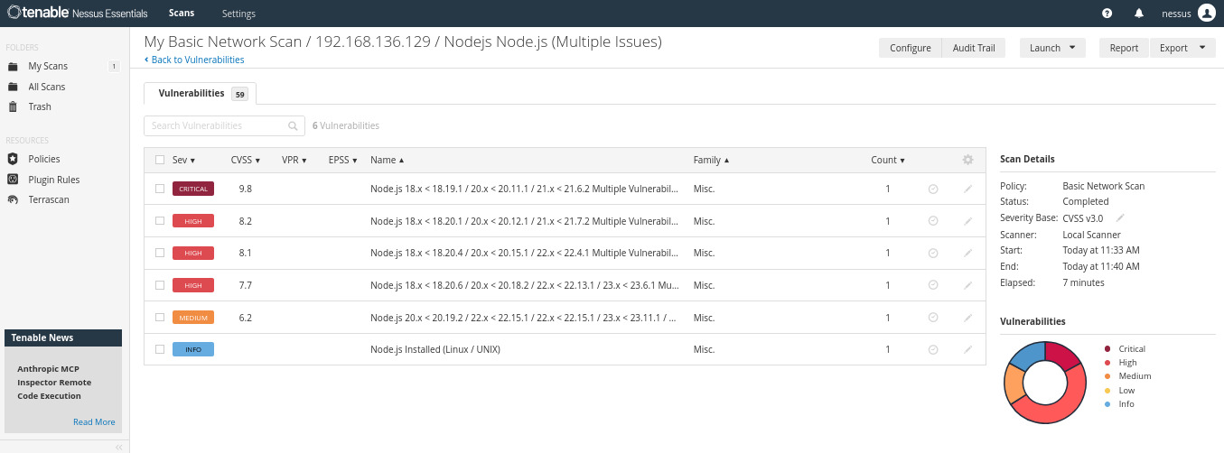
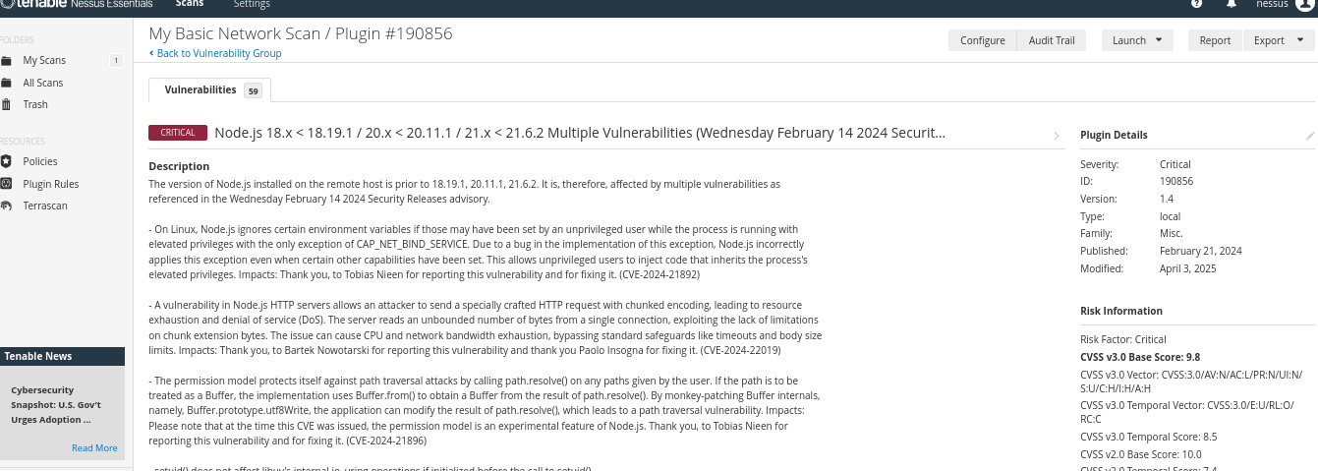
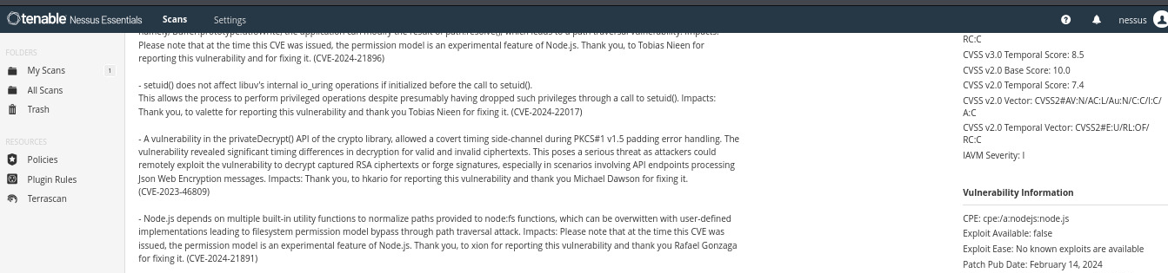
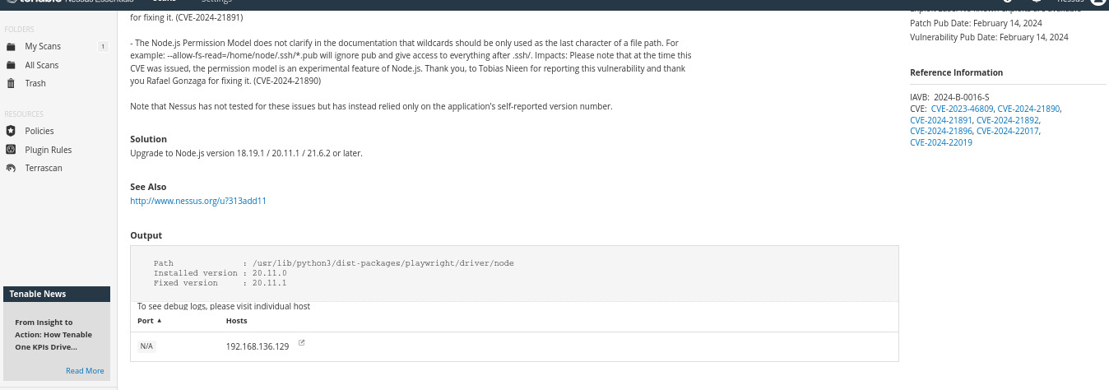
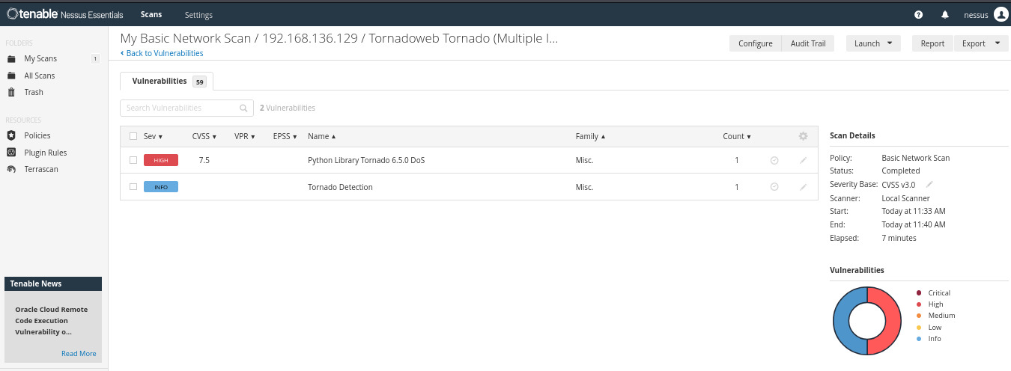
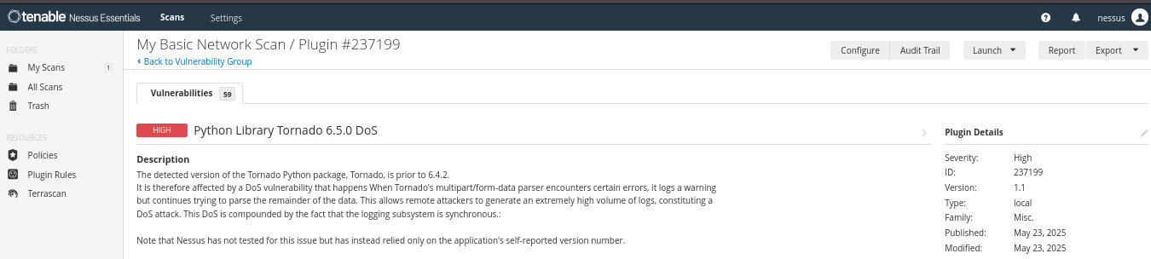
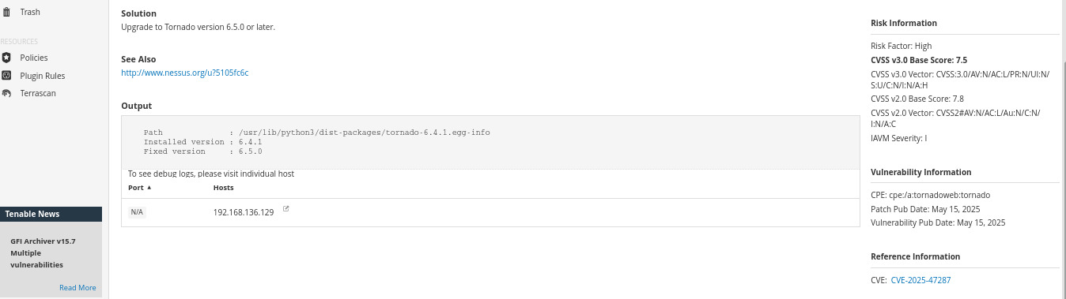
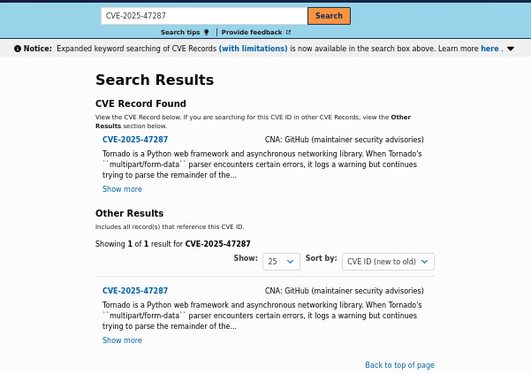
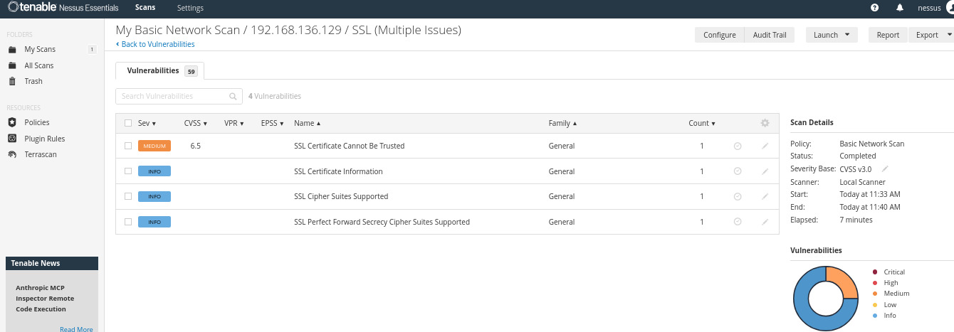
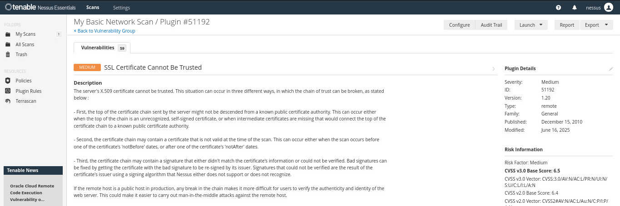
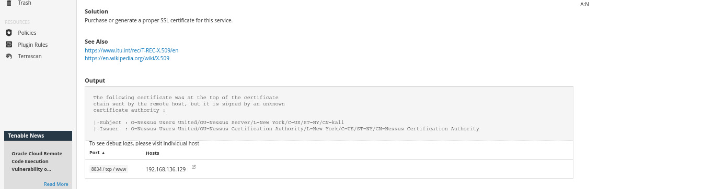

7.Document the most critical vulnerabilities.
Vulnerability 1: Node.js 18.x < 18.19.1 / 20.x < 20.11.1 / 21.x < 21.6.2 Multiple Vulnerabilities
A vulnerability in Node.js HTTP servers allows an attacker to send a specially crafted HTTP request with chunked encoding, leading to resource exhaustion and denial of service (DoS).
Severity: Critical
CVE: CVE-2023-46809, CVE-2024-21890, CVE-2024-21891, CVE-2024-21892, CVE-2024-21896, CVE-2024-22017, CVE-2024-22019
Fix: Upgrade to Node.js version 18.19.1 / 20.11.1 / 21.6.2 or later.

Vulnerability 2: Python Library Tornado 6.5.0 DoS
Severity: High
CVE: CVE-2025-47287
Fix: Upgrade to Tornado version 6.5.0 or later.

Vulnerability 3: SSL Certificate Cannot Be Trusted
Severity: Medium
Fix: Purchase or generate a proper SSL certificate for this service.

