C:\Program Files\Apache Software Foundation\Tomcat 6.0\webapps\MFRP\images\logo.gif

***E-com Site***

--- Get Your Best

INDEX:

1. Introduction

2. Technologies used

3. Tools Used

4. Description

5. Screenshots

6. Conclusion

Introduction:

“Get your Best” is an Ecommerce website. It provides opportunity to purchase the user needs through online. It consists of Electronics, Media, Men and Women categories where each category includes different products which satisfy user needs.

Technologies Used:

* Html5
* CSS3
* Bootstrap
* Angular JS

Tools Used:

* Sublime Text 2
* Apache Tomcat6

Description:

“Get the Best” is an e-commerce website. In this website user can browse for

Electronics which are sub divided into different categories like Mobiles , Laptops , TVs and

Tablets. These categories are again classified based on their brands. So that the user can access the need without any difficulty. Like wise ,Media has the categories like Audio,Video, Games.

Men has the categories like Sunglasses , Foot ware , Watches. Women has the categories like Handbags , Jewellery , Goggles.

When user selects a particular product to purchase it is added to cart. User can review the products he/she has selected in cart page. User can also see the number of items selected and the total price he needs to pay. User can also remove the item if he does not want to purchase by using close button at that particular selected item. Thus this site provides an easy way to do online shopping.

Screen shots:

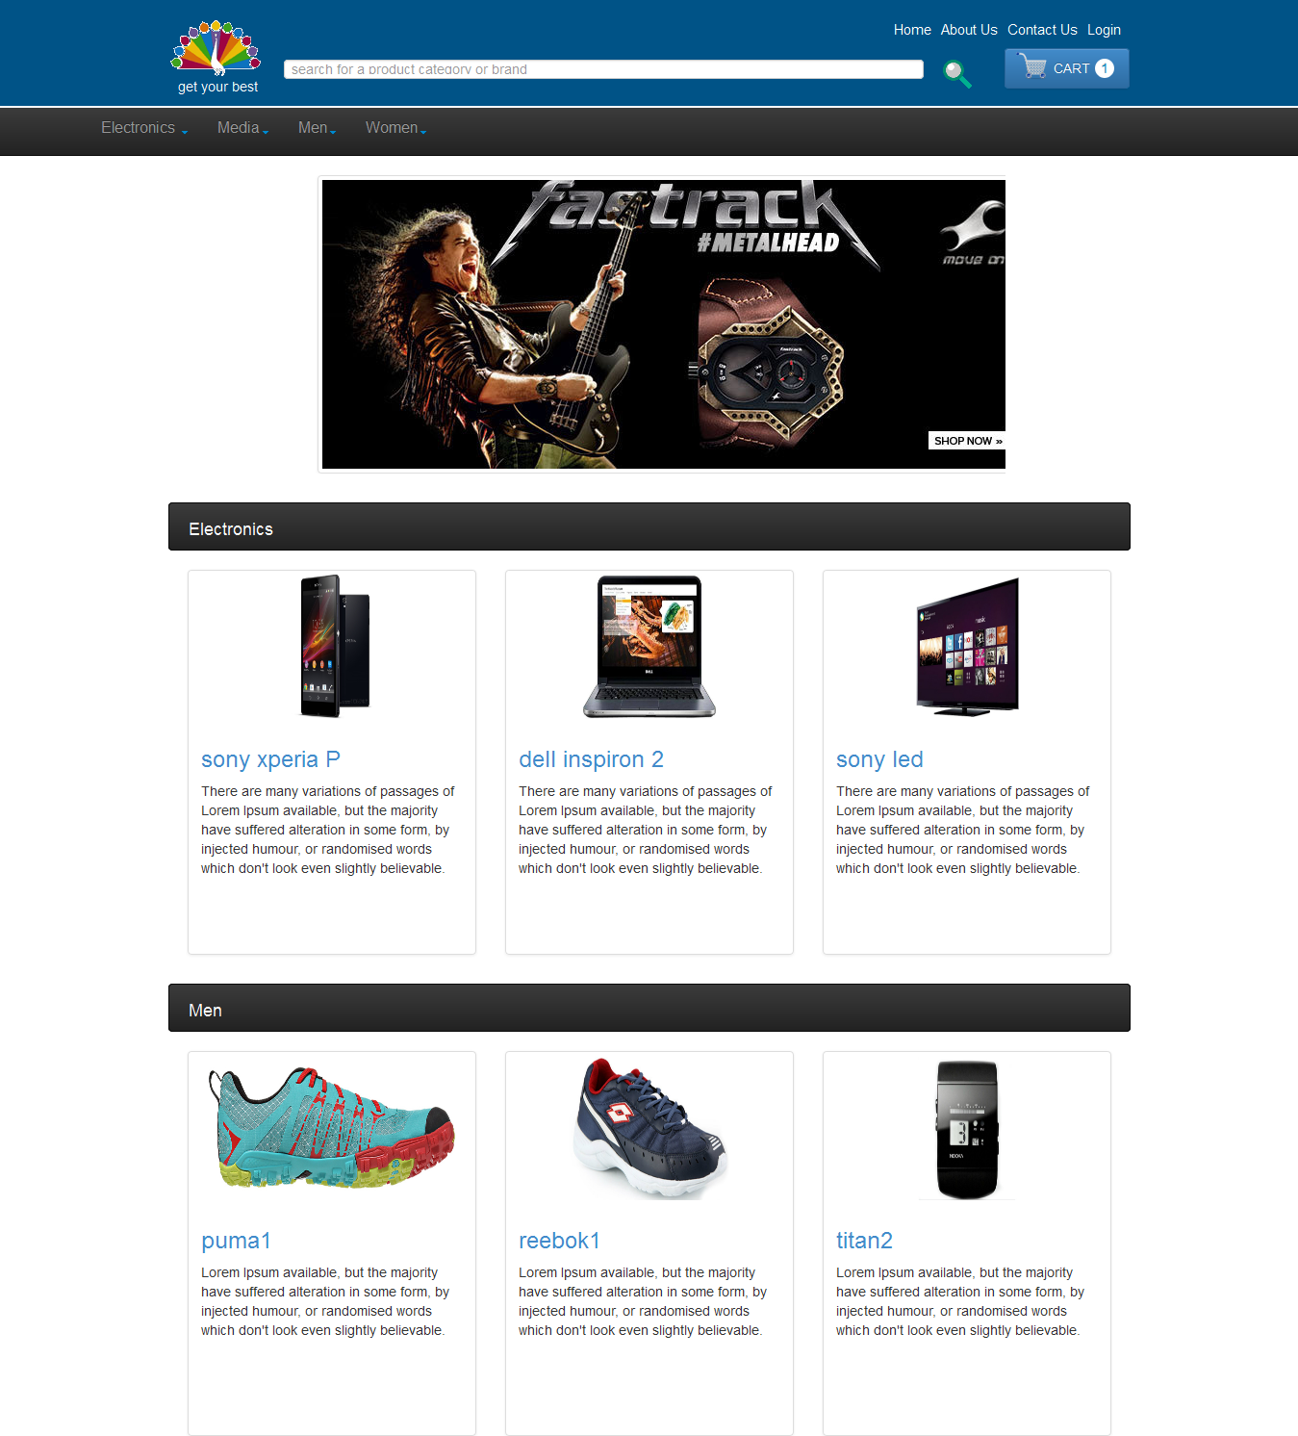

1. Screenshot of home page

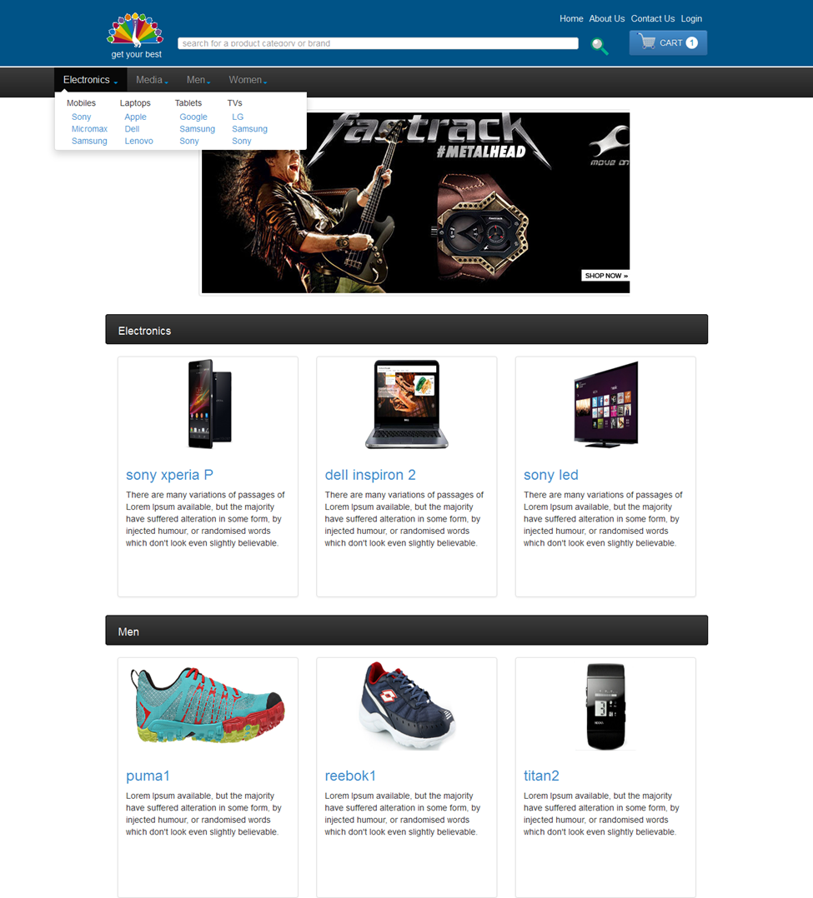 2. Screen shot for the first tab Electronics.

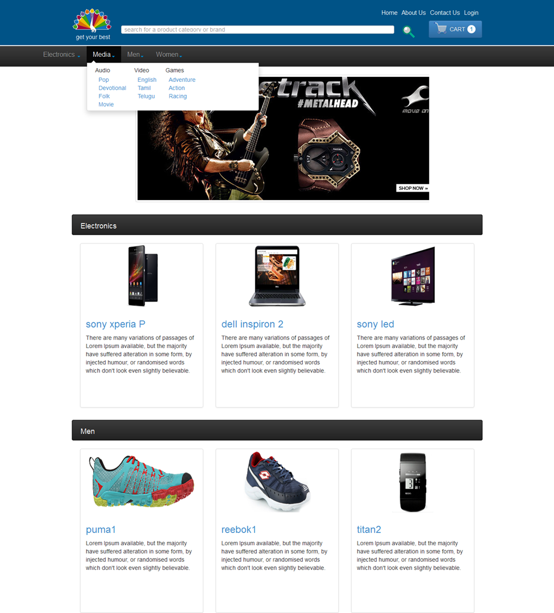

3. Screen shot for second tab Media

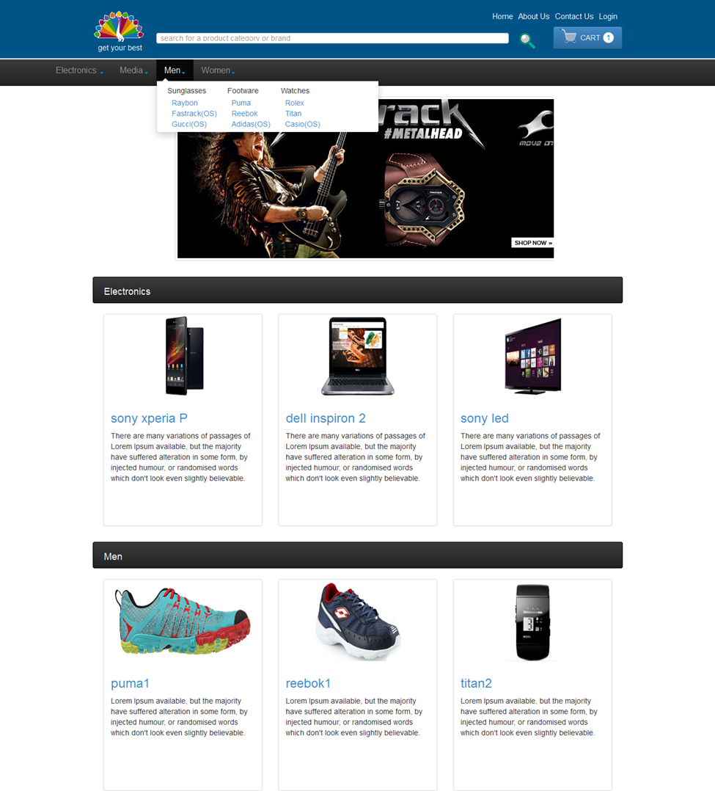

4. Screen shot for third tab Men

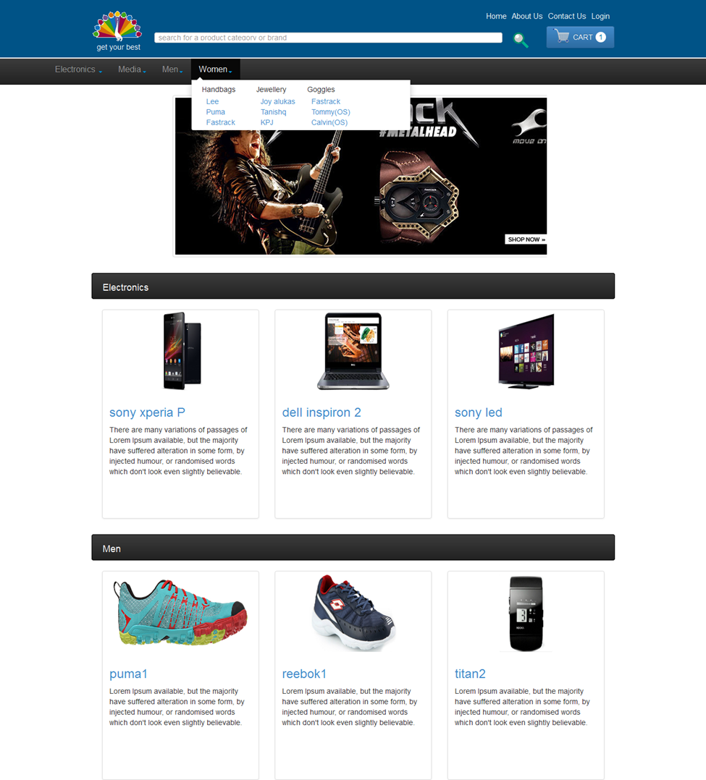

5. Screen shot for fourth tab Women

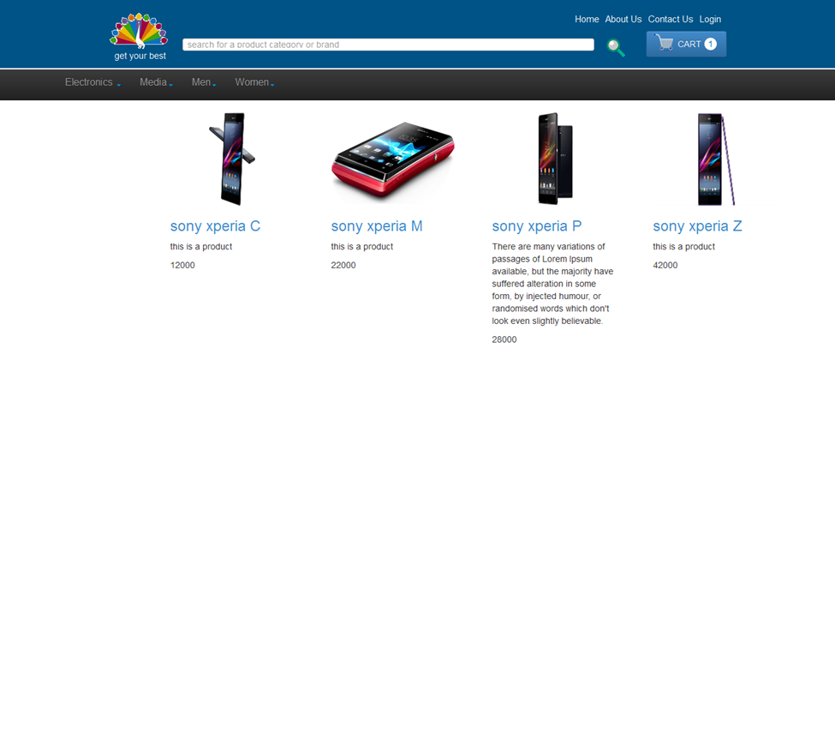

6. Screen shot for particular brand Sony mobiles

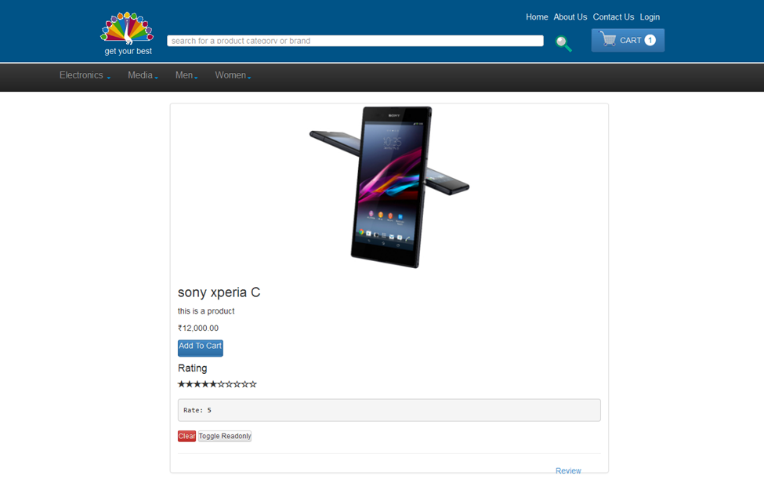

7. Screen shot for selected product Sony Xperia C

Conclusion:

“Get your Best” E-commerce website provides a user-friendly environment for efficient shopping through online. It helps user to browse and purchase the products at any time.