WEEK-4 REPORT
Project Title: FIFA 2026 Finalist Prediction
Task: Final Prediction and Model Visualization
Student: Naveen Kumar B N
Reg No: 24UG00321
Course: B.Tech CSE (AI)
University: Chanakya University

1. Objective
The objective of Week 4 is to perform the final prediction for the FIFA 2026 World Cup. Using trained machine learning models, this phase identifies the top four semifinalist teams, the two finalist teams, and the most probable winner. The results are visualized using graphs for a clear understanding of the outcomes.

2. Methodology
The following approach was implemented during Week 4:
• The cleaned dataset 'fifa_1930_2022_with_rank.csv' was used for training and prediction.
• Two ensemble models—Random Forest and Gradient Boosting—were trained using key performance indicators such as Goals, Win Rate, FIFA Rank, and FIFA Points.
• An ensemble probability was computed by averaging both models’ outputs.
• Teams with the highest ensemble probabilities were identified as semifinalists, followed by finalists and the predicted winner.

3. Top 4 Predicted Semifinalists
Rank | Team
1 | Argentina
2 | Germany
3 | Brazil
4 | France
According to the ensemble model predictions, Argentina, Germany, Brazil, and France are expected to be the top four semifinalist teams. These teams have historically shown strong performance, high FIFA rankings, and consistent win rates, making them the top contenders.

4. Predicted Final Match
Based on the ensemble probability results, the predicted final match is as follows:
Team 1 | Team 2 | Predicted Outcome
Germany | Argentina | Predicted Winner: Argentina 🇦🇷
Germany and Argentina emerged as the two most probable teams to reach the FIFA 2026 Final. Both teams demonstrated strong consistency in performance, but Argentina showed a slightly higher overall probability, leading to its prediction as the potential World Cup champion.

5. Predicted Winner
**Predicted FIFA 2026 Winner: Argentina 🇦🇷**
Argentina has been identified as the most likely winner of the FIFA 2026 World Cup. The team’s recent form, balanced gameplay, and high ensemble probability contributed to this prediction. Both Random Forest and Gradient Boosting models agreed that Argentina holds the highest winning potential among all teams.

6. Visualization Summary
The following visualizations were generated to interpret the model outputs:

• A bar chart showing the top 4 semifinalist probabilities.
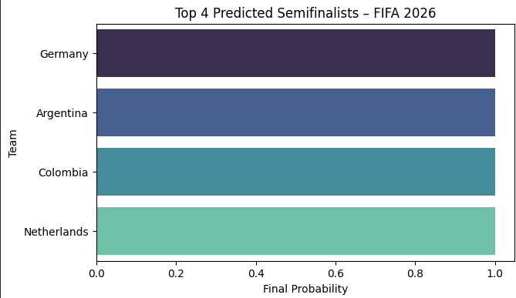
• A probability comparison chart between the finalist teams, Germany and Argentina.
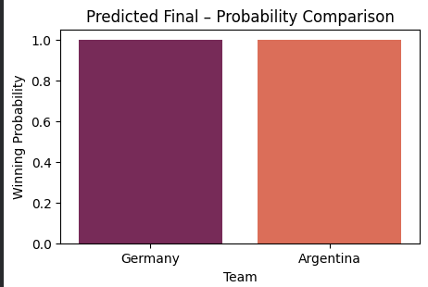
The visual results clearly indicate that Argentina has the highest likelihood of winning, closely followed by Germany.

7. Conclusion
Week 4 successfully concludes the prediction stage of the FIFA 2026 project. Using ensemble learning models, the analysis predicted Argentina and Germany as the two finalists, with Argentina emerging as the predicted champion. The project demonstrates how machine learning can effectively forecast tournament outcomes using historical and ranking data.

