1. Let’s say the cluster has two nodes, one of which has a GPU, and we want the sample app to be deployed only on the node with the GPU, how can you ensure deployment runs app on that  node exclusively?

To schedule the application exclusively on nodes with GPUs, label the GPU node and use a nodeSelector in your deployment

Below is the precodure we need to apply the label and nodeselector  
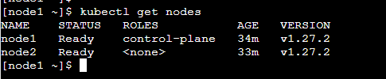

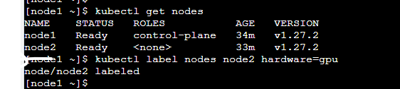

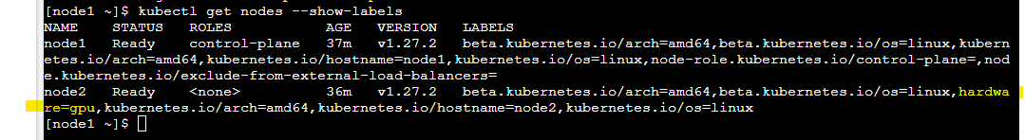

**Using below specifications we can opt deployment runs app on that  node exclusively**

spec:

nodeSelector:

hardware: gpu

1. Whenever we deploy container into the cluster it is pulled from DockerHub but what change will have to be made if we need to pull container from alternative source, say Azure Repos?

**We can configure an ACR registry secret and specify it in the Kubernetes deployment belos is the example**

kubectl create secret docker-registry acr-secret --docker-server=<loginserver> --docker-username=<username> --docker-password=<password>

**Using below specifications we can pull image from other sources like acr**

spec:

imagePullSecrets:

- name: acr-secret

1. **Describe any logging infrastructure to implement centralized logging.**

Consider deploying **ELK (Elasticsearch, Logstash, Kibana)** or using **Fluentd** to aggregate logs from each container, enabling comprehensive access to centralized logs via Kibana or Grafana.