**COMPUTER SCIENCE**

Adequate numbers of classrooms are available for conducting classes. Classrooms are spacious enough to accommodate students and are well furnished and ensure proper circulation of fresh air a  
Classrooms are kept clean and hygienic.

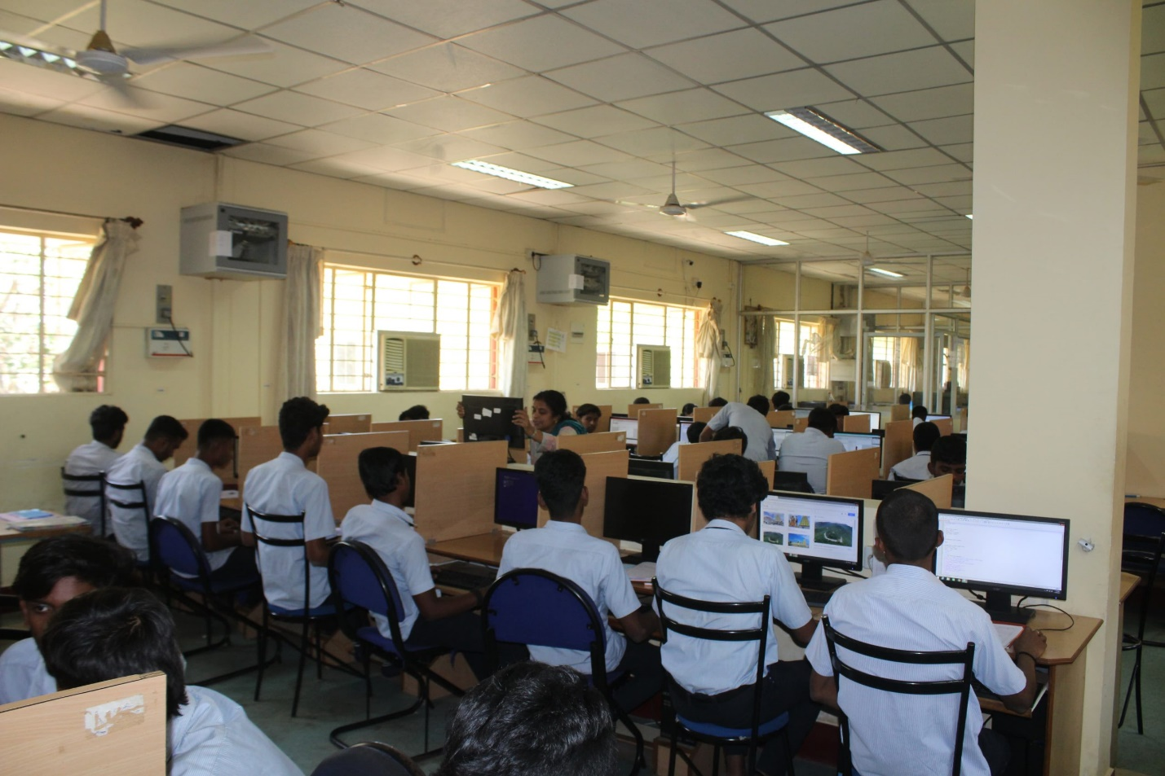

|  |  |  |  |
| --- | --- | --- | --- |
| **Room Description** | **Carpet Area in Sq.m.** | **USAGE** | **Rooms Equipped with** |
| Class Room 213 | 63.8 | Class Room For 3rd YEAR Student | 1) Desktop, 2) Multimedia Projector 3) CC TV 4) Green Board 5)Sufficient desks 6)Lights, Fan |
| Class Room 207 | 54.75 | Class Room For 2nd YEAR Student | 1) Desktop, 2) Multimedia Projector 3) CC TV 4) Green Board Sufficient desks 6) Lights, Fans |
| Class Room CS-P104 | 91.2 | Class Room For 1ST YEAR Students | 1) Green Board 2)Sufficient Desks 3) Lights, Fans |
| 201 Seminar Hall (Main Block) | 147 | All Departments | 1)I/O Point available with internet facility 2) Desktop, 3) Multimedia Projector 4) CC TV 5) Green Board 6)Sufficient desks 7) Lights, Fans |

**Adequacy**

* The department has well-established laboratories with sufficient computers installed with necessary softwares for the students to do their practical experiments as per the timetable.
* Students can use the laboratories during their free time for their project work and online courses etc.
* The students can enhance their knowledge with the guidance of faculty members and well trained technical staff.
* Size of the laboratories is adequate to accommodate the students.
* All laboratories are well furnished.
* The laboratory is kept clean and hygienic.

**Quality of Labs/workshop**

* All laboratories are well equipped with essential hardware, software to aid the students to learn the course and complete all lab experiments as per curriculum requirements.
* After completion of practical exercises, the students write observation and record books which are checked and evaluated.
* One faculty member and one technical staff member are assigned for each lab session.
* Computers are provided to students on a 1:1ratio.
* Each batch size is around 20.
* List of experiments for the different courses as per curriculum is displayed.
* The requirements of consumables for laboratory are given in advance.
* Subject related charts are displayed in the laboratory.
* Lab manuals are shared to all students