**ELECTRONIC AND COMMUNICATION DEPARTMENT**

Adequate numbers of classrooms are available for conducting classes. Classrooms are spacious enough to accommodate students and are well furnished and ensure proper circulation of fresh air a  
Classrooms are kept clean and hygienic.

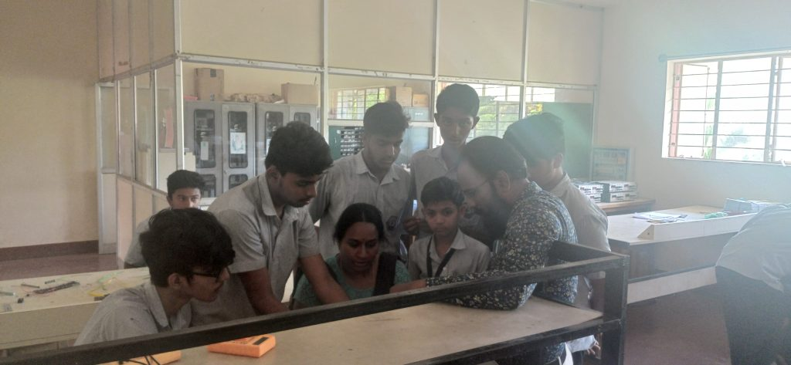

|  |  |  |  |  |  |
| --- | --- | --- | --- | --- | --- |
| **Room Description** | **Room Number** | **Carpet Area in Sq.m** | **Usage** | **Capacity** | **Rooms Equipped with** |
| Main Block | 206 | 54.75 | 1st year | 60 | Black board, Desk, Podium, Notice board CCTV |
| Main Block | 211 | 41.8 | 2nd year | 40 | Black board, Desk, Podium, Notice board CCTV |
| Block 2 | P105 | 91.2 | 3rd year | 60 | Black board, Desk, Podium, Notice board |

**Adequacy**

* The department has well-established laboratories that impart practical knowledge to students.
* The students can enhance their knowledge with the guidance of faculty members and well trained technical staff

|  |  |  |  |  |
| --- | --- | --- | --- | --- |
| **Sl** **NO** | **Name of the Laboratory** | **Room No** | **Carpet area in**   **Sqm** | **No of students per batch** |
| 1 | Electronics Lab | 101 | 91.98 Sqm | 20 |
| 2 | Computer Lab | 102 | 38.69 Sqm | 20(1:1) |
| 3 | Digital Lab | 103 | 55.48 Sqm | 20 |

**Quality of Labs/workshop**

* All laboratories are well equipped with essential electronic equipments & instructional manuals.
* The observation and record books are checked, verified and maintained.
* Student Computers ratio is 1:1.
* Adequate number of equipments are available in the Laboratories.
* Each batch size consists of 20 students.
* The assessment is based on DTE curriculum rubrics.
* The requirements of consumables for laboratory are given on time so that practical’s can be conducted smoothly.
* Safety measures, charts are displayed in the Laboratory.
* The laboratory is kept clean and hygienic.

**Safety Measures**

* Safety measure charts are displayed in all labs.
* Electrical wires are protected by MCB and fuses.
* First-aid Kit is available.
* Proper earthing is done.
* CCTV cameras are installed.