**ELECTRICAL AND ELECTRONICS ENGINEERING**

Adequate numbers of classrooms are available for conducting classes. Classrooms are spacious enough to accommodate students and are well furnished and ensure proper circulation of fresh air a  
light. The dimensions and other facilities of the classrooms are maintained as per the AICTE Norms. Classrooms are kept clean and hygienic.

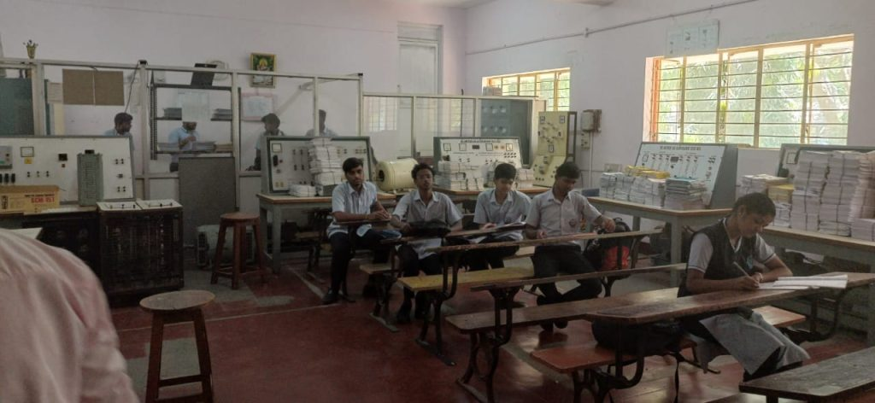

|  |  |  |  |
| --- | --- | --- | --- |
| **Room Description** | **Carpet Area in Sq.m.** | **USAGE** | **Rooms Equipped with** |
| Class Room 006 | 41.8 | Class Room For 3rd YEAR Student | Green board |
| Class Room 210 | 41.8 | Class Room For 2nd YEAR Student | Green Board/Projector |
| Class Room CS-P001 | 91.6 | Class Room For 1ST YEAR Students | Projector and black board |

**Adequacy**

* All Laboratories are equipped with electrical equipments for students to do their practical work during the working hours as per the time table and beyond the working hours according to their o
* interest.
* All experiments prescribed in curriculum are conducted as per time table and also students carry out their mini projects/lab related activities apart from syllabus.
* The students can enhance their knowledge with the guidance of faculty and well trained technical staff.
* All the laboratories are provided with sufficient furniture facilities.

|  |  |  |
| --- | --- | --- |
| **SL NO** | **Name of the Laboratory** | **Dimension in Sqm** |
| 1 | Electrical machines lab | 41.8 |
| 2 | Switch Gear and Protection lab | 41.8 |
| 3 | Electronics lab | 41.8 |
| 4 | Computer lab | 55.48 |

**Quality of Labs/workshop**

* All laboratories are well equipped with essential electrical and electronics equipments.
* The observation and record books are checked, verified and maintained.
* One faculty member and one technical staff member are assigned for each lab session.
* Various Resource persons are invited to conduct hands-on workshops/Guest Lectures on latest trends in the industry and practice.
* Adequate numbers of equipments are available in the Laboratories.
* Each batch sizes 20
* The students can perform the experiments without any difficulty.
* The assessment is done based on DTE Curriculum Rubrics
* The requirements of consumables for laboratory are given on time so that practical’s will be conducted smoothly.
* Safety measures, charts are displayed in the Laboratory.
* The requirements of consumables for laboratory are given on time so that practical works are carried out smoothly

**Safety Measures**

* Safety measure charts are displayed in all labs.
* Electrical Wires are
* protected by MCB and fuses
* First-aid Kit
* Fire
* Extinguisher
* Safety gloves
* Proper
* Earthing
* CCTV Cameras