**MECHNICAL DEPARTMENT**

Adequate numbers of classrooms available for conducting classes. classrooms are spacious enough to accommodate students and are well furnished and ensure proper circulation of fresh air and light. classrooms are kept clean and hygienic.

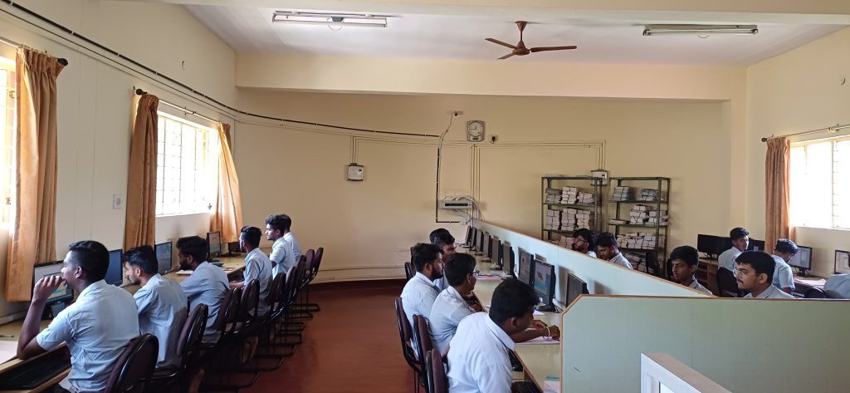

|  |  |  |  |  |
| --- | --- | --- | --- | --- |
| **SL NO** | **CLASS ROOM** | **CARPET AREA (sqm)** | **Equipment** | **SEATING CAPACITY** |
| 1 | 201 A | 73.5 | CCTV Multimedia projector | 60 |
| 2 | 216 | 112.42 | CCTV | 60 |
| 3 | P003 | 91.2 | CCTV | 60 |

**Adequacy**

* The department has well –established laborites that excel in enriching the practical knowledge of students with creative engineering experiments.
* Size of the laboratories is adequate to accommodate the students.
* All laboratories are well furnished.
* All the doors are sufficiently wide and available in adequate numbers.
* The laboratory is kept clean and hygienic.
* Adequate numbers of equipment are available in the Laboratories.

|  |  |  |
| --- | --- | --- |
| **SL NO** | **Name of the laboratory** | **CARPET AREA (sqm)** |
| 1 | Computer lab | 144 |
| 2 | Fluid power Engineering lab | 30.8 |
| 3 | 3D printing lab | 31.8 |
| 4 | Machine shop | 170 |
| 5 | Workshop | 200 |

**Quality of Labs/workshop**

* The students learn and practice the fundamentals of various fields in these laboratories.
* All laboratories are well equipped with essential lathes, shapers, milling machine, 3D printer, and soft wares and instructional manuals.
* The observation and record books are checked, verified and maintained.
* One faculty member and one technical staff member are assigned for each lab session.
* Various resource person are invited to conduct hands-on workshop/guest lectures on latest technology in the industry and practice.
* Lathes, shapers, milling machines, tools and equipments are provided to students.
* Computers are provided to students on 1:1 ratio.
* Adequate numbers of equipments are available in the laboratories.
* Each batch size is 21.
* The students can perform the experiments without any difficulty.
* The assessment is done based on the DTE curriculum and rubrics, Student’s involvement and performance on- time submission of records.
* The requirements of consumables for workshop/laboratory are given on time so that the practical will be conducted smoothly.

**Safety measures**

* Safety measures, charts are displayed all labs
* Electrical wires are protected by MCB and fuses.
* First aid kit.
* Fire extinguisher.
* Safety gloves. Welding apron. Welding goggles.
* Proper earthing.
* CCTV cameras