PLACEMENT
Career Guidance & Counselling:
JSS Polytechnic Training and Placement Cell to support and guide the students to shape up their career. The institute, for the benefit of students, organi “Career Awareness Programme ” to help the students to plan for their career.
Training and Placement Cell
Thetrainingandplacementcellsmoothenstheprocedureofplacementactivitiesforstudentspassingoutfromtheinstitute.Italsoassociateswithleading organizations and institutes for the beneficial of students in terms of internship and training programmes. The cell is led by a committed member Sri.
Roopesh Kumar B, expert advice of the Principal and last but not the least, the effective support from the department placement coordinators.
List of Department Placement Coordinators
SI. No | Department | PlacementCoordinators’
1. | MechanicalEngineering | Sri.UdayR
2. | Electronics& CommunicationEngineering | Smt.VimalaHN
3. | ComputerScience &Engineering | Smt.ShruthiS
4. | InformationScience &Engineering | Smt.ShruthiM
5. | MechatronicsEngineering | Kum.MayeshwariD
6. | Electrical&Electronics Engineering | Smt.VidyaSK
7. | CivilEngineering | Smt.BhavyaM
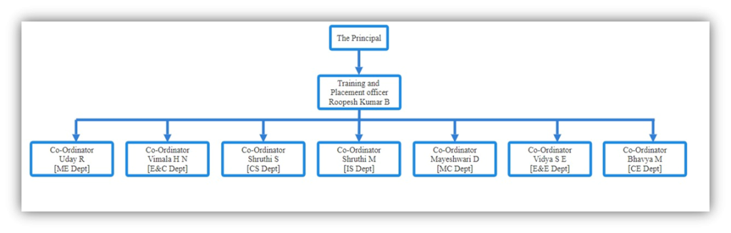
Functions of Training and Placement Cell:
Theinstitutehascontactswithvariouscompaniesfortheplacementofstudents.OurstudentsgetplacedwithdifferentMulti-National Companies, Retails, Hospitality, Industries, Service and Skill Oriented sectors. Training and Placement cell also impart productive direction among students to pursue higher education. The cell operates like a link between the institution and industries.
MOUs’ signed in support of placement and training ventures with the following companies/industries:
1) | Mechanical Engineering | 1. KGTTI, Mysuru 2. Flow & Force Engineers, Bengaluru 3. GTTC, Mysuru 4. VIDYUT Automation, Mysuru 5. IRobo Automations Pvt.Ltd, Mysuru
2) | Electronics & Communication Engineering | 1. Ultismart Infotech LLP, Mysuru 2. IQuest Technologies, Mysuru 3. MARCONICS Technologies, Mysuru 4. KGTTI, Mysuru
3) | Computer Science & Engineering | 1. Diliber Foundation 2. StormX Technologies Pvt Ltd 3.Sai Sofsol Hebbal Industrial Area Mysuru 4.Ecclesia Advanced Computer Technology Mysuru 5.MyViz Mysuru 6. Jupiter King Infotech, Srirampura,Mysuru
4) | Mechatronics Engineering | 1. BDS Enterprises, Mysuru 2. KGTTI, Mysuru 3. GTTC, Mysuru
5) | Electrical & Electronics Engineering | 1.Vidyut Automation, Mysuru 2. Sri Sai Enterprises, Hebbal, Mysuru
6) | Civil Engineering | 1. CAD DESK
Placement Details
Click here the file to get know the status of the placement (last 4 year) click here to view
Higher Education Details
2018-2021 Higher education details click here to view
2019-2022 Higher Education details click here to view
2020-2023 Higher Education details click here to view

