ELECTRONIC AND COMMUNICATION DEPARTMENT
Adequate numbers of classrooms are available for conducting classes. Classrooms are spacious enough to accommodate students and are well furnished and ensure proper circulation of fresh air a
Classrooms are kept clean and hygienic.
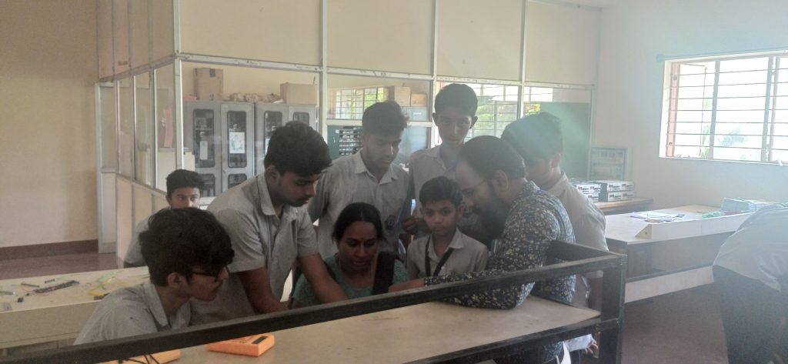
Room Description | Room Number | Carpet Area in Sq.m | Usage | Capacity | Rooms Equipped with
Main Block | 206 | 54.75 | 1st year | 60 | Black board, Desk, Podium, Notice board CCTV
Main Block | 211 | 41.8 | 2nd year | 40 | Black board, Desk, Podium, Notice board CCTV
Block 2 | P105 | 91.2 | 3rd year | 60 | Black board, Desk, Podium, Notice board
Adequacy
- The department has well-established laboratories that impart practical knowledge to students.
- The students can enhance their knowledge with the guidance of faculty members and well trained technical staff

Sl  NO | Name of the Laboratory | Room No | Carpet area in Sqm | No of students per batch
1 | Electronics Lab | 101 | 91.98 Sqm | 20
2 | Computer Lab | 102 | 38.69 Sqm | 20(1:1)
3 | Digital Lab | 103 | 55.48 Sqm | 20
Quality of Labs/workshop
- All laboratories are well equipped with essential electronic equipments & instructional manuals.
- The observation and record books are checked, verified and maintained.
- Student Computers ratio is 1:1.
- Adequate number of equipments are available in the Laboratories.
- Each batch size consists of 20 students.
- The assessment is based on DTE curriculum rubrics.
- The requirements of consumables for laboratory are given on time so that practical’s can be conducted smoothly.
- Safety measures, charts are displayed in the Laboratory.
- The laboratory is kept clean and hygienic.
Safety Measures
- Safety measure charts are displayed in all labs.
- Electrical wires are protected by MCB and fuses.
- First-aid Kit is available.
- Proper earthing is done.
- CCTV cameras are installed.

