1. **Changes in main menus (Exams and circular)**

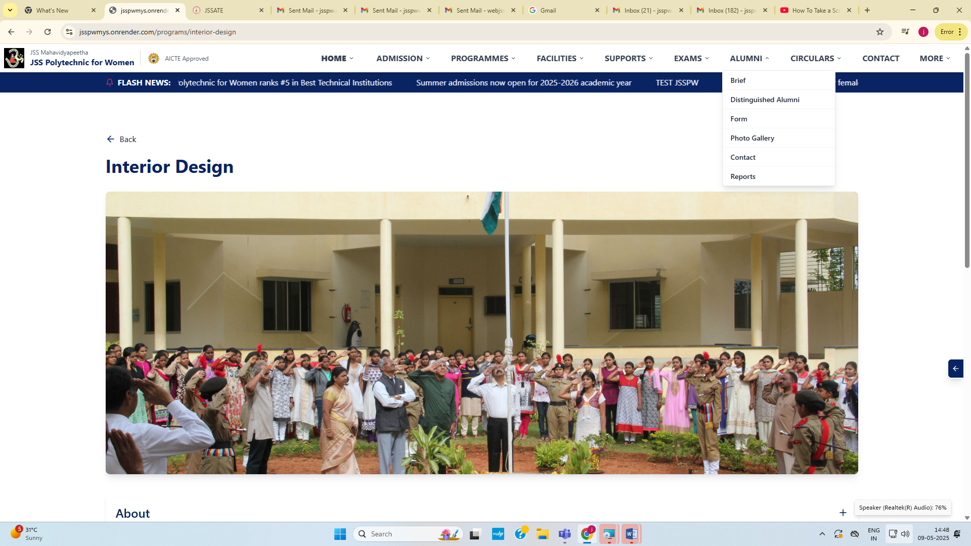

Add submenus within alumni like below format

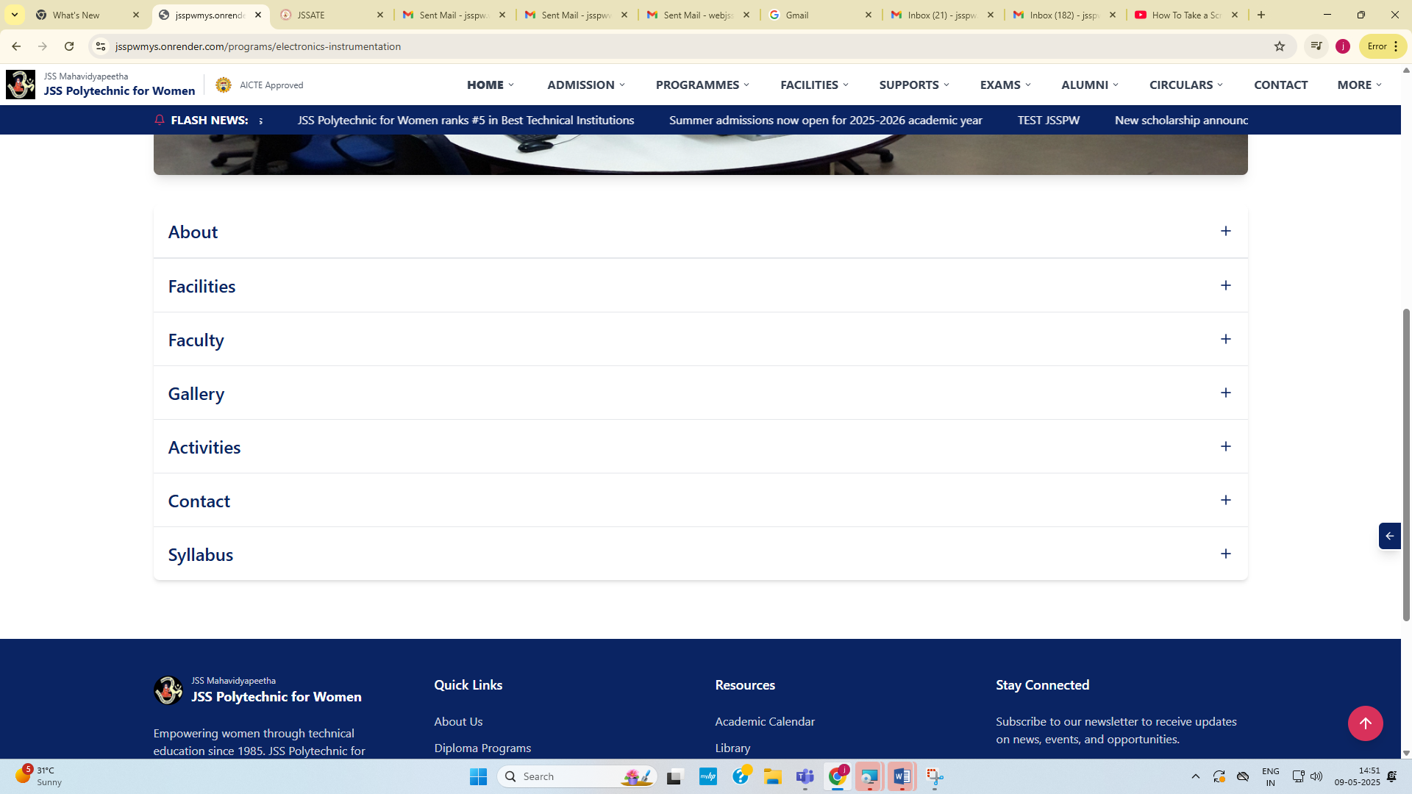

1. **Add under “More” menu**

Audited statements

Toppers list

E-magazine

1. **Dept. of Commercial practice**

**Add HOD photo and message**

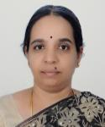

**Message from HOD**

The world is changing fast with new innovations and technologies every day. These newer technologies are helping the people to improve their standards of lives. The Department of Commercial Practice always keeps a watch on this and updates itself with respect to the Curriculum, Faculty, Technical Staff, Infrastructure and Pedagogy, so that its Students become very competitive with regard to Knowledge and Skill and get better jobs and live a comfortable life.

After assessing the requirements of Industries, the Curriculum is changed through the Faculty who are Members in the State Level Curriculum Revision Committee. All Faculty and Technical Staff update themselves accordingly, so that effective teaching is done with most appropriate Teaching Methods. Correspondingly, Infrastructural facilities like Computer Center, Class Rooms, Laboratories, Library, etc., are developed with the support of Management of the Polytechnic.

For the overall development of the Students, the Department provides additional training in Communication Skills, Soft Skills and Employability Skills which are the needs of the hour. Through NCC, NSS, Sports and Cultural Activities, the Department sees that the students are disciplined and motivated.

With this approach, the Department has churned about 7000 girl students since 1980, who express their gratitude to the Department.

In recent years, this Programme is much sought after by the students, especially those who want to get employment.

I welcome all the students to our Department.

**About:**

Department of Commercial Practice (CP) was established in JSS Polytechnic for Women in the year 1980 with an intake of 30. Considering the demand for the Programme, the intake was increased to 60. Being Veteran Programme, it is a Six Semester Diploma Programme, providing a broad based training in both theoretical and practical aspects related to Accounting, Commerce, Management, Secretarial Services, Documentation, Communication, Economics,Business Law, Professional Ethics and Computer oriented subjects like MS Office,DTP,Tally.The syllabus envisages extensive learning which facilitates the students to acquire Secretarial, Managerial and Office Management skills.

With a view to provide quality education and overall improvement of the students, the Strengths and Weaknesses of the students are assessed and Counseling and Mentoring is done to overcome the weaknesses and build their personality.

The Department prides in having very good infrastructure, and dedicated and qualified Faculty and Supporting staff. Parents-Teachers Meeting is organized periodically to have good rapport amongst Teachers, Parents and Students. Also, the Department is in constant touch with its Alumni.

Regular Guest lectures and Workshops are arranged by inviting Academicians and Industrial experts by entering into MOUs with organizations and professional bodies like National Institute of Personnel Management. Industrial visits and Career Guidance Programms are arranged to Final year students with a view to give practical exposure of working environment.

Since 2015, the Department has moved towards Goal-oriented approach, by adopting Outcome Based Education System. Further inclusion of In-plant training and Project work in the curriculum has facilitated our students in enhancing their employability skills

Keeping in pace with National Education Policy 2020 and technological advancement, the curriculum is being revised with more stress on Practical aspects.

The successful students of CP get jobs easily in both Government and Private Sectors. Many successful students of our Polytechnic are now well settled in their lives by working in reputed Organizations like Wipro, Accenture, Reserve Bank of India, Indian Institute of Management, Banks, Courts (including High Court), Legal Offices, Financial Offices, etc, at Supervisory and Middle level management levels.

For the students who are knowledge thirsty, the Department has another avenue of Higher Studies. Commercial Practice Diploma holders can pursue their higher education by getting lateral entry directly to second year B.Com and BBM.

**Vision of Department**

Establish as a hallmark institute to equip diligent, ethically strong, socially responsible, potentially upright professionals in office administration cognizant with the emerging requirements of Governmental, Non-governmental and Corporate sectors.

**Mission of Department**

1. To impart high quality teaching and practices in an excellent ambience fortified by well thought of curriculum, competent faculty and infrastructure with state of art services.
2. To foster students’ learning in respect of organizational modules covering the areas of management, Finance, Communication, Trading, Human Resource, Legal aspects
3. To promote acquisition of secretarial skills, adaptability to trends, exposure to industrial arena, job market and corporate world
4. To enable overall personality development by acquiring hands on expertise, etiquettes, soft skills through vigilance over changing scenario for employability and promote the culture of entrepreneurship

**Program Educational Objectives of Department**

1. To prepare students for a continuous learning in order to meet changing demands of the Industry and make them successful Professionals
2. To provide students a strong foundation in the core areas of business and Industry
3. To inculcate team work, Life skills ,environmental issues and professional ethics, social responsibilities and need for life time learning

**Program Specific Objectives**

Students will be able to

1. Acquire Skill based knowledge in core areas of Commerce, Management, Communication, Accounts, Law, Tax and Computers
2. Demonstrate knowledge of Principles of Management required to combat the challenges in workplace
3. Develop an ability to make proper decisions at right time in personal and professional life
4. Strengthen their Multitasking ability, so that they can adapt themselves to the changing technological needs in their career with confidence

**Program Outcomes**

1. **Basic and Discipline specific knowledge**

An ability to apply Commerce skills, Statistics and office operation skills for Corporate and Government sectors to assist in the solution of the Managerial activities

1. **Problem analysis**

Identify and analyze well-defined problems by using Management Techniques and Accounting Rules and Conventions

1. **Design/development of solutions**

An ability to apply office operation skills and execute jobs independently at all levels of management

1. **Managerial /Secretarial Tools**

Apply appropriate technologies and tools with an understanding of their merits and limitations

1. **Best practices for society, sustainability and environment**

Apply appropriate technology in context of society, sustainability, environment and ethical Practices

1. **Project Management**

Use management principles individually, as a team member or a leader to manage projects and effectively communicate about well-defined commercial activities

1. **Life-long learning**

Ability to analyze the individual needs and to upgrade in the context of technological changes

**Facility**

• Excellent infrastructure with the state-of-the-art equipment and laboratory facilities.

• Spacious classrooms and well-stocked library.

• Laboratories in Computer Applications in Office, DeskTop Publishing, E-Office, Tally

**Details of Lab facilities**

|  |  |
| --- | --- |
|  |  |
| **Computer Application in Office**  **DeskTop Publishing**  **E-Office**  **Tally Accounting** | DELL Computers, Intel i5, Canon Printer, Networking with Optical Cables, Cat-6  HCL Computers  10 KV UPS |

**Typographical Laboratory**

| **Name of the Laboratory** | **Name of the Important Equipment** |
| --- | --- |
| **Typewriting** | Facit Typewriters |

**Class room**

Department has spacious class rooms with adequate seating capacity. In addition to the regular Class Rooms, a Smart Classroom is also available with LCD Project facility for Audio - Visual purposes which is a necessity in blended learning mode

In addition Green glass board and Podium are provided in each class rooms.

**Department Library**

The department has well maintained library with 130 books. The previous year’s project reports and synopsis are also made available in the department library. Laboratory Manuals are made available in the Department Library.

**Faculty:**

**Faculty**

### **SAVITHA M**

Designation: HOD

Educational Qualification: M.com

Area of Specialization: Costing

E-Mail: msavitha.devaru@gmail.com



##### **VARALAKSHMI B**

Designation: Lecturer

Educational Qualification: M.com, PGDBA

Area of Specialization: Management

E-Mail: varalakshmi972015@gmail.com

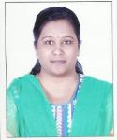

##### **Madhu Sudhan T**

Designation: Lecturer

Educational Qualification: Mcom

Area of Specialization: Management Accounting

E-Mail: madhusudhan.t24@gmail.com

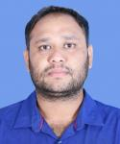

##### **VAISHALI B C**

Designation: Lecturer

Educational Qualification: M Com

Area of Specialization: Managment

E-Mail: vaishali4satish@gmail.com

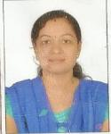

Shilpashree

Designation: Lecturer

Educational Qualification: M.com

Area of Specialization: Taxation

E-Mail: [shilpashreek22@gmail.com](mailto:shilpashreek22@gmail.com)

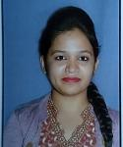

SANDHYA R K

Designation: Lecturer

Educational Qualification: M Com

Area of Specialization: Management

E-Mail: [sandhyak2019@gmail.com](mailto:sandhyak2019@gmail.com)

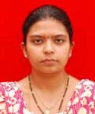

JYOTHI N

Designation: Lecturer

Educational Qualification: M.A. in English, B. Ed.

Area of Specialization: Literature

E-Mail: [jyothinagesh9593@gmail.com](mailto:jyothinagesh9593@gmail.com)

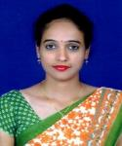

**Gallery**

**It’s in separate folder**

**Contact**

##### **SAVITHA M**

Head of the Department

Mob: 9591650765

Email: [msavitha.devaru@gmail.com](mailto:msavitha.devaru@gmail.com)