CREATE TABLE Customer (
customer_id INT PRIMARY KEY,
customer_name VARCHAR(50),
city VARCHAR(50)
);

CREATE TABLE Orders (
order_id INT PRIMARY KEY,
customer_id INT REFERENCES Customer(customer_id),
amount INT
);
INSERT INTO Customer (customer_id, customer_name, city)
VALUES
(1, 'Aman', 'Delhi'),
(2, 'Neha', 'Delhi'),
(3, 'Raj', 'Mumbai'),
(4, 'Priya', 'Mumbai'),
(5, 'Karan', 'Pune');

INSERT INTO Orders (order_id, customer_id, amount)
VALUES
(101, 1, 4000),
(102, 1, 3000),
(103, 2, 5000),
(104, 3, 6000),
(105, 3, 2000),
(106, 4, 8000),
(107, 5, 4500);

select * from Customer;
select * from Orders;

create table ans1(
customer_name varchar(20),
city varchar(10),
total_purchase int
);

insert into ans1
values
('Aman','Delhi',7000),
('Raj','Mumbai',8000),
('Priya','Mumbai',8000),
('Karan','PUNE',4500);

select * from ans1;

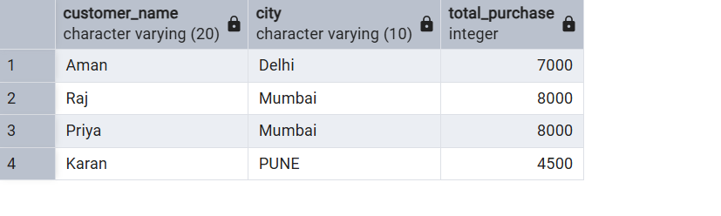

CREATE TABLE product_inventory (
product_id INT PRIMARY KEY,
product_name VARCHAR(50),
price INT
);
CREATE TABLE output(
audit serial,
product_id INT,
product_name VARCHAR(50),
ac_tion VARCHAR(40) 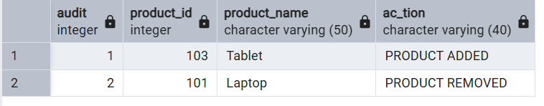
);

insert into output(product_id, product_name, ac_tion)
values
(103, 'Tablet', 'PRODUCT ADDED'),
(101, 'Laptop', 'PRODUCT REMOVED');

select * from output;

