AI-Augmented Backend Development

TEAM DETAILS
TEAM LEADER | Naveena T A | nn7680774@gmail.com

TEAM MEMBERS
MEMBERS | NAMES | ROLES
Member 1 | Naveena T A | Demo video
Member 2 | Nisha begum S | Code Execution
Member 3 | Oviya L | documentation
Member 4 | Prasanna V | Voice - Demo Audio

PROJECT TITLE: AI STUDYBUDDY

INTRODUCTION

The AI Study Buddy API is a backend development project under the AI-Augmented Backend Development technology track. The project focuses on developing an API that can support students in their learning activities by combining backend technologies with AI-based assistance. The main purpose of the project is to provide a structured and reliable backend through which learners can interact with study-related features and receive useful AI-generated support.

In modern learning environments, students often need quick explanations, summaries, practice questions, and organized study assistance. An AI-powered study system can help provide these services through a single application. The AI Study Buddy API acts as the backend layer that manages user requests, processes study-related information, communicates with AI services, and returns suitable responses to the client application.

The backend is responsible for important functions such as user authentication, study-material management, API request handling, data storage, validation, error handling, and AI integration. By organizing these functions into separate modules, the system can be made easier to understand, maintain, test, and extend.

The project also demonstrates how AI can be integrated with conventional backend development. Instead of keeping AI functionality directly inside the frontend application, the API provides a controlled communication layer between the client and the AI service. This allows sensitive information such as API keys and authentication details to remain on the server side while providing AI-powered study features to authorized users.

Overall, this project provides an opportunity to understand the complete backend workflow, starting from a client request and continuing through authentication, validation, business logic, database operations, AI processing, and response generation. It combines backend programming concepts with AI-assisted development practices and provides a foundation that can be expanded with additional educational features in the future.

PROJECT OVERVIEW

The AI Study Buddy API is a backend project under the AI-Augmented Backend Development technology track. The project focuses on developing an API that provides AI-based study assistance to learners. The backend manages study-related requests, processes user input, communicates with AI services, and provides structured responses. It is designed to support learning activities such as obtaining explanations, summaries, and practice-oriented study assistance. The API also provides a foundation for handling authentication, validation, data management, and communication between the client application and AI services.

KEY OBJECTIVES
- To develop a structured backend API for study-related activities.
- To integrate AI capabilities into the backend for providing study assistance.
- To manage and process user study requests efficiently.
- To provide secure authentication and controlled access to user data.
- To validate requests and provide consistent API responses.
- To understand practical concepts of AI-augmented backend development.

TARGET USERS
- Students – For getting study assistance and learning support.
- Learners – For understanding topics and revising study materials.
- College Students – For academic preparation and practice.
- Self-Learners – For learning topics independently with AI assistance.
- Educational Application Users – Users accessing study features through a web or mobile application.

PROJECT INSTRUCTION
- Install Node.js and npm before starting backend development.
- Create a clear project structure for routes, controllers, models, middleware, utilities, and configuration.
- Use environment variables for sensitive configuration values.
- Validate user input before database operations.
- Hash passwords before storing them.
- Protect private endpoints with JWT authentication.
- Use role-based authorization where administrative access is required.
- Connect the backend to MongoDB using Mongoose.
- Keep AI communication inside a dedicated service or utility module.
- Test API requests and responses using Postman or Thunder Client.
- Maintain clear documentation for every major API.

PRE-REQUISITES:
Software | Purpose
Node.js | JavaScript runtime for backend execution
npm | Package manager for project dependencies
MongoDB | NoSQL database for application data
Mongoose | ODM for MongoDB schema and database operations
Visual Studio Code | Development environment
Postman / Thunder Client | REST API testing

KNOWLEDGE REQUIREMENTS
- JavaScript ES6 concepts
- Node.js and Express.js
- REST API development
- MongoDB and Mongoose
- JWT authentication
- Middleware architecture
- Basic Generative AI/API concepts

PROJECT ARCHITECTURE

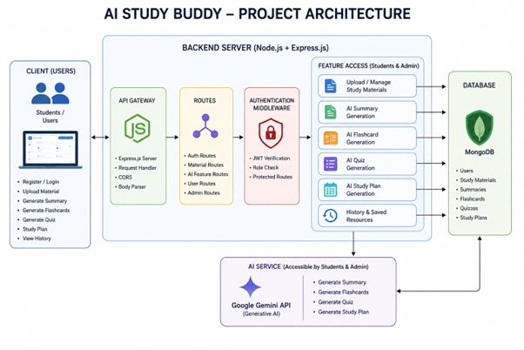

HIGH-LEVEL ARCHITECTURE
Layer | Responsibility
Client / Frontend | Sends authentication, material, and AI feature requests.
Express Server | Receives HTTP requests and manages routing.
Authentication Middleware | Verifies JWT tokens and protects private routes.
Route Layer | Maps API endpoints to controllers.
Controller Layer | Handles request validation and business logic.
AI Service Layer | Sends learning prompts to the Generative AI model.
Database Layer | Stores users, materials, and generated resources.
MongoDB | Provides persistent NoSQL data storage.

TECHNICAL ARCHITECTURE
- RESTful API architecture using Express.js.
- JWT-based authentication middleware.
- MVC-style separation of models, controllers, and routes.
- MongoDB document-based data storage.
- Mongoose ODM for schemas and validation.
- Dedicated AI utility/service for Generative AI communication.
- Environment-based configuration using .env.

ENTITY-RELATIONSHIP DIAGRAM

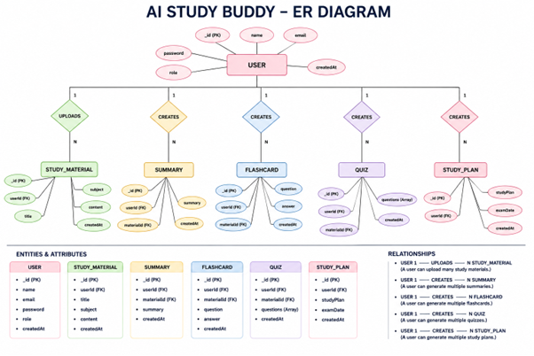

1. USER ENTITY
- _id – Primary key / ObjectId
- name – Required string
- email – Required and unique string
- password – Hashed password
- role – Student or Admin
- createdAt – Record creation timestamp

2. STUDY MATERIAL ENTITY
- _id – Primary key
- userId – Reference to User
- title – Material title
- subject – Subject name
- content – Study material content
- createdAt – Record creation timestamp

3. SUMMARY ENTITY
- _id – Primary key
- userId – Reference to User
- materialId – Reference to Study Material
- summary – AI-generated summary
- createdAt – Timestamp

4. FLASHCARD ENTITY
- _id – Primary key
- userId – Reference to User
- materialId – Reference to Study Material
- question – Flashcard question
- answer – Flashcard answer
- createdAt – Timestamp

5. QUIZ ENTITY
- _id – Primary key
- userId – Reference to User
- materialId – Reference to Study Material
- questions – AI-generated quiz questions
- createdAt – Timestamp

6. STUDY PLAN ENTITY
- _id – Primary key
- userId – Reference to User
- studyPlan – Generated personalized plan
- examDate – Examination date
- createdAt – Timestamp

ROLES AND RESPONSIBILITIES
STUDENT
- Register and log in
- Upload or enter study material
- Generate summaries
- Generate flashcards
- Generate quizzes
- Generate study plans
- View previously generated resources
- Manage profile and learning resources

ADMINISTRATOR
- Manage registered users
- Monitor application activity
- Review system usage
- Maintain platform integrity
- Monitor AI service utilization
- Handle system-level management tasks

USER FLOW
- Student opens the application.
- Student registers or logs in.
- Backend validates credentials.
- JWT token is generated after successful authentication.
- Student accesses the dashboard using the authenticated session.
- Student uploads or provides study material.
- Student selects an AI feature.
- Backend validates the request and identifies the user.
- AI service processes the study content.
- Generated learning resource is returned to the backend.
- Backend stores the generated resource.
- Student views the result and can use it for revision.

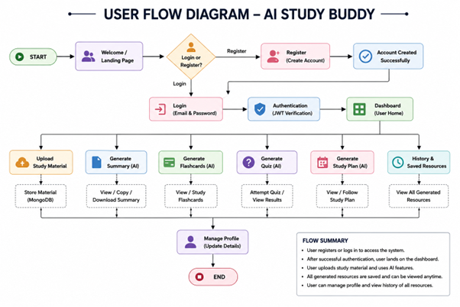

MVC ARCHITECTURE PATTERN

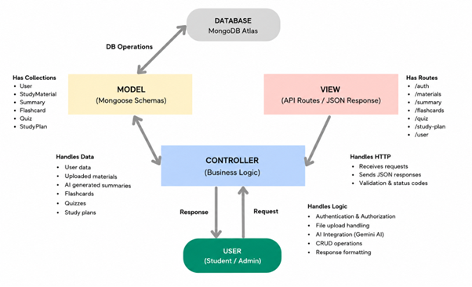

The backend follows the Model-View-Controller pattern to separate data management, business logic, and API communication. This organization makes the application easier to understand, test, maintain, and extend.

MODEL LAYER
The Model layer defines MongoDB collections through Mongoose schemas. It manages user accounts, study materials, and generated learning resources. Validation rules help maintain consistent database records.

VIEW LAYER
Because the application is a REST API, there is no traditional server-rendered view. The backend returns structured JSON responses that can be consumed by a React or other frontend client.
CONTROLLER LAYER
Controllers receive API requests, validate input, check authentication and authorization, communicate with models, invoke the AI service when needed, and return suitable responses.

MVC BENEFITS
- Improves code organization
- Separates responsibilities
- Simplifies debugging
- Supports easier testing
- Makes future features easier to integrate
- Improves maintainability and scalability

PROJECT SETUP AND CONFIGURATION

CREATING THE PROJECT FOLDER
- Create a new folder for the AI learning assistant backend.
- Open the folder in Visual Studio Code.
- Open the integrated terminal

INITIALIZE NODE.JS PROJECT
Open the project folder in the VS Code terminal and execute:
Install the required dependencies:
Install Nodemon for development:
MAIN PROJECT FILES
- index.js / server.js
- package.json
- .env
- .gitignore
- src/controllers/
- src/models/
- src/routes/
- src/middleware/
- src/utils/

FOLDER STRUCTURE
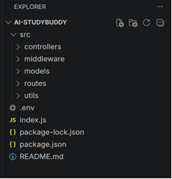

ENVIRONMENT CONFIGURATION
Sensitive configuration should be kept outside source code using environment variables.
Variable | Purpose
PORT | Backend server port
MONGO_URI | MongoDB connection string
JWT_SECRET | Secret used to sign JWT tokens
GEMINI_API_KEY | Credential for the Generative AI service

CONFIGURATION PRACTICES
- Do not expose secret keys in public repositories.
- Use .gitignore for .env files.
- Load configuration using dotenv.
- Use separate configuration values for development and deployment where required.

BACKEND DEVELOPMENT

Backend Structure
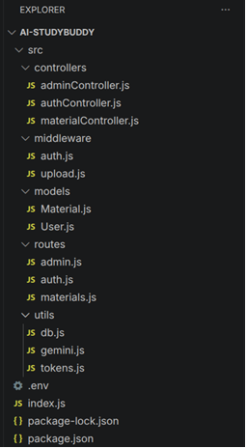

SETUP EXPRESS SERVER
The main server file initializes Express, loads environment variables, configures middleware, connects to MongoDB, registers routes, and starts listening on the configured port.

DATABASE CONNECTION
A dedicated database utility connects the application to MongoDB using Mongoose. The connection should be established before processing requests that depend on database access.

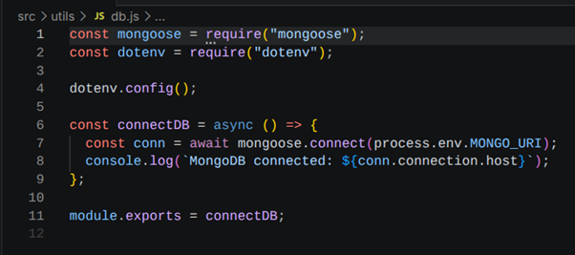

AUTHENTICATION MIDDLEWARE
Authentication middleware checks the Authorization header for a Bearer JWT token. A valid token identifies the user and allows the request to continue. Invalid or missing tokens should result in an unauthorized response.
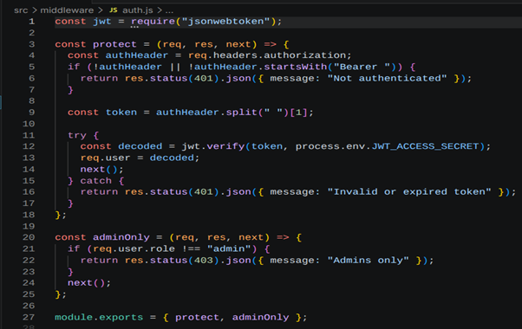

AI Integration
The AI utility communicates with the Generative AI API. It accepts structured prompts and study content, sends the request to the model, and returns the generated learning resource to the controller.
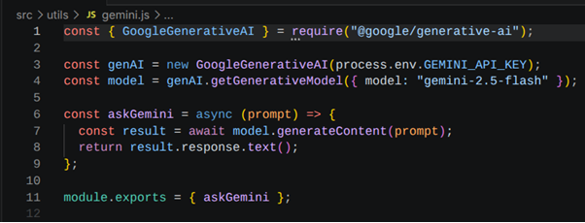

File Upload Middleware
If the application supports file-based study materials, upload middleware handles incoming files and validates them before the content is passed to the learning pipeline.
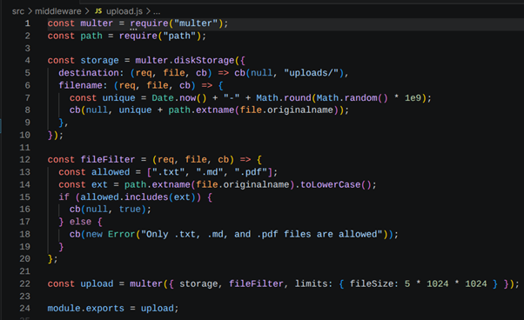

AUTHENTICATION AND AUTHORIZATION
AUTH CONTROLLER
The authentication controller manages registration and login operations. It validates user information, checks whether an email is already registered, hashes passwords before storage, verifies login credentials, and generates JWT tokens for authenticated users.

RESPONSIBILITIES
- Register new users
- Validate input
- Hash passwords using bcryptjs
- Verify credentials
- Generate JWT access tokens
JWT AUTHENTICATION FLOW
- User submits registration or login details.
- Server validates the request.
- Password is hashed during registration.
- During login, the submitted password is compared with the stored hash.
- Server creates a JWT token for valid credentials.
- Client sends the token in the Authorization header.
- Middleware verifies the token before protected operations.
- Decoded user information is attached to the request.

DATABASE CONFIGURATION AND SETUP
MONGODB:
MongoDB is used as the primary NoSQL database. It stores user information, study materials, and AI-generated learning resources in document collections.

MONGOOSE:
Mongoose provides schema definitions, validation, database connection handling, and convenient query operations. It also supports references between related documents.
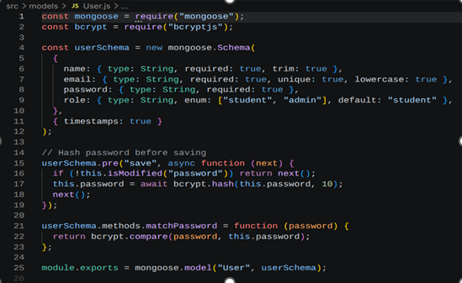
DATABASE COLLECTIONS
- Users
- Study Materials
- Summaries
- Flashcards
- Quizzes
- Study Plans

SECURITY CONSIDERATIONS
- Passwords must never be stored as plain text.
- JWT secrets and AI API keys should be stored in environment variables.
- Protected routes must verify authentication.
- User-specific queries should filter resources using the authenticated user ID.
- Administrative endpoints should check role permissions.
- Uploaded content should be validated before processing.

DATA MANAGEMENT
Generated resources should retain links to the user and, where applicable, the source study material. This allows the application to display previous resources and maintain a structured learning history.

PROJECT EXECUTION
Running the Backend Server
Install all required dependencies:
Start the development server:
After successful execution, the server connects to MongoDB and starts listening for incoming API requests.
EXECUTION STEPS
- Open the terminal in the backend project folder.
- Install all dependencies using npm install.
- Configure the .env file.
- Ensure MongoDB is available.
- Start the server using the configured start command.
- Confirm that the database connection succeeds.
- Use Postman or Thunder Client to test APIs.

API TESTING
1. REGISTER USER
Send a registration request containing the required user details. The server validates the input, hashes the password, and stores the user.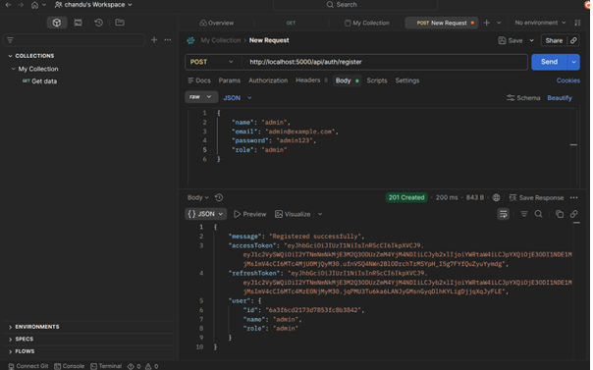

2. LOGIN USER
Send valid credentials. The server verifies the credentials and returns a JWT token.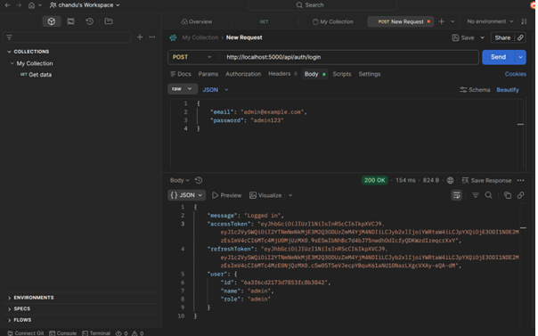

3. UPLOAD STUDY MATERIAL
Send authenticated material content to the material endpoint. The backend stores the material and associates it with the authenticated user.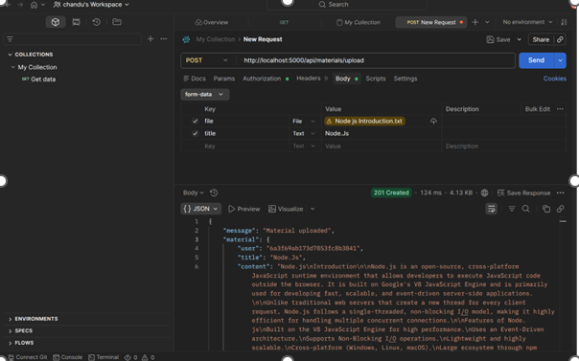

4. GENERATE SUMMARY
Send a material identifier to the summary endpoint. The AI service processes the material and returns a concise summary.

5. GENERATE FLASHCARDS
Send the relevant material or request data to the flashcard endpoint and store the generated question-and-answer resources.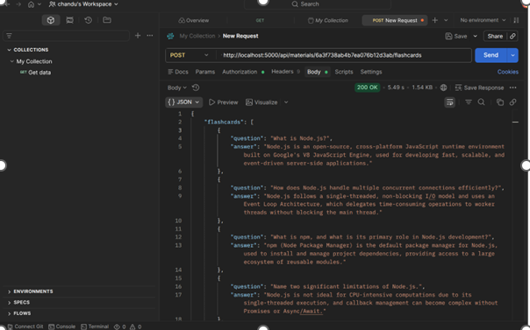

6. GENERATE QUIZ
The quiz endpoint generates multiple-choice questions from the selected study material. The response should contain structured quiz data suitable for the frontend.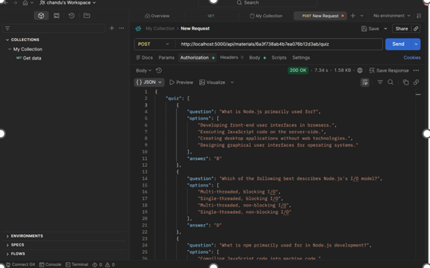

7. GENERATE STUDY PLAN
The study-plan endpoint creates a personalized schedule using the user's learning requirements and examination timeline.

