Voting.sol :
pragma solidity ^0.8.0;
contract Voting {
address public owner;
bool public votingActive;
struct Candidate {
uint id;
string name;
uint voteCount;
}
mapping(uint => Candidate) public candidates;
mapping(address => bool) public authorizedVoters;
mapping(address => bool) public hasVoted;
uint public candidateCount;
modifier onlyOwner() {
require(msg.sender == owner, "Not owner");
_;
}
modifier isActive() {
require(votingActive, "Voting is not active");
_;
}
constructor() {
owner = msg.sender;
votingActive = true;
}
function addCandidate(string memory _name) public onlyOwner {
candidateCount++;
candidates[candidateCount] = Candidate(candidateCount, _name, 0);
}
function authorizeVoter(address _voter) public onlyOwner {
authorizedVoters[_voter] = true;
}
function vote(uint _candidateId) public isActive {
require(authorizedVoters[msg.sender], "Not authorized");
require(!hasVoted[msg.sender], "Already voted");
require(_candidateId > 0 && _candidateId <= candidateCount, "Invalid ID");
hasVoted[msg.sender] = true;
candidates[_candidateId].voteCount++;
}
function getVotes(uint _candidateId) public view returns (uint) {
return candidates[_candidateId].voteCount;
}
function endVoting() public onlyOwner {
votingActive = false;
}
}

Screenshots:
Step 1: Compile Success -Go to Solidity Compiler tab → Click "Compile Voting.sol"
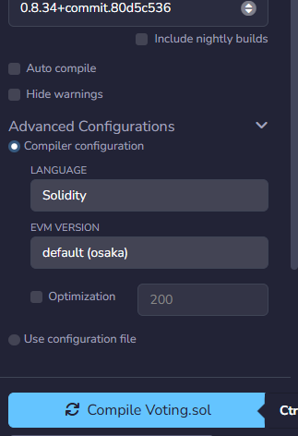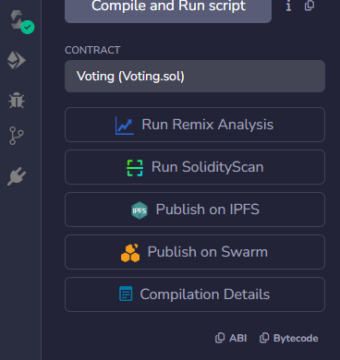
Step 2: Deploy Success- Deploy & Run tab → Select Remix VM (Cancun) → Click Deploy
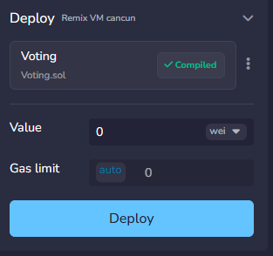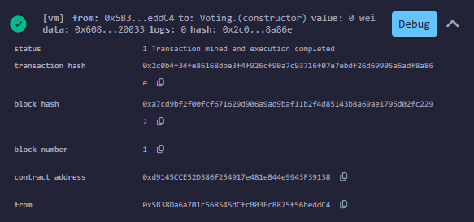
Step 3: Add Candidates (Alice,Bob,Charlie) - In Deployed Contracts → addCandidate → type Alice → transact. Repeat for Bob, Charlie What to capture: Terminal showing 3 successful transact calls
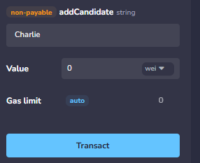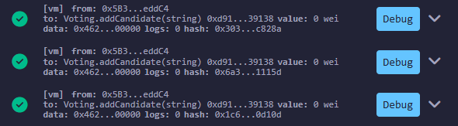
Step 4: Authorize Voter - Copy account address → paste in authorizeVoter() → click transact
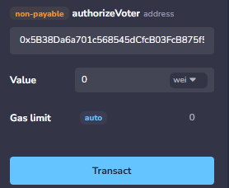
Step 5: Cast Vote - Switch account to authorized voter → vote() → enter 1 → transact
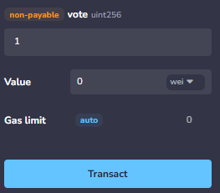
Step 6 : View Results (getVotes) -getVotes() → enter 1 → click blue call button
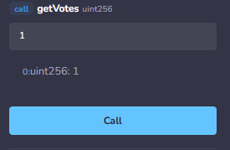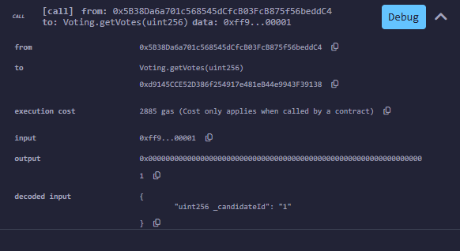
Step 7: End Voting - Switch back to owner account → click endVoting()
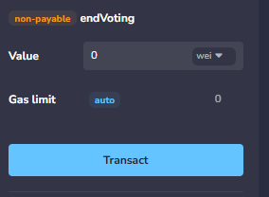
Output Table :
Candidate ID | Name | Votes
1 | Alice | 1
2 | Bob | 0
3 | Charlie | 0

