ABSTRACTION

1. Area Calculation:

Code:
#include <iostream>
using namespace std;

// Abstract Base Class
class Shape {
public:
// Pure virtual function
virtual double calculateArea() = 0;
virtual ~Shape() {} // Virtual destructor
};

class Circle : public Shape {
double radius;
public:
Circle(double r) : radius(r) {}
double calculateArea() override { return 3.14 * radius * radius; }
};

class Rectangle : public Shape {
double width, height;
public:
Rectangle(double w, double h) : width(w), height(h) {}
double calculateArea() override { return width * height; }
};

int main() {
Shape* s1 = new Circle(5);
Shape* s2 = new Rectangle(4, 5);

cout << "Circle Area: " << s1->calculateArea() << endl;
cout << "Rectangle Area: " << s2->calculateArea() << endl;

delete s1; delete s2;
return 0;
}
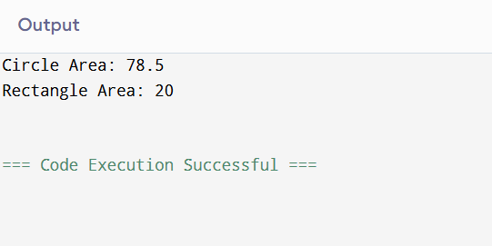

2. Online Shopping Discount System

Code:
#include <iostream>
using namespace std;

// abstract class
class Shopping {
public:
virtual void calculateTotal() = 0; // abstract function
};

// derived class
class Customer : public Shopping {
private:
float price, discount;

public:
void input() {
cout << "Enter price and discount (%): ";
cin >> price >> discount;
}

void calculateTotal() {
float total = price - (price * discount / 100); // apply discount
cout << "Final Price: " << total;
}
};

int main() {
Customer c;
c.input(); // take input
c.calculateTotal(); // calculate bill
return 0;
}
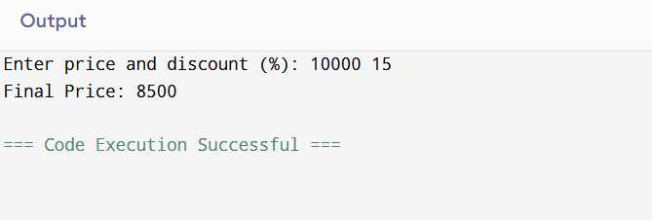

3. Electricity Bill Calculator

Code:
#include <iostream>
using namespace std;

// abstract class
class EB {
public:
virtual void bill() = 0; // abstract method
};

// derived class
class House : public EB {
private:
int units;
float amount;

public:
void input() {
cout << "Enter units consumed: ";
cin >> units;
}

void bill() {
// simple slab calculation
if (units <= 100)
amount = units * 1.5;
else
amount = units * 2.5;

cout << "Electricity Bill: " << amount;
}
};

int main() {
House h;
h.input(); // input units
h.bill(); // calculate bill
return 0;
}
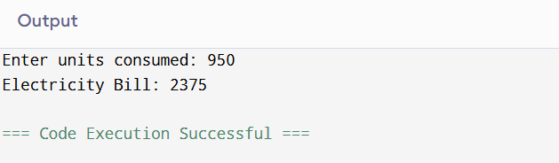

4. Student Grade System

Code:
#include <iostream>
using namespace std;

// abstract class
class Student {
public:
virtual void calculateGrade() = 0; // pure virtual
};

// derived class
class Result : public Student {
private:
int marks;

public:
void input() {
cout << "Enter marks: ";
cin >> marks;
}

void calculateGrade() {
// grading logic
if (marks >= 90)
cout << "Grade: A";
else if (marks >= 75)
cout << "Grade: B";
else if (marks >= 50)
cout << "Grade: C";
else
cout << "Grade: Fail";
}
};

int main() {
Result r;
r.input(); // take marks
r.calculateGrade(); // display grade
return 0;
}
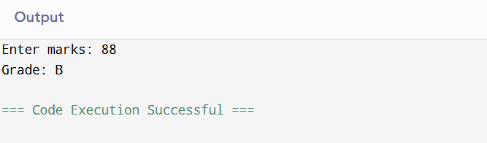

5. Library Fine Calculator System

Code:
#include <iostream>
using namespace std;

// abstract class
class Library {
public:
virtual void calculateFine() = 0; // abstract function
};

// derived class
class Book : public Library {
private:
int daysLate;
float fine;

public:
void input() {
cout << "Enter number of late days: ";
cin >> daysLate;
}

void calculateFine() {
// fine logic hidden from user
if (daysLate <= 5)
fine = daysLate * 2; // small fine
else
fine = daysLate * 5; // higher fine

cout << "Library Fine: " << fine;
}
};

int main() {
Book b;
b.input(); // take late days
b.calculateFine(); // calculate fine
return 0;
}
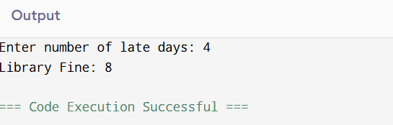

EXCEPTION HANDLING

6.Division with Custom Exception:

Code:

// Aim: Handle division using exception handling
#include <iostream>
using namespace std;

int main() {
float a, b;

try {
cout << "Enter two numbers: ";
cin >> a >> b;

if (b == 0)
throw "Division by zero not allowed";

cout << "Result: " << a / b << endl;
}
catch (const char* msg) {
cout << "Error: " << msg << endl;
}

return 0;
}
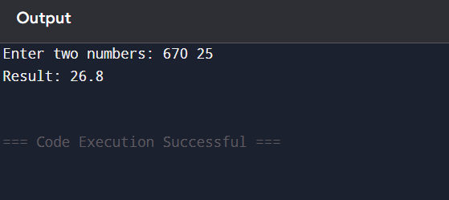
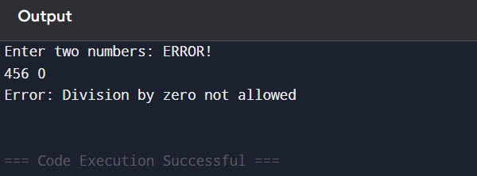

7. Array Index Validation:

Code:
// Aim: Access array safely using exception handling

#include <iostream>
using namespace std;

int main() {
int arr[5] = {10, 20, 30, 40, 50};
int index;

try {
cout << "Enter index: ";
cin >> index;

if (index < 0 || index >= 5)
throw index;

cout << "Element: " << arr[index] << endl;
}
catch (int i) {
cout << "Error: Invalid index " << i << endl;
}

return 0;
}
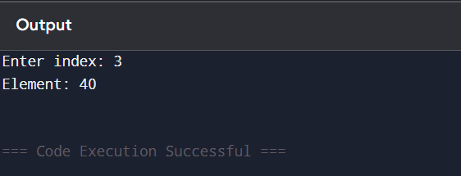

8.Bank Withdrawal System

Code:
// Aim: Simulate bank withdrawal with exception handling

#include <iostream>
using namespace std;

int main() {
double balance = 5000, amount;

try {
cout << "Enter withdrawal amount: ";
cin >> amount;

if (amount <= 0)
throw "Invalid amount";

if (amount > balance)
throw amount;

balance -= amount;

cout << "Withdrawal successful\n";
cout << "Remaining balance: " << balance << endl;
}
catch (const char* msg) {
cout << "Error: " << msg << endl;
}
catch (double amt) {
cout << "Error: Insufficient balance for " << amt << endl;
}

return 0;
}
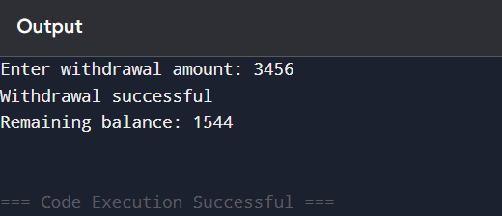

9. Marks Validation Program

Code:
// Aim: Validate student marks using exceptions

#include <iostream>
using namespace std;

int main() {
int marks;

try {
cout << "Enter marks: ";
cin >> marks;

if (marks < 0 || marks > 100)
throw marks;

cout << "Valid marks entered: " << marks << endl;
}
catch (int m) {
cout << "Error: Invalid marks (" << m << ")" << endl;
}

return 0;
}
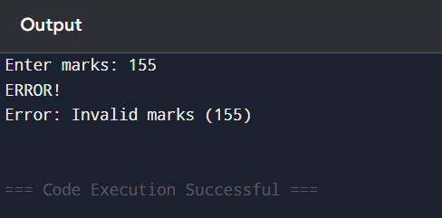
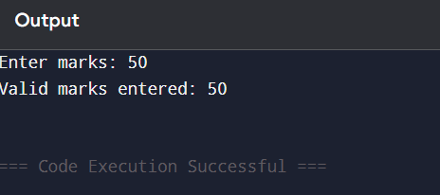

10. File Opening Check

Code:
// Aim: Handle file opening errors

#include <iostream>
#include <fstream>
using namespace std;

int main() {
ifstream file;

try {
file.open("data.txt");

if (!file)
throw "File could not be opened";

cout << "File opened successfully" << endl;

file.close();
}
catch (const char* msg) {
cout << "Error: " << msg << endl;
}

return 0;
}
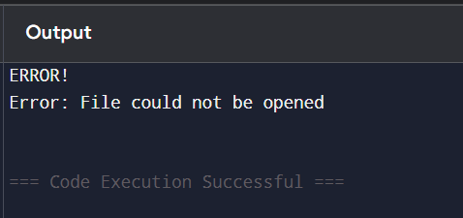

TEMPLATES

11.Generic Swap Function

Code:
// Aim: Swap two values using function template

#include <iostream>
using namespace std;

template <class T>
void swapValues(T &a, T &b) {
T temp = a;
a = b;
b = temp;
}

int main() {
int x = 10, y = 20;
swapValues(x, y);
cout << "Swapped integers: " << x << " " << y << endl;

float p = 1.5, q = 2.5;
swapValues(p, q);
cout << "Swapped floats: " << p << " " << q << endl;

return 0;
}
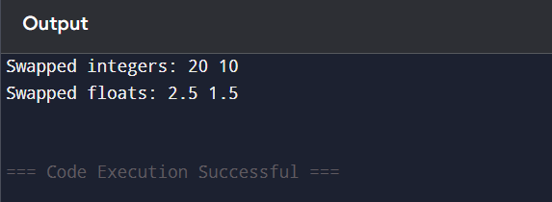

12.Find Maximum of Two Values

Code:

// Aim: Find maximum using template

#include <iostream>
using namespace std;

template <typename T>
T findMax(T a, T b) {
return (a > b) ? a : b;
}

int main() {
cout << "Max (int): " << findMax(10, 25) << endl;
cout << "Max (float): " << findMax(3.5, 2.1) << endl;
cout << "Max (char): " << findMax('A', 'Z') << endl;

return 0;
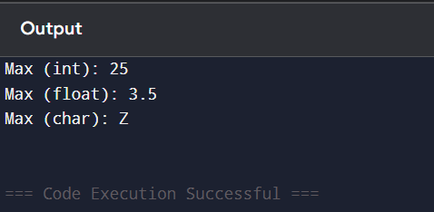

13.Generic Array Sum

code:
// Aim: Find sum of array elements using template

#include <iostream>
using namespace std;

template <class T>
T arraySum(T arr[], int size) {
T sum = 0;
for (int i = 0; i < size; i++) {
sum += arr[i];
}
return sum;
}

int main() {
int arr1[] = {1, 2, 3, 4};
cout << "Sum (int): " << arraySum(arr1, 4) << endl;

float arr2[] = {1.1, 2.2, 3.3};
cout << "Sum (float): " << arraySum(arr2, 3) << endl;

return 0;
}
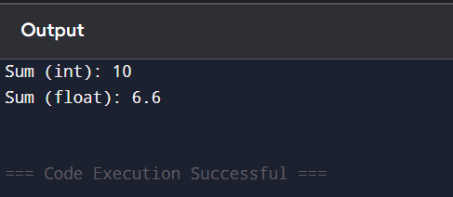

14.Class Template for Calculator

Code:
// Aim: Perform arithmetic operations using class template

#include <iostream>
using namespace std;

template <class T>
class Calculator {
T a, b;

public:
Calculator(T x, T y) {
a = x;
b = y;
}

void display() {
cout << "Addition: " << a + b << endl;
cout << "Subtraction: " << a - b << endl;
cout << "Multiplication: " << a * b << endl;
if (b != 0)
cout << "Division: " << a / b << endl;
else
cout << "Division not possible" << endl;
}
};

int main() {
Calculator<int> c1(10, 5);
c1.display();

Calculator<float> c2(5.5, 2.2);
c2.display();

return 0;
}
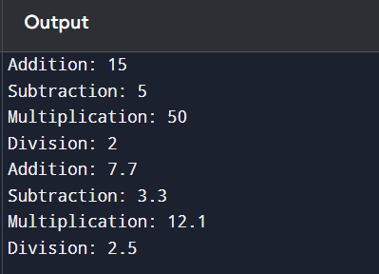

15. Template for Sorting Array

Code:

// Aim: Sort array using template function

#include <iostream>
using namespace std;

template <class T>
void sortArray(T arr[], int size) {
for (int i = 0; i < size - 1; i++) {
for (int j = i + 1; j < size; j++) {
if (arr[i] > arr[j]) {
T temp = arr[i];
arr[i] = arr[j];
arr[j] = temp;
}
}
}
}

int main() {
int arr[] = {5, 2, 8, 1};
sortArray(arr, 4);

cout << "Sorted array: ";
for (int i = 0; i < 4; i++)
cout << arr[i] << " ";

return 0;
}
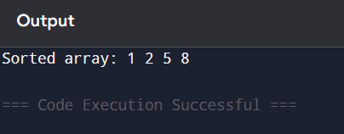

POINTER

16. Find Largest Element Using Pointer Traversal

Code:
// Aim: Find largest element using pointer traversal

#include <iostream>
using namespace std;

int main() {
int arr[] = {12, 45, 7, 89, 34};
int *ptr = arr;

int max = *ptr;

for (int i = 1; i < 5; i++) {
if (*(ptr + i) > max)
max = *(ptr + i);
}

cout << "Largest element: " << max << endl;

return 0;
}
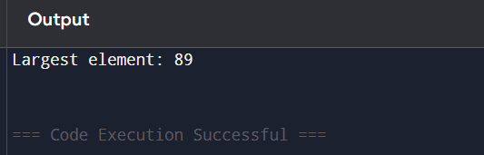

17. Count Vowels Using Pointer

Code:
// Aim: Count vowels in a string using pointer

#include <iostream>
using namespace std;

int main() {
char str[100];
cout << "Enter a string: ";
cin.getline(str, 100);

char *ptr = str;
int count = 0;

while (*ptr != '\0') {
char ch = tolower(*ptr);

if (ch == 'a' || ch == 'e' || ch == 'i' || ch == 'o' || ch == 'u')
count++;

ptr++;
}

cout << "Number of vowels: " << count << endl;

return 0;
}
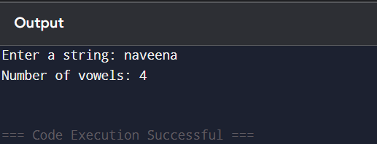

18. Merge Two Arrays Using Pointer

Code:
// Aim: Merge two arrays using pointers

#include <iostream>
using namespace std;

int main() {
int a[3] = {1, 2, 3};
int b[3] = {4, 5, 6};
int c[6];

int *p1 = a, *p2 = b, *p3 = c;

for (int i = 0; i < 3; i++)
*(p3++) = *(p1++);

for (int i = 0; i < 3; i++)
*(p3++) = *(p2++);

cout << "Merged array: ";
for (int i = 0; i < 6; i++)
cout << c[i] << " ";

return 0;
}
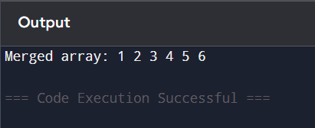

19. Compare Two Strings Using Pointer

Code:
// Aim: Compare two strings using pointers

#include <iostream>
using namespace std;

int main() {
char str1[100], str2[100];

cout << "Enter first string: ";
cin.getline(str1, 100);
cout << "Enter second string: ";
cin.getline(str2, 100);

char *p1 = str1;
char *p2 = str2;

while (*p1 && *p2 && *p1 == *p2) {
p1++;
p2++;
}

if (*p1 == *p2)
cout << "Strings are equal";
else
cout << "Strings are not equal";

return 0;
}
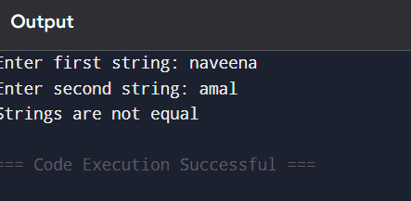

20. Pointer to Pointer (Double Pointer)

Code:
// Aim: Demonstrate pointer to pointer

#include <iostream>
using namespace std;

int main() {
int x = 10;

int *ptr = &x;
int **dptr = &ptr;

cout << "Value of x: " << x << endl;
cout << "Using ptr: " << *ptr << endl;
cout << "Using dptr: " << **dptr << endl;

return 0;
}
