Steps to load and run binary in RaspberryPi from desktop

1. Download the cross build folder(QtComm) from below path to your local drive (C:\)

<https://drive.google.com/file/d/1a7waO7mxofBgRv5lTJtG88EcJaQgrbVV/view?usp=sharing>

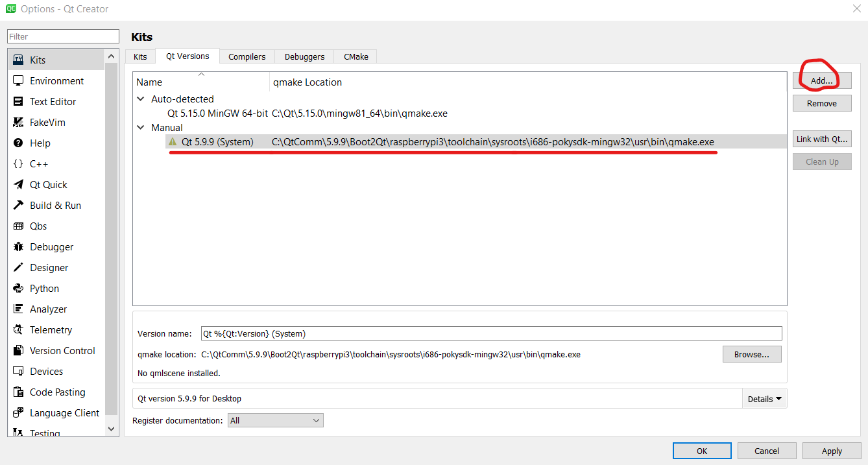

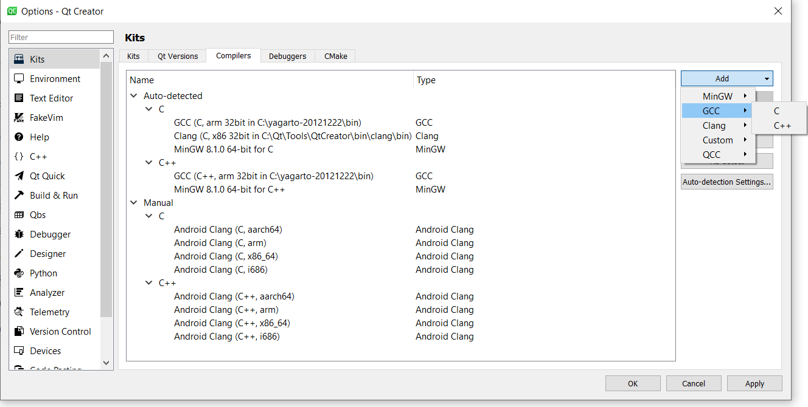

C:\QtComm\5.9.9\Boot2Qt\raspberrypi3\toolchain\sysroots\i686-pokysdk-mingw32\usr\bin\arm-poky-linux-gnueabi\arm-poky-linux-gnueabi-gcc.exe

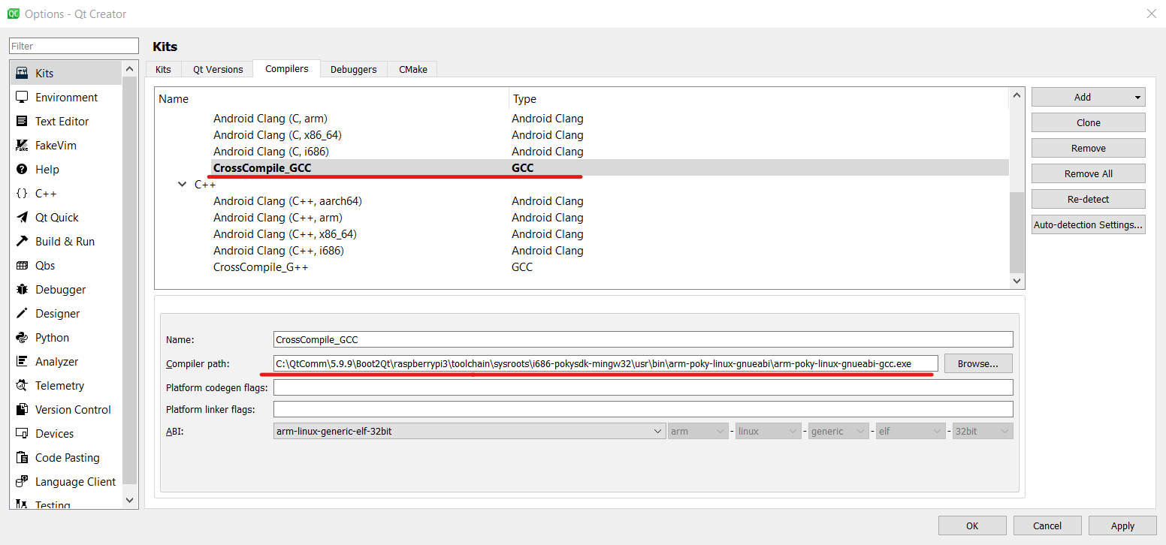

C:\QtComm\5.9.9\Boot2Qt\raspberrypi3\toolchain\sysroots\i686-pokysdk-mingw32\usr\bin\arm-poky-linux-gnueabi\arm-poky-linux-gnueabi-g++.exe

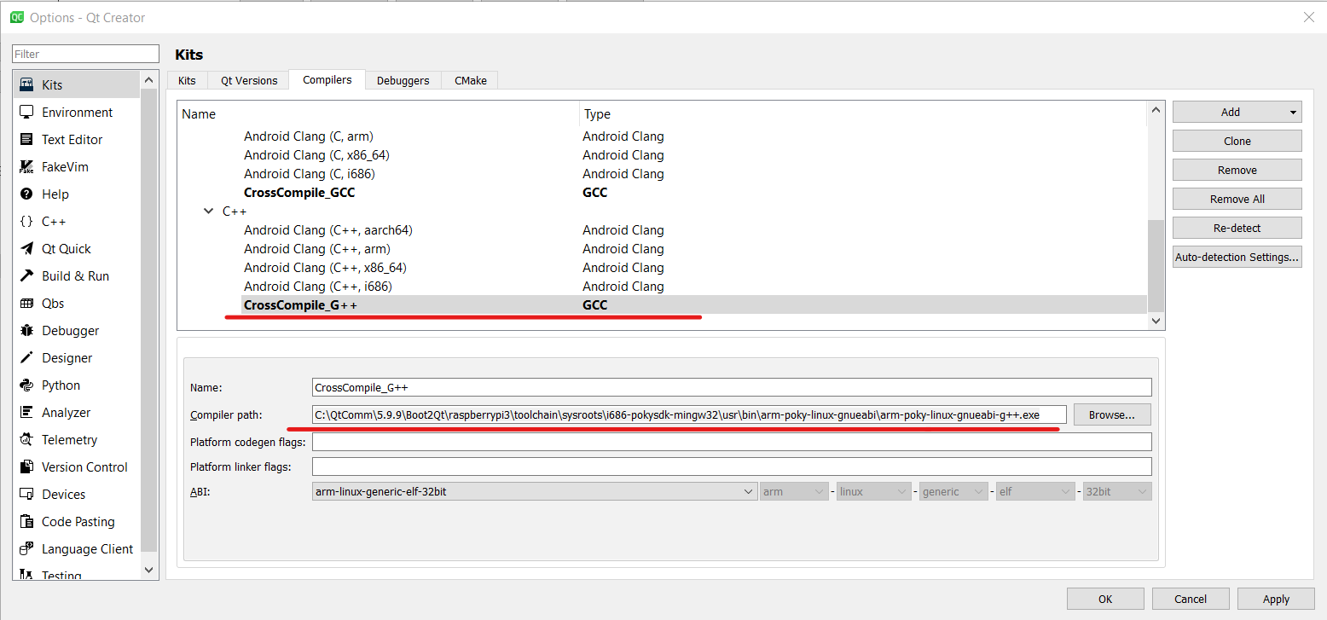

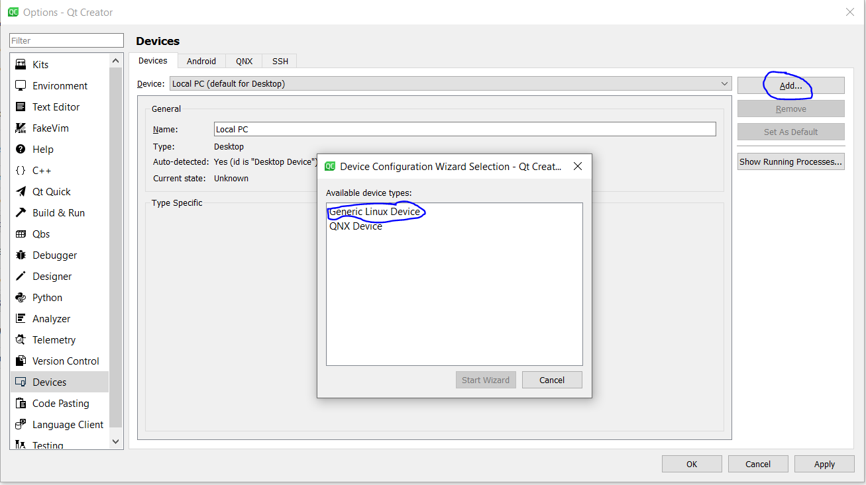

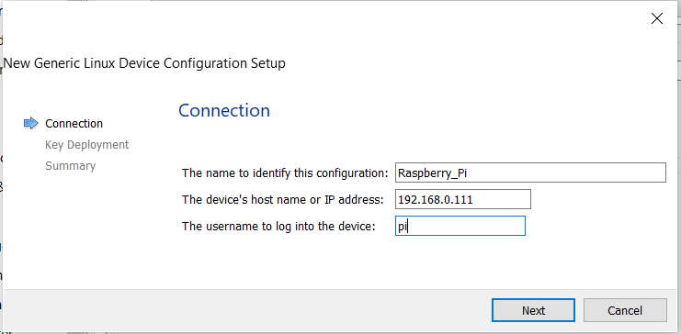

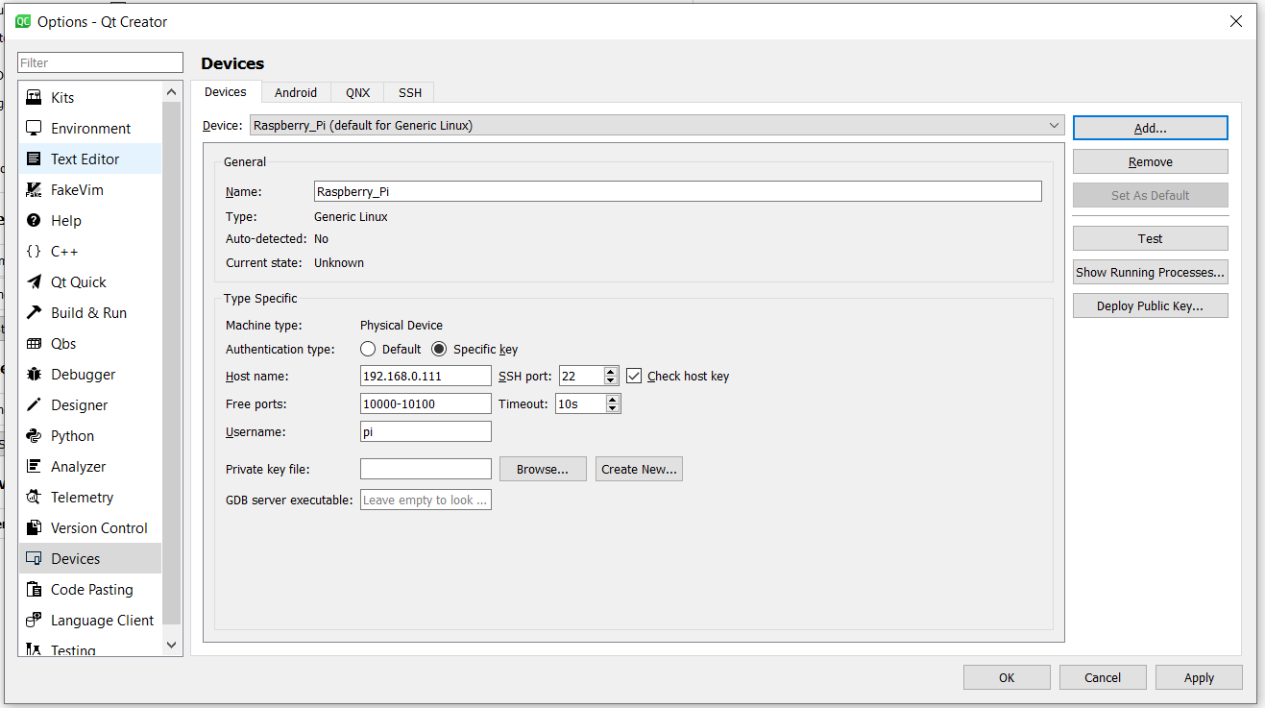

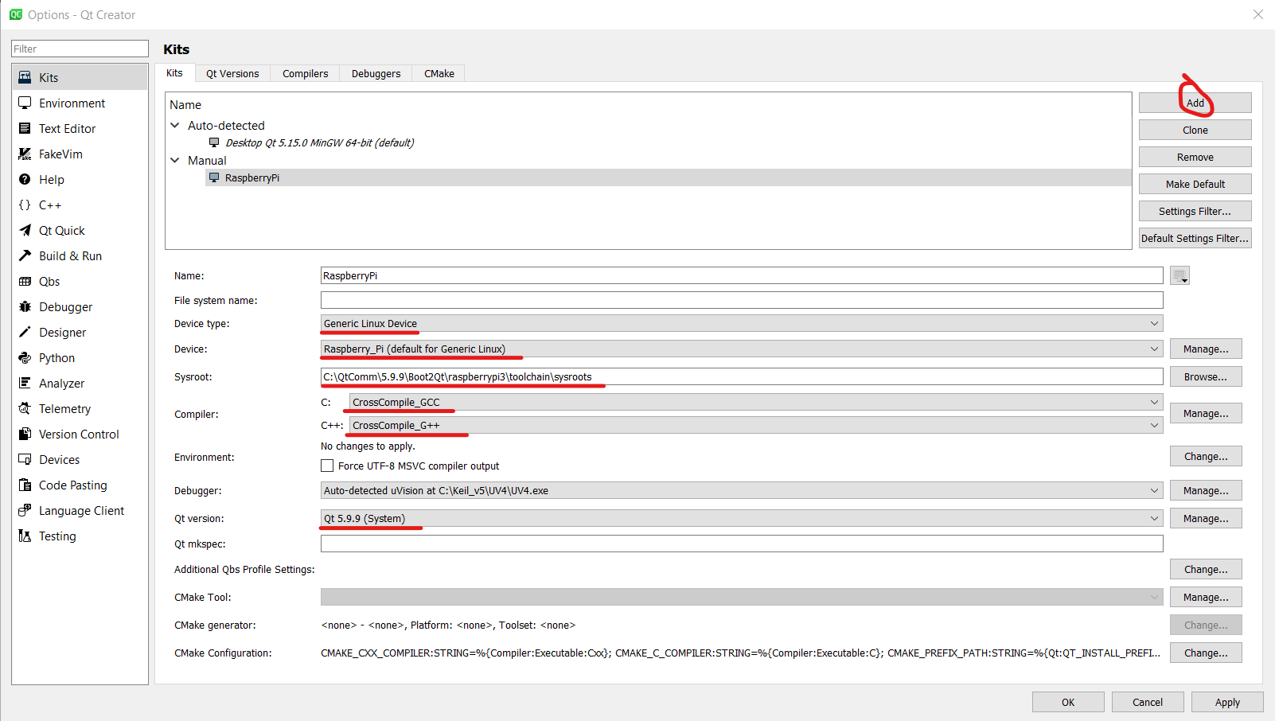

<https://github.com/git-for-windows/git/releases/download/v2.27.0.windows.1/Git-2.27.0-64-bit.exe>

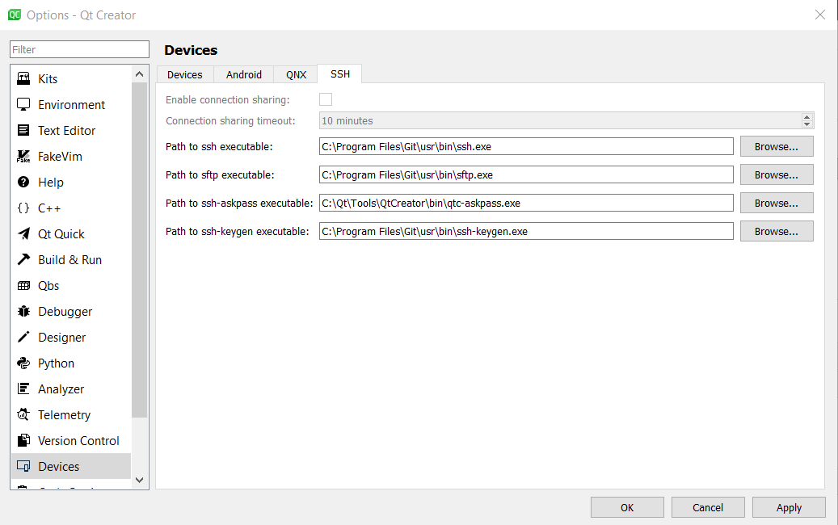

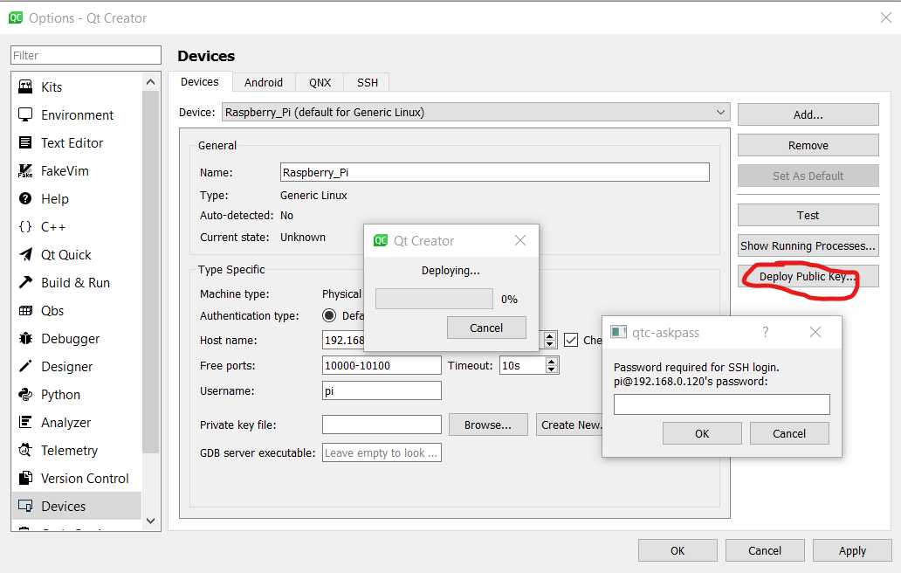

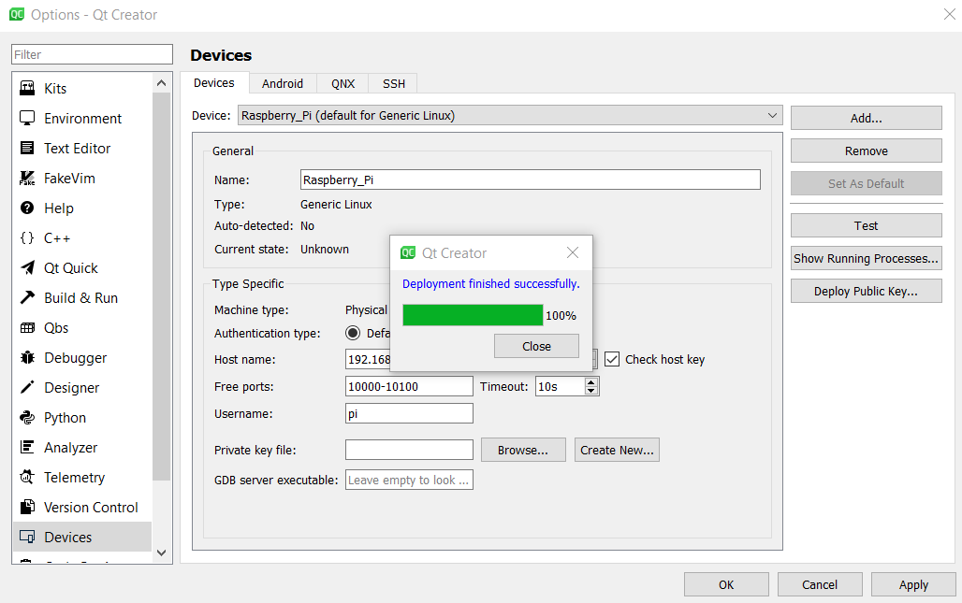

2. RaspberryPi Settings

a. /home/pi/.ssh --> ssh-keygen (if not done before)

provide the proper file name

b. ssh-copy-id -i ~/.ssh/<Keyname> <username>@<laptop ip>

c. Copy the generated key to laptop

d.note:enable the ssh in the raspberry pi by using terminal

sudo raspi-config->interfacing options->enable ssh ->reboot

Raspberry pi settings:

1.Add Qt-5.14.1 library in raspberry pi(this file is in the office pendrive)

Path ----> usr->local->Qt-5.14.1

2.Then configure the qmake in Qt-5.14.1(in terminal)

Path--- >cd /usr/local/Qt-5.14.1/bin/ ------- press enter

Then put the comment “ sudo chmod 777 qmake”

Before run your qt project in desktop export the library in raspberry pi

export LD_LIBRARY_PATH=/usr/local /Qt-5.14.1/lib/

note:

if ssh key test is failed then remove all the device in the kits and them add new device generate new key and deploy